Supplymentary Materials for

NCBP2 Predicts the Prognosis and the Immunotherapy Response of Cancers: A Pan-Cancer Analysis
Shichao Li^{1,#,*}, Yulan Wang^{1,#}, Xi Yang², Miao Li³, Guoxiang Li², Qiangqiang Song¹ and Junyu Liu^{4,*}
¹Department of Pathology, General Hospital of Xinjiang Military Command, Urumqi, Xinjiang, China;
²Department of Medical Service, General Hospital of Xinjiang Military Command, Urumqi, Xinjiang, China;
³School of Rehabilitation Medicine, Xinjiang Medical University, Urumqi, Xinjiang, China;
⁴Department of Gastroenterology, The Third Affiliated Hospital of Sun Yat-Sen University, Guangzhou, China
#These authors contributed equally to this work;
*Corresponding authors.
Corresponding Authors: Dr. Junyu Liu (ljysci@foxmail.com). Department of Gastroenterology, The Third Affiliated Hospital of Sun Yat-Sen University, Guangzhou, China; Dr. Shichao Li (lishichao1208@126.com). Department of Pathology, General Hospital of Xinjiang Military Command, Youhao Bei street of the region of Shayibake, 830000 Urumqi, Xinjiang, China.

Supplementary Figures
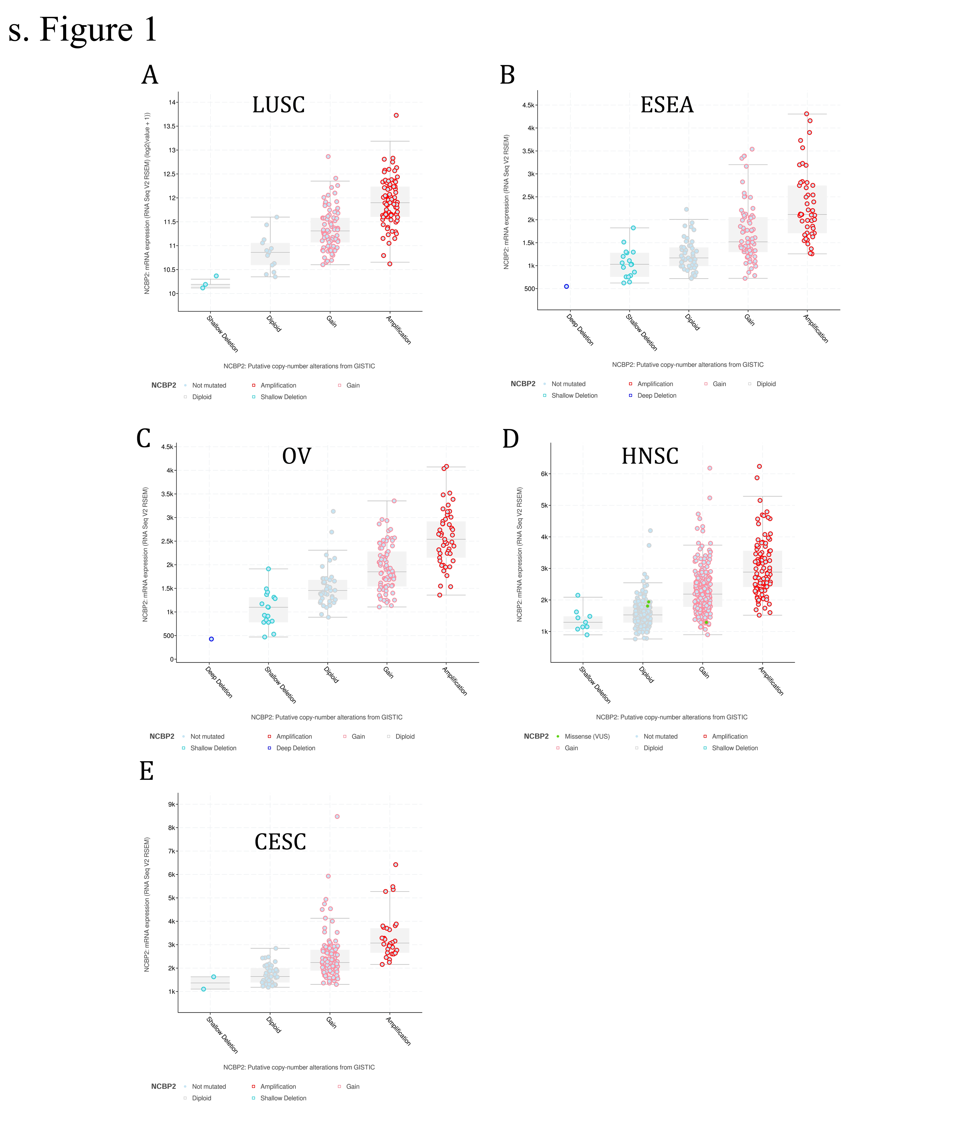
Supplementary Figure 1
the relationship between NCBP2 expression and copy numbers in top five cancers: LUSC, ESEA, OV, HNSC and CESC.

Supplementary Figure 2
the expression of NCBP2 in LUSC, PAAD, KIRP and KIRC was detected by Immunohistochemistry.

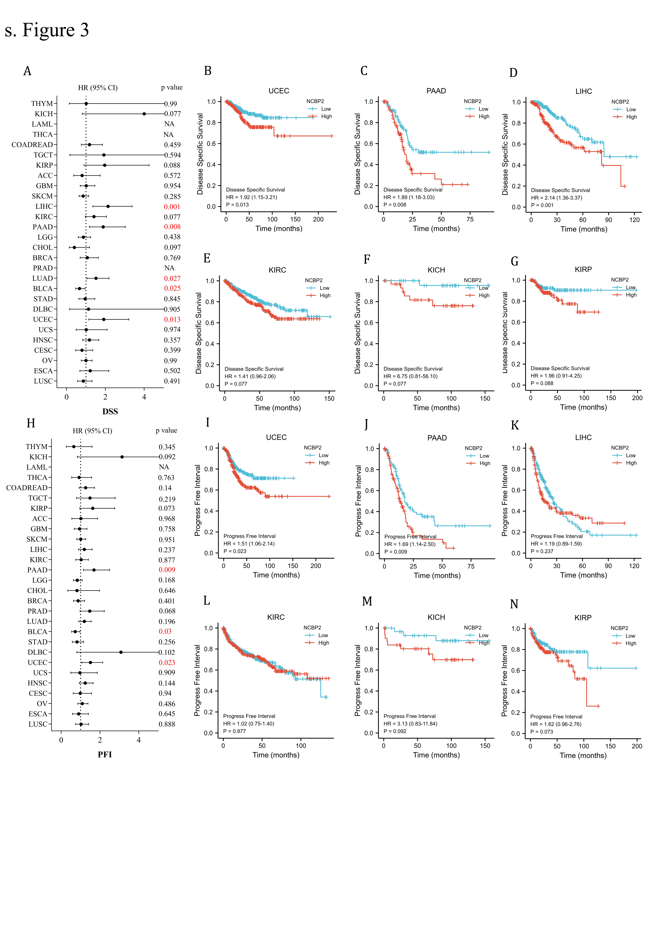
Supplementary Figure 3
- The relationship between NCBP2 and disease specific survival (DSS);
B-G. The DSS were compared between “NCBP2 high” and “NCBP2 low” groups using Kaplan-Meier analysis for UCEC (B), PAAD (C), LIHC (D), KIRC (E), KICH (F) and KIRP (G);
H. The relationship between NCBP2 and progress free interval (PFI);
I-N. The PFI were compared between “NCBP2 high” and “NCBP2 low” groups using Kaplan-Meier analysis for UCEC (I), PAAD (J), LIHC (K), KIRC (L), KICH (M) and KIRP (N).

Table s1. Abbreviations of Cancers

THYM | Thymoma
KICH | Kidney Chromophobe
LAML | Acute Myeloid Leukemia
THCA | Thyroid carcinoma
COADREAD | Colorectal carcinoma
TGCT | Testicular Germ Cell Tumors
KIRP | Kidney renal papillary cell carcinoma
ACC | Adrenocortical carcinoma
GBM | Glioblastoma multiforme
SKCM | Skin Cutaneous Melanoma
LIHC | Liver hepatocellular carcinoma
KIRC | Kidney renal clear cell carcinoma
PAAD | Pancreatic adenocarcinoma
LGG | Brain Lower Grade Glioma
CHOL | Cholangio carcinoma
BRCA | Breast invasive carcinoma
PRAD | Prostate adenocarcinoma
LUAD | Lung adenocarcinoma
BLCA | Bladder Urothelial Carcinoma
STAD | Stomach adenocarcinoma
DLBC | Lymphoid Neoplasm Diffuse Large B-cell Lymphoma
UCEC | Uterine Corpus Endometrial Carcinoma
UCS | Uterine Carcinosarcoma
HNSC | Head and Neck Squamous Cell Carcinoma
CESC | Cervical squamous cell carcinoma and endocervical adenocarcinoma
OV | Ovarian Serous Cystadenocarcinoma
ESCA | Esophageal Carcinoma
LUSC | Lung Squamous Cell Carcinoma
MESO | Mesothelioma
PCPG | Pheochromocytoma and Paraganglioma
SARC | Sarcoma
UVM | Uveal Melanoma
DEGs | differential expressed genes
GSEA | gene set enrichment analysis
CBC | cap-binding complex

