**MIQE checklist**

**1 Experimental design**

**1.1 Definition of experimental and control groups**

Table1 Tissue-specific expression of Pe-TElncRNA2 in the root, stem, leaf, and bud.

|  |  |  |
| --- | --- | --- |
| Control groups | Roots of five-leaf-stage Moso bamboo | 3 groups |
| Experimental | Leaves of five-leaf-stage Moso bamboo | 3 groups |
| Stems of five-leaf-stage Moso bamboo | 3 groups |
| Buds of five-leaf-stage Moso bamboo | 3 groups |

Table2 Cellular localization of *Pe-TElncRNA2* and the reference genes (*PeACT* and *PeEF1α*) in the cytoplasm and nucleus.

|  |  |  |  |
| --- | --- | --- | --- |
| Nucleus | Control groups | PeACT | 3 groups |
| Experimental | Pe-TElncRNA2 | 3 groups |
| Cytoplasm | Control groups | PeEFla | 3 groups |
| Experimental | Pe-TElncRNA2 | 3 groups |

Table3 Expression patterns of *Pe-TElncRNA2* and four genes, such as *PeFZR2*, *PeNOT3*, *PeABCG44*, and *PeAGD6*, in the leaves under cold stress

|  |  |  |
| --- | --- | --- |
| Control groups | Cold stress-treated 0h five-leaf-stage Moso bamboo seedlings | 3 groups |
| Experimental | Cold stress-treated 8h five-leaf-stage Moso bamboo seedlings | 3 groups |
| Cold stress-treated 16h five-leaf-stage Moso bamboo seedlings | 3 groups |
| Cold stress-treated 24h five-leaf-stage Moso bamboo seedlings | 3 groups |
| Cold stress-treated 32h five-leaf-stage Moso bamboo seedlings | 3 groups |

Table4 Relative expression levels of Pe-TElncRNA2 and four genes in the pUBQ10-Pe-TElncRNA2-transfected Moso bamboo protoplasts.

|  |  |  |
| --- | --- | --- |
| Control groups | Cold stress-treated 0h pUBQ*10*-transfected protoplasts | 3 groups |
| Experimental | Cold stress-treated 0h pUBQ*10*-*Pe-TElncRNA2*-transfected protoplasts | 3 groups |
| Cold stress-treated 4h pUBQ*10*-*Pe-TElncRNA2*-transfected protoplasts | 3 groups |

Table5 Expression analysis of Pe-TElncRNA2 and four homologous genes in the wild-type and transgenic Arabidopsis under cold stress.

|  |  |  |
| --- | --- | --- |
| Control groups | Leaves of cold stress-treated 0D the transgenic *Arabidopsis* | 3 groups |
| Experimental | Leaves of cold stress-treated 2D the transgenic *Arabidopsis* | 3 groups |
| Leaves of cold stress-treated 4D the transgenic *Arabidopsis* | 3 groups |

**2 Sample**

**2.1 Description**

Moso bamboo seeds from a single plant and *Arabidopsis thaliana* seeds (Columbia ecotype) were used in this study. All seedlings were cultivated in a controlled greenhouse under a 16-hour light/8-hour dark photoperiod at 25°C/22°C (day/night) and 60% relative humidity.

For cold stress treatment, five-leaf-stage Moso bamboo seedlings were subjected to 4°C for 8, 16, 24, and 32 hours in a plant incubator. For *Arabidopsis*, four-week-old wild-type and transgenic *Arabidopsis* plants were subjected to 4°C for 2 and 4 days in a plant incubator. After the respective cold stress treatments, five mature leaves from Moso bamboo seedlings and *Arabidopsis* leaves were collected, immediately frozen in liquid nitrogen, and stored at -80°C for subsequent RNA extraction. Three biological replicates of each stress treatment were used for both species.

**2.2 If frozen, how and how quickly?**

All fresh plant samples were frozen in liquid nitrogen immediately and then stored at -80 °C.

**3 Nucleic acid extraction**

**3.1 Procedure**

**the SteadyPure Universal RNA Extraction Kit II (Accurate Biology, Changsha, China)**

**Lysis of plant tissues:**

1. Transfer fresh or frozen plant tissue samples to a mortar pre-cooled with liquid nitrogen, and grind the animal and plant tissues with a pestle and mortar (liquid nitrogen needs to be added to the mortar continuously during the grinding process) until they are ground to a powder (no visible particles, insufficient grinding will affect the sample collection).
2. Transfer the appropriate amount of powdered sample to a 1.5 ml centrifuge tube (RNasefree) containing the appropriate amount of lysate Buffer RLS (according to the recommended amount in Table 1, and make sure that 50×DTT Solution has been added to Buffer RLS before use), and immediately vortex at high speed or blow repeatedly with a pipette gun until there is no obvious precipitate in the lysate.

3. Allow the lysate to stand at room temperature for 2 minutes.

4. Centrifuge at 12,000 rpm for 5 minutes at 4°C.

5. Carefully pipette the supernatant into a new 1.5 ml centrifuge tube (RNasefree).

**Purification steps:**

1. Add an equal volume of 70% ethanol to the tissue lysate and mix well by blowing with a pipette gun. If there is obvious sticky substance or precipitate, blow several times with a pipette gun to break up the precipitate.

2. Immediately transfer all of the above mixture and precipitate to a Universal RNA Mini Column, centrifuge at 12,000 rpm for 1 minute at room temperature, and discard the filtrate.

3. Add 600 μl of Buffer RWA to the Universal RNA Mini Column and centrifuge at 12,000 rpm for 1 minute at room temperature.

4. Add 650 μl of Buffer RWB to the Universal RNA Mini Column and centrifuge at 12,000 rpm for 1 minute at room temperature.

5. Prepare the DNase I reaction solution according to the table below and mix well. Add 50 μl of DNase I Reaction Solution to the centre of the Universal RNA Mini Column and allow to stand at room temperature for 15 minutes.

|  |  |
| --- | --- |
| ingredients | volumes |
| DNase I（RNase free） | 4μl |
| 10×DNase I Buffer | 5μl |
| RNase free water | 41μl |

6. Add 350 μl of Buffer RWB to the centre of the Universal RNA Mini Column membrane and centrifuge at 12,000 rpm for 1 minute at room temperature, discard the filtrate.

7. Add 650 μl of Buffer RWB to the centre of the Universal RNA Mini Column and centrifuge at 12,000 rpm for 1 minute at room temperature. 6. Place the adsorbent column of the Universal RNA Mini Column on a new 2.0 ml Collection Tube and centrifuge at 12,000 rpm for 2 minutes at room temperature.

8. Place the adsorption column of Universal RNA Mini Column on the new RNase Free Tube, add 50 μl-200 μl 650 μl Buffer RWB to the centre of the adsorption column membrane, wash twice, centrifuge the empty tube for 2 minutes 50 μl-200 μl RNase Free Water to elute RNase Free Water, leave for 5 minutes at room temperature. RNase Free Water, let stand at room temperature for 5 minutes, then centrifuge at 12,000 rpm for 2 minutes at room temperature to elute RNA, and store the lysed RNA at -80℃.

**3.2 Details of DNase or RNAse treatment**

Prepare the DNase I reaction solution according to the table below and mix well. Add 50 μl of DNase I Reaction Solution to the centre of the Universal RNA Mini Column and allow to stand at room temperature for 15 minutes.

|  |  |
| --- | --- |
| ingredients | volumes |
| DNase I（RNase free） | 4μl |
| 10×DNase I Buffer | 5μl |
| RNase free water | 41μl |

**3.3 Contamination assessment**

The integrity of RNA were assessed using electrophoresis on 1% agarose gels.

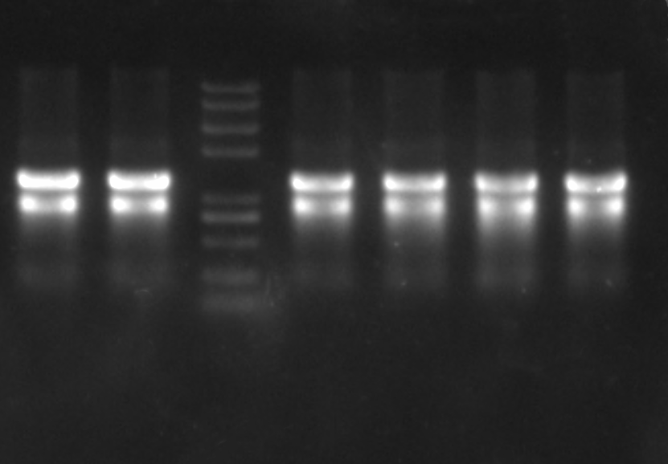

Nucleus Cytoplasm Marker Roots Stems Leaves Buds

Fig. 1 1% agarose gel electrophoresis detection of total RNA extracted from moso bamboo tissues

(Note:Marker:Trans2K® Plus II DNA Marker)

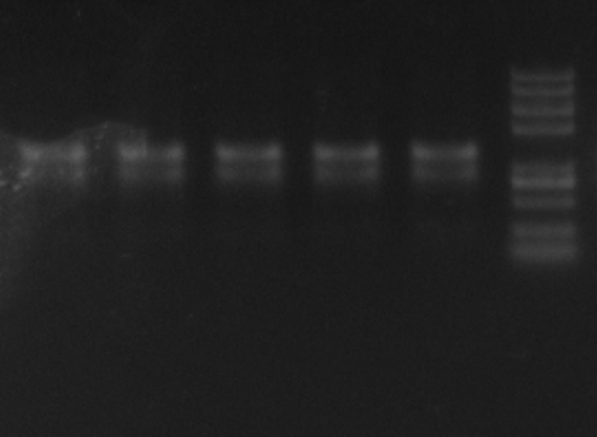

1 2 3 4 5 Marker

Fig. 2 1% agarose gel electrophoresis detection of total RNA extracted from cold-stressed moso bamboo tissues

(Note:Marker:Trans2K® Plus II DNA Marker;1:Cold stress-treated 0h five-leaf-stage Moso bamboo seedlings;2:Cold stress-treated 8h five-leaf-stage Moso bamboo seedlings;3:Cold stress-treated 16h five-leaf-stage Moso bamboo seedlings;4:Cold stress-treated 24h five-leaf-stage Moso bamboo seedlings;5:Cold stress-treated 32h five-leaf-stage Moso bamboo seedlings)

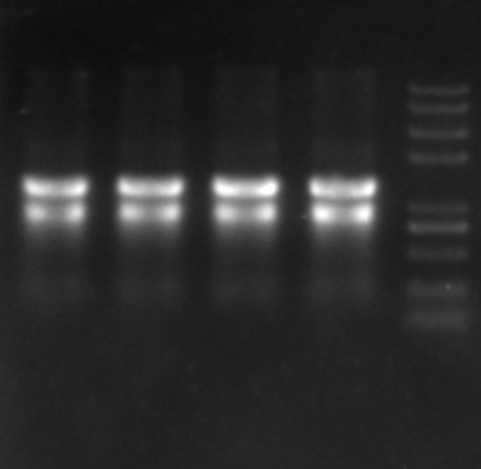

1 2 3 4 Marker

Fig. 3 1% agarose gel electrophoresis detection of total RNA extracted from cold-stressed moso bamboo protoplasts

(Note:Marker:Trans2K® Plus II DNA Marker;1-2:Cold stress-treated 0h pUBQ*10*-transfected protoplasts;3:Cold stress-treated 0h pUBQ*10*-*Pe-TElncRNA2-*transfected protoplasts;4:Cold stress-treated 4h pUBQ*10*-*Pe-TElncRNA2-*transfected protoplasts)

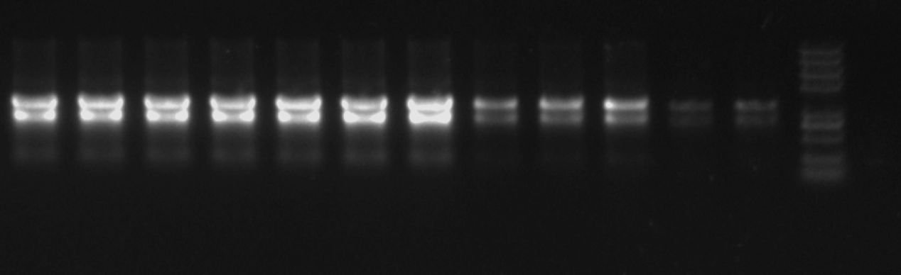

1 2 3 4 5 6 7 8 9 10 11 12 Marker

Fig. 3 1% agarose gel electrophoresis detection of total RNA extracted from cold stress-treated the transgenic *Arabidopsis* leaves

[Note:Marker:Trans2K® Plus II DNA Marker;1:Leaves of cold stress-treated 0D the transgenic *Arabidopsis* OE1;2:Leaves of cold stress-treated 2D the transgenic *Arabidopsis* OE1;3:Leaves of cold stress-treated 4D the transgenic *Arabidopsis* OE1;4:Leaves of cold stress-treated 0D the transgenic *Arabidopsis* OE2;5:Leaves of cold stress-treated 2D the transgenic *Arabidopsis* OE2;6:Leaves of cold stress-treated 4D the transgenic *Arabidopsis* OE2;7:Leaves of cold stress-treated 0D the transgenic *Arabidopsis* OE3;8:Leaves of cold stress-treated 2D the transgenic *Arabidopsis* OE3;9:Leaves of cold stress-treated 4D the transgenic *Arabidopsis* OE3;10:Leaves of cold stress-treated 0D the *Arabidopsis* (WT);11:Leaves of cold stress-treated 2D the *Arabidopsis* (WT);12:Leaves of cold stress-treated 4D the *Arabidopsis* (WT)]

**4 Reverse transcription**

**4.1 Complete reaction conditions**

Extracted RNA was reverse transcribed into cDNA using 2×Hieff Canace® Plus PCR Master Mix (with Dye) (Yesen, Shanghai, China).Operation steps refer to the manual.

**4.2 Amount of RNA and reaction volume**

Amount of RNA: 1 μg; reaction volume: 20µL.

**4.3 Priming oligonucleotide (if using GSP) and concentration**

Anchored oligo (dT)18 (50μM)

**4.4 Reverse transcriptase and concentration**

4×Hifair®AdvanceFast SuperMix.

**4.5 Temperature and time**

Incubate at 42°C for 2min to synthesize the firststrand of cDNA.

Reverse transcription programme settings

|  |  |
| --- | --- |
| Temperature | Time |
| 25 ℃ | 5 min |
| 55 ℃ | 15 min |
| 85 ℃ | 5 min |

**5 qPCR target information and qPCR oligonucleotides**

|  |  |  |  |  |
| --- | --- | --- | --- | --- |
| Name | Primers | Sequence | Length | Product length（bp） |
| *Pe-TElncRNA2* | Y3-F | AGCTACACGCCCGTACCA | 18 | 232 |
| Y3-R | GGACCAAGTCCACCGAGC | 18 |
| FZR2 | G0260-F | ACTGTTTGTTCCGTGGGTTG | 20 | 229 |
| G0260-R | TGCTAACATAGTCGCCCTGA | 20 |
| NOT3 | G0060-F | TGAATCGGCACCACAAACAC | 20 | 158 |
| G0060-R | TGGCTGCTGAGGTAGGAACA | 20 |
| ABCG44 | G0200-F | TCCACCAGCCTAGCATTGAC | 20 | 234 |
| G0200-R | CTTCTGCGAAACTGACACCC | 20 |
| AGD6 | G0280-F | GGAGGATGGCGGAGAACGAG | 20 | 181 |
| G0280-R | CAGATGCTGCAACTAGCGAAA | 21 |
| PheACT | PheACT-F | CAGCAACTGGGATGATATGGAGAA | 24 |  |
| PheACT-R | TGGCAACGTACATAGCAGGAGTGT | 24 |
| PheEFla | PheEFla-F | CGCTGAGATGAACAAGAGGTCG | 22 |  |
| PheEFla-R | CGGTGGTGGAGTCAATGATGAG | 22 |
| NTB | NTB-F | TCTTGTTTGACACCGAAGAGGAG | 23 | 133 |
| NTB-R | AATAGCTGTCCCTGGAGGAGTTT | 23 |
| lnc2-R | GAAATTTGAAACACCCAATT | 20 |
| AtACTIN2 | AtACTIN2-F | GGTAACATTGTGCTCAGTGGTGG | 23 | 108 |
| AtACTIN2-R | AACGACCTTAATCTTCATGCTGC | 23 |
| AT4G22910 | AtFZR2-F | ATGGGGTTCATCGGTTCTGT | 20 | 164 |
| AtFZR2-R | CGTTTCCACCAGATGCTAGC | 20 |
| AT5G18230 | AtNOT3-F | TGCGCTCAGAAGAATCCTCA | 20 | 170 |
| AtNOT3-R | TCGTTACCACCAGCTTCCAT | 20 |
| AT1G15520 | AtABCG44-F | CGTCAGCATCTCAAGTTCGG | 20 | 200 |
| AtABCG44-R | AAGGCCTGCACCATTCTTTG | 20 |
| AT1G53710 | AtAGD6-F | GTGCTTCCATTTGAGCCACA | 20 | 206 |
| AtAGD6-R | CCGGCAAGAACATCCATCAG | 20 |

**6 qPCR protocol**

**6.1 Complete reaction conditions**

Quantitative real-time PCR (qRT-PCR) amplification was conducted on a CFX96 Touch Real-Time PCR System (Bio-Rad) using the Hieff® qPCR SYBR® Green Master Mix (Yeasen Biotechnology, Shanghai, China).

**6.2 kit identity and manufacturer**

Hieff® qPCR SYBR® Green Master Mix (Yeasen Biotechnology, Shanghai, China)

**6.3 Additives**

5×Hieff® qPCR SYBR® Green Master Mix (Yeasen Biotechnology, Shanghai, China)

**6.4 Reaction volume and amount of cDNA/DNA**

|  |  |  |
| --- | --- | --- |
| **component** | **volume** | **Final concentration** |
| template | Variable | As required |
| Forward primer(10µM) | 1µL | 0.2µM |
| Reverse primer(10µM) | 1µL | 0.2µM |
| 5×Hieff® qPCR SYBR® Green Master Mix | 10µL | 5× |
| RNase Free dd H2O | 0.4µL | - |
| Total | 20µL | - |

**6.5 Complete thermocycling parameters**

95 ◦C 3min;

95 ◦C 10 s;

40cycles

60 ◦C30 s;

1. **qPCR VALIDATION**

**Primer specificity verification**

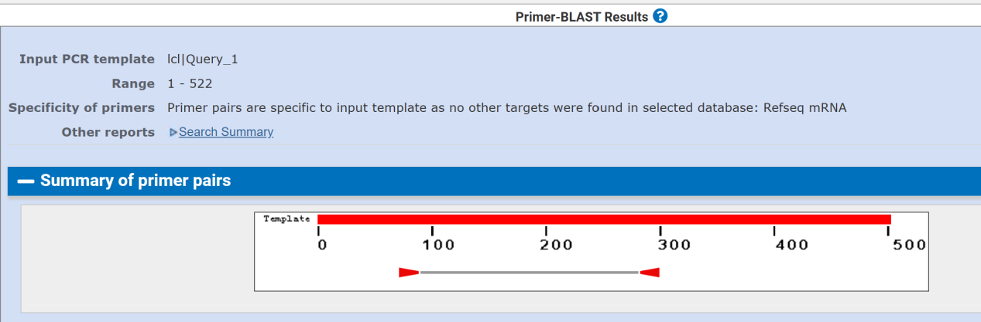

**Pe-TElncRNA2**

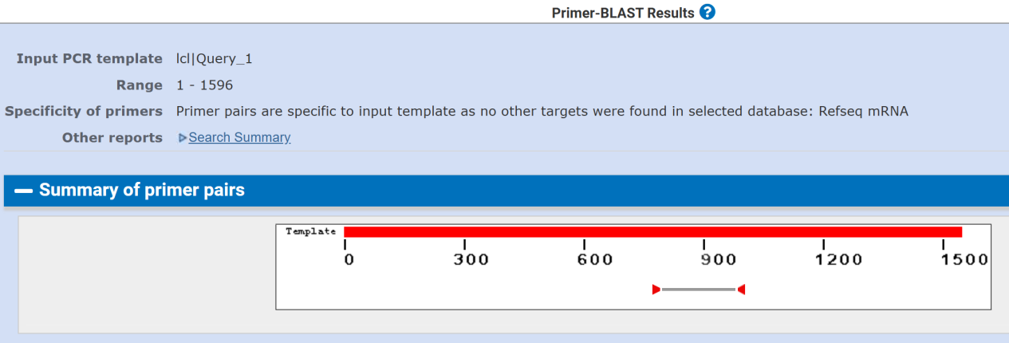

**FZR2**

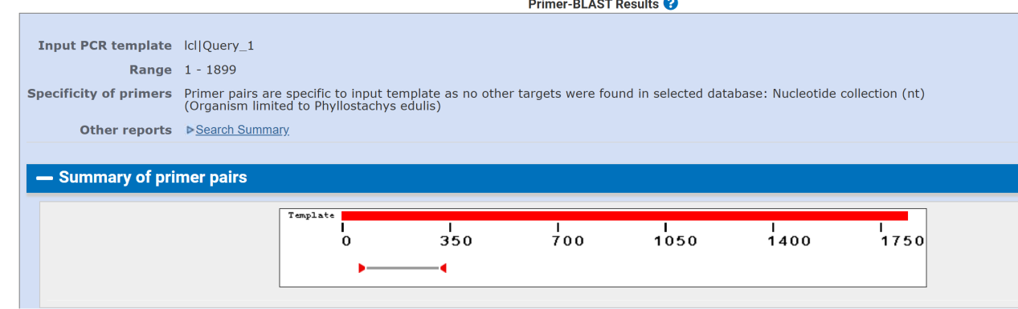

**NOT3**

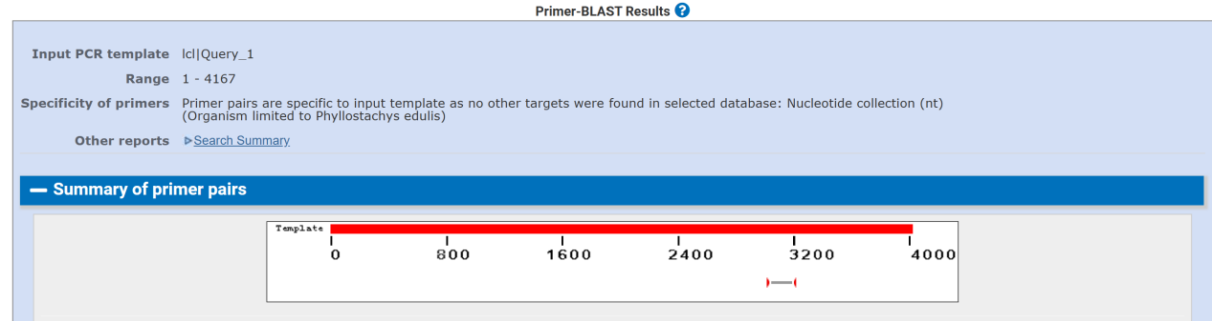

**ABCG44**

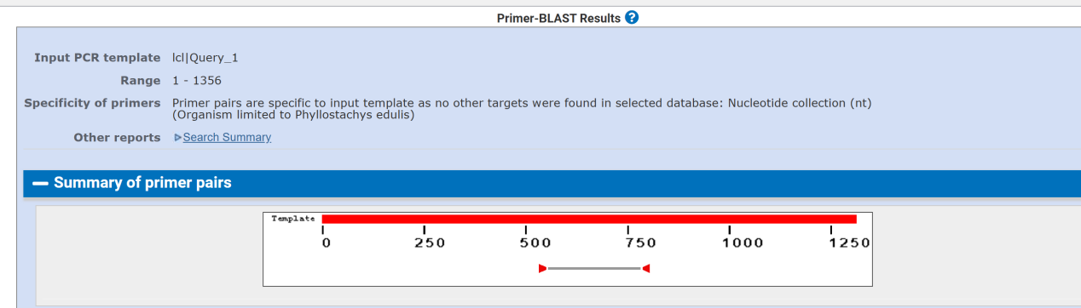

**AGD6**

Designed primers were proven to be specific.

**8 Data analysis**

**8.1 qPCR analysis program (source, version)**

Excel office16 and GraphPad Prism 8.0.

**8.2 Cq method determination**

The Cqvalue range is between 15-35.

**8.3 Outlier identification and disposition**

The Cq exceeding 35 indicates that it has not been amplified.If the peak starts before 15, it may caused by the high template concentration, we should changed the template concentration.

**8.4 Statistical methods for results significance**

One-WayANOVA（LSD）

**8.5 Software (source, version)**

SPSS v26.0

**8.6 Justification of number and choice of reference genes**

Based on the previous studies, we selected NTB gene as the reference gene of Moso bamboo and ACTIN2 gene as the reference gene of *Arabidopsis thaliana*, and verified their stability through experiments and could be used as the reference genes. The specific references are as follows:

1. Fan C, Ma J, Guo Q, *et al*. 2013. Selection of reference genes for quantitative real-time PCR in bamboo (*Phyllostachys edulis*)[J]. PLoS One, 8(2): e56573. [DOI:10.1371/journal.pone.0056573](http://dx.doi.org/10.1371/journal.pone.0056573)
2. McDowell JM, Huang S, McKinney EC, An YQ, Meagher RB. Structure and evolution of the actin gene family in Arabidopsis thaliana. Genetics. 1996 Feb;142(2):587-602. Doi: 10.1093/genetics/142.2.587. PMID: 8852856; PMCID: PMC1206991.

**8.7 Description of normalization method**

Relative gene expression levels were calculated using the 2-ΔΔCt method, and column charts were obtained by GraphPad Prism 8.0 (GraphPad Software, San Diego, CA, USA, [www.graphpad.com](http://www.graphpad.com)).