**Funnel Plots**

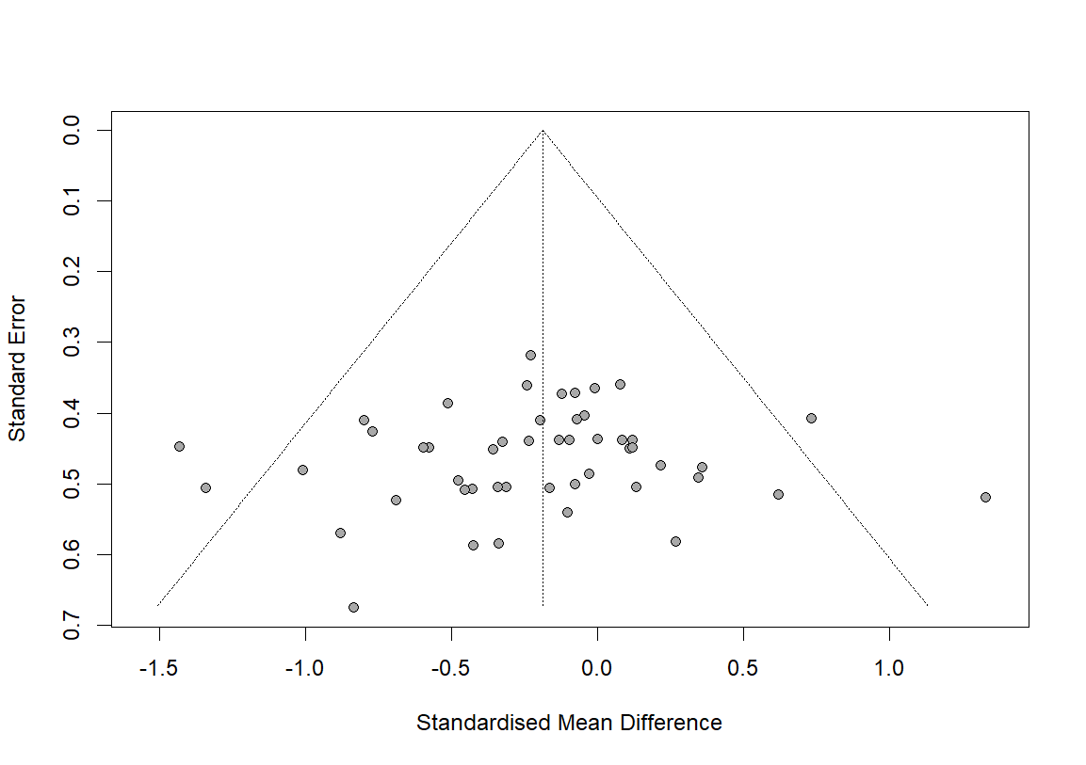

**Figure 1. Funnel plot for maximal strength**

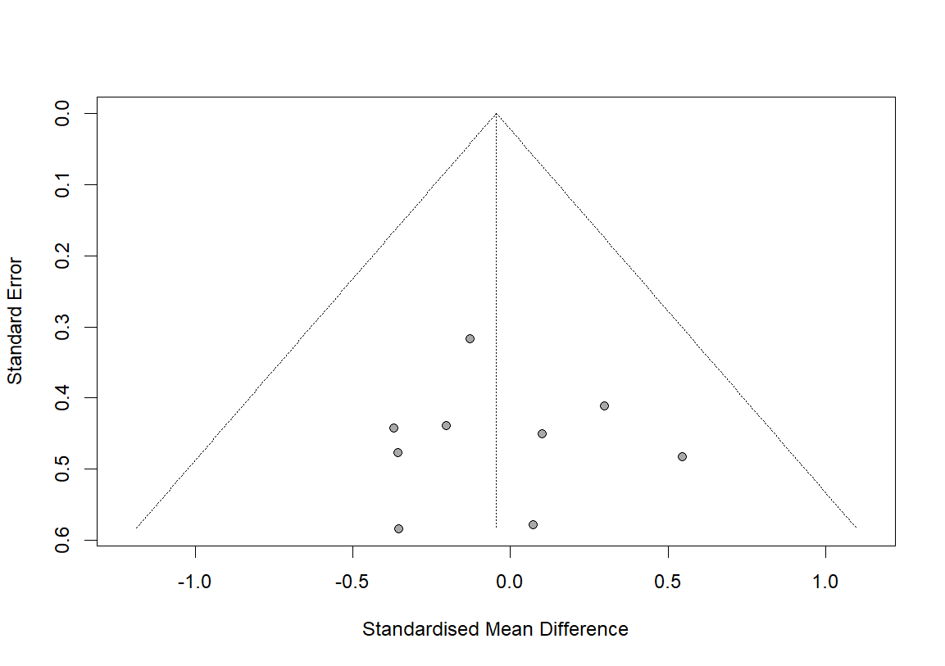

**Figure 2. Funnel plot for muscle power**

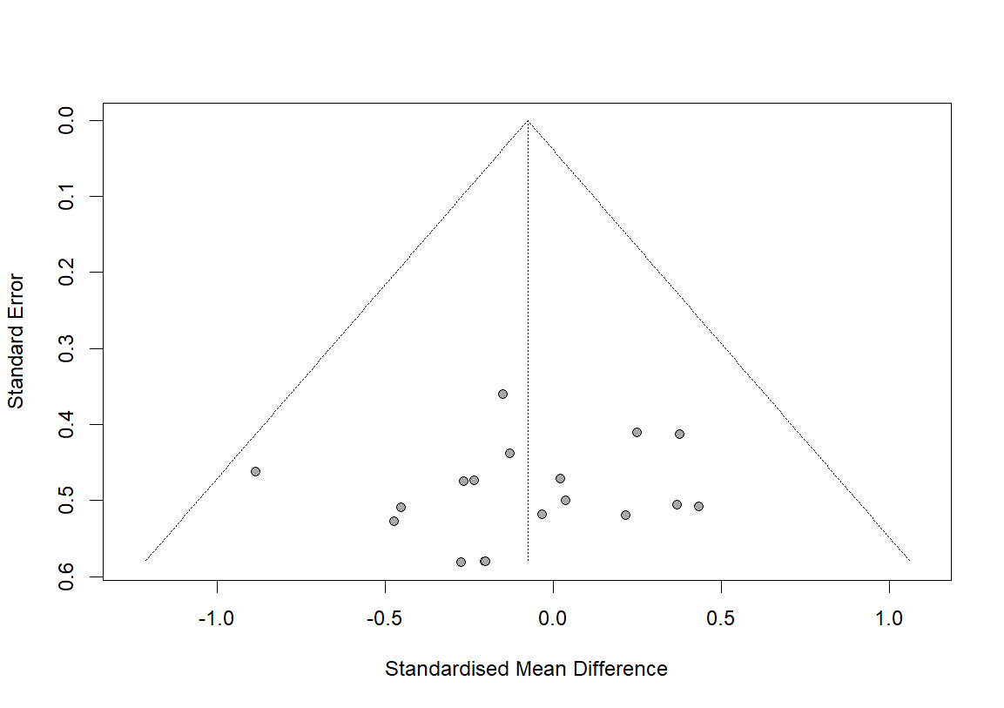

**Figure 3. Funnel plot for jump performance**



**Figure 4. Funnel plot for sprint performance**