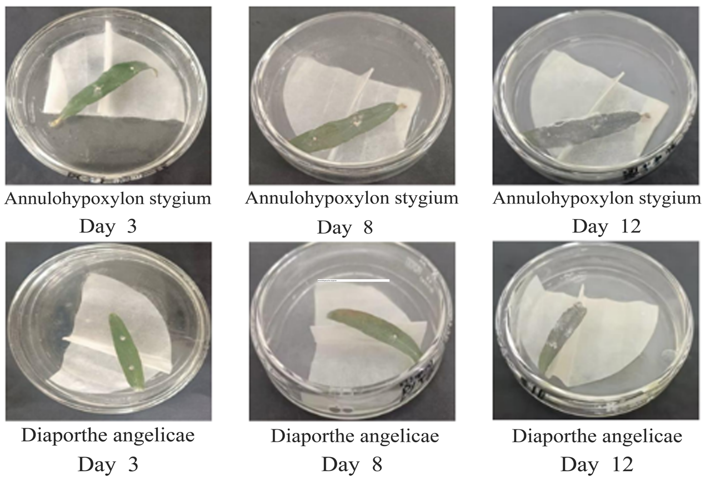

Figure S5 Disease morphology of the two pathogenic fungi in different periods. The colony status of healthy leaf of *Ardisia crispa* (Thunb.) A.DC. was infected with pathogenic fungi for 3 days, 8 days and 12 days.