**Fig. S1.** The suture was secured with a suture anchoring coil device.

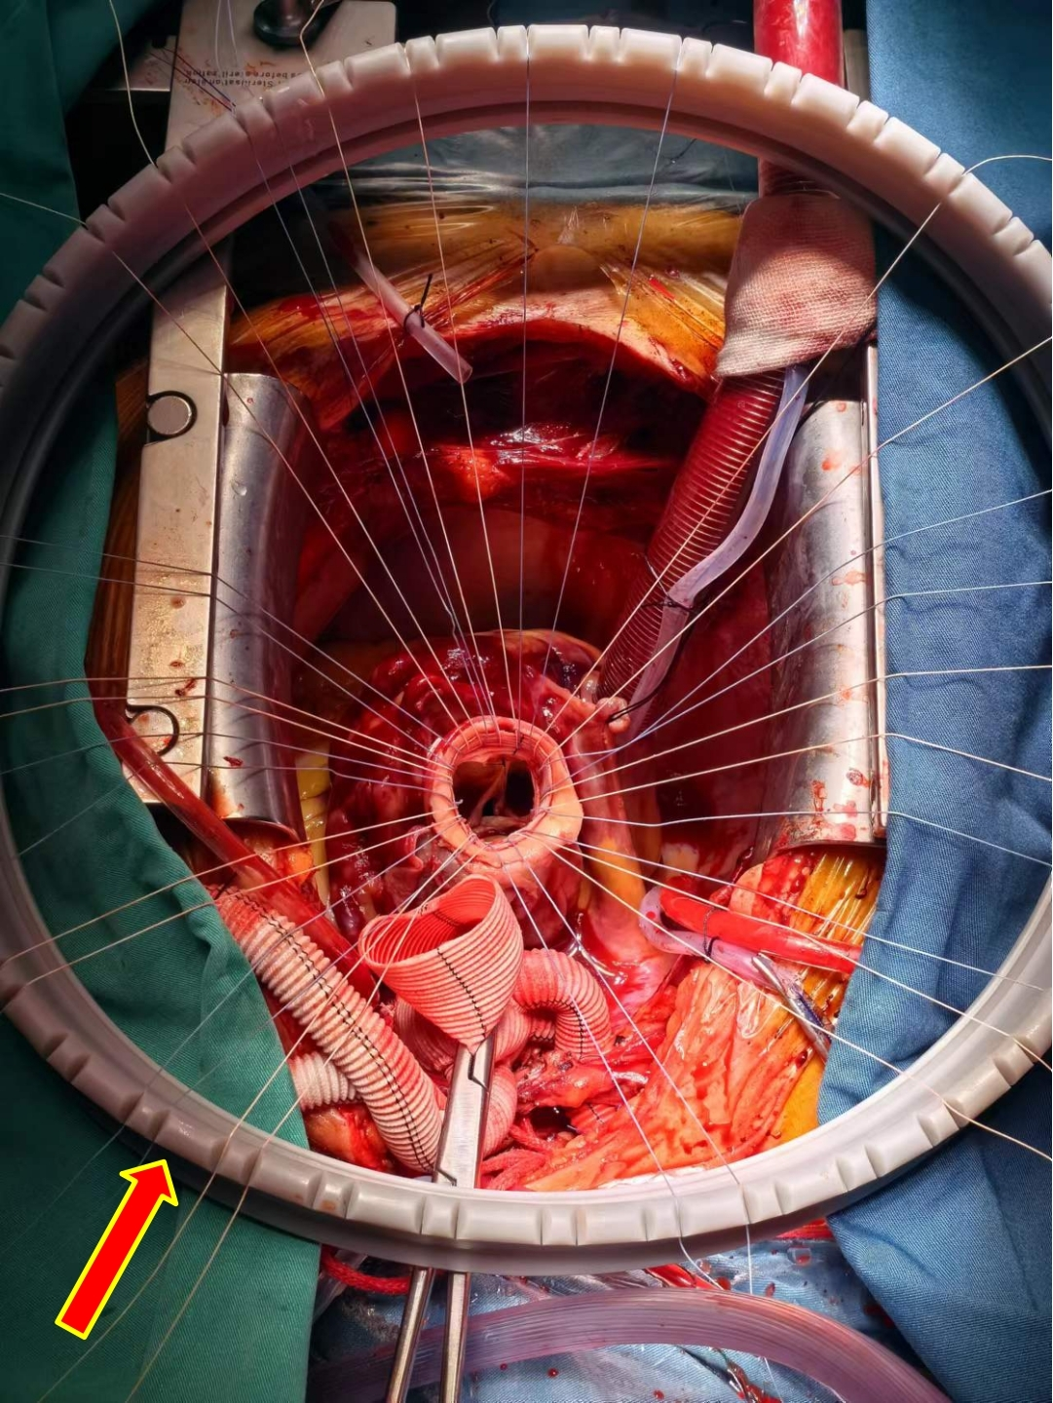

**Fig. S2.** The artificial vessel strips was lined with adventitia and intima.

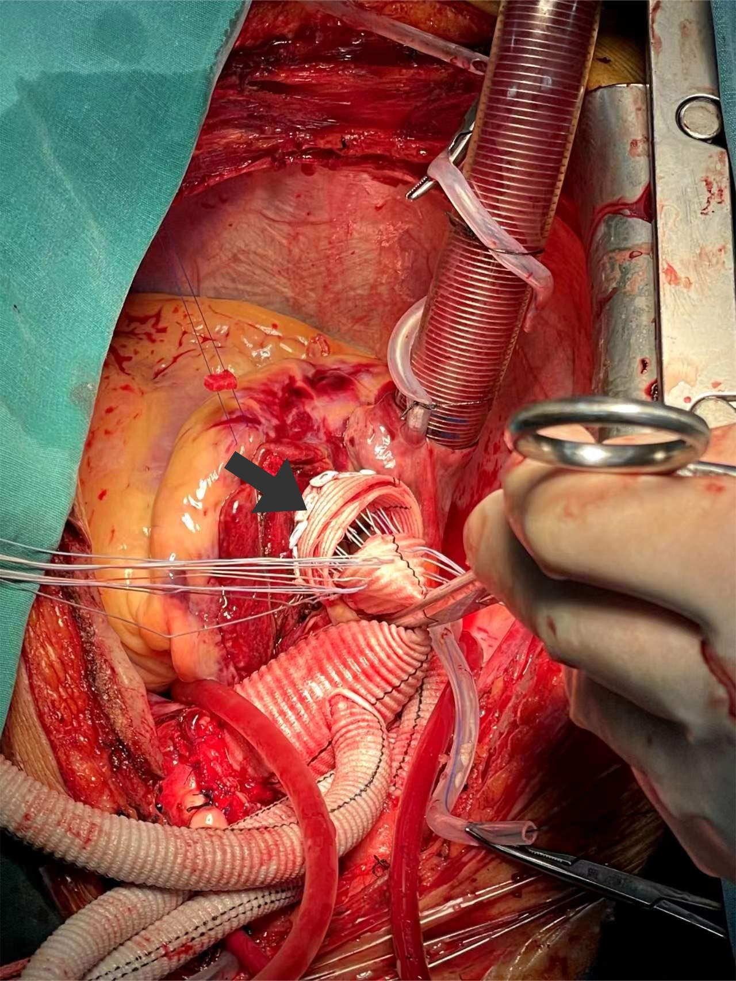

**Fig. S3.** Flow diagram for patient enrollment. ATAAD = acute type A aortic dissection; TAR = total arch replacement; FET = frozen elephant trunk; CABG = coronary artery bypass grafting; U-ACP = unilateral antegrade cerebral perfusion; IHMS = intermittent horizontal mattress sutures.

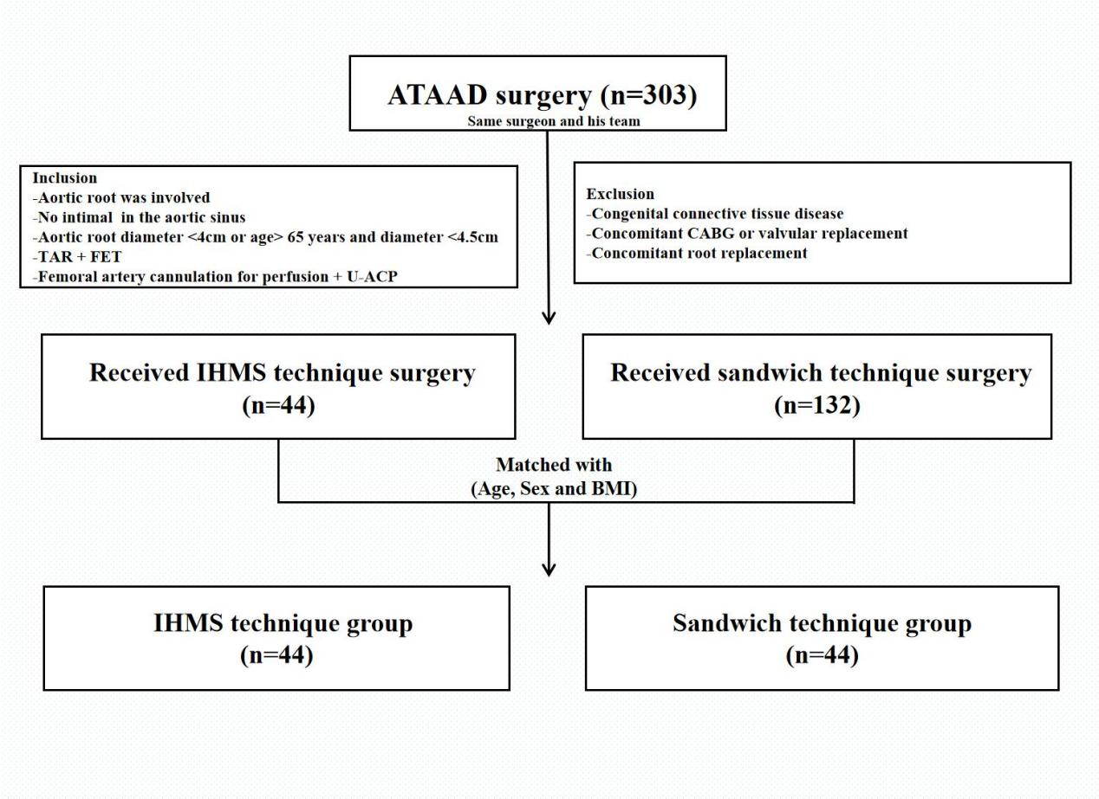

**Fig. S4.** The intimal rupture was located at the sinus-tubular junction.

