Search number | Query | Sort By | Filters | Search Details | Results | Time
8 | ((((idiopathic scoliosis[Title/Abstract]) OR (Adolescent idiopathic scoliosis[Title/Abstract])) OR ("Scoliosis"[Mesh])) AND (("Adolescent"[Mesh]) OR (Adolescent[Title/Abstract]))) AND ((((((exercise[Title/Abstract]) OR (movement[Title/Abstract])) OR (training[Title/Abstract])) OR (motion[Title/Abstract])) OR ("exercise"[Mesh])) OR ((((((physiotherapeutic scoliosis specific exercises[Title/Abstract]) OR (PSSE[Title/Abstract])) OR (Schroth[Title/Abstract])) OR (SEAS[Title/Abstract])) OR (BSPTS[Title/Abstract])) OR (Lyon[Title/Abstract]))) |  |  | ("idiopathic scoliosis"[Title/Abstract] OR "adolescent idiopathic scoliosis"[Title/Abstract] OR "Scoliosis"[MeSH Terms]) AND ("Adolescent"[MeSH Terms] OR "Adolescent"[Title/Abstract]) AND ("exercise"[Title/Abstract] OR "movement"[Title/Abstract] OR "training"[Title/Abstract] OR "motion"[Title/Abstract] OR "exercise"[MeSH Terms] OR ("physiotherapeutic scoliosis specific exercises"[Title/Abstract] OR "PSSE"[Title/Abstract] OR "Schroth"[Title/Abstract] OR "SEAS"[Title/Abstract] OR "BSPTS"[Title/Abstract] OR "Lyon"[Title/Abstract])) | 1,053 | 3:46:22
7 | (((((exercise[Title/Abstract]) OR (movement[Title/Abstract])) OR (training[Title/Abstract])) OR (motion[Title/Abstract])) OR ("exercise"[Mesh])) OR ((((((physiotherapeutic scoliosis specific exercises[Title/Abstract]) OR (PSSE[Title/Abstract])) OR (Schroth[Title/Abstract])) OR (SEAS[Title/Abstract])) OR (BSPTS[Title/Abstract])) OR (Lyon[Title/Abstract])) |  |  | "exercise"[Title/Abstract] OR "movement"[Title/Abstract] OR "training"[Title/Abstract] OR "motion"[Title/Abstract] OR "exercise"[MeSH Terms] OR "physiotherapeutic scoliosis specific exercises"[Title/Abstract] OR "PSSE"[Title/Abstract] OR "Schroth"[Title/Abstract] OR "SEAS"[Title/Abstract] OR "BSPTS"[Title/Abstract] OR "Lyon"[Title/Abstract] | 1,482,099 | 3:46:07
6 | (((((physiotherapeutic scoliosis specific exercises[Title/Abstract]) OR (PSSE[Title/Abstract])) OR (Schroth[Title/Abstract])) OR (SEAS[Title/Abstract])) OR (BSPTS[Title/Abstract])) OR (Lyon[Title/Abstract]) |  |  | "physiotherapeutic scoliosis specific exercises"[Title/Abstract] OR "PSSE"[Title/Abstract] OR "Schroth"[Title/Abstract] OR "SEAS"[Title/Abstract] OR "BSPTS"[Title/Abstract] OR "Lyon"[Title/Abstract] | 8,537 | 3:45:43
5 | ((((exercise[Title/Abstract]) OR (movement[Title/Abstract])) OR (training[Title/Abstract])) OR (motion[Title/Abstract])) OR ("exercise"[Mesh]) |  |  | "exercise"[Title/Abstract] OR "movement"[Title/Abstract] OR "training"[Title/Abstract] OR "motion"[Title/Abstract] OR "exercise"[MeSH Terms] | 1,474,034 | 3:44:43
4 | ("Adolescent"[Mesh]) OR (Adolescent[Title/Abstract]) |  |  | "Adolescent"[MeSH Terms] OR "Adolescent"[Title/Abstract] | 2,305,176 | 3:43:51
3 | ((idiopathic scoliosis[Title/Abstract]) OR (Adolescent idiopathic scoliosis[Title/Abstract])) OR ("Scoliosis"[Mesh]) |  |  | "idiopathic scoliosis"[Title/Abstract] OR "adolescent idiopathic scoliosis"[Title/Abstract] OR "Scoliosis"[MeSH Terms] | 23,584 | 3:43:21
2 | (idiopathic scoliosis[Title/Abstract]) OR (Adolescent idiopathic scoliosis[Title/Abstract]) |  |  | "idiopathic scoliosis"[Title/Abstract] OR "adolescent idiopathic scoliosis"[Title/Abstract] | 9,368 | 3:43:12
1 | "Scoliosis"[Mesh] | Most Recent |  | "Scoliosis"[MeSH Terms] | 21,576 | 3:29:54

Cobb
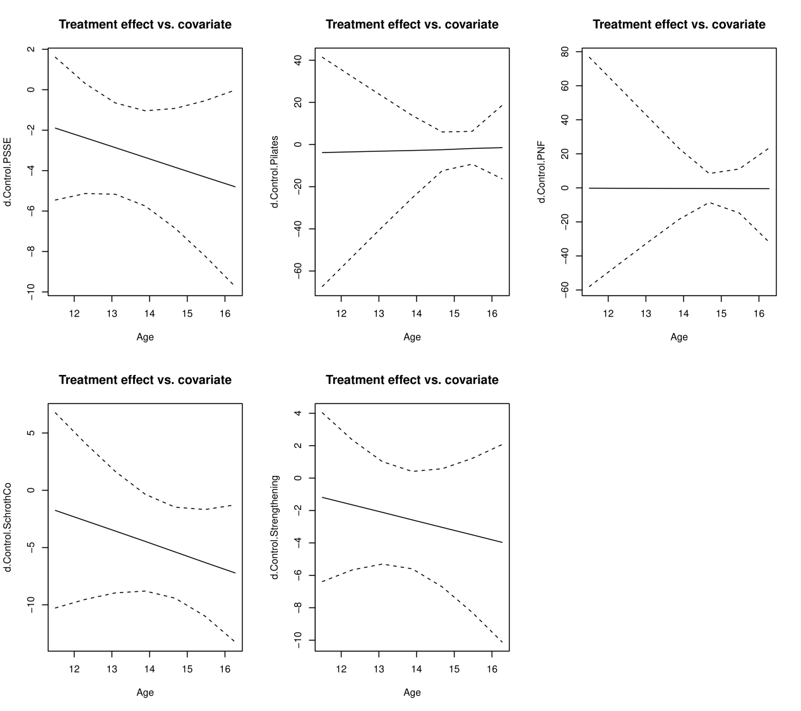
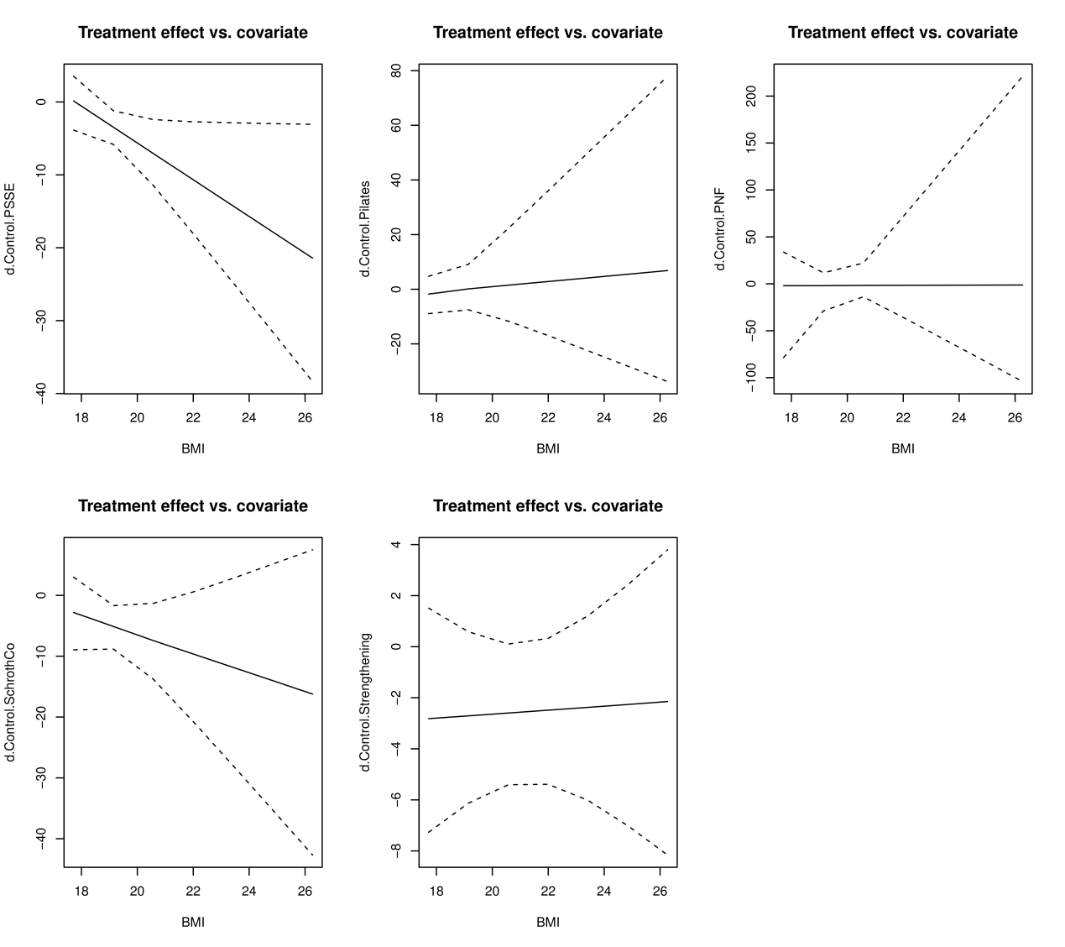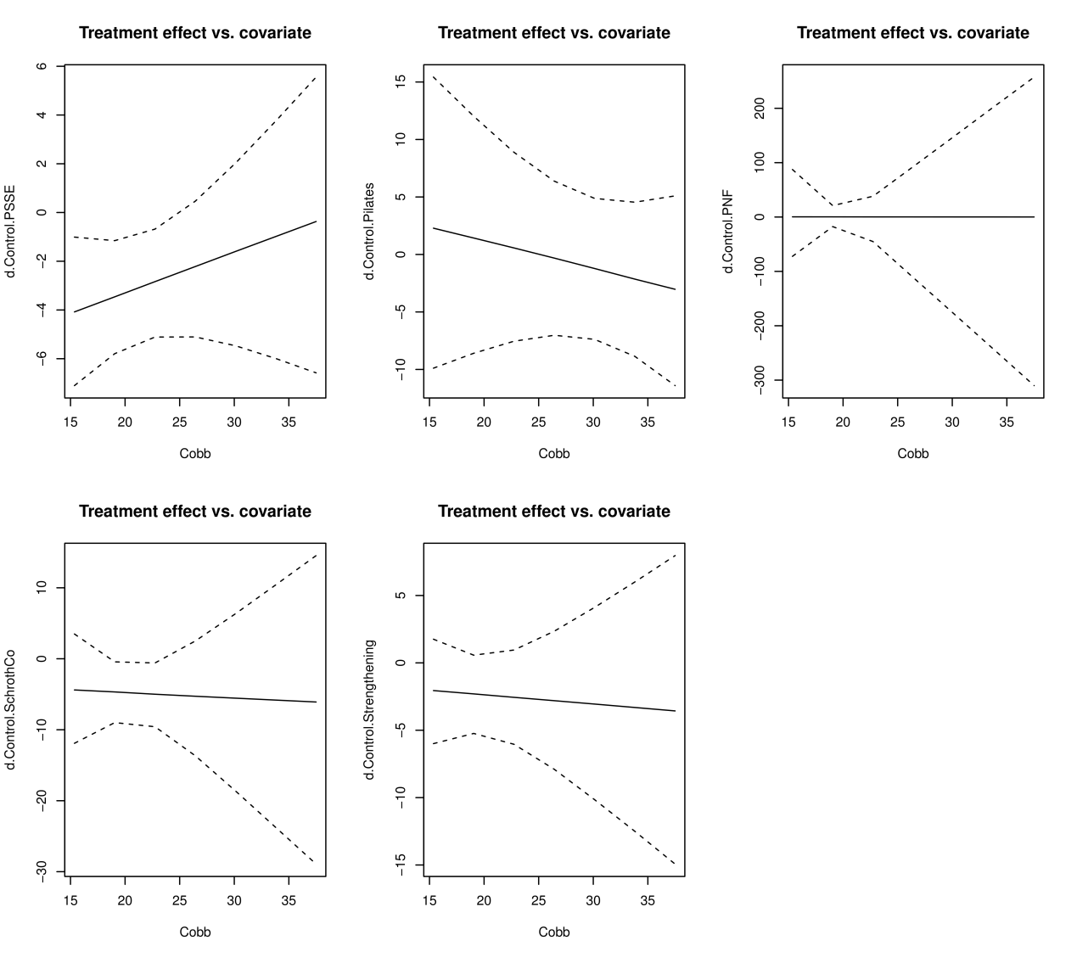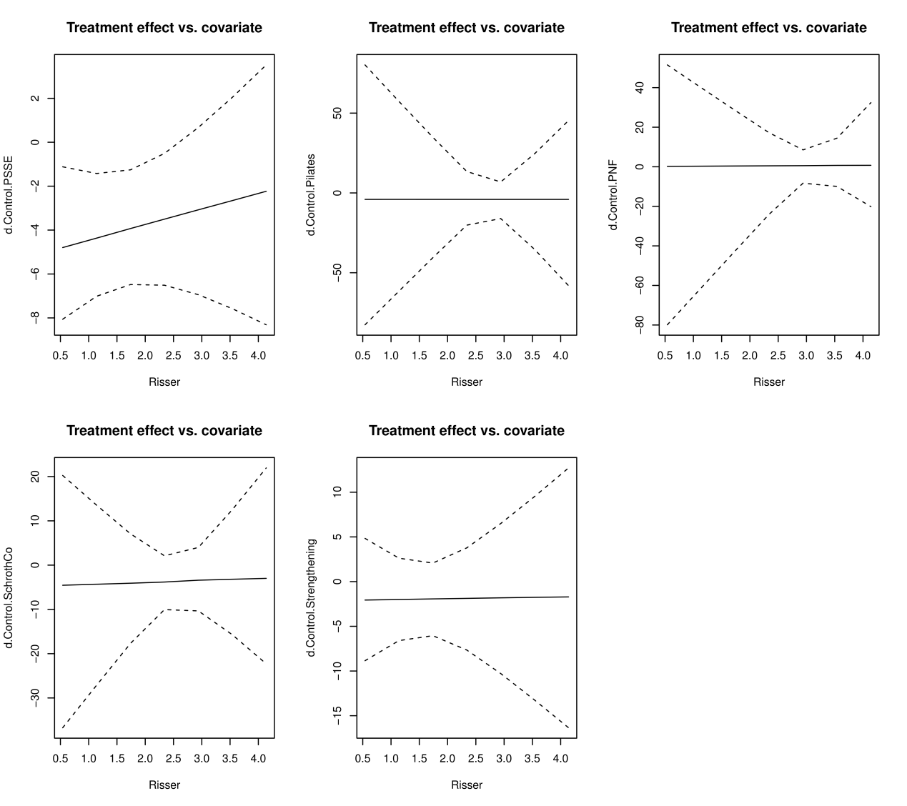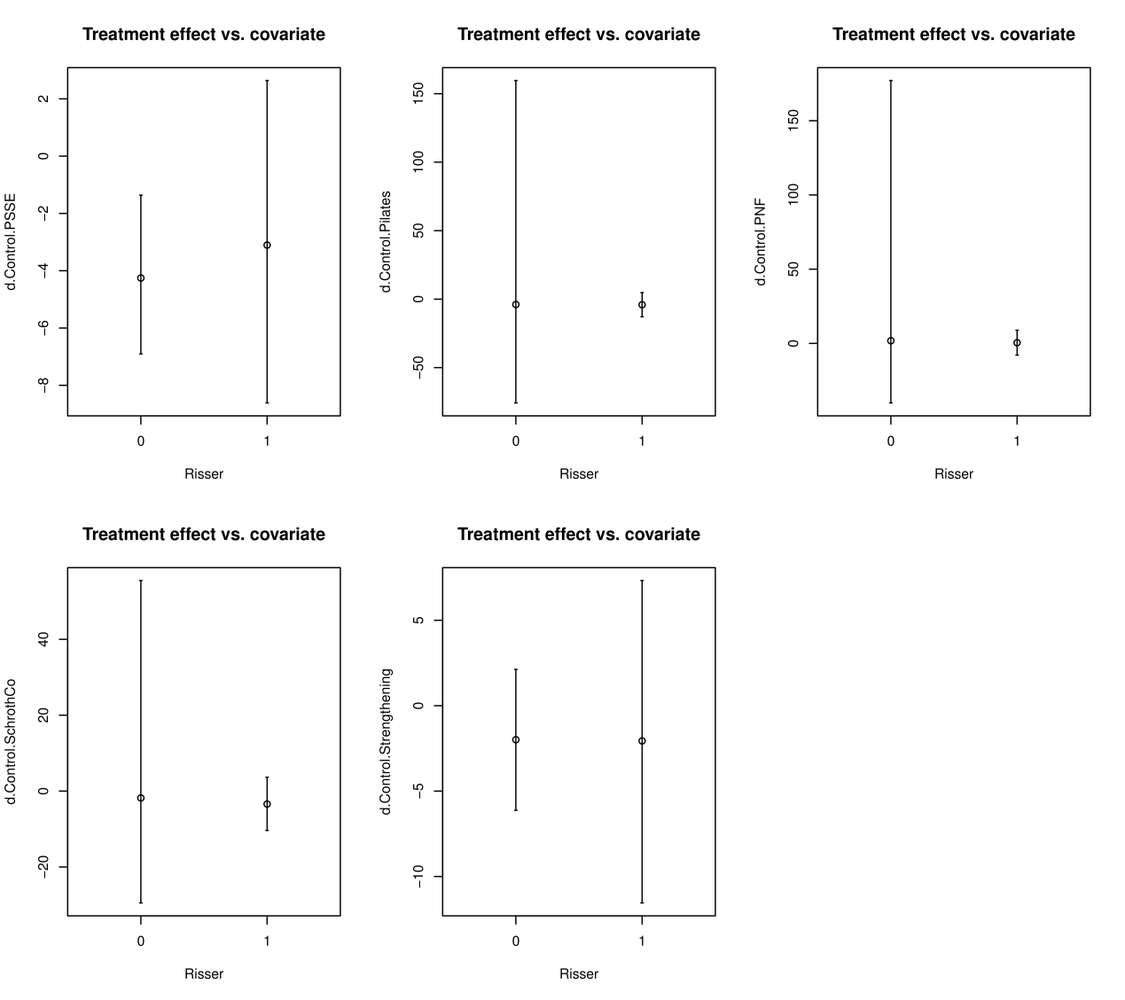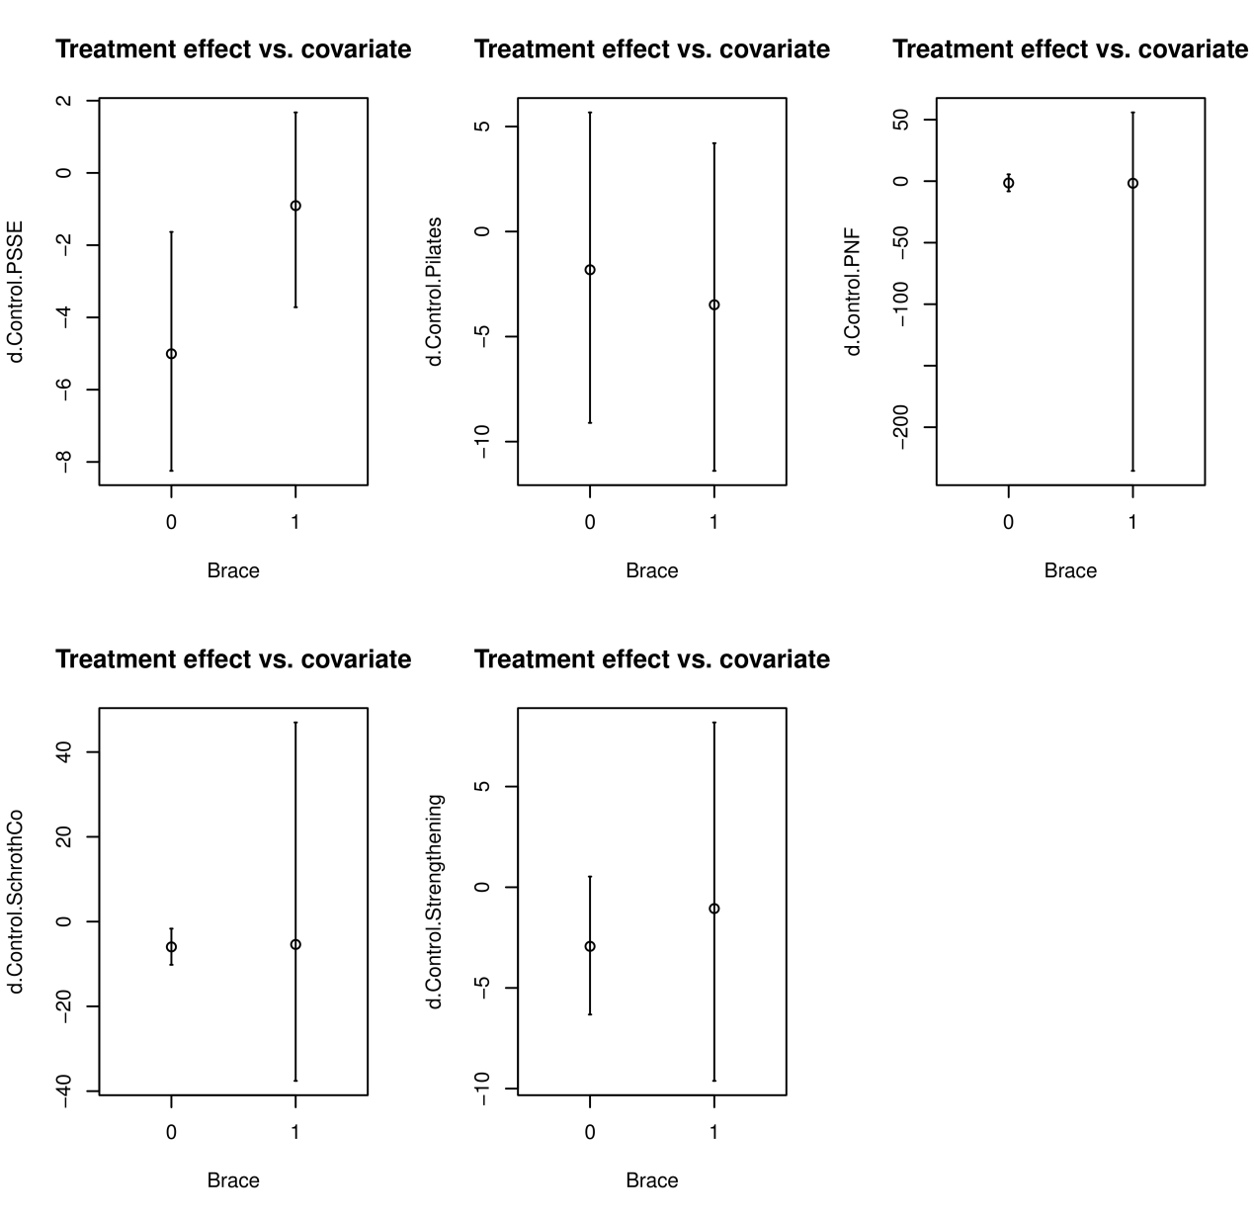
Treatment | Rank 1 | Rank 2 | Rank 3 | Rank 4 | Rank 5 | Rank 6 | Rank 7 | Rank 8 | Rank 9 | Rank 10 | Rank 11 | Rank 12 | Rank 13 | SUCRA
BSPTS | 0.2111 | 0.1702 | 0.1352375 | 0.1045 | 0.078225 | 0.0569 | 0.0468125 | 0.0416625 | 0.039425 | 0.034775 | 0.0308375 | 0.0285875 | 0.0217375 | 71.3654166666667
Control | 0 | 1.25e-05 | 5e-05 | 0.000925 | 0.0033 | 0.0111625 | 0.031825 | 0.0780375 | 0.1590375 | 0.252925 | 0.26325 | 0.1557375 | 0.0437375 | 23.0983333333333
Core | 0.001425 | 0.0085125 | 0.0251625 | 0.057675 | 0.0941375 | 0.1261125 | 0.1410625 | 0.15215 | 0.150225 | 0.118425 | 0.075725 | 0.036975 | 0.0124125 | 43.90875
Lyon | 0.005025 | 0.0106125 | 0.0159625 | 0.0226 | 0.0272625 | 0.0309625 | 0.03555 | 0.044575 | 0.0563 | 0.0719375 | 0.10965 | 0.2025625 | 0.367 | 18.9495833333333
Pilates | 0.012075 | 0.027625 | 0.04705 | 0.0602625 | 0.0712875 | 0.074225 | 0.0765 | 0.083675 | 0.0926625 | 0.105175 | 0.1225875 | 0.1303125 | 0.0965625 | 37.42125
PNF | 0.006925 | 0.01345 | 0.01985 | 0.0264625 | 0.0325125 | 0.0373625 | 0.0418875 | 0.0503875 | 0.0625875 | 0.0816625 | 0.1175125 | 0.2095875 | 0.2998125 | 21.9380208333333
Sch_Co_Balance | 0.0380375 | 0.061375 | 0.08145 | 0.092875 | 0.093675 | 0.0877375 | 0.080525 | 0.077325 | 0.0802375 | 0.080925 | 0.085825 | 0.081825 | 0.0581875 | 48.6040625
Sch_Co_Core | 0.2387125 | 0.21575 | 0.162725 | 0.1130125 | 0.076075 | 0.0526 | 0.0377 | 0.0309875 | 0.0235125 | 0.0185625 | 0.014375 | 0.010375 | 0.0056125 | 78.5746875
Sch_Co_HippoT | 0.1798 | 0.163275 | 0.13985 | 0.1101875 | 0.0863875 | 0.06475 | 0.0503125 | 0.0441375 | 0.0383125 | 0.0367 | 0.035525 | 0.0310875 | 0.019675 | 69.8017708333333
Sch_Co_Sling | 0.0523125 | 0.080025 | 0.0974625 | 0.1048 | 0.101575 | 0.0905 | 0.0802875 | 0.07415 | 0.071975 | 0.070475 | 0.0714625 | 0.0632625 | 0.0417125 | 53.5828125
Schroth | 0.0001375 | 0.0020375 | 0.0129375 | 0.0434875 | 0.108225 | 0.1928 | 0.2399625 | 0.2095875 | 0.1266875 | 0.0497875 | 0.0123 | 0.0018875 | 0.0001625 | 49.4211458333333
SEAS | 0.030675 | 0.0818375 | 0.1325875 | 0.1623875 | 0.1519375 | 0.1181125 | 0.0912 | 0.073725 | 0.0613125 | 0.0445375 | 0.0281625 | 0.0162625 | 0.0072625 | 62.2103125
Sling | 0.223775 | 0.1652875 | 0.129675 | 0.100825 | 0.0754 | 0.056775 | 0.046375 | 0.0396 | 0.037725 | 0.0341125 | 0.0327875 | 0.0315375 | 0.026125 | 71.1238541666667
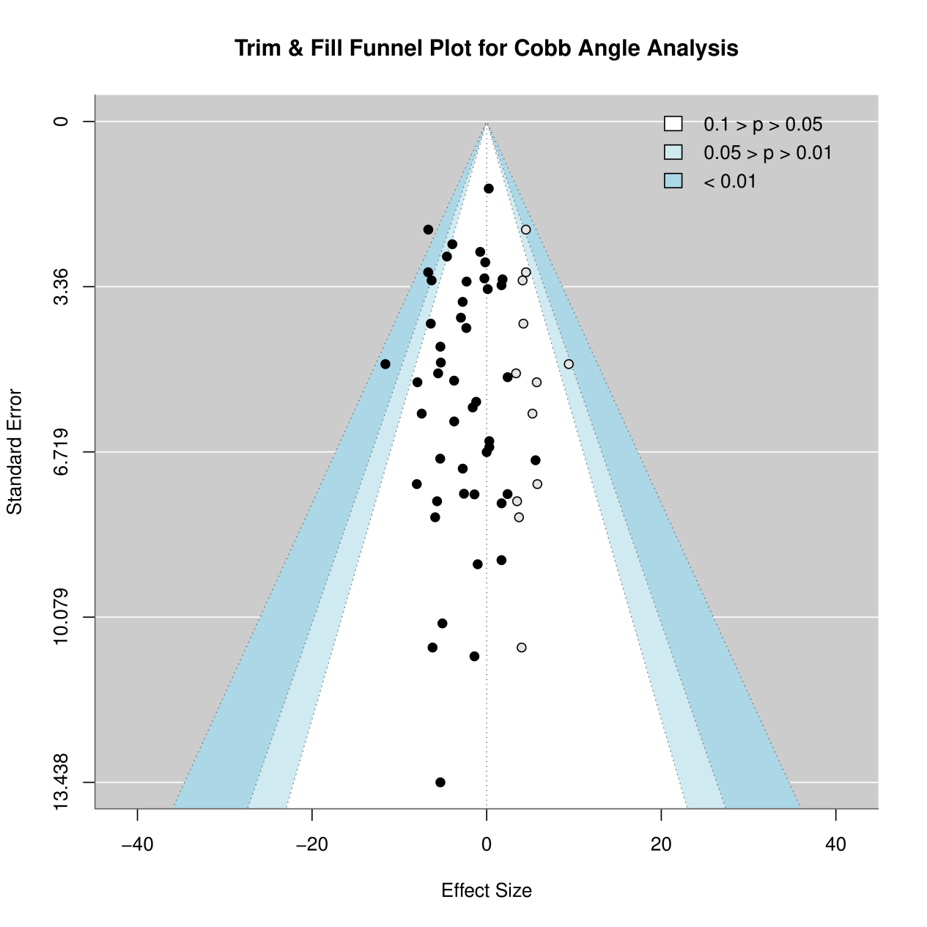

ATR
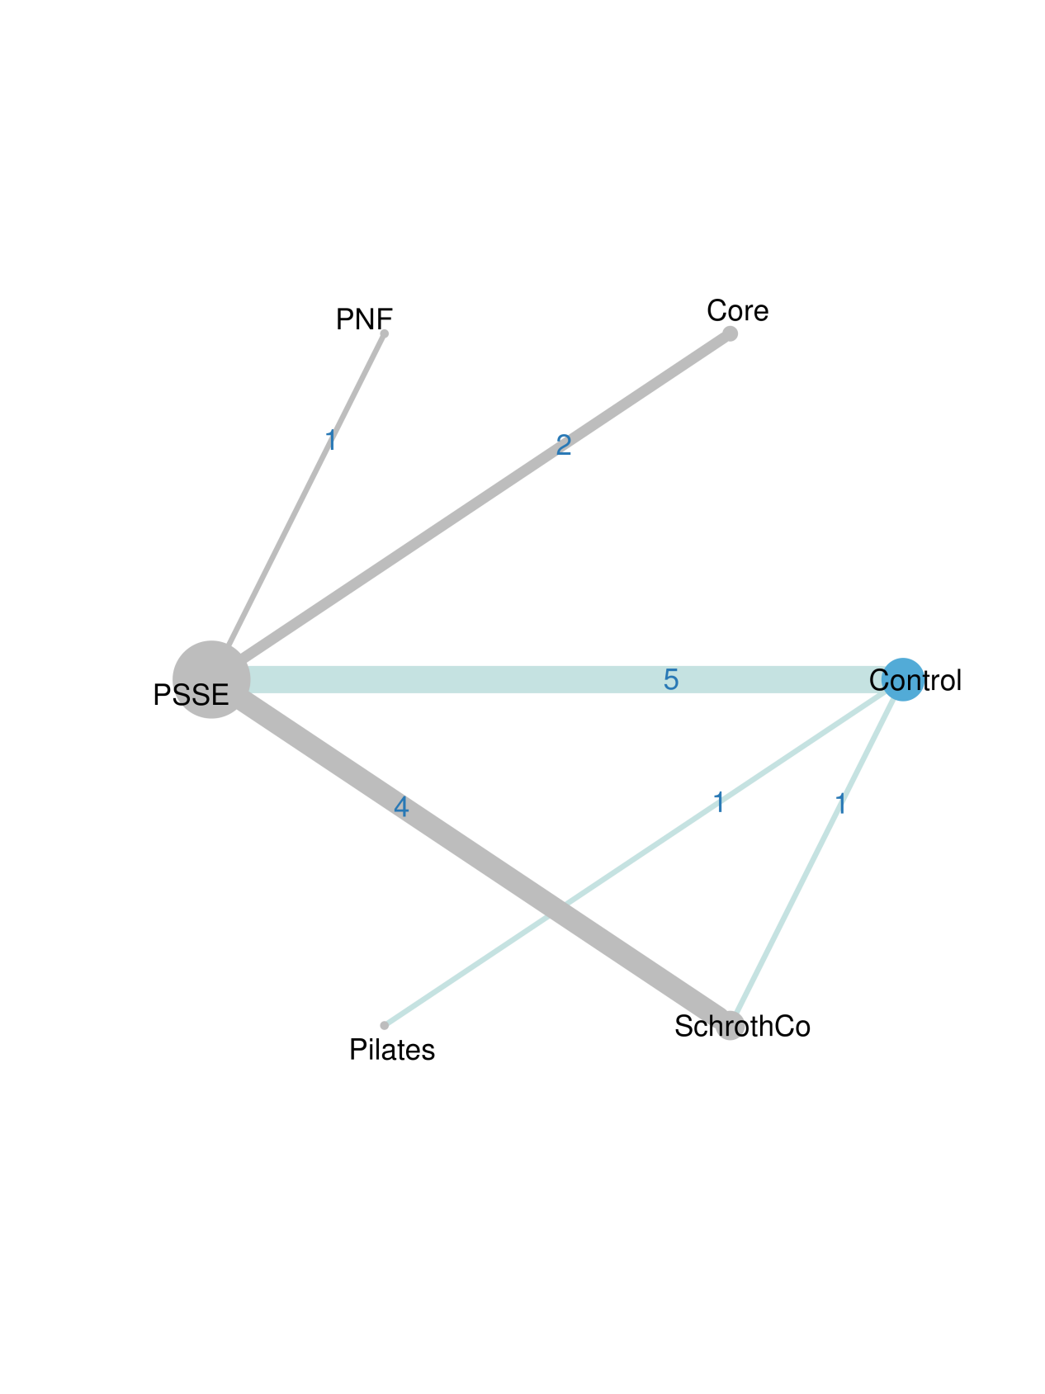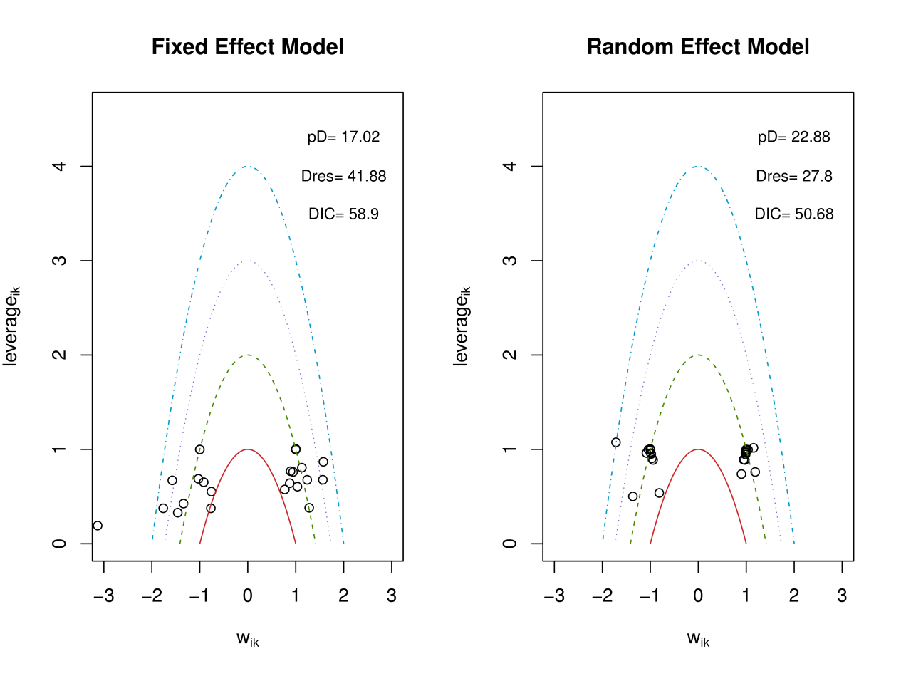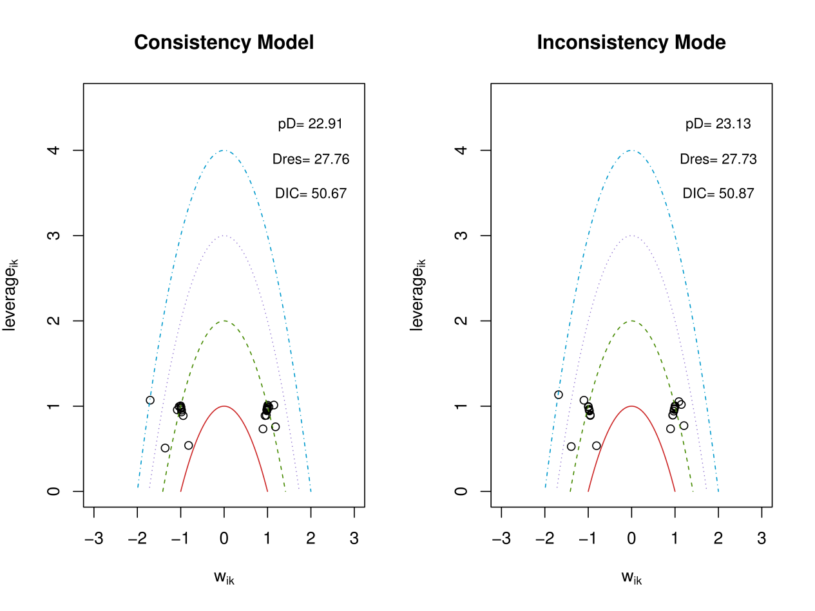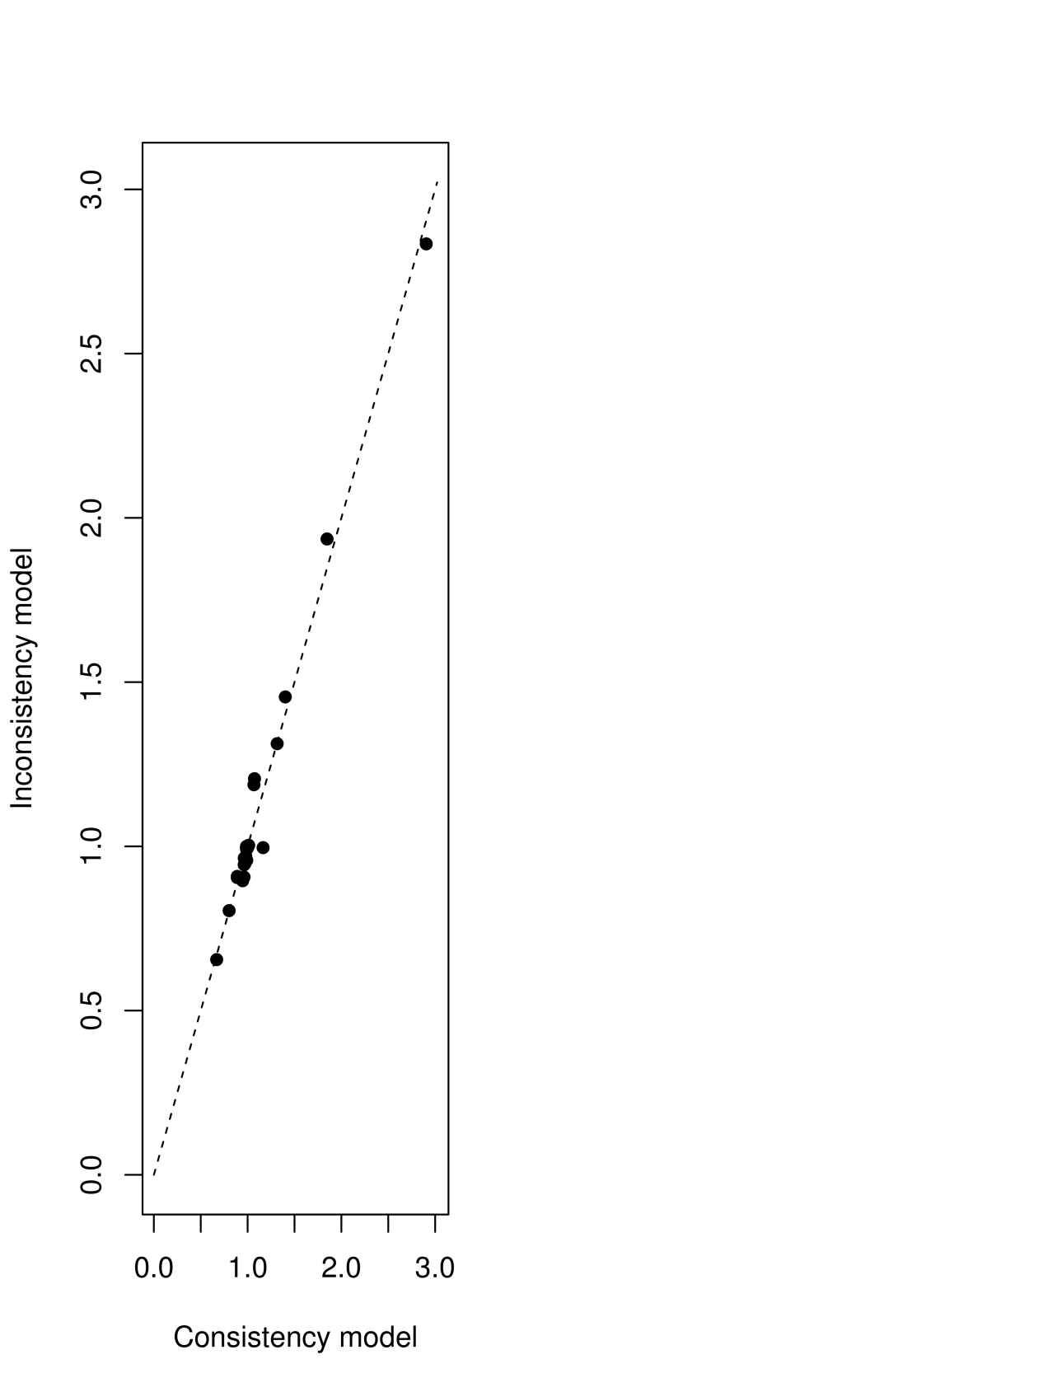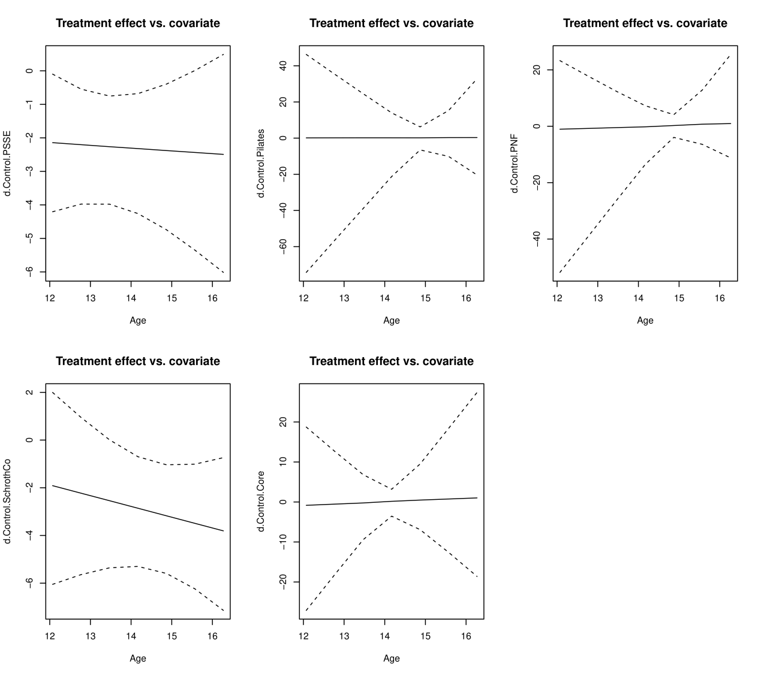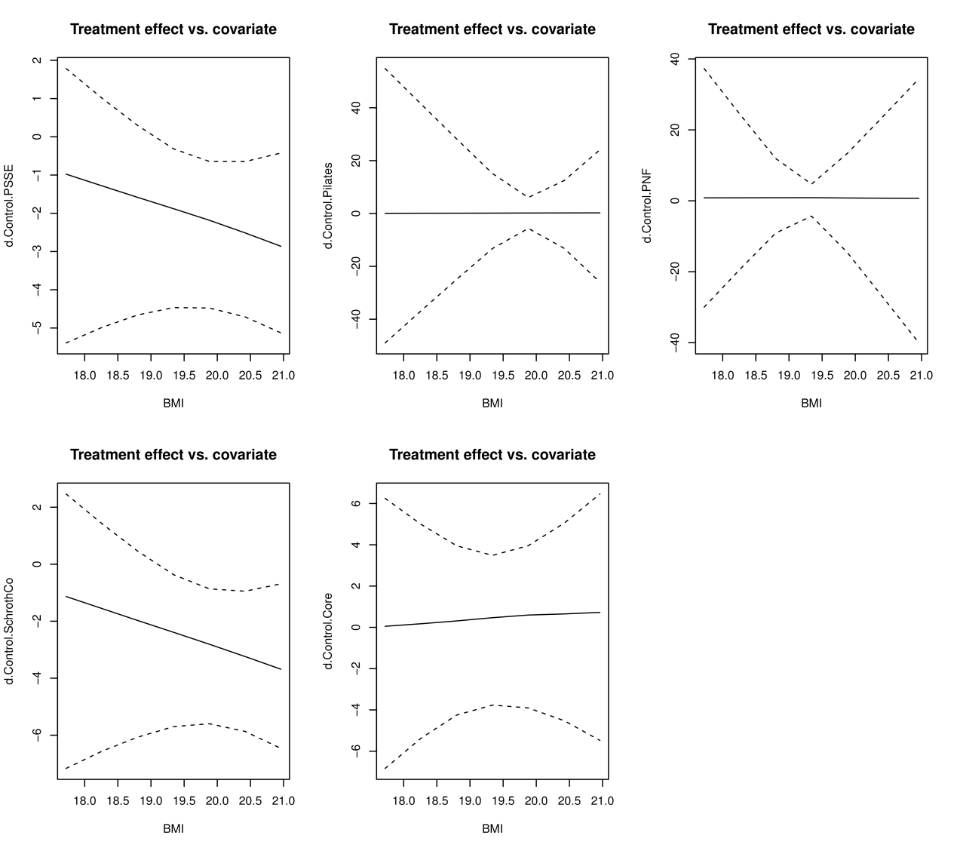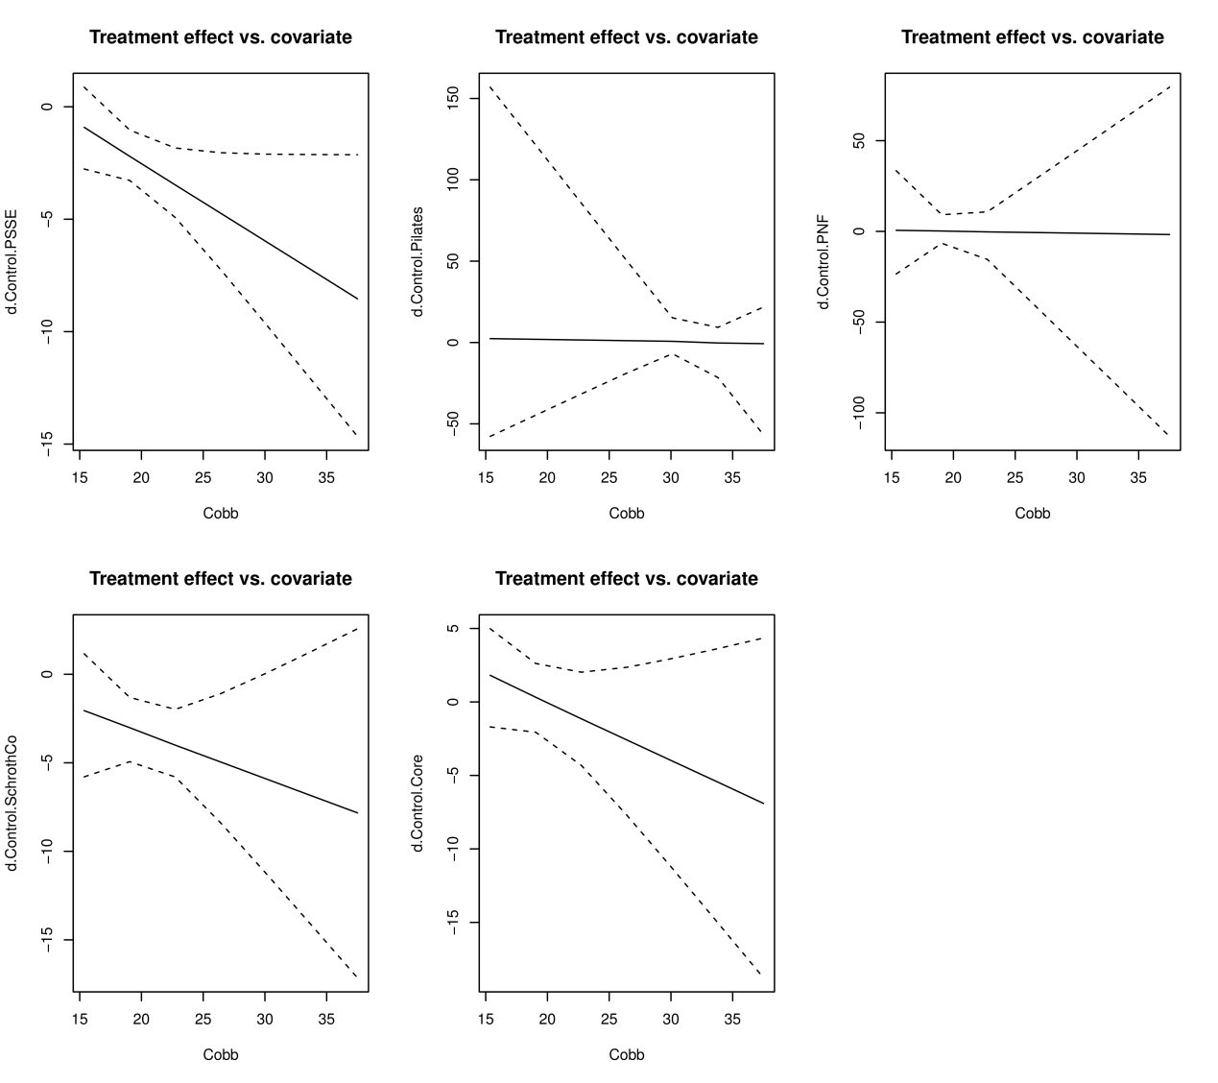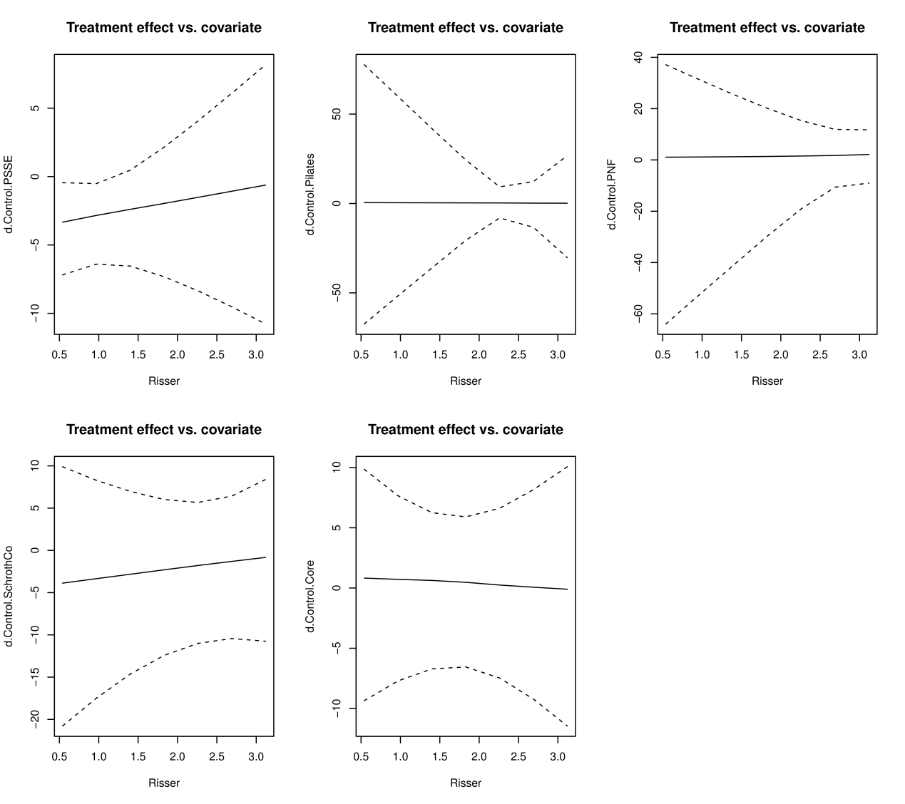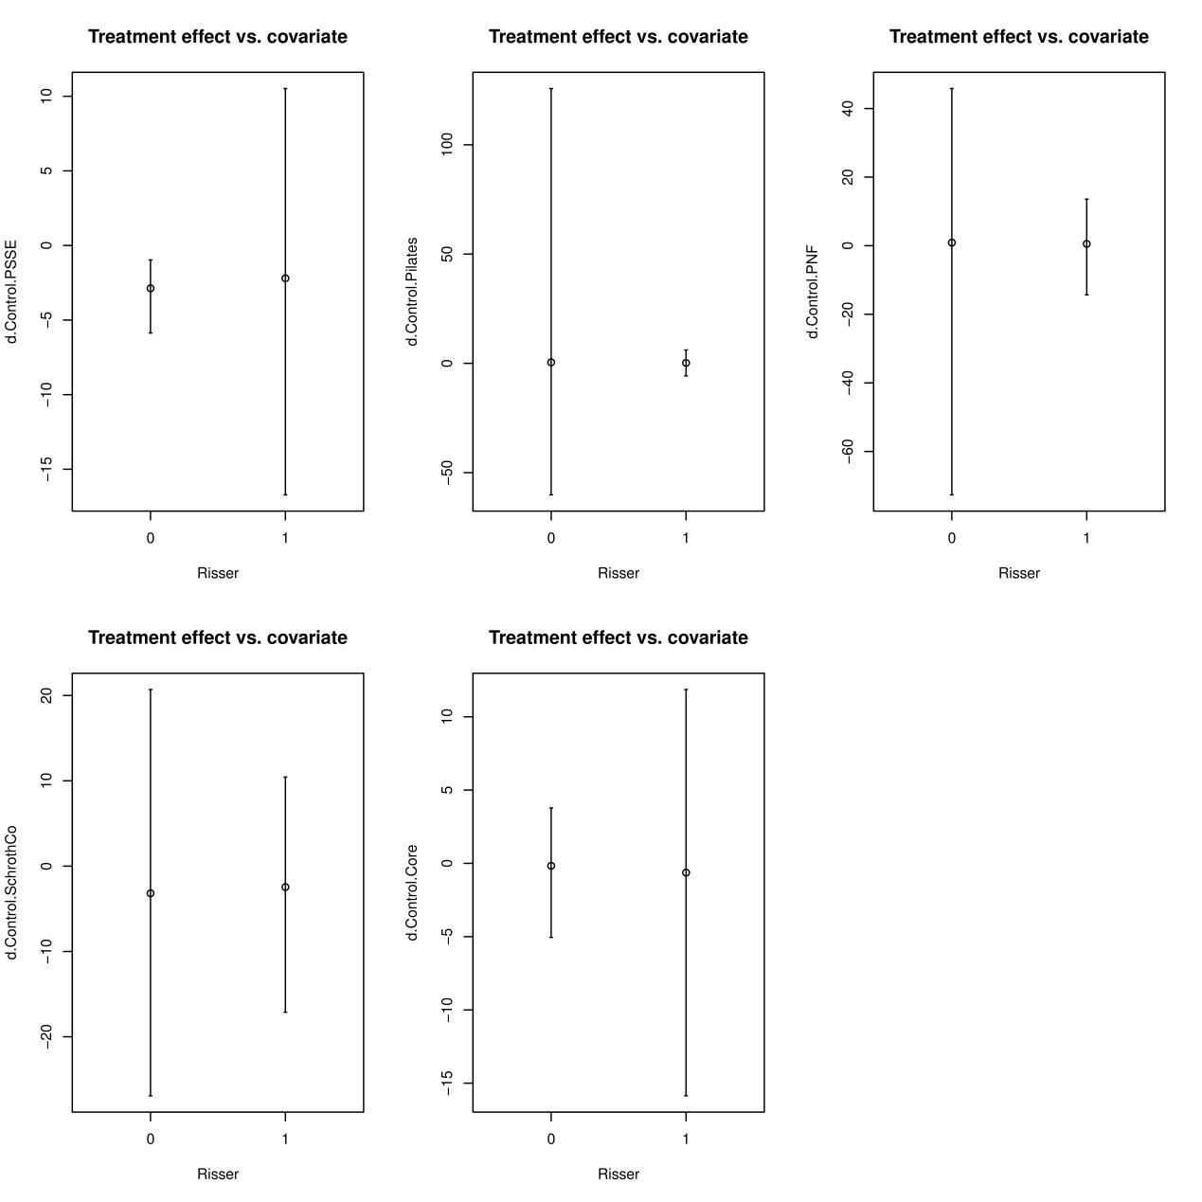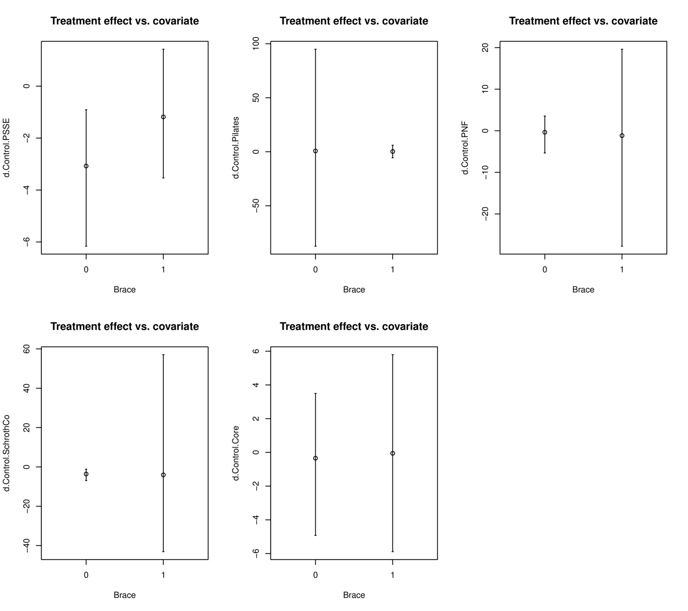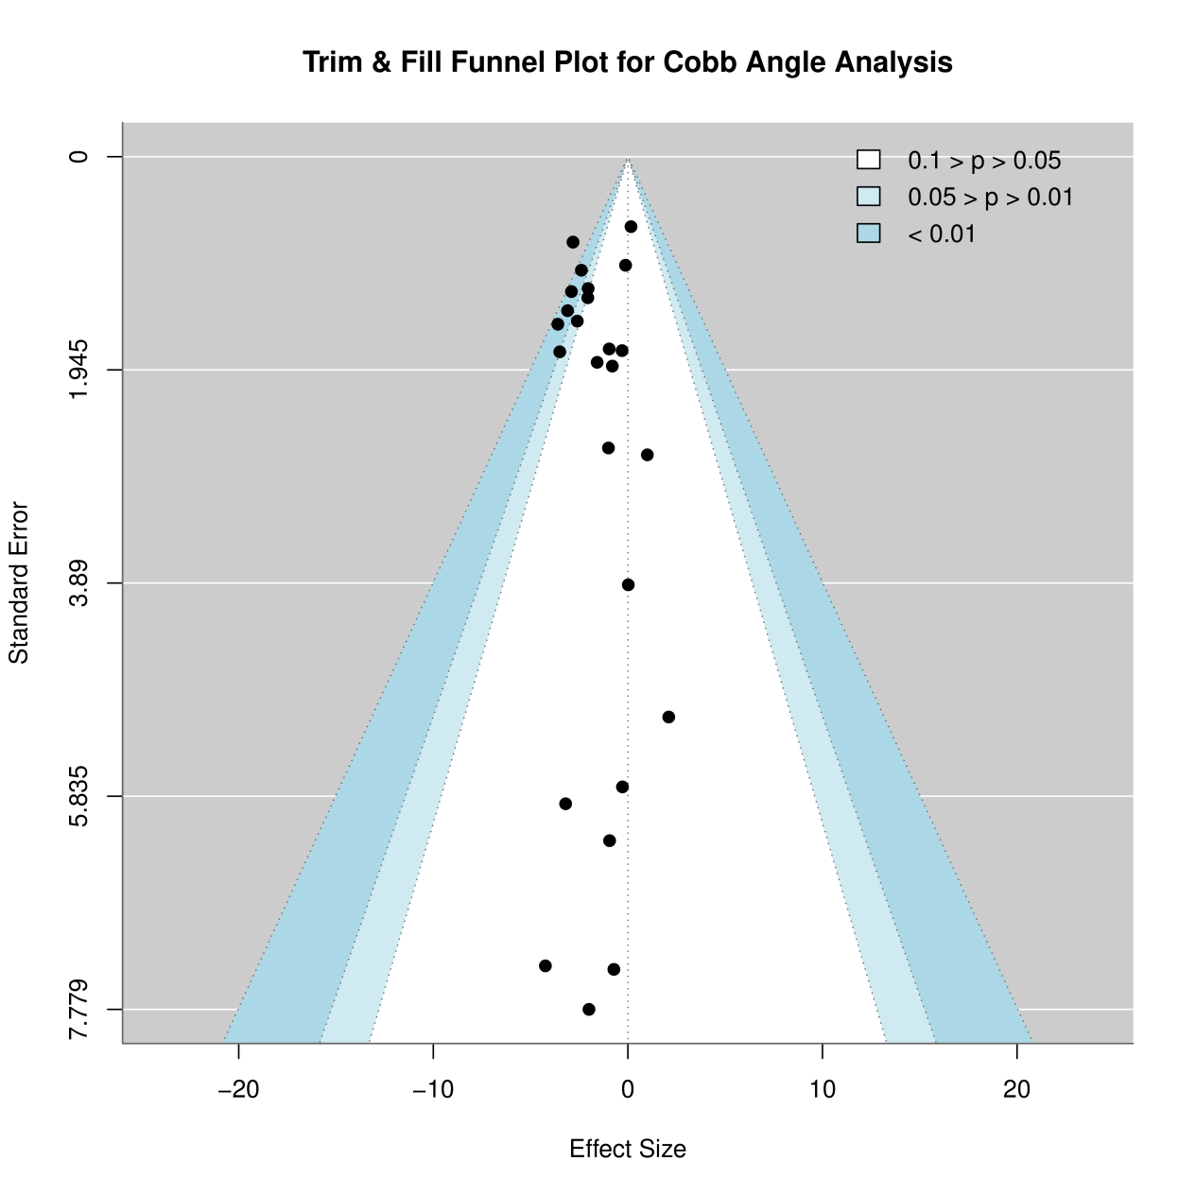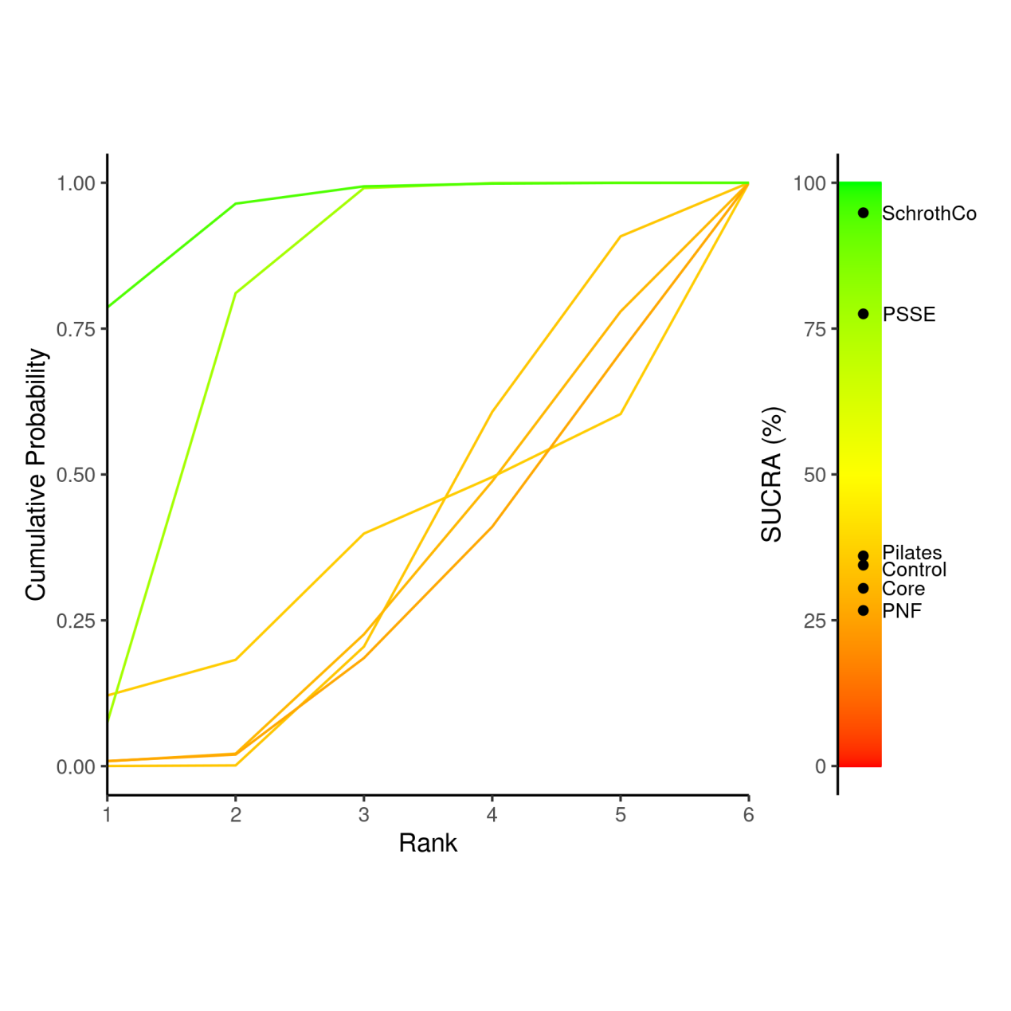
 | Control | Core | Pilates | PNF | PSSE | SchrothCo
Control | Control | 0.16 (-2.57, 2.55) | 0.16 (-5.14, 5.51) | 0.33 (-2.45, 3.15) | -2.37 (-3.59, -1.14) | -3.03 (-4.68, -1.46)
Core | -0.16 (-2.55, 2.57) | Core | 0.02 (-5.8, 6.01) | 0.16 (-3.01, 3.71) | -2.54 (-4.62, -0.13) | -3.2 (-5.64, -0.48)
Pilates | -0.16 (-5.51, 5.14) | -0.02 (-6.01, 5.8) | Pilates | 0.17 (-5.82, 6.15) | -2.52 (-8.04, 2.91) | -3.21 (-8.84, 2.33)
PNF | -0.33 (-3.15, 2.45) | -0.16 (-3.71, 3.01) | -0.17 (-6.15, 5.82) | PNF | -2.7 (-5.24, -0.19) | -3.36 (-6.26, -0.61)
PSSE | 2.37 (1.14, 3.59) | 2.54 (0.13, 4.62) | 2.52 (-2.91, 8.04) | 2.7 (0.19, 5.24) | PSSE | -0.66 (-1.96, 0.55)
SchrothCo | 3.03 (1.46, 4.68) | 3.2 (0.48, 5.64) | 3.21 (-2.33, 8.84) | 3.36 (0.61, 6.26) | 0.66 (-0.55, 1.96) | SchrothCo
Treatment | Rank 1 | Rank 2 | Rank 3 | Rank 4 | Rank 5 | Rank 6 | SUCRA
Control | 0.000225 | 0.001075 | 0.20365 | 0.40245 | 0.300775 | 0.091825 | 34.441
Core | 0.008525 | 0.0129125 | 0.204625 | 0.262325 | 0.2909875 | 0.220625 | 30.47575
Pilates | 0.121175 | 0.0611625 | 0.2163625 | 0.096925 | 0.1079875 | 0.3963875 | 36.029
PNF | 0.0088625 | 0.0110375 | 0.1654875 | 0.2251 | 0.2985625 | 0.29095 | 26.67375
PSSE | 0.0749375 | 0.735875 | 0.1802 | 0.0084625 | 0.0005125 | 1.25e-05 | 77.5245
SchrothCo | 0.786275 | 0.1779375 | 0.029675 | 0.0047375 | 0.001175 | 2e-04 | 94.856
 | Control | Core | Lyon | Pilates | PNF | Sch_Co_Balance | Sch_Co_Core | Sch_Co_HippoT | Sch_Co_Sling | Schroth | SEAS
Control | Control | -0.11 (-5.53, 4.74) | -0.98 (-8.02, 5.22) | 0.22 (-6.91, 7.48) | -0.06 (-6.94, 6.09) | -2.98 (-9.87, 3.11) | -4.03 (-9.37, -0.98) | -3.39 (-10.29, -2.84) | -3.12 (-10.05, -2.94) | -2.79 (-6.4, -0.1) | -1.64 (-5.31, 2.19)
Core | 0.11 (-4.74, 5.53) | Core | -0.86 (-8.48, 6.47) | 0.38 (-8.09, 9.43) | 0.04 (-7.48, 7.41) | -2.86 (-10.38, 4.51) | -3.92 (-10.58, 3.02) | -3.27 (-10.77, 4.03) | -3.02 (-10.52, 4.29) | -2.66 (-7.52, 2.05) | -1.51 (-6.4, 4.1)
Lyon | 0.98 (-5.22, 8.02) | 0.86 (-6.47, 8.48) | Lyon | 1.26 (-8.11, 11.35) | 0.91 (-7.11, 8.96) | -2 (-10.1, 6.02) | -3.05 (-10.56, 4.98) | -2.42 (-10.48, 5.72) | -2.16 (-10.26, 5.9) | -1.79 (-7.54, 4.02) | -0.66 (-7.52, 7.21)
Pilates | -0.22 (-7.48, 6.91) | -0.38 (-9.43, 8.09) | -1.26 (-11.35, 8.11) | Pilates | -0.36 (-10.28, 9) | -3.26 (-13.25, 6.01) | -4.27 (-13.27, 4.36) | -3.65 (-13.72, 5.69) | -3.41 (-13.38, 5.89) | -3.07 (-11.29, 4.56) | -1.85 (-9.89, 6.27)
PNF | 0.06 (-6.09, 6.94) | -0.04 (-7.41, 7.48) | -0.91 (-8.96, 7.11) | 0.36 (-9, 10.28) | PNF | -2.92 (-10.92, 5.11) | -3.96 (-11.46, 3.91) | -3.31 (-11.39, 4.74) | -3.06 (-11.17, 4.92) | -2.7 (-8.37, 2.99) | -1.59 (-8.35, 6.18)
Sch_Co_Balance | 2.98 (-3.11, 9.87) | 2.86 (-4.51, 10.38) | 2 (-6.02, 10.1) | 3.26 (-6.01, 13.25) | 2.92 (-5.11, 10.92) | Sch_Co_Balance | -1.04 (-8.51, 6.77) | -0.4 (-8.48, 7.68) | -0.14 (-8.19, 7.85) | 0.23 (-5.43, 5.86) | 1.33 (-5.35, 9.1)
Sch_Co_Core | 4.03 (0.98, 9.37) | 3.92 (-3.02, 10.58) | 3.05 (-4.98, 10.56) | 4.27 (-4.36, 13.27) | 3.96 (-3.91, 11.46) | 1.04 (-6.77, 8.51) | Sch_Co_Core | 0.62 (-7.2, 8.22) | 0.89 (-7.04, 8.42) | 1.25 (-4.16, 6.24) | 2.37 (-3.58, 8.92)
Sch_Co_HippoT | 3.39 (2.84, 10.29) | 3.27 (-4.03, 10.77) | 2.42 (-5.72, 10.48) | 3.65 (-5.69, 13.72) | 3.31 (-4.74, 11.39) | 0.4 (-7.68, 8.48) | -0.62 (-8.22, 7.2) | Sch_Co_HippoT | 0.26 (-7.86, 8.32) | 0.62 (-5.1, 6.31) | 1.76 (-5.12, 9.46)
Sch_Co_Sling | 3.12 (2.94, 10.05) | 3.02 (-4.29, 10.52) | 2.16 (-5.9, 10.26) | 3.41 (-5.89, 13.38) | 3.06 (-4.92, 11.17) | 0.14 (-7.85, 8.19) | -0.89 (-8.42, 7.04) | -0.26 (-8.32, 7.86) | Sch_Co_Sling | 0.36 (-5.28, 6.05) | 1.48 (-5.27, 9.33)
Schroth | 2.79 (0.1, 6.4) | 2.66 (-2.05, 7.52) | 1.79 (-4.02, 7.54) | 3.07 (-4.56, 11.29) | 2.7 (-2.99, 8.37) | -0.23 (-5.86, 5.43) | -1.25 (-6.24, 4.16) | -0.62 (-6.31, 5.1) | -0.36 (-6.05, 5.28) | Schroth | 1.15 (-3.03, 6.21)
SEAS | 1.64 (-2.19, 5.31) | 1.51 (-4.1, 6.4) | 0.66 (-7.21, 7.52) | 1.85 (-6.27, 9.89) | 1.59 (-6.18, 8.35) | -1.33 (-9.1, 5.35) | -2.37 (-8.92, 3.58) | -1.76 (-9.46, 5.12) | -1.48 (-9.33, 5.27) | -1.15 (-6.21, 3.03) | SEAS

Treatment | Rank 1 | Rank 2 | Rank 3 | Rank 4 | Rank 5 | Rank 6 | Rank 7 | Rank 8 | Rank 9 | Rank 10 | Rank 11 | SUCRA
Control | 0.000125 | 0.0010875 | 0.004025 | 0.009775 | 0.0219375 | 0.051825 | 0.118575 | 0.2095 | 0.2666375 | 0.2285 | 0.0880125 | 23.669875
Core | 0.008775 | 0.0177 | 0.0253625 | 0.035125 | 0.0483375 | 0.077775 | 0.117525 | 0.1500125 | 0.1663625 | 0.1901875 | 0.1628375 | 28.17775
Lyon | 0.038025 | 0.0528375 | 0.0561 | 0.061425 | 0.0763875 | 0.1088125 | 0.135575 | 0.127525 | 0.1144125 | 0.120025 | 0.108875 | 40.10675
Pilates | 0.0526 | 0.048825 | 0.0453 | 0.0427875 | 0.0451875 | 0.059125 | 0.0746375 | 0.0798125 | 0.08925 | 0.122625 | 0.33985 | 30.332
PNF | 0.0190875 | 0.0280375 | 0.0330625 | 0.0387 | 0.0509875 | 0.0738875 | 0.1034 | 0.1233 | 0.1414375 | 0.181775 | 0.206325 | 29.02125
Sch_Co_Balance | 0.1511625 | 0.1612875 | 0.141375 | 0.1144875 | 0.1091875 | 0.09895 | 0.0741125 | 0.0519 | 0.0409875 | 0.033475 | 0.023075 | 66.131
Sch_Co_Core | 0.3195 | 0.2159625 | 0.13915 | 0.0925625 | 0.073175 | 0.0561875 | 0.0405125 | 0.0261875 | 0.0175875 | 0.0121 | 0.007075 | 79.07675
Sch_Co_HippoT | 0.21065 | 0.188075 | 0.1440875 | 0.1064625 | 0.0921 | 0.0802 | 0.0583375 | 0.0416375 | 0.0325375 | 0.0260625 | 0.01985 | 71.001125
Sch_Co_Sling | 0.169275 | 0.1708375 | 0.1449875 | 0.1134625 | 0.10465 | 0.0920125 | 0.067875 | 0.0475875 | 0.0372875 | 0.0305125 | 0.0215125 | 67.917375
Schroth | 0.0084 | 0.0623875 | 0.187575 | 0.2937375 | 0.2578125 | 0.128725 | 0.0449125 | 0.01295 | 0.0029 | 0.0005625 | 3.75e-05 | 66.176125
SEAS | 0.0224 | 0.0529625 | 0.078975 | 0.091475 | 0.1202375 | 0.1725 | 0.1645375 | 0.1295875 | 0.0906 | 0.054175 | 0.02255 | 48.39

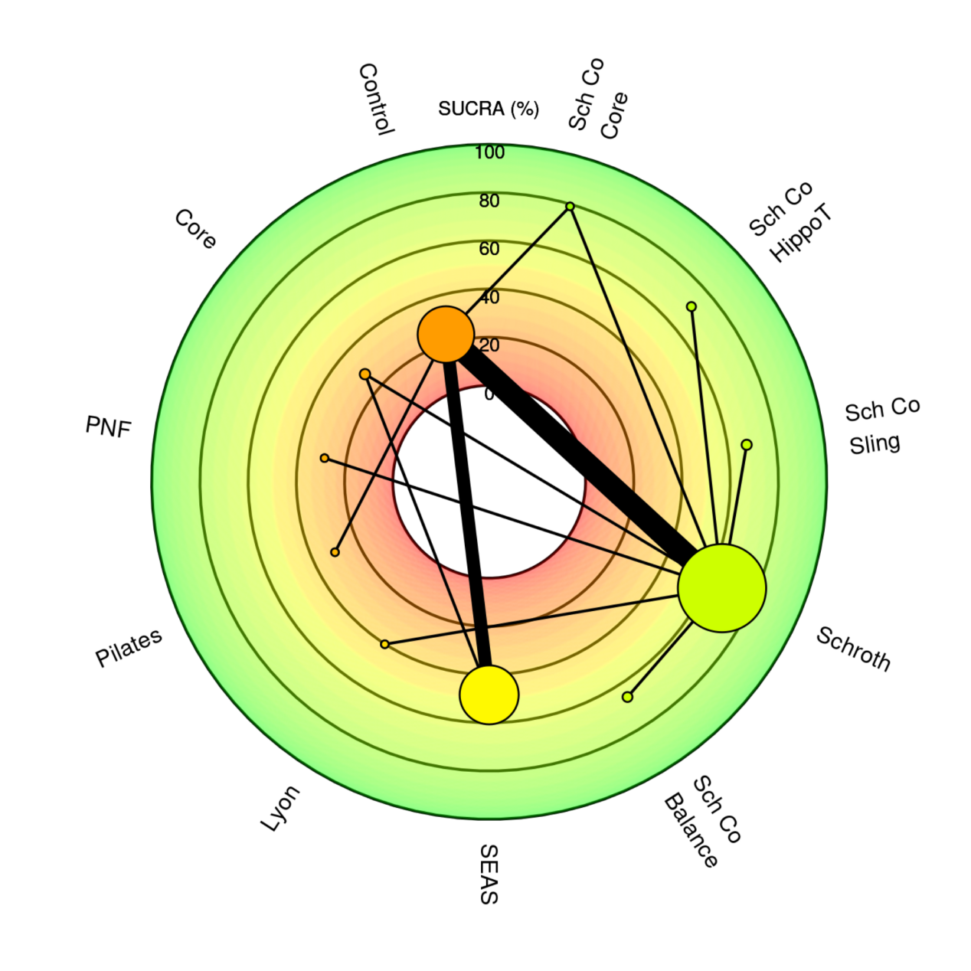
SRS-22

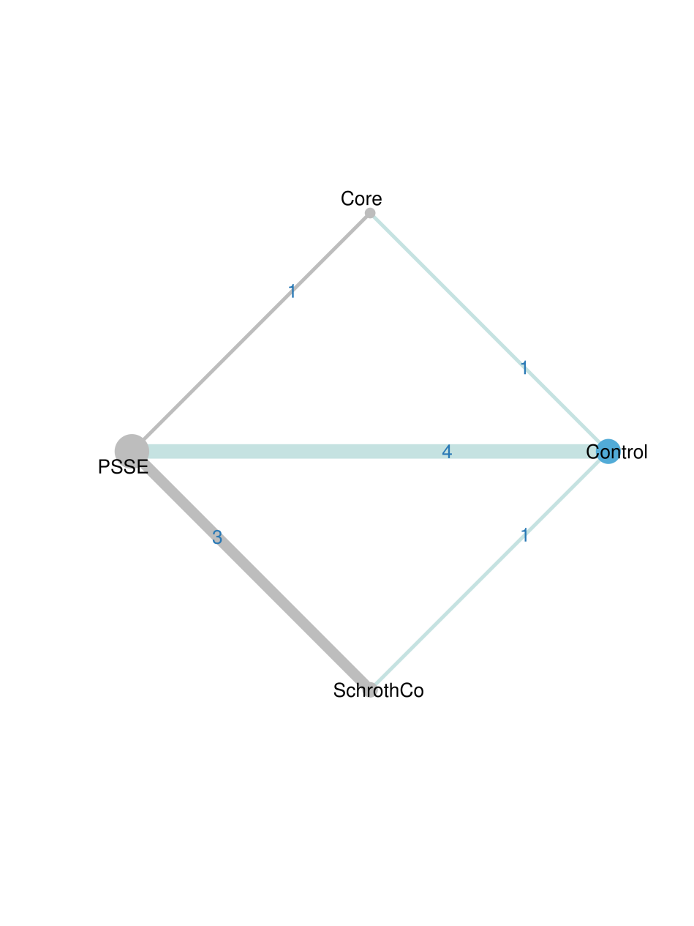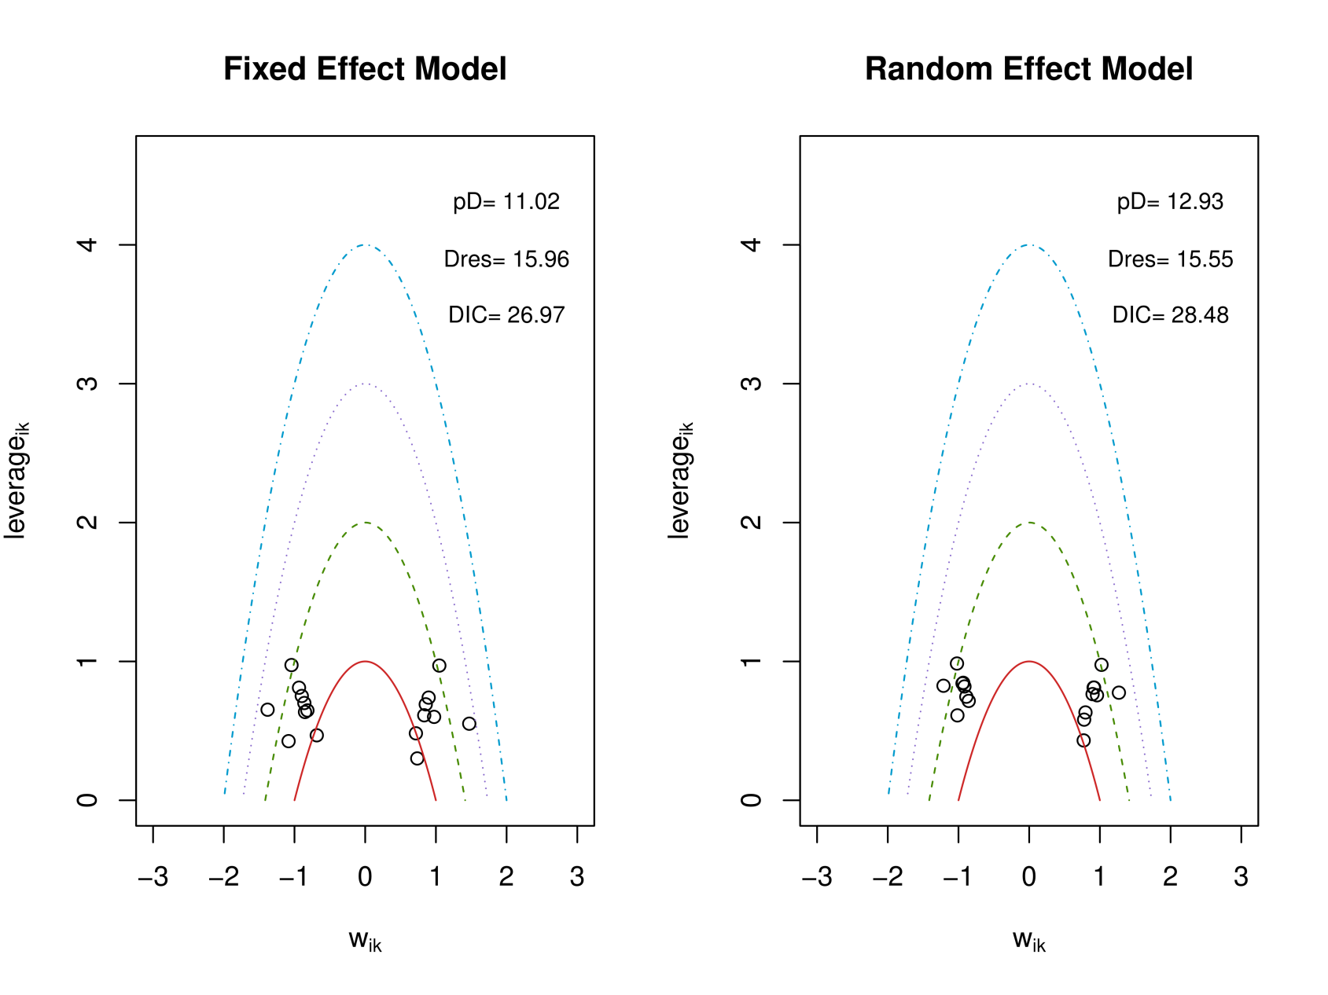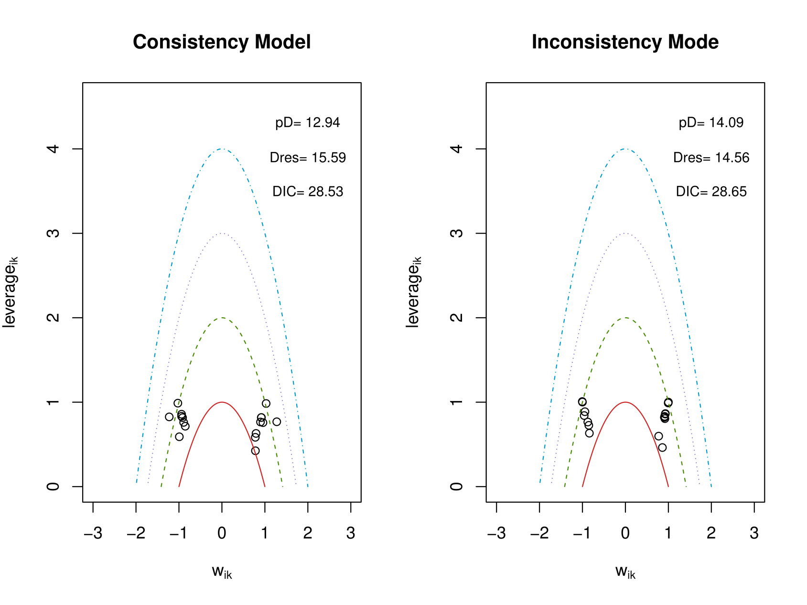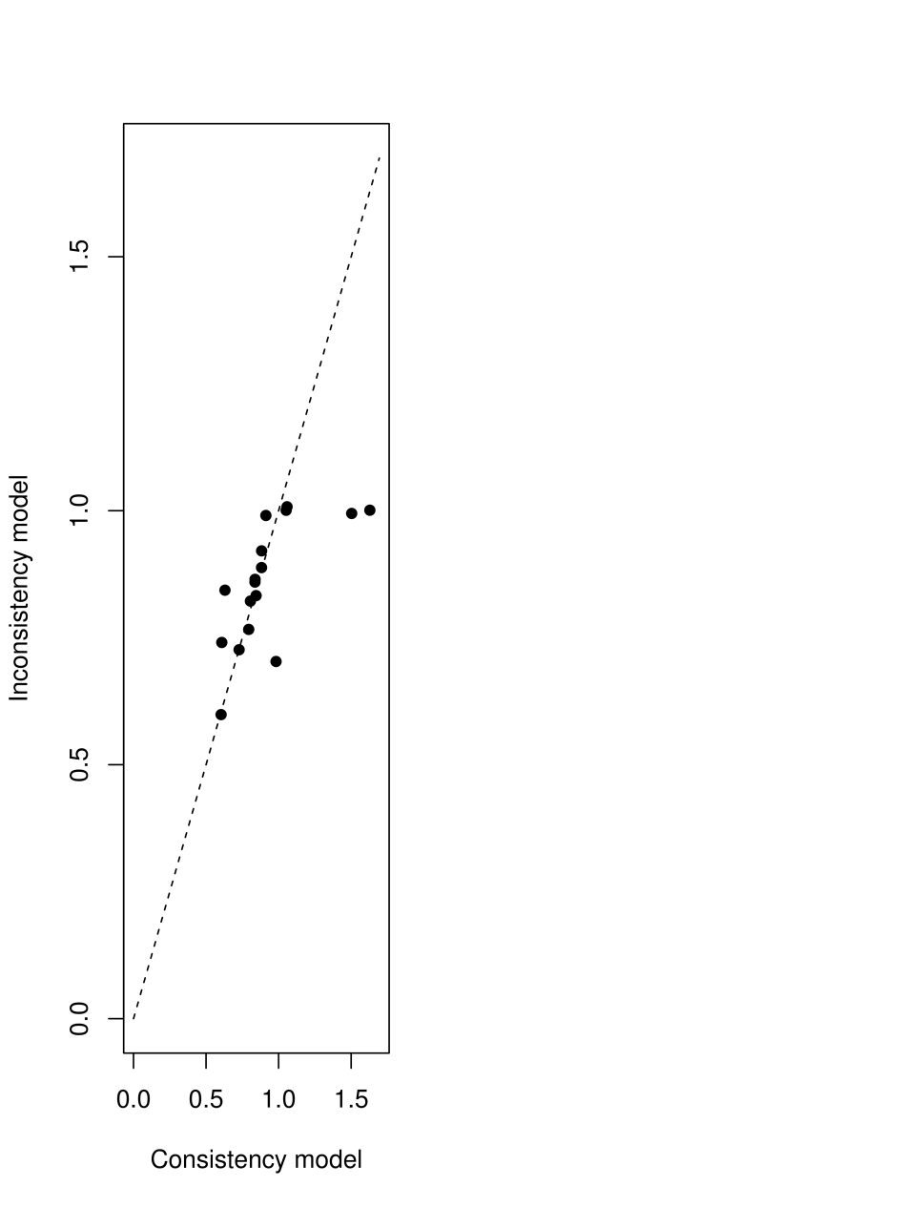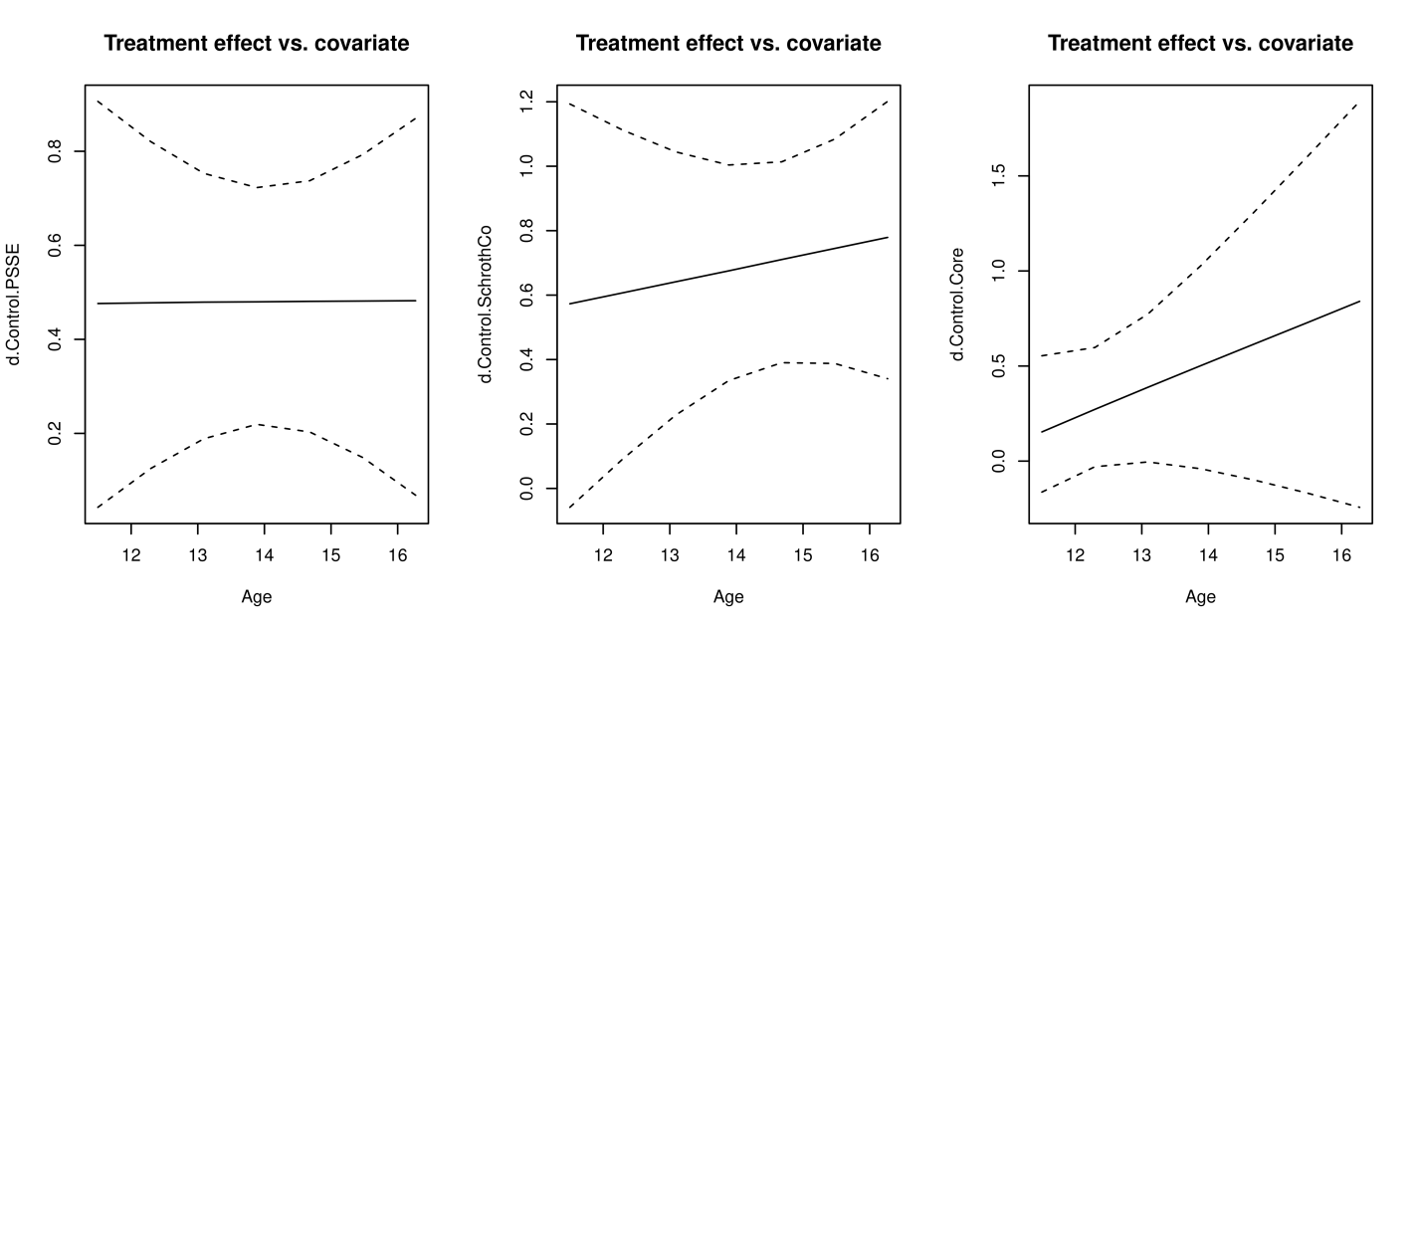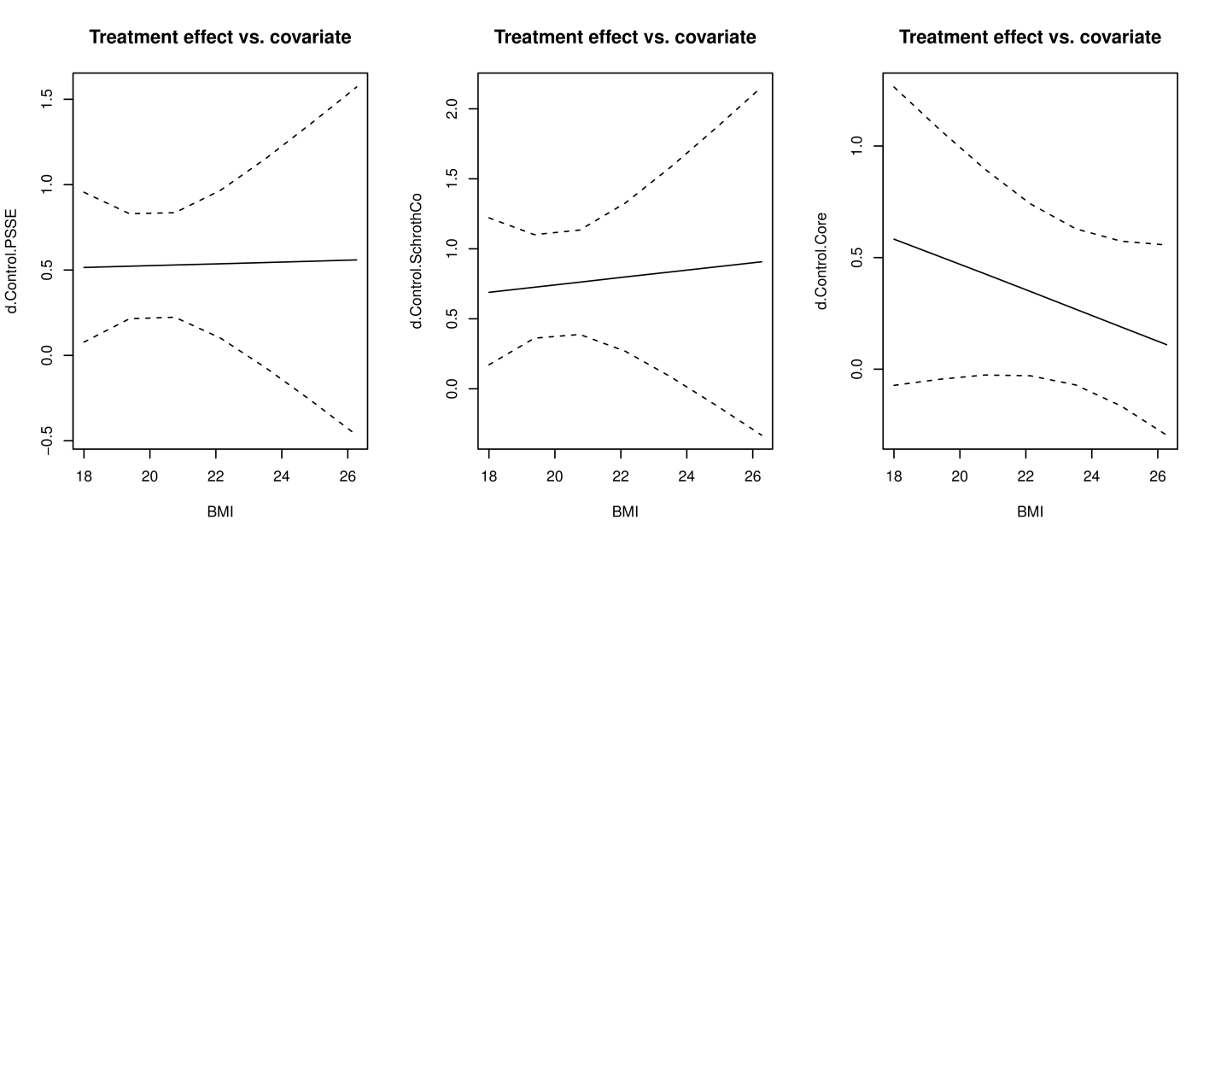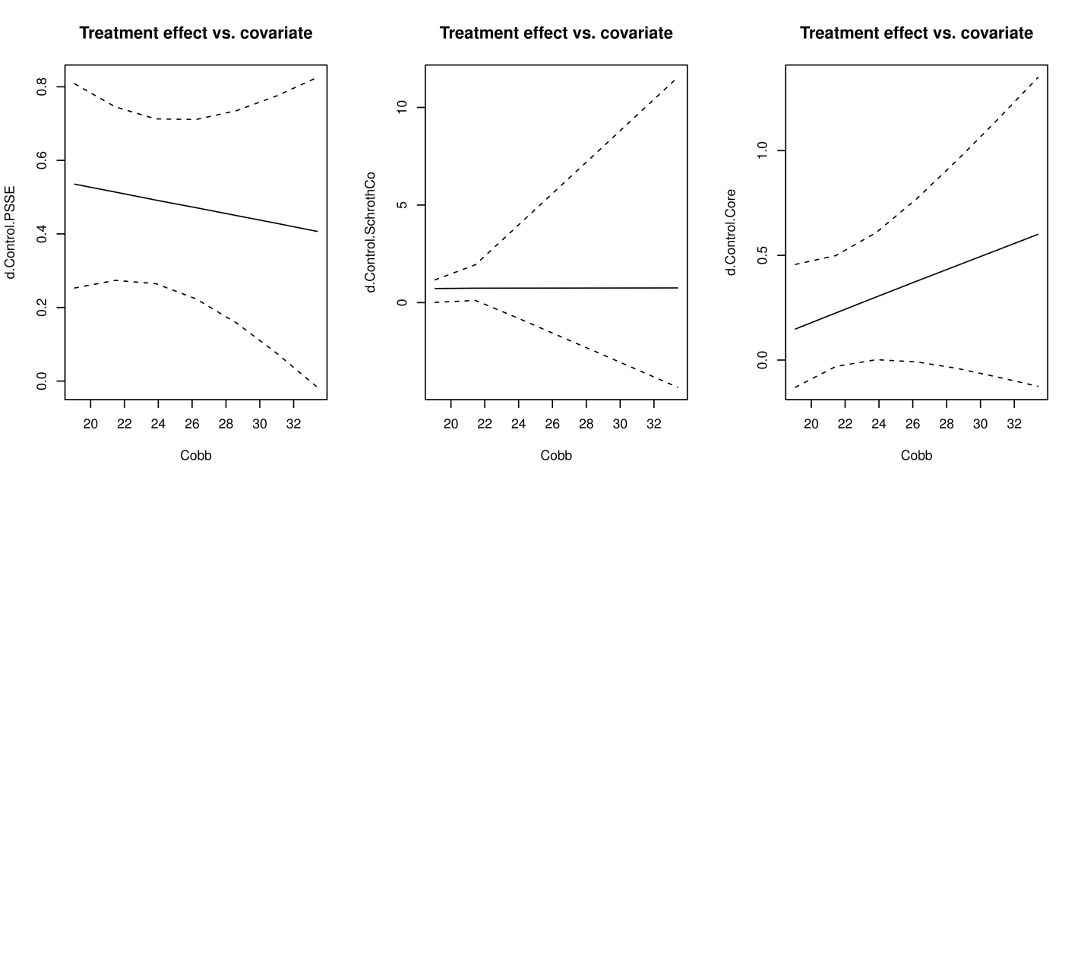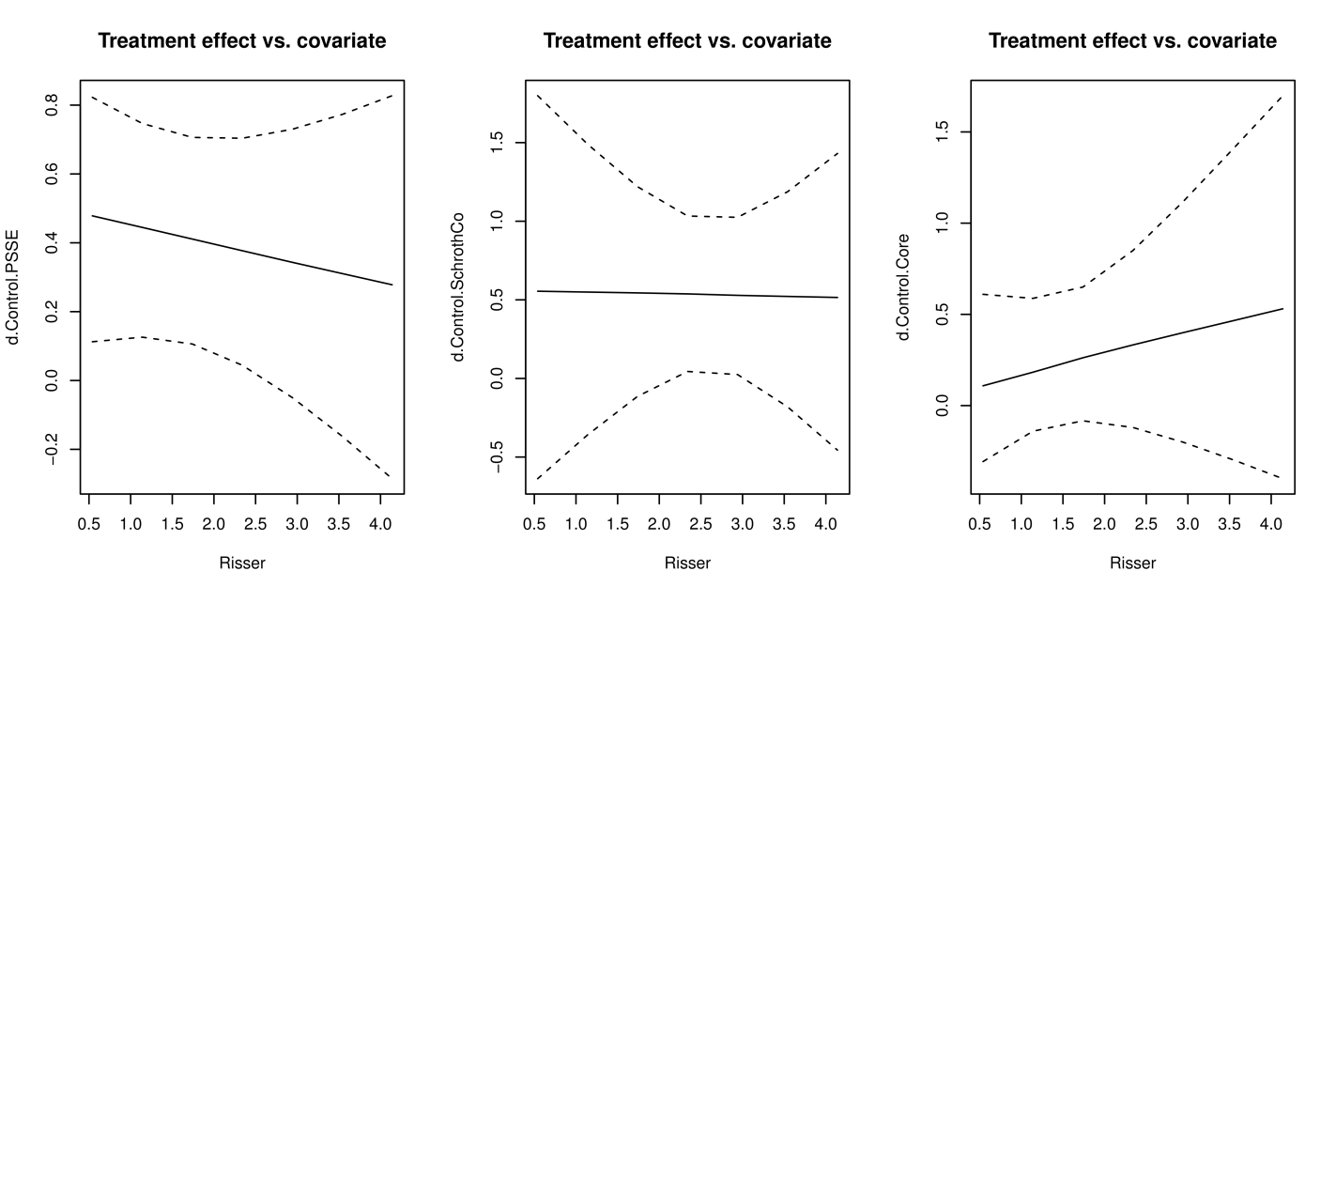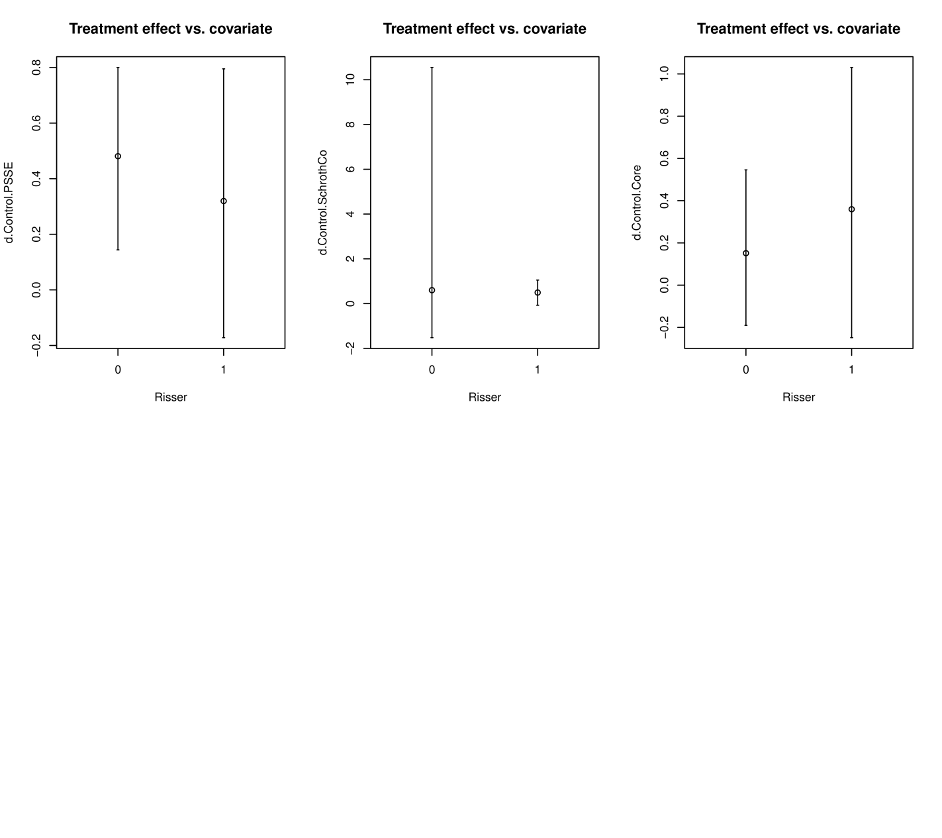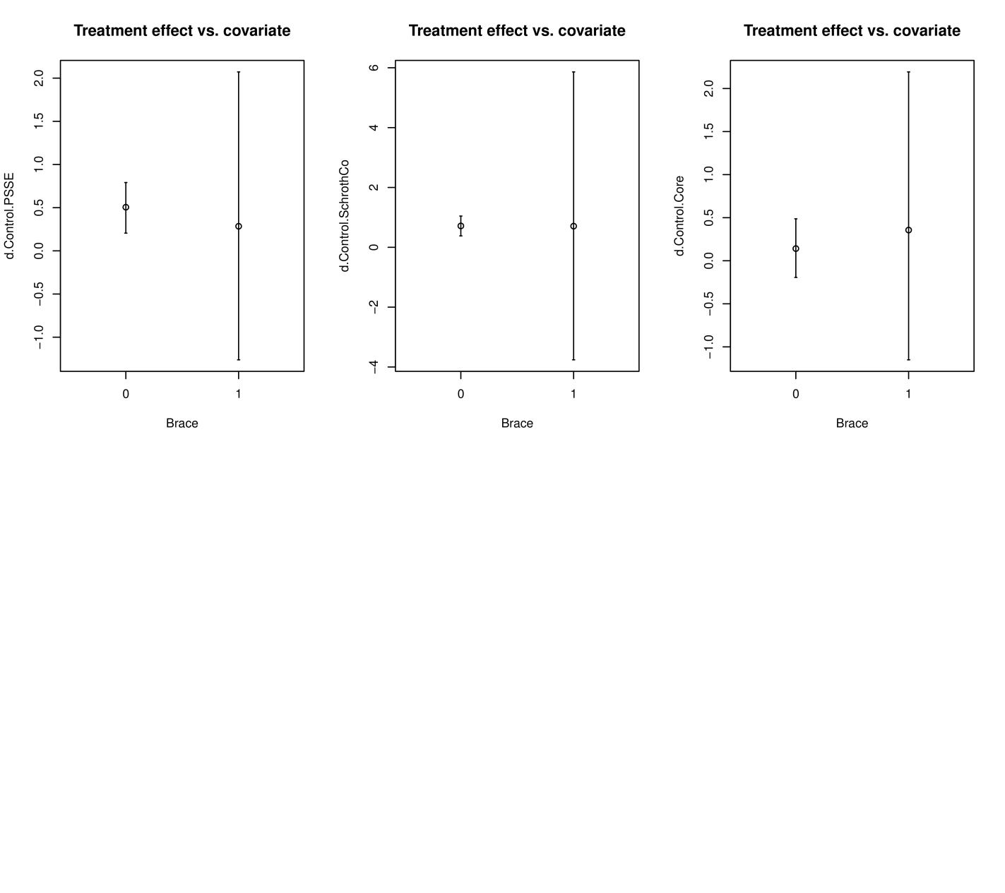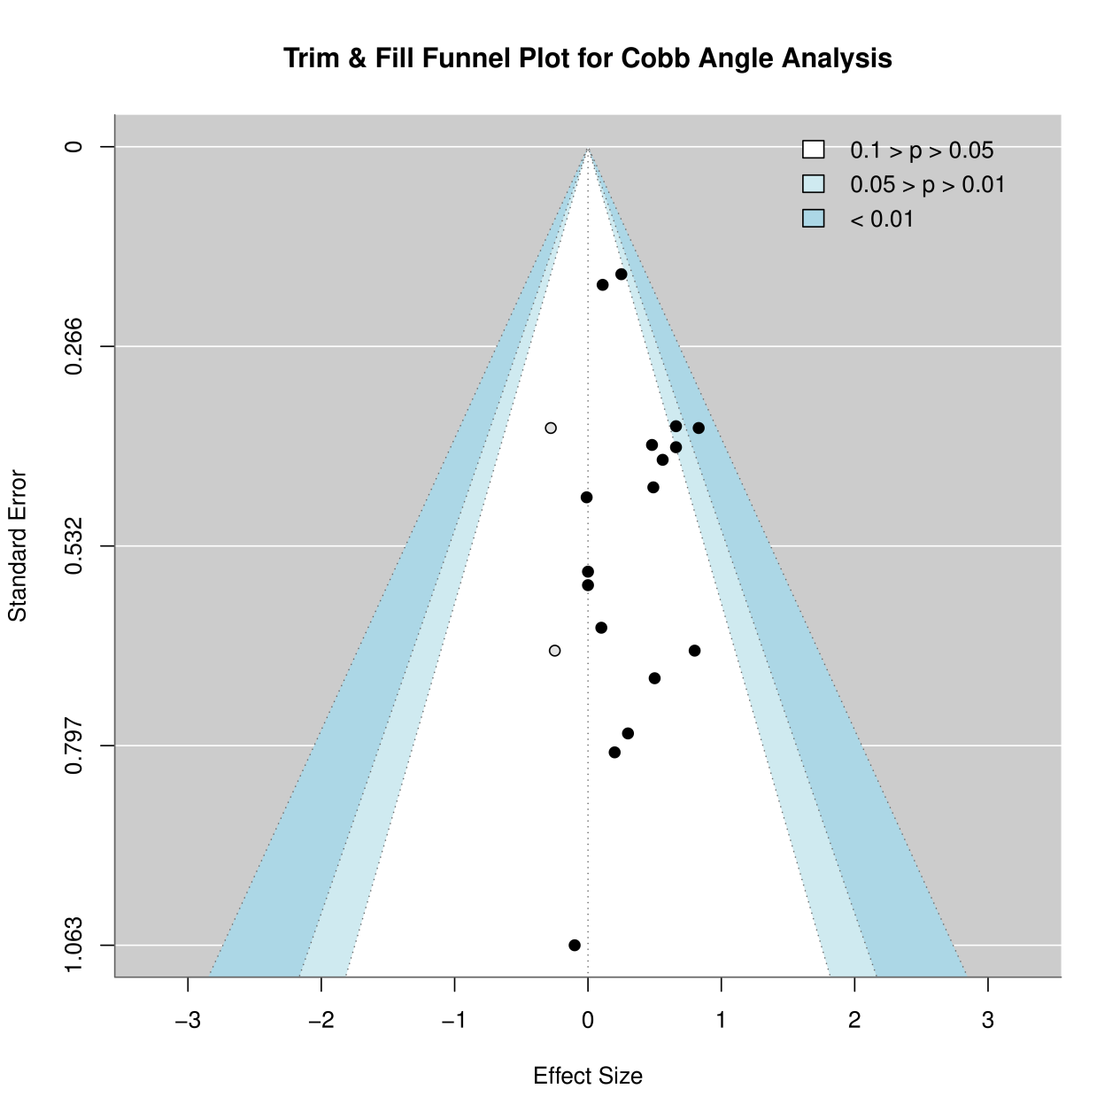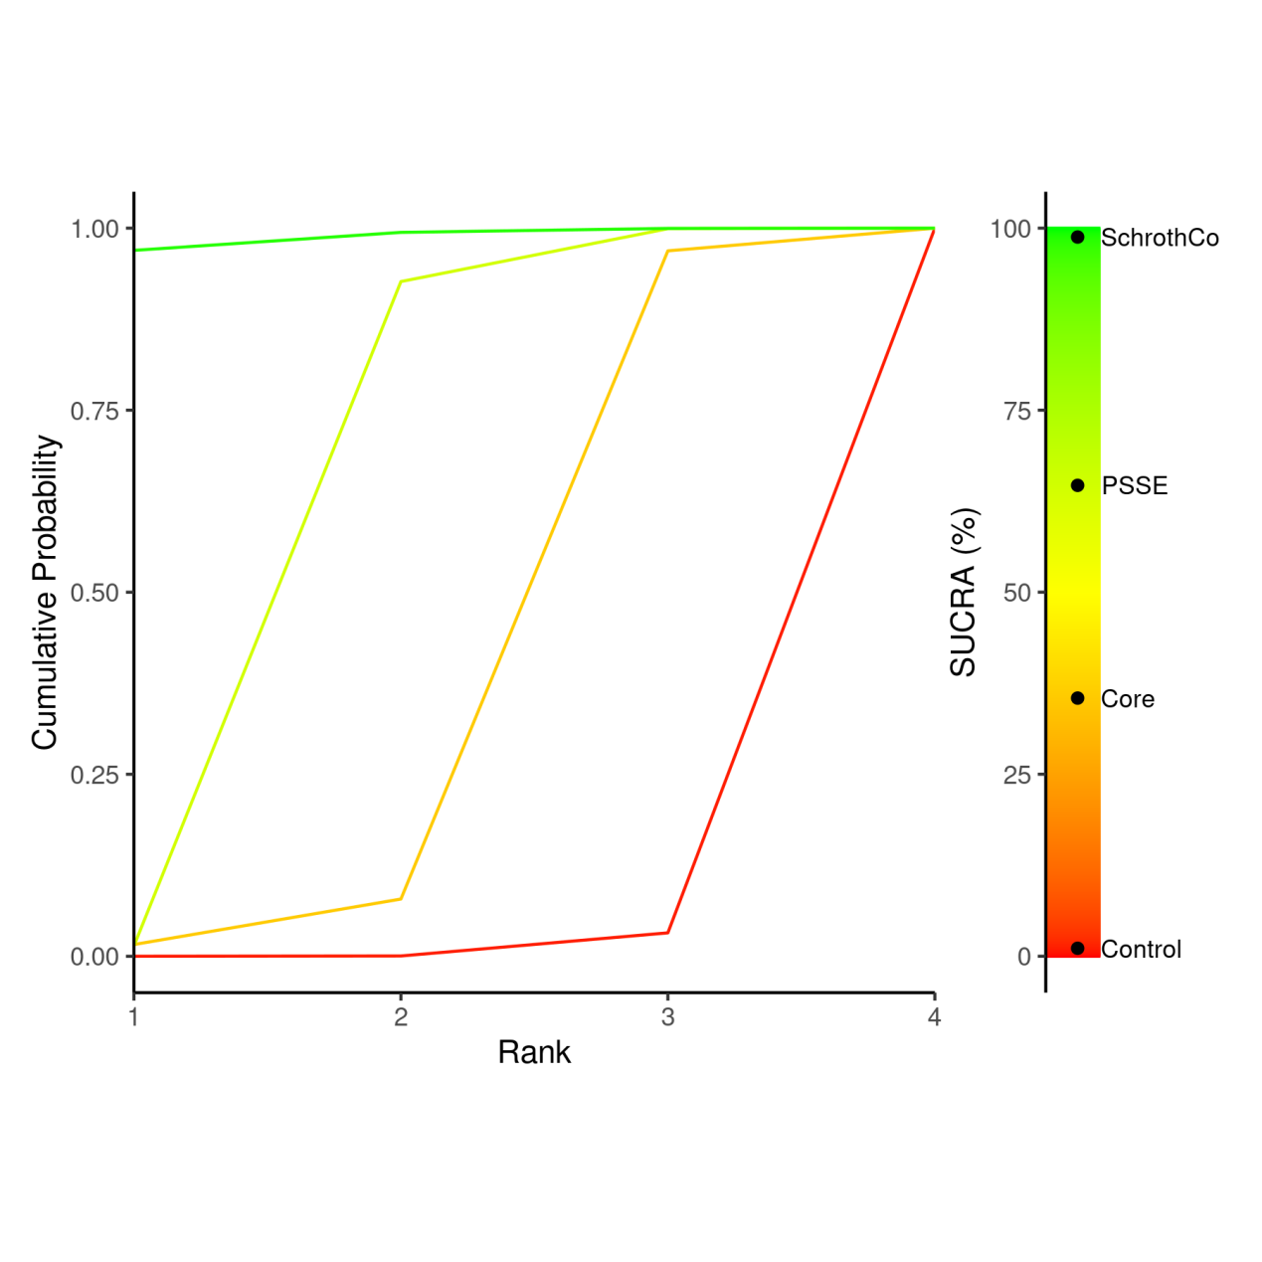
 | Control | Core | PSSE | SchrothCo
Control | Control | 0.2 (-0.01, 0.56) | 0.44 (0.22, 0.66) | 0.66 (0.39, 0.94)
Core | -0.2 (-0.56, 0.01) | Core | 0.23 (-0.14, 0.51) | 0.45 (0.04, 0.77)
PSSE | -0.44 (-0.66, -0.22) | -0.23 (-0.51, 0.14) | PSSE | 0.22 (0.02, 0.44)
SchrothCo | -0.66 (-0.94, -0.39) | -0.45 (-0.77, -0.04) | -0.22 (-0.44, -0.02) | SchrothCo

Treatment | Rank 1 | Rank 2 | Rank 3 | Rank 4 | SUCRA
Control | 8.75e-05 | 4e-04 | 0.0317375 | 0.967775 | 1.09333333333333
Core | 0.0162 | 0.0624625 | 0.8901625 | 0.031175 | 35.45625
PSSE | 0.0142125 | 0.9124375 | 0.07265 | 7e-04 | 64.6720833333333
SchrothCo | 0.9695 | 0.0247 | 0.00545 | 0.00035 | 98.7783333333333
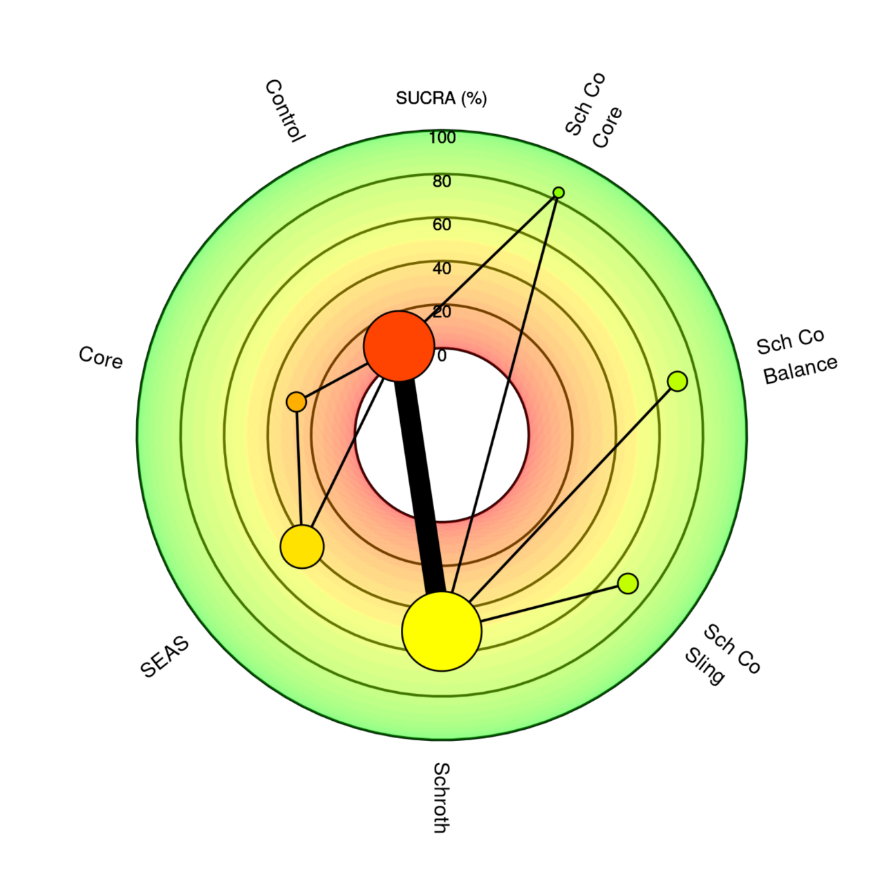
 | Control | Core | Sch_Co_Balance | Sch_Co_Core | Sch_Co_Sling | Schroth | SEAS
Control | Control | 0.21 (-0.27, 0.83) | 0.66 (-0.16, 1.44) | 0.79 (0.13, 1.43) | 0.65 (-0.17, 1.43) | 0.48 (0.02, 0.9) | 0.37 (-0.21, 0.92)
Core | -0.21 (-0.83, 0.27) | Core | 0.44 (-0.62, 1.35) | 0.57 (-0.36, 1.36) | 0.43 (-0.63, 1.32) | 0.26 (-0.52, 0.87) | 0.15 (-0.51, 0.67)
Sch_Co_Balance | -0.66 (-1.44, 0.16) | -0.44 (-1.35, 0.62) | Sch_Co_Balance | 0.13 (-0.79, 1.08) | -0.01 (-0.96, 0.95) | -0.18 (-0.85, 0.5) | -0.29 (-1.28, 0.69)
Sch_Co_Core | -0.79 (-1.43, -0.13) | -0.57 (-1.36, 0.36) | -0.13 (-1.08, 0.79) | Sch_Co_Core | -0.14 (-1.07, 0.79) | -0.31 (-0.96, 0.33) | -0.43 (-1.29, 0.44)
Sch_Co_Sling | -0.65 (-1.43, 0.17) | -0.43 (-1.32, 0.63) | 0.01 (-0.95, 0.96) | 0.14 (-0.79, 1.07) | Sch_Co_Sling | -0.17 (-0.85, 0.5) | -0.28 (-1.26, 0.71)
Schroth | -0.48 (-0.9, -0.02) | -0.26 (-0.87, 0.52) | 0.18 (-0.5, 0.85) | 0.31 (-0.33, 0.96) | 0.17 (-0.5, 0.85) | Schroth | -0.11 (-0.81, 0.6)
SEAS | -0.37 (-0.92, 0.21) | -0.15 (-0.67, 0.51) | 0.29 (-0.69, 1.28) | 0.43 (-0.44, 1.29) | 0.28 (-0.71, 1.26) | 0.11 (-0.6, 0.81) | SEAS

Treatment | Rank 1 | Rank 2 | Rank 3 | Rank 4 | Rank 5 | Rank 6 | Rank 7 | SUCRA
Control | 0.0001625 | 0.0010375 | 0.004075 | 0.0153125 | 0.0498125 | 0.1485625 | 0.7810375 | 5.27645833333333
Core | 0.0189625 | 0.041075 | 0.059875 | 0.0831875 | 0.1944 | 0.514075 | 0.088425 | 28.518125
Sch_Co_Balance | 0.2335375 | 0.291925 | 0.2235875 | 0.11255 | 0.0615375 | 0.04495 | 0.0319125 | 71.0145833333333
Sch_Co_Core | 0.492125 | 0.2502375 | 0.1348125 | 0.066225 | 0.0289625 | 0.0190125 | 0.008625 | 83.6466666666667
Sch_Co_Sling | 0.2106875 | 0.274425 | 0.2426125 | 0.125575 | 0.0657375 | 0.046875 | 0.0340875 | 69.3629166666667
Schroth | 0.0069875 | 0.0564125 | 0.2159125 | 0.4535 | 0.1951 | 0.066 | 0.0060875 | 50.0722916666667
SEAS | 0.0375375 | 0.0848875 | 0.119125 | 0.14365 | 0.40445 | 0.160525 | 0.049825 | 42.1089583333333

