Key to the 29 currently recognized species of the T. opinatus subgroup; figures underneat a couplet illustrate the relevant gonopodal characteristics referred to in the couplet (updated from Pimvichai et al., 2016)

1. Apical part of telopodite with spatulate lobe (sl)……………………...……………………....2
− Apical part of telopodite with lamellar lobe (ll)……………….………...…………..………22
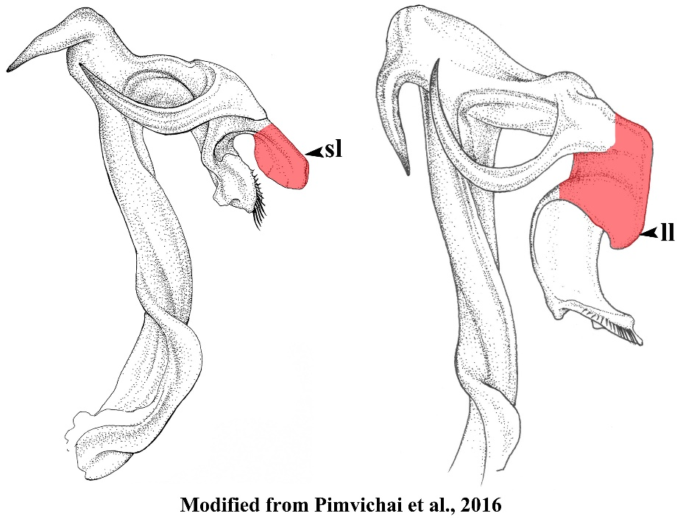
2. Spatulate lobe (sl) distally drawn out into one or two sharp dark brown spine(s)…….………3
− Spatulate lobe (sl) distally expanded and/or rounded, spoon-like, without a spine...…........…9
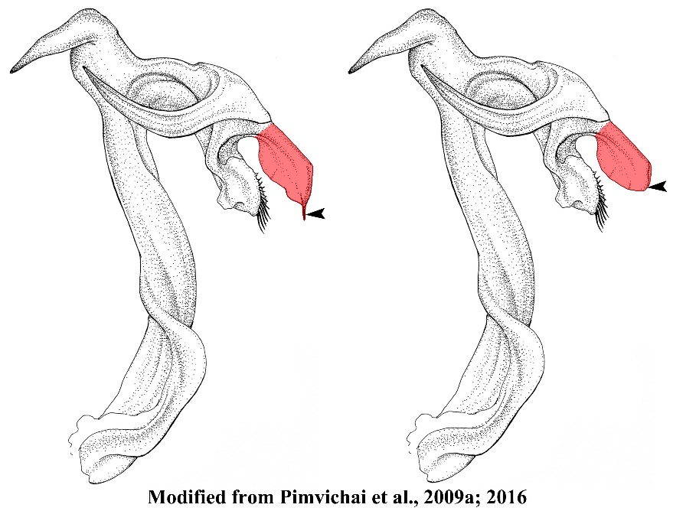
3. Spatulate lobe (sl) terminating in two sharp brown spines, the outer spine slightly smaller and shorter than the inner one; lateral process of anterior coxal fold (alp) slender, slightly curving mesad; mesal process of anterior coxal fold (amp) almost as long as alp, flattened…………... ..………………………….…………………………………………………...T. bispinispatula
− Spatulate lobe (sl) terminating in a single sharp dark brown spine...........................................4
4. Telopodite without a lobe distal to fe; lateral process of anterior coxal fold (alp) long, slender, regularly curved, tip close to tip of opposite alp, the two together forming a circle; mesal process of anterior coxal fold (amp) straight, shorter than alp; femoral spine (fe) directed distad, pointed……………………………..…………..……………...….....T. erectus
− Telopodite distally to fe with a large, round lobe (lo) projecting distolaterally…………..…..5
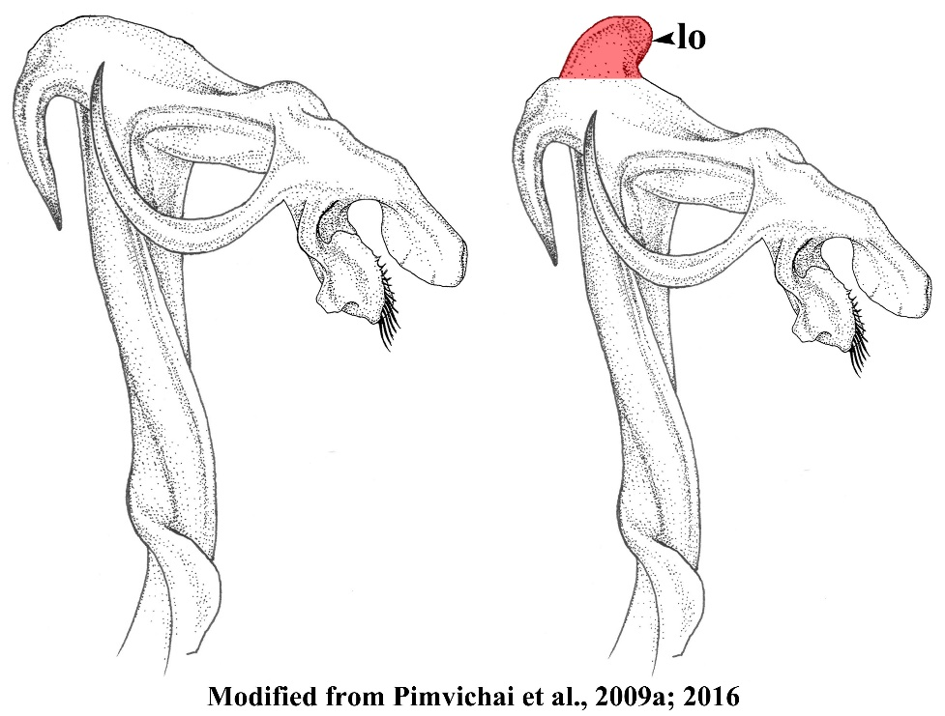
5. Lateral process of anterior coxal fold (alp) very slender, regularly curved………………..….6
− Lateral process of anterior coxal fold (alp) different, broader and/or with several apical denticles.....................................................................................................................................8
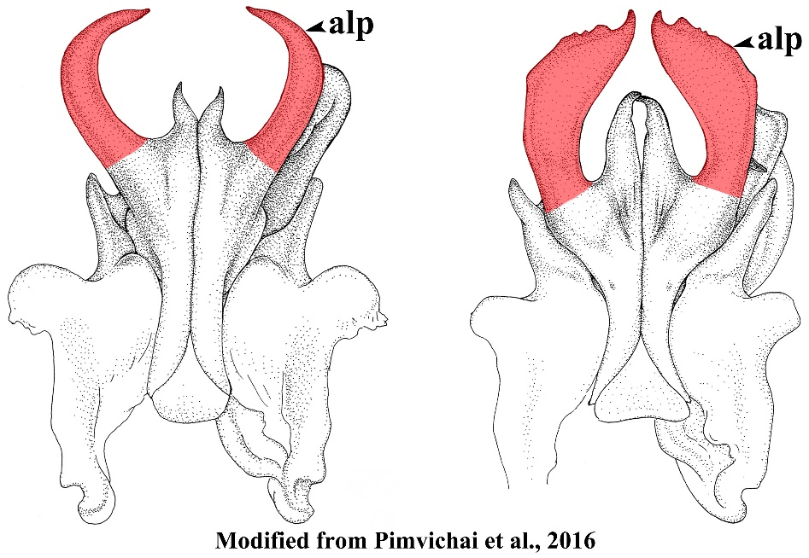
6. Mesal margin of lateral process of anterior coxal fold (alp) with fine serrations; mesal process of anterior coxal fold (amp) almost as long as alp, broadly expanded, apically sharp, straight distad, mesal margin forming a strong longitudinal crest (lc) in posterior view……………………………………...……………………………………….T. navychula
− Mesal margin of lateral process of anterior coxal fold (alp) without serrations, tip of lateral process close to tip of the opposite side, the two together forming a circle……………….….7
7. Mesal process of posterior coxal fold (pmp) strongly developed along anterior-posterior axis...............................................................................................................................T. floweri
− Mesal process of posterior coxal fold (pmp): slender, directed distolaterad…......….T. forceps
8. Lateral process of anterior coxal fold (alp) broad, apically gradually narrowed; mesal process of anterior coxal fold (amp) almost as long as lateral process (alp), slender, straight, terminally slightly curved, pointed...........................................................................T. opinatus
− Lateral process of anterior coxal fold (alp) apically bent abruptly mesad, tip with serrate margins; mesal process of anterior coxal fold (amp) much shorter than lateral process (alp), directed mesodistad, simple, pointed; mesal process of posterior coxal fold (pmp): strongly developed along anterior-posterior axis………….………...……………..……...T. implicatus
9. Telopodite with a single femoral spine (fe)…………...………………………....…..………10
− Telopodite with two femoral spines (fe 1 and fe 2)…………………...………..……………19
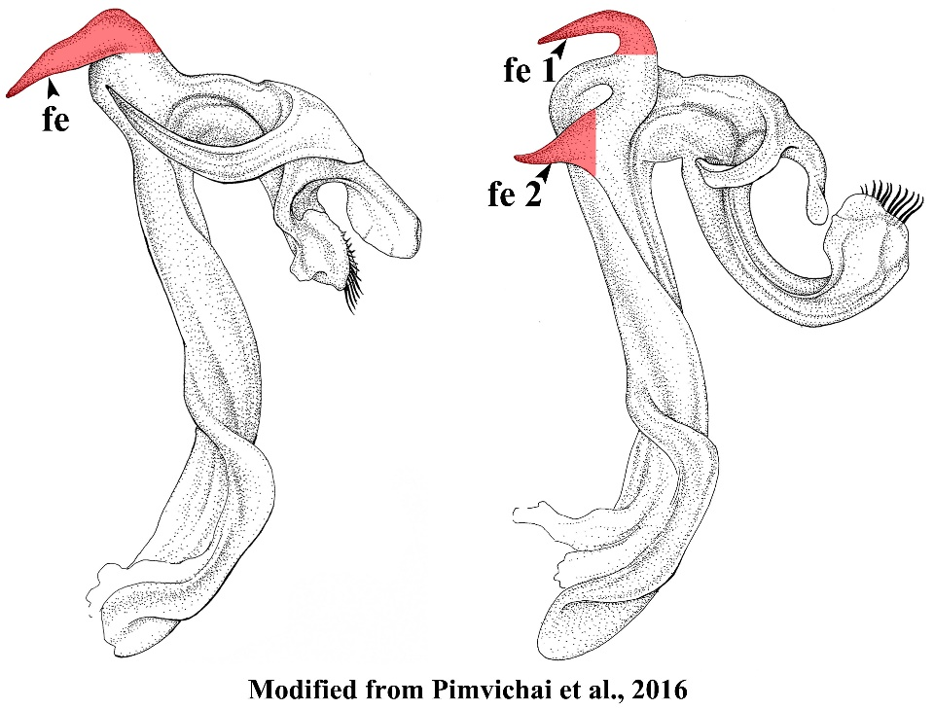
10. Mesal process of anterior coxal fold (amp) short……………………………..……………..11
− Mesal process of anterior coxal fold (amp) long, slender………..………..……....................13
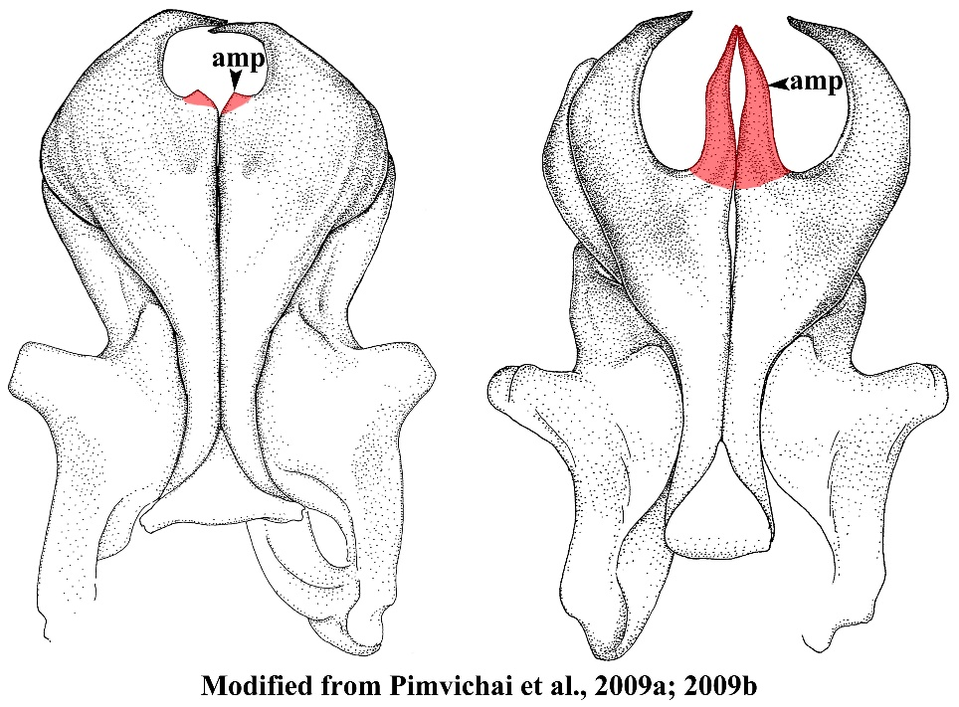
11. Telopodite with slender tibial spine (ti), not curving mesad; fe curving backward, without small spine; mesal process of anterior coxal fold (amp) very short, pointed......T. peninsularis
− Telopodite with short, slender tibial spine (ti), curving mesad …………………..………….12
12. Femoral spine (fe) with a small, slender, pointed spine (sfe) at base (Fig. 3C); mesal process of anterior coxal fold (amp) short, forming a triangular process; telopodite distally to fe without a small round lobe (lo)……………………...……….......….…T. payamense sp. nov.
− Femoral spine (fe) without a small slender, pointed spine (sfe) at base; telopodite distally to fe with a small round lobe (lo) projecting distolaterally.....................................................T. loxia
13. Lateral process of anterior coxal fold (alp) apically abruptly truncate………...…….. T. bearti
− Lateral process of anterior coxal fold (alp) apically pointed………………………….……..14
14. Mesal process of anterior coxal fold (amp) shorter than lateral process (alp)...…………......15
− Mesal process of anterior coxal fold (amp) as long as lateral process (alp)…………...….....16
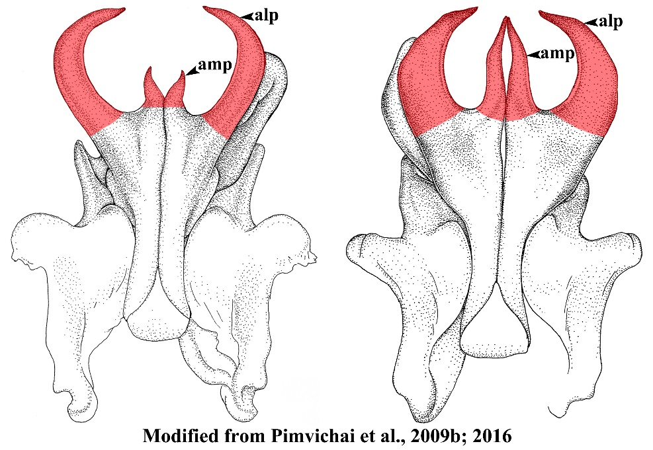
15. Mesal process of anterior coxal fold (amp) directed obliquely distomesad, slender, straight
.........................................................................................................................................T. chelatus
− Mesal process of anterior coxal fold (amp) directed distad, thicker, slightly sigmoid…………
……………………………………………………………………………….....T. brachyacanthus
16. Mesal process of anterior coxal fold (amp) directed obliquely distomesad, tip overlapping tip of opposite amp; lateral process of posterior coxal fold (plp) a massive, broad lobe, projecting laterad….……………………….……….…………......................……T. sutchariti
− Mesal process of anterior coxal fold (amp) directed distad…………………....…..………...17
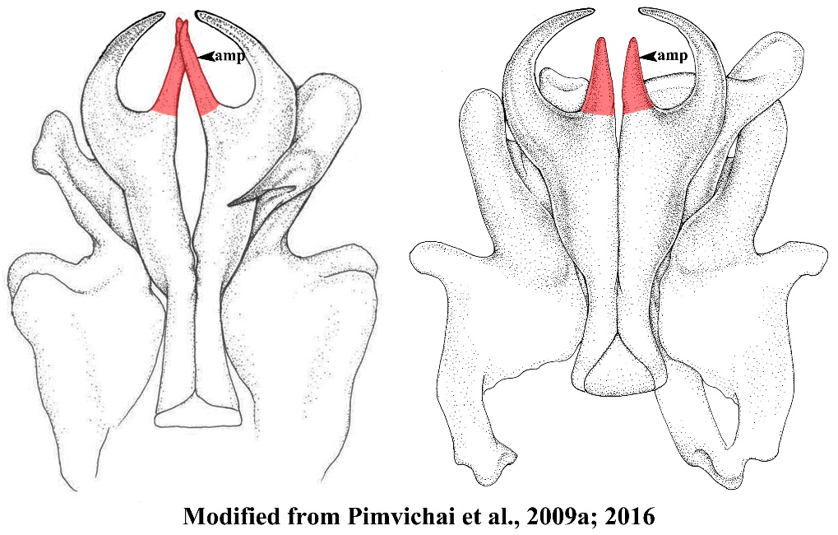

17. Lateral process of anterior coxal fold (alp) apically without a crest; telopodite distally with a rounded lobe (lo); margins of spatulate lobe (sl) terminally meeting in a distinct angle ...................................................................................................................................T. bispinus
− Lateral process of anterior coxal fold (alp) apically with a crest…………….…….…….….18
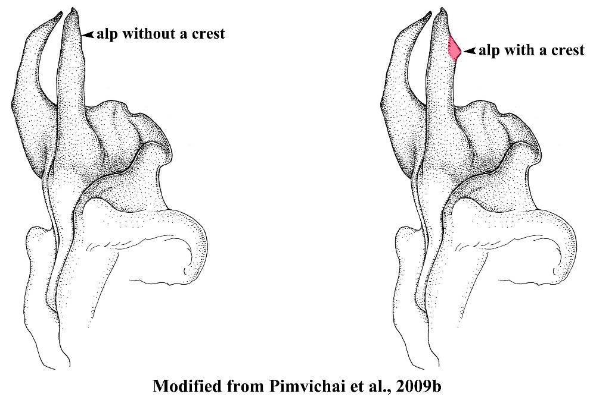
18. Mesal process of anterior coxal fold (amp) apically irregularly tuberculate; telopodite distally without a rounded lobe (lo)........................................................................................T. inflexus
− Mesal process of anterior coxal fold (amp) slender, straight, its tip pointed, its mesal margin forming a strong longitudinal crest (lc) in posterior view…………...….……T. mesocristatus
19. Anterior coxal fold (ac) with an additional spine-like process (aip) between alp and amp; lateral process of anterior coxal fold (alp) broad, mesal margin concave, tip with serrate margins, chicken comb-like; mesal process of anterior coxal fold (amp) much shorter than lateral process (alp), directed mesodistad, simple, pointed; both femoral spines (fe) slender, long.........................................................................................................................T. cristagalli
− Anterior coxal fold (ac) without an additional spine-like process (aip) between alp and amp……………………………………………………...…………………….………….......20
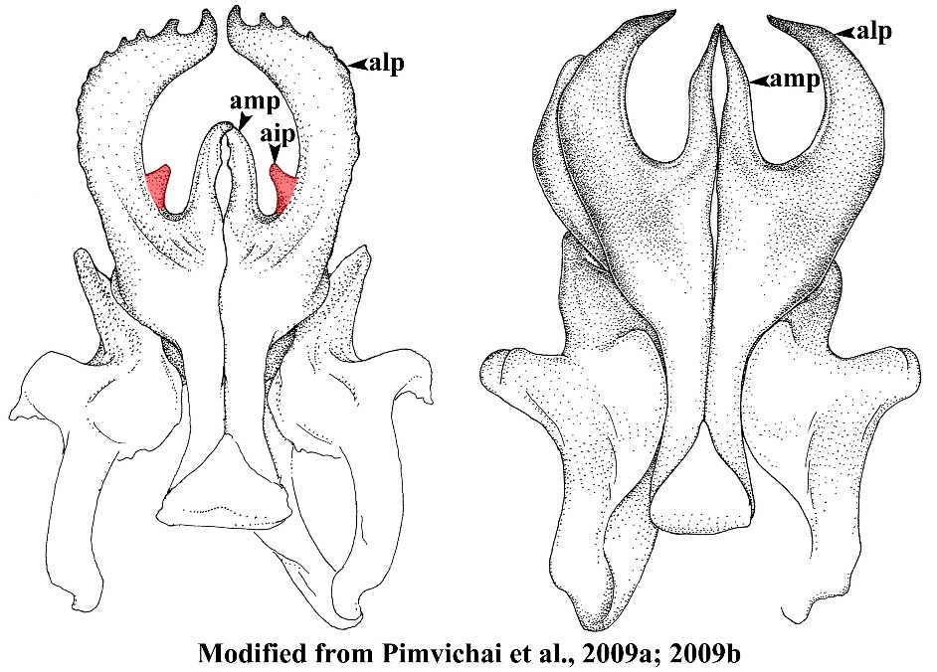
20. Lateral process of anterior coxal fold (alp) apically without a crest, flattened, slightly curved, its laterodistal margin coarsely dentate, terminating in a short, sharp, pointed spine; mesal process (amp) much shorter than alp, directed distad, tip curving mesad, pointed; both femoral spines (fe 1, fe 2) long, curving backward; tibial spine (ti) long, not curving in horizontal plane……………………………………………………………...……...…T. culter
− Lateral process of anterior coxal fold (alp) apically with a crest extending caudad………...21
21. Lateral process (alp) flattened, curving mesad, laterodistal margin coarsely dentate, terminating in a short spine, tip curving against the tip of opposite side; mesal process (amp) much shorter than alp, slender, curving mesad; both femoral spines (fe 1, fe 2) broad, long; tibial spine (ti) long, curving in horizontal plane, not ending in a sharp spine…...T. undulatus
− Lateral process (alp) regularly curved, terminating in a sharp, slightly upward pointing spine; mesal process (amp) slightly shorter than alp, flattend, straight, directed distad; tibial spine (ti) flattend, short, curving mesad…………………………………..……………T. planispina
22. Telopodite with a single femoral spine…………...………………………...…..……………23
− Telopodite with two femoral spines……………………………………….........……………25
23. Lateral process of anterior coxal fold (alp) without an apical crest; mesal process of anterior coxal fold (amp) shorter than and as broad as alp, directed distad; femoral spine (fe) very long and slender.......................................................................................................T. casjeekeli
− Lateral process of anterior coxal fold (alp), with a sharp crest on the posterior surface near the tip………………………………………………………………..……………...………..24
24. Lateral process of anterior coxal fold (alp) flattened, slightly curved, inflexed; femoral spine (fe) very long, slender, with an additional lamella at base…………..…..…….T. quadricuspis
− Lateral process of anterior coxal fold (alp) regularly curved, basally broad, gradually tapering towards end and ending in sharp point; femoral spine (fe) very long, slender, without an additional lamella at base….........................................................................................…T. cimi
25. Lateral process of anterior coxal fold (alp) flatten, broad..……………….………………....26
− Lateral process of anterior coxal fold (alp) slender, regularly curved, sickle-shaped….…....27
26. Lateral process of anterior coxal fold (alp) terminating in a very short external spine and a very long internal one; mesal process of anterior coxal fold (amp) as long as alp; first femoral spine (fe 1) very short, pointed; second femoral spine (fe 2) very long, as long as tibial spine (ti); an additional lamella at both side of base of fe 2..................................T. richardhoffmani
− Lateral process (alp) flattened, apically curved laterad as a short spine, lateral margin of alp slightly folded; mesal process (amp) shorter than alp, slender, straight, directed distad, pointed; the first femoral spine (fe 1) very short, directed upward, situated above fe 2, the second fe (fe2) very long, slender, curved downward……………………...………….T. ursus
27. Mesal margin of lateral process of anterior coxal fold (alp) simple, without a caudad spine or crest; mesal process of anterior coxal fold (amp) much shorter than lateral process (alp), curved, pointed…………………………………...……….…………..……..…......T. enghoffi
− Mesal margin of lateral process of anterior coxal fold (alp) with a caudad small spine or crest..........................................................................................................................................28
28. Mesal margin of lateral process of anterior coxal fold (alp) with a small caudad crest; mesal process of anterior coxal fold (amp) slightly shorter than alp, slightly sigmoid, pointed………………………………………………………………………………………..T. bifurcus
− Mesal margin of lateral process of anterior coxal fold (alp) with a short curved caudad spine; mesal process of anterior coxal fold (amp) as long as alp, straight……..……..T. demangei

