Supplementary material
Table S1. Vapor pressure of fungal volatile organic compounds (VOCs) and insect semiochemicals used in field experiments.
VOCs | Vapor pressure
styrene (C1) | 8.6 torr
3-cycloheptenone (C7) | 6.7 torr (cyclohexanone)
1,3-dimethoxybenzene (C5) | 2.6 torr (phenetole)
benzothiazole (C2) | <2.6 torr (according to its pKa and molecular mass)
Semiochemicals | Vapor pressure
sordidin | 0.3±0.4 torr ((1S,3R,5R,7S)-1-ethyl-3,5,7-trimethyl-2,8-dioxabicyclo [3.2.1] octane)
No vapor pressure data for C2, C5 and C7 is available. Values for cyclohexanone and phenetole (analogues of C7 and C5, respectively) are given. No vapor pressure data for compounds like C2 is available. No vapor pressure data for sordidin but similar compound data was found.
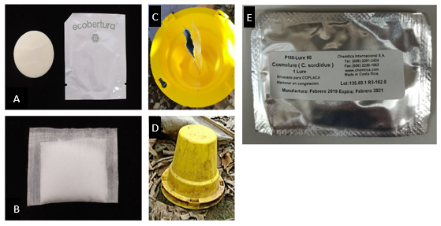
Figure S1. Pit-fall trap components used in field experiments. A) ECOSordidina30 dispenser. B) Miracloth VOCs dispenser. C) Trap baited with dispensers. D) Trap located in the field. E) Cosmolure™ P160-Lure90 dispenser.
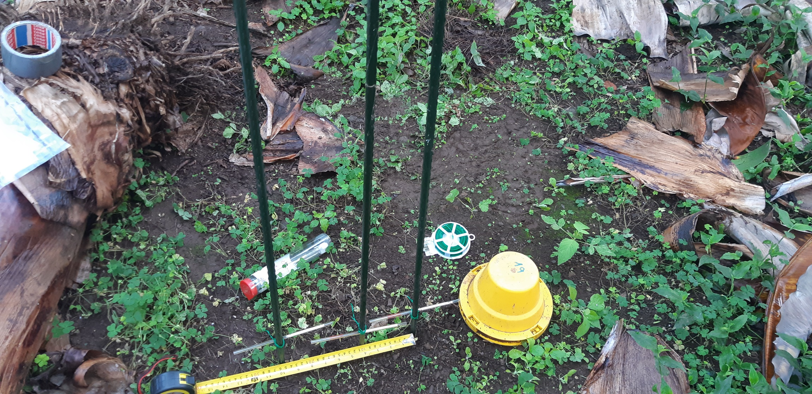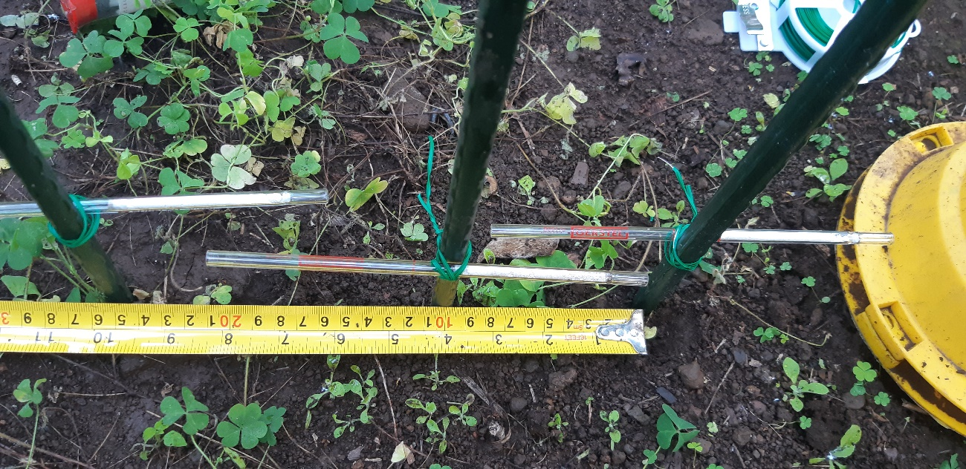
Figure S2. Pit-fall trap and tenax fibers for VOC C5 field detection. Tenax tubes are placed at 0, 10 and 25 cm from the trap where C5 dispensers are located.
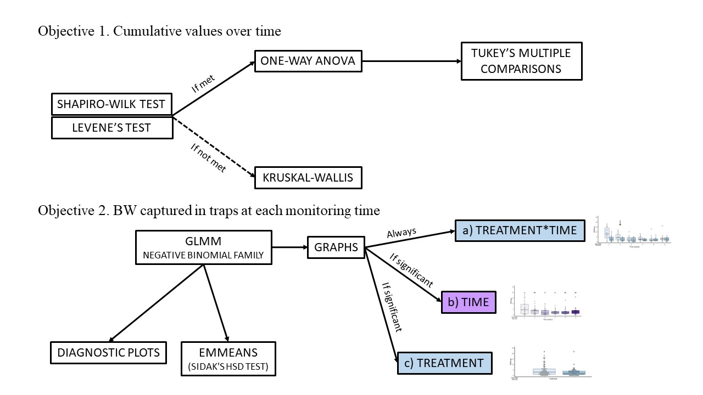

Figure S3. Statistical analyses workflow of the data in this paper.

Table S2. GC-MS detection of fungal VOC C5 in the field.
Trap treatments | Tenax fibers distance from traps (cm) | GC-MS
 |  | Retention time (min) | Peak height | Correlation area
Empty | 0 | - | - | -
Ph. + C5 | 0 | 36,581 | 2709444 | 115314692
 | 10 | 36,648 | 780473 | 129513632
 | 25 | 36,727 | 117285 | 3758585
VOC C5 | 0 | 36,834 | 146175 | 14305301
 | 10 | 36,771 | 102458 | 4051603
 | 25 | 36,759 | 85493 | 3014313
Location of Tenax fibers in the field: Figures 2 and S2.
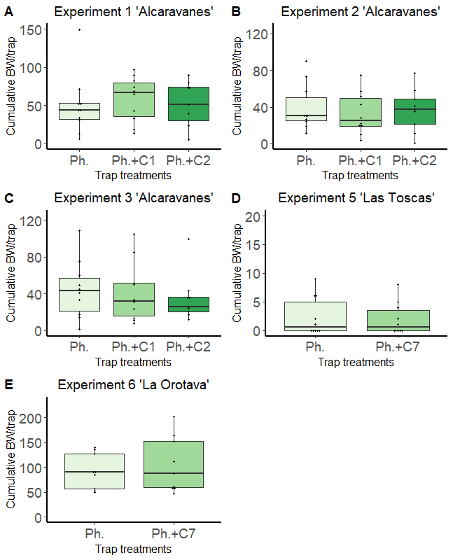
Figure S4. Effect of VOCs (C1, C2 and C7) on C. sordidus adult trapping in banana fields from Canary Islands. A-C) Experiment 1-3 “Alcaravanes”. Pheromone (n=10), Ph. + C1 (n=10), Ph. + C2 (n=9). One-way ANOVA. Experiment 1: F_{2,26}=0.1887; p-value=0.8292; Experiment 2: F_{2,26}=0.1739; p-value=0.8413; Experiment 3: F_{2,26}=0.2031; p-value=0.8175. D) Experiment 5 “Las Toscas”. Pheromone, Ph. + C7. Kruskall-wallis, χ²=0.040, p-value=0.8398(n=10). E) Experiment 6 “Los Llanos”. Pheromone, Ph. + C7. Unpaired t-student, two tailed; p-value=0.5636 (n=9). Columns represent the mean of total BWs captured over time per trap. Error bars = SEM. BW = Banana weevil (C. sordidus); Ph. = BW pheromone; C1 = styrene; C2
= benzothiazole; C7 = 3-cycloheptenone. No significant differences were found.

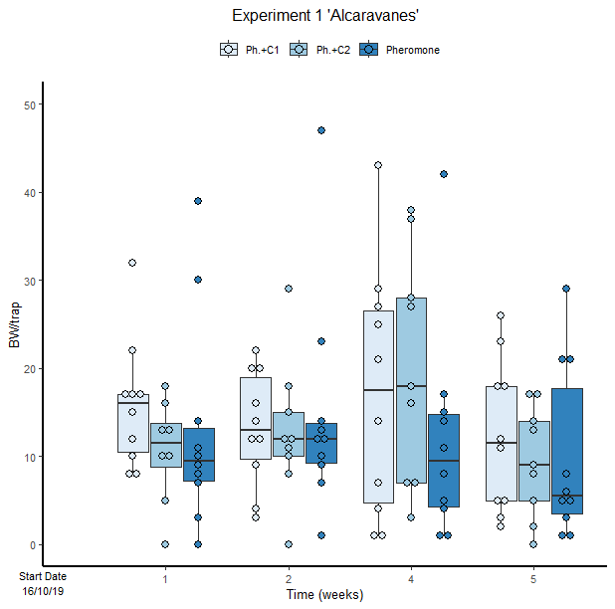
Figure S5. Cosmopolites sordidus captures per treatment with time in the Experiment 1 used to establish the periodicity of repellent replacement. Treatments: C1 with pheromone, C2 with pheromone and pheromone only traps. Columns represent BWs trapped every monitoring time. Error bars = SEM. Arrows indicate dates of fungal VOC dispensers’ replacement. No significant differences between were found (emmeans analysis).

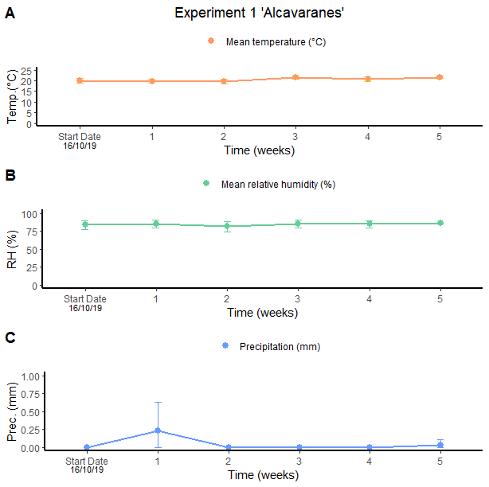
Figure S6. Meteorological data collected from Alcaravanes for Experiment 1. A) Temperature (weekly mean temperature): Spearman’s test, ρ= 0.55, p-value<0.001. , there is a correlation between the time, going into autumn/winter, and a decrease in the temperature. B) Relative humidity (weekly mean relative humidity): Spearman’s test, cor=0.13, p.value= 0.41, it remains stable for all the times. C) Precipitation (weekly mean precipitation): Spearman’s test, ρ= -0.0.3, p-value=0.79..Despite there is not a significant correlation, there is a week of rain, in the second week of the experiment. Columns represent BWs trapped every monitoring time. Error bars = SEM.

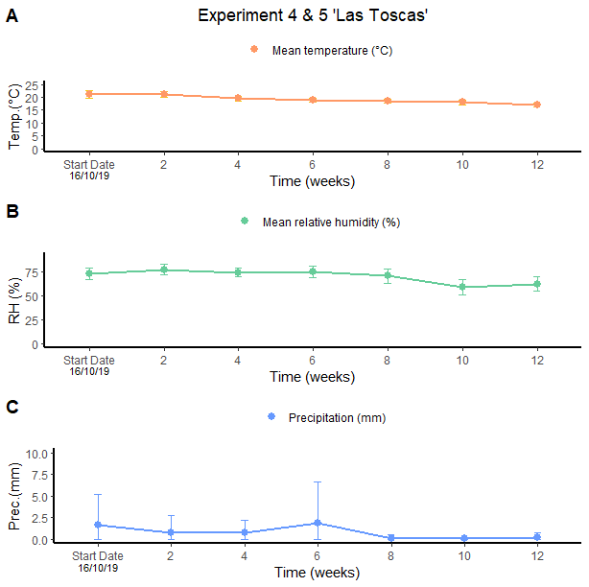
Figure S7. Meteorological data collected from Las Toscas for Experiments 4 and 5. A) Temperature (weekly mean temperature):Pearson’s test, cor=-0.81, p-value<0.001., there is a correlation between the time, going into autumn/winter, and a decrease in the temperature. B) Relative humidity (weekly mean relative humidity): Spearman’s test, ρ=-0.55, p-value<0.001. , there is a slight reduction at the end of the experiment. C) Precipitation (weekly mean precipitation): Spearman’s test, ρ=-0.25, p-value<0.01., there is a correlation, because there are several weeks of rain, above all in the first half of the experiment. Columns represent BWs trapped every monitoring time. Error bars = SEM.

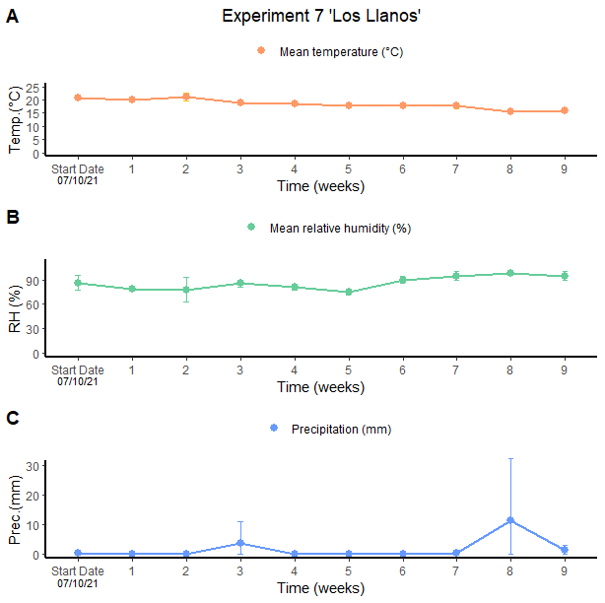
Figure S8. Meteorological data collected from Los Llanos for Experiment 7. A) Temperature (weekly mean temperature):Pearson’s test, cor=-0.86, p-value<0.001,, there is a correlation between the time, going into autumn/winter, and a decrease in the temperature. B) Relative humidity (weekly mean relative humidity): Spearman’s test, ρ=0.56, p-value<0.0001, it remains almost stable for all the times. C) Precipitation (weekly mean precipitation):Spearman’s test, ρ=0.31, p-value=0.08, there is no correlation despite there is a light rain at the 3rd week and a heavy rain at the 8th week of the experiment. Columns represent BWs trapped every monitoring time. Error bars = SEM.

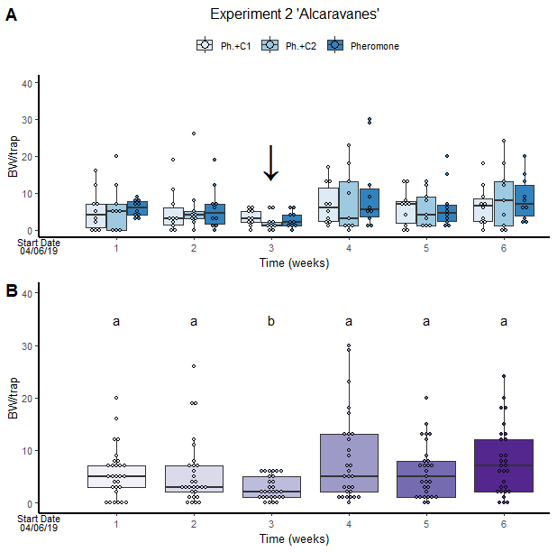
Figure S9. Cosmopolites sordidus captures per treatment with time in the Experiment 2. Treatments: C1 with pheromone, C2 with pheromone and pheromone only traps. Columns represent BWs trapped every monitoring time. Error bars = SEM. Arrows indicate dates of fungal VOC dispensers’ replacement. Letters indicate differences between times (emmeans analysis).

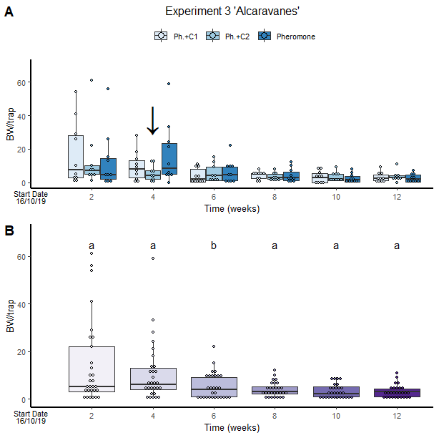
Figure S10. Cosmopolites sordidus captures per treatment with time in the Experiment 3. A) Number of captures in each treatment (Treatments: C1 with pheromone, C2 with pheromone and pheromone only traps) in each monitoring time. B) Total captures in each monitoring time. Columns represent BWs trapped every monitoring time. Error bars = SEM. Arrows indicate dates of fungal VOC dispensers’ replacement. Letters indicate differences between times (emmeans analysis).

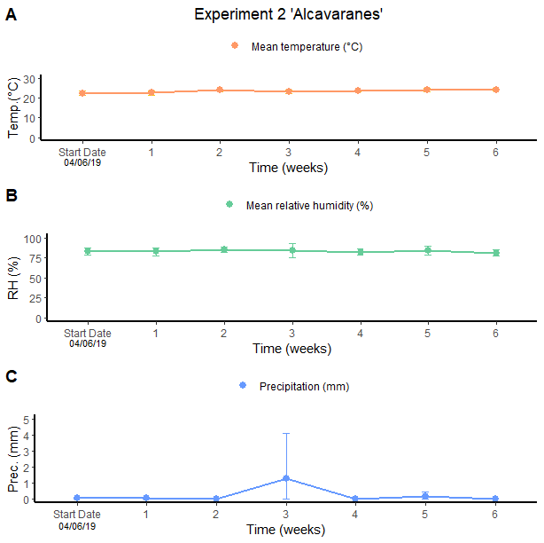
Figure S11. Meteorological data collected from Alcazavares for Experiment 2. A) Temperature (weekly mean temperature): Pearson’s test, cor=0.56, p-value<0.0001there is a correlation between time and temperature.. B) Relative humidity (weekly mean relative humidity): Spearman’s test, ρ=-0.05, p-value=0.71, it remains stable. C) Precipitation (weekly mean precipitation): Spearman’s test, ρ=1, p-value<0.0001, there is a week of rain in the 4th week of the experiment. Columns represent BWs trapped in each monitoring time. Error bars = SEM.

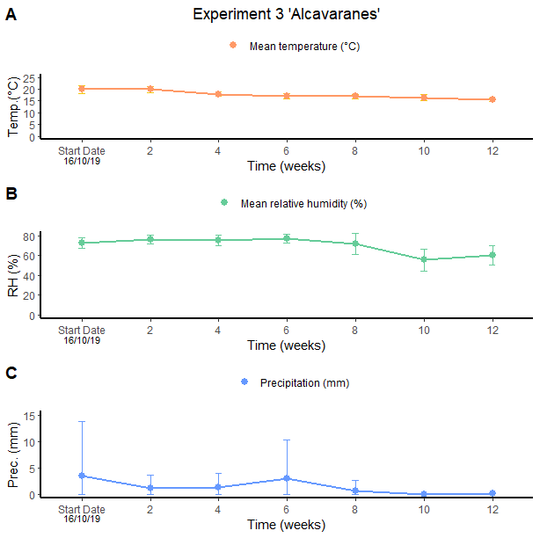
Figure S12. Meteorological data collected from El Drago for Experiment 3. A) Temperature (weekly mean temperature):Spearman’s test, ρ=-0.81, p-value<0.0001, there is a correlation between the time, going into autumn/winter, and a decrease in the temperature. B) Relative humidity (weekly mean relative humidity):Spearman’s test, ρ=-0.47, p-value<0.0001, there is a reduction in the relative humidity in the second half of the experiment. C) Precipitation (weekly mean precipitation):Spearman’s test, ρ=-0.25, p-value=0.009, there are several weeks of rains, above all in the first half of the experiment. Columns represent BWs trapped every monitoring time. Error bars = SEM.

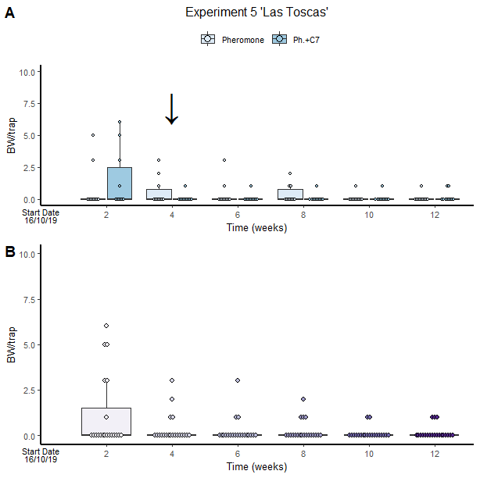
Figure S13. Cosmopolites sordidus captures per treatment with time in the Experiment 5. A) Differences in the treatment in each monitoring time. B) Differences on banana captures in each monitoring time. Columns represent BWs trapped every monitoring time. Error bars = SEM. Arrows indicate dates of fungal VOC dispensers’ replacement. No significant differences were found.

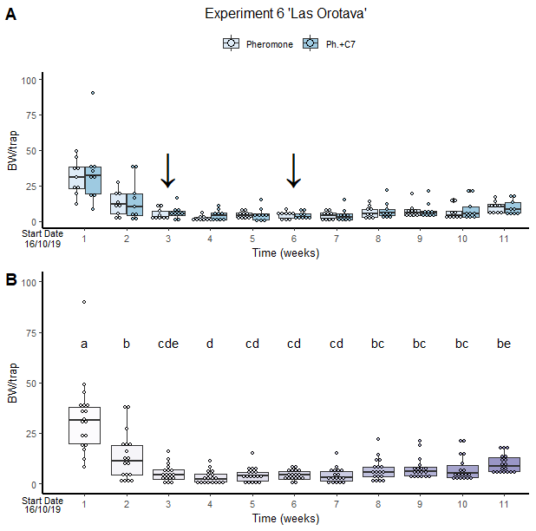
Figure S14. Cosmopolites sordidus captures per treatment with time in the Experiment 6. A) Differences in the treatment in each monitoring time. B) Date represent differences in BW captures in each monitoring time. Columns represent BWs trapped every monitoring time. Error bars = SEM. Arrows indicate dates of fungal VOC dispensers’ replacement. Letters indicate differences between times (emmeans analysis).
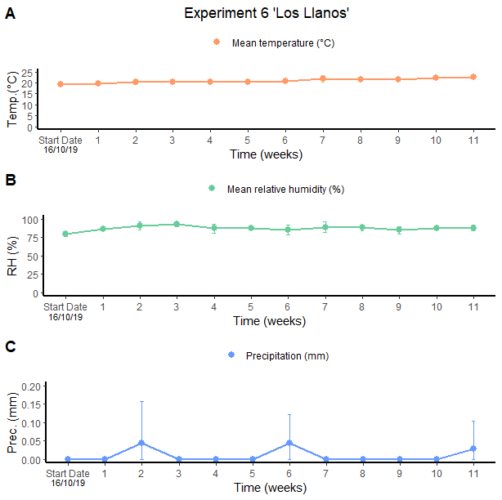
Figure S15. Meteorological data collected from La Orotava for Experiment 6. A) Temperature (weekly mean temperature):Spearman’s test, ρ=0.85, p-value<0.0001, there is a correlation between the time, going into summer, and a light increase in the temperature. B) Relative humidity (weekly mean relative humidity): Spearman’s test, cor=0.07, p.-value=0.49, there is no a significant correlation. C) Precipitation (weekly mean precipitation): Spearman’s test, ρ=0.04, p-value=0.67, despite there is no significant correlation, there are two weeks of rain along the experiment. Columns represent BWs trapped every monitoring time. Error bars = SEM. For starting date see Table 1.
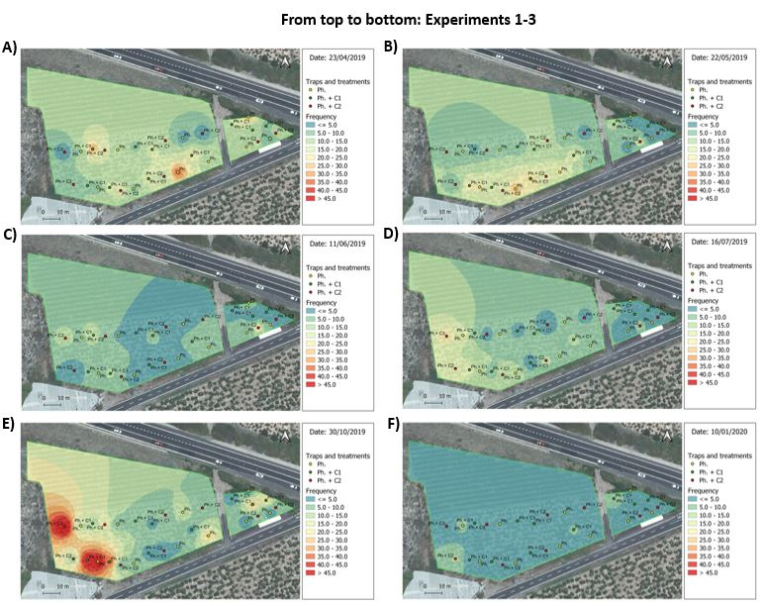
Figure S16. Spatial distribution of Cosmopolites sordidus adults. Weekly captures from the first (left) and the last (right) monitoring times in banana fields shown by surface maps constructed based on the Inverse Distance Weight (IDW) interpolation. A-B) Experiment 1. C-D) expetiment 2 and E-F) experiment 3. All experiments were performed in“Alcaravanes”. Field divided into two adjacent areas of 3407.29m² and 530.88m², each one. Green points = location of pheromone traps in the field; Yellow points = location of traps with pheromone and VOC C2 in the field; Red points = location of traps with pheromone and VOC C1 in the field. Low density = blue colors; High density = red colors.
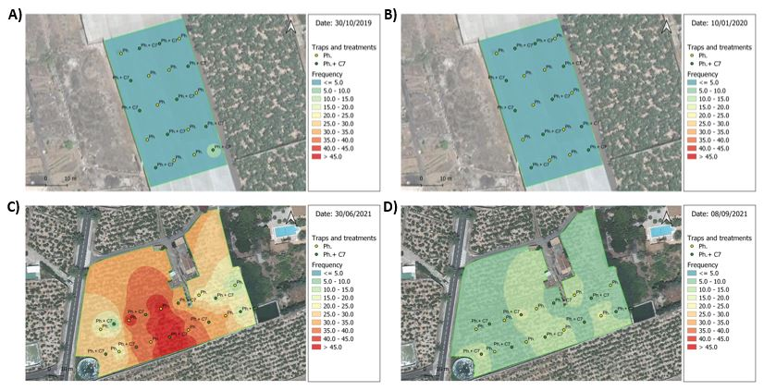
Figure S17. Spatial distribution of Cosmopolites sordidus adults. Weekly captures from the first (left) and the last (right) monitoring times in banana fields shown by surface maps constructed based on the Inverse Distance Weight (IDW) interpolation. A, B) Experiment 5 “Las Toscas”. Greenhouse plantation (field covered with a film) with an area of 2404.22m². Yellow points = location of pheromone traps in the field; Blue points = location of traps with pheromone and repellent C7 in the field. C, D) Experiment 6 “Los Llanos”. Field with an area of 4417.9m². Yellow points = location of pheromone traps in the field; Green points = location of traps with pheromone and repellent C7 in the field. Low density = blue colors; High density = red colors.
Figure S18. Spatial distribution of Cosmopolites sordidus adults (weekly captures; each picture represents a different sampling time) in banana fields shown by surface maps constructed based on the Inverse Distance Weight (IDW) interpolation. Top: Experiment 4 “Las Toscas”. Open-air field with an area of 3102.9 m². Yellow points = location of pheromone traps in the field; Green points = location of traps with pheromone and VOC C5 in the field. Bottom: Experiment 7 “Los Llanos”. Five adjacent fields with an area of 9444.4 m2. Yellow points = location of pheromone traps in the field; Green points = location of traps with pheromone and VOC C5 in the field; Orange points = location of C5 traps in the field; Blue points = location of empty traps in the field. Low density = blue colors; High density = red colors.
Figure S19. Spatial distribution of Cosmopolites sordidus adults (weekly captures; each picture represents a different sampling time) in banana fields shown by surface maps constructed based on the Inverse Distance Weight (IDW) interpolation. From top to bottom: Experiments 1-3 “Alcaravanes”. Field divided into two adjacent areas of 3407.29m² and 530.88m², each one. Green points = location of pheromone traps in the field; Yellow points = location of traps with pheromone and VOC C2 in the field; Red points = location of traps with pheromone and VOC C1 in the field. Low density = blue colors; High density = red colors.
Figure S20. Spatial distribution of Cosmopolites sordidus adults (weekly captures; each picture represents a different sampling time) in banana fields shown by surface maps constructed based on the Inverse Distance Weight (IDW) interpolation. Top: Experiment 5 “Las Toscas”. Greenhouse plantation (field covered with a film) with an area of 2404.22m². Yellow points = location of pheromone traps in the field; Blue points = location of traps with pheromone and repellent C7 in the field. Bottom: Experiment 6 “Los Llanos”. Field with an area of 4417.9m². Yellow points = location of pheromone traps in the field; Green points = location of traps with pheromone and repellent C7 in the field. Low density = blue colors; High density = red colors.

Table S3. ANOVA table showing the results for the different GLMM models. Trt: Treatments. Chisq: Chi squared statistic. Df: degree of freedom.

Factor | Chisq | Df | p.value
Experiment 1
Trt | 1.3982 | 2 | 0.497
Time | 4.5067 | 3 | 0.2117
Trtxtime | 4.1681 | 6 | 0.6539
Experiment 2
Trt | 1.2433 | 2 | 0.537
Time | 21.2286 | 5 | 0.0007***
Trtxtime | 3.7743 | 10 | 0.9569
Experiment 3
Trt | 0.3958 | 2 | 0.8204
Time | 54.5638 | 5 | 1.6*10⁻¹⁰***
Trtxtime | 10.7381 | 10 | 0.3783
Experiment 4
Trt | 12.3008 | 1 | 0.0004***
Time | 18.7085 | 5 | 0.0021***
Trtxtime | 4.0741 | 5 | 0.5387
Experiment 5
Trt | 0.2177 | 1 | 0.6407
Time | 13.6655 | 5 | 0.0178
Trtxtime | 6.1346 | 5 | 0.2933
Experiment 6
Trt | 1.3279 | 1 | 0.2492
Time | 220.8929 | 10 | <2*10⁻¹⁶***
Trtxtime | 3.6869 | 10 | 0.9604
Experiment 7
Trt | 611.76 | 3 | <2*10⁻¹⁶***
Time | 127.22 | 8 | <2*10⁻¹⁶***
Trtxtime | 47.87 | 24 | 0.0026**

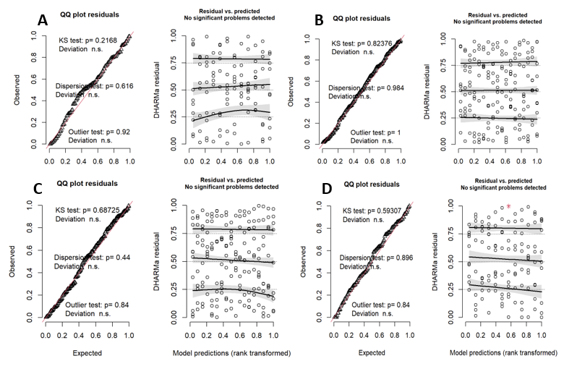
Diagram S1. Diagnostic plots of A) Experiment 1, B) Experiment 2, C) Experiment 3, and D) Experiment 4 glmm models. DHARMa package R software.

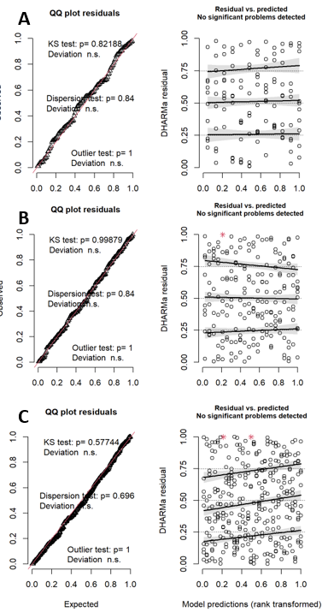
Diagram S2. Diagnostic plots of A) Experiment 5, B) Experiment 6, and C) Experiment 7 glmm models. DHARMa package R software.

