Supplementary Table 1 Primers information
Primers | Primer sequence (5'→3')
ITS1 | TCCGTAGGTGAACCTGCGG
ITS4 | TCCTCCGCTTATTGATATGC

Supplementary Table 2 PCR reaction system
Fungal gDNA | 1 µL
ITS1 | 1 µL
ITS4 | 1 µL
Max PCR Master Mix(2×Premix) | 12.5 µL
ddH₂O | 9.5 µL
Total volume | 25 µL

Supplementary Table 3 PCR reaction condition
Phase | Cycle index | Temperature | Time
Predegeneration | 1× | 95℃ | 5 min
Reaction | 30× | 95℃ | 30 s
 |  | 60℃ | 40 s
 |  | 72℃ | 50 s
Supplementary extension | 1× | 72℃ | 10 min
Preserve |  | 12℃ | ∞

Supplementary Table 4 Endophytic fungi isolated from different organs of C. blinii.
Plant organ | Endopyte fungi number | Total
Root | CBF1, CBF2, CBF5, CBF7, CBF12, CBF13, CBF15, CBF18 | 8
Stem | CBF3, CBF4, CBF6, CBF9, CBF10, CBF14, CBF17 | 7
Leaf | CBF8, CBF11, CBF16, CBF19, CBF20 | 5

Supplementary Table 5 The homologous strain of endophyte fungi from C. blinii.
Endopyte fungi | Most closely related strain | Ident(%) | Accession
CBF1 | Epicoccum thailandicum | 98.98% | NR_152926.1
CBF2 | Epicoccum viticis | 99.57% | NR_158267.1
CBF3 | Pseudohumicola lutea | 97.85% | NR_189397.1
CBF4 | Fusarium hechiense | 98.84% | NR_182846.1
CBF5 | Fusarium pseudoanthophilum | 97.82% | NR_163682.1
CBF6 | Fusarium bactridioides | 98.18% | NR_120262.1
CBF7 | Fusarium torreyae | 93.71% | NR_172378.1
CBF8 | Fusarium hechiense | 97.74% | NR_182846.1
CBF9 | Fusarium foetens | 99.59% | NR_159865.1
CBF10 | Fusarium circinatum | 96.02% | NR_120263.1
CBF11 | Paracremonium apiculatum | 99.60% | NR_172839.1
CBF12 | Epicoccum djirangnandiri | 99.55% | NR_173179.1
CBF13 | Trametes ellipsoidea | 90.66% | NR_171793.1
CBF14 | Humicola olivacea | 97.25% | NR_147677.1
CBF15 | Cosmospora lavitskiae | 99.40% | NR_182322.1
CBF16 | Paracremonium ellipsoideum | 99.41% | NR_172840.1
CBF17 | Epicoccum catenisporum | 99.16% | NR_158229.1
CBF18 | Fusarium panlongense | 98.46% | NR_182847.1
CBF19 | Fusarium inflexum | 98.75% | NR_120262.1
CBF20 | Fusarium acutatum | 99.21% | NR_111142.1

Supplementary Table 6 Chromatographic conditions.
Chromatographic conditions
Chromatographic column | Waters ACQUITY UPLC HSS T3 Column 1.8 µm, 2.1 mm * 100 mm
Mobile phase A | Water containing 0.05% formic acid
Mobile phase B | Acetonitrile containing 0.05% formic acid
Column temperature | 40℃
Flow rate | 0.3 mL/min
Injection volume | 4 μL

Supplementary Table 7 Gradient conditions for the mobile phase in the chromatography column.
Time(min) | A(%) | B(%)
0 | 95 | 5
5 | 95 | 5
13.5 | 5 | 95
16 | 95 | 5

Supplementary Table 8 Mass spectrometry conditions.
MS conditions. | ESI+ | ESI-
Duration (min) | 10 | 10
IonSpray Voltage (V) | 5000 | -4000
Temperature (°C) | 550 | 550
Ion Source Gas1 (psi) | 50 | 50
Ion Source Gas2 (psi) | 60 | 60
Curtain Gas (psi) | 35 | 35
Declustering Potential (V) | 60 | -60
MS1 Collision Energy (V) | 10 | -10
MS2 Collision Energy (V) | 30 | -30
Collision Energy Spread (V) | 15 | 15
MS1 TOF Masses (Da) | 50~1250 | 50~1250
MS2 TOF Masses (Da) | 25~1250 | 25~1250

Supplementary Figure 1 The colony morphology of endophytic fungi isolated from Conyza blini.

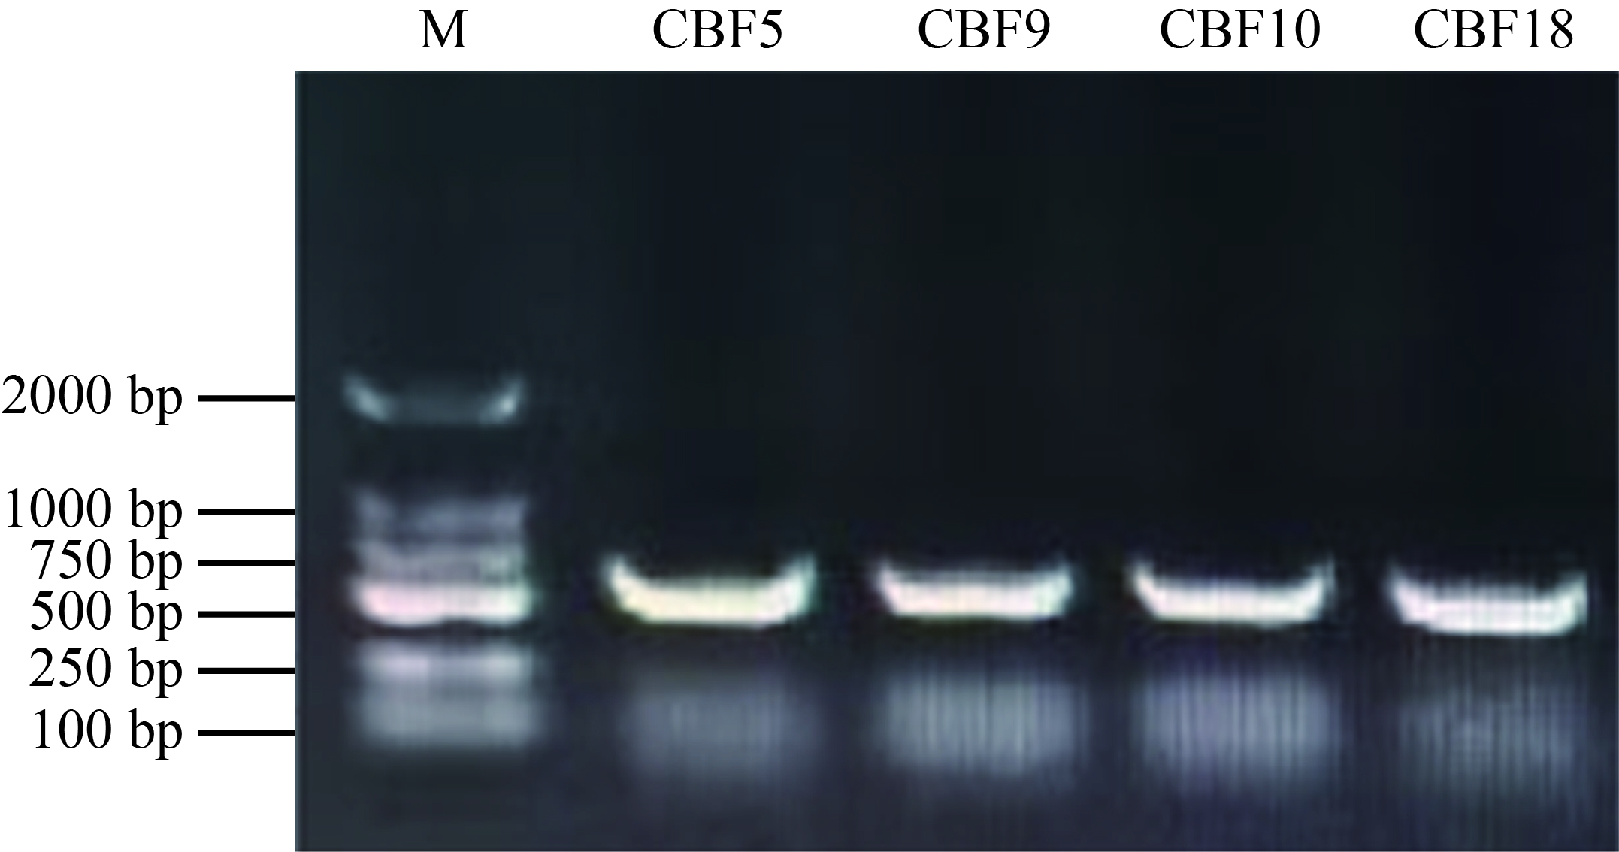
Supplementary Figure 2 Agarose gel electrophoresis of fungal ITS sequences.
（M: Maker D2000）

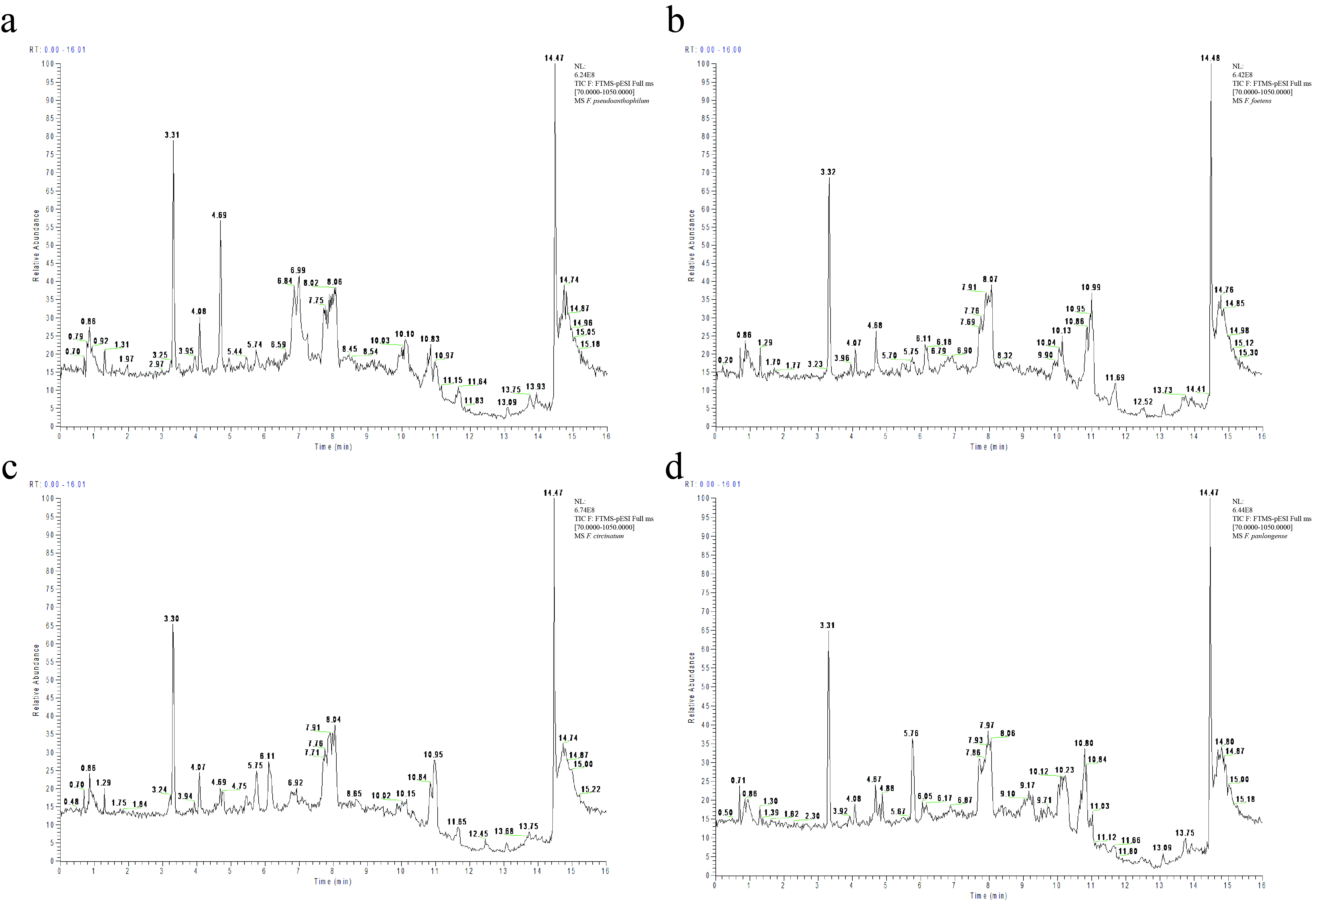
Supplementary Figure 3 LC/MS chromatogram of fungal extracts. a: LC/MS chromatogram of F. pseudoanthophilum extracts; b: LC/MS chromatogram of F. foetens extracts; c: LC/MS chromatogram of F. circinatum extracts. d: LC/MS chromatogram of F. panlongense extracts.

