sFigure 2. Forest plots of asprin treatment vs. non-asprin treatment for the bleeding (A: major bleeding; B: minor bleeding). CI = confidence intervals; M-H = Mantel-Haenszel; IV= inverse variance
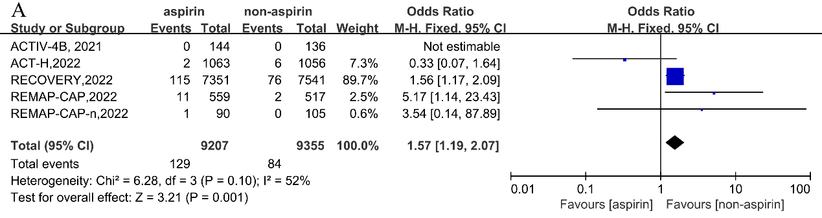
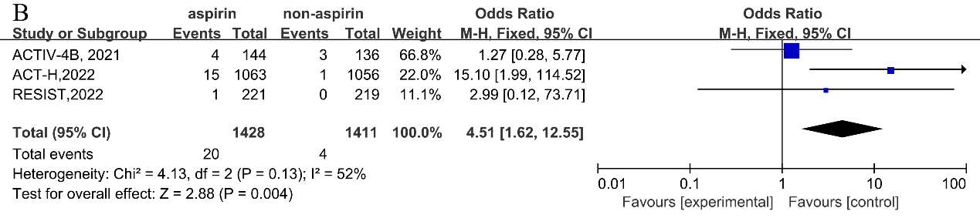

sFigure 3. Forest plots of asprin treatment vs. non-asprin treatment for outcomes (A: deep venous thrombosis; B: pulmonary embolism; C: stroke; D: myocardial infarction). CI= confidence intervals; M-H= Mantel-Haenszel; IV= inverse variance
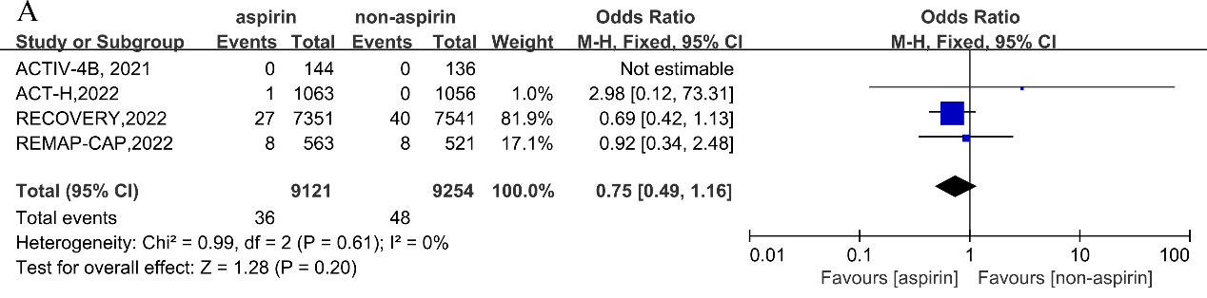
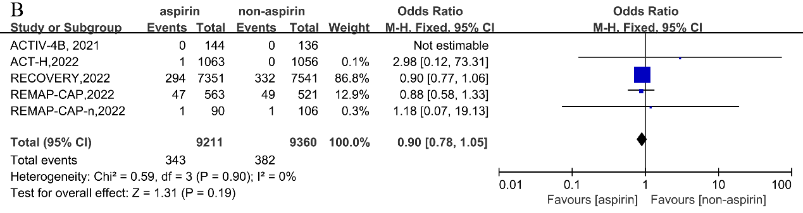
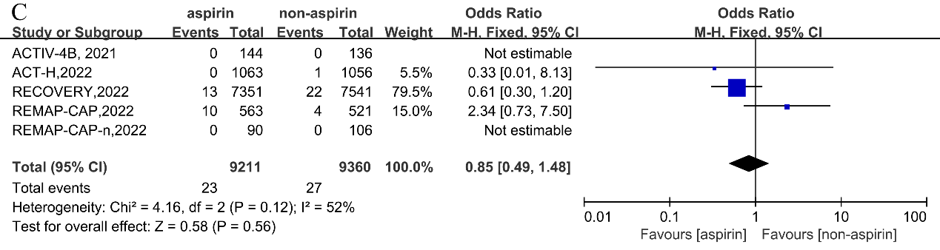
D
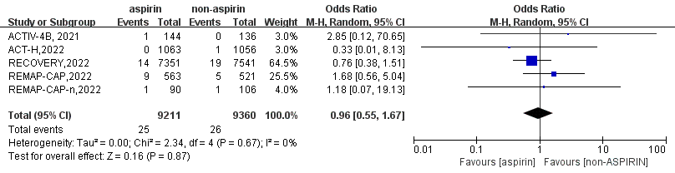

sFigure 4. Forest plots of asprin treatment vs. non-asprin treatment for being discharged alive. CI= confidence intervals; M-H= Mantel-Haenszel; IV= inverse variance
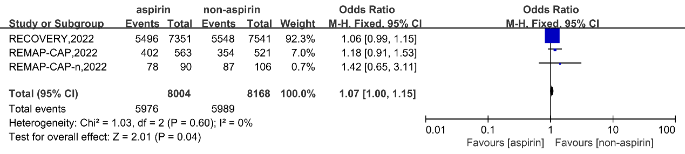
sFigure 5. Forest plots of asprin treatment vs. non-asprin treatment for acute kidney injury. CI= confidence intervals; M-H= Mantel-Haenszel; IV= inverse variance
