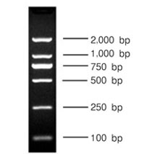

Note: The sample size for loading PCR products is 3 μL. The marker used is DL2000, the sample volume is 3 μL, and CK serves as the negative control.

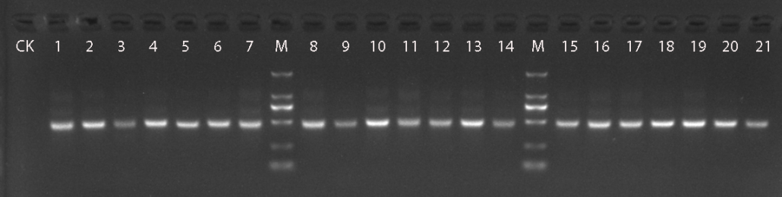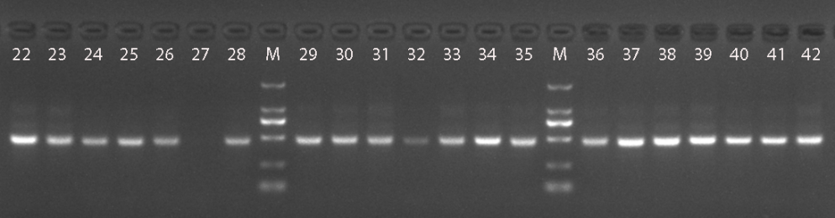

Note: Samples 2 through 20 and 22 are included in our study.

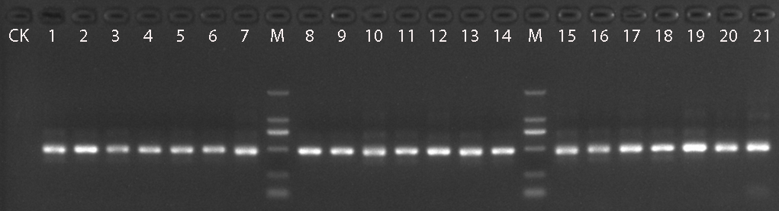

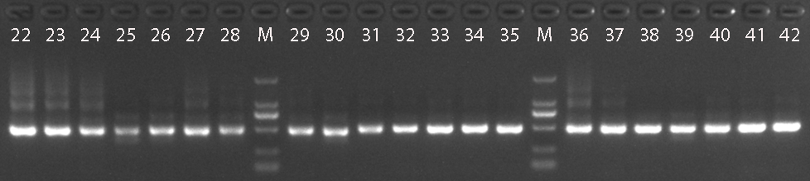

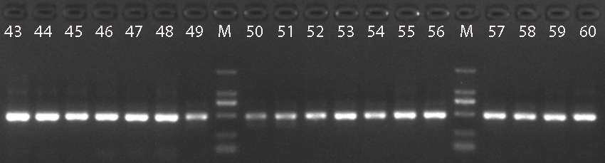

Note: Samples 3, 6, 10, 11, 12, 13, 14, 16, 17, 19, 33, 42, 44, 46, 47, 48, 49, 50, 51, and 52 are included in our study.