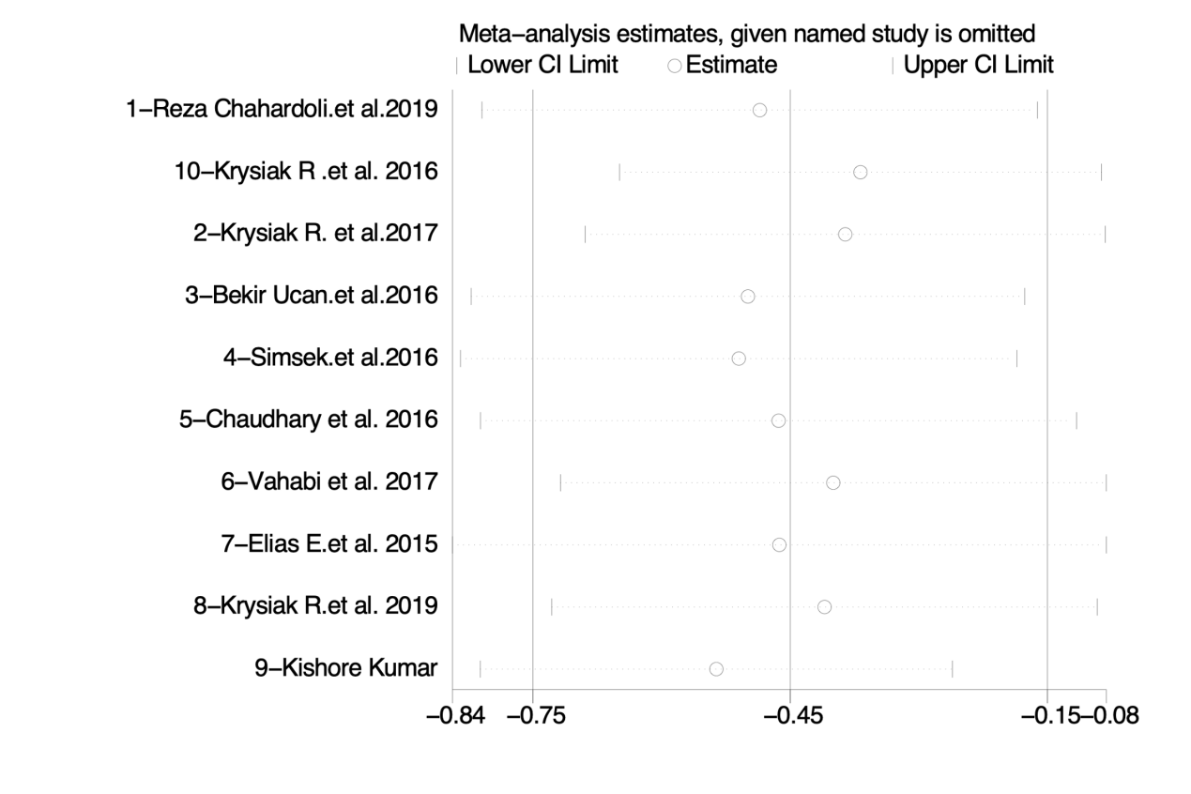

Fig 1 Sensitivity testing of Anti-thyroid peroxidase antibodies based on the whole 10 prospective studies severity score.

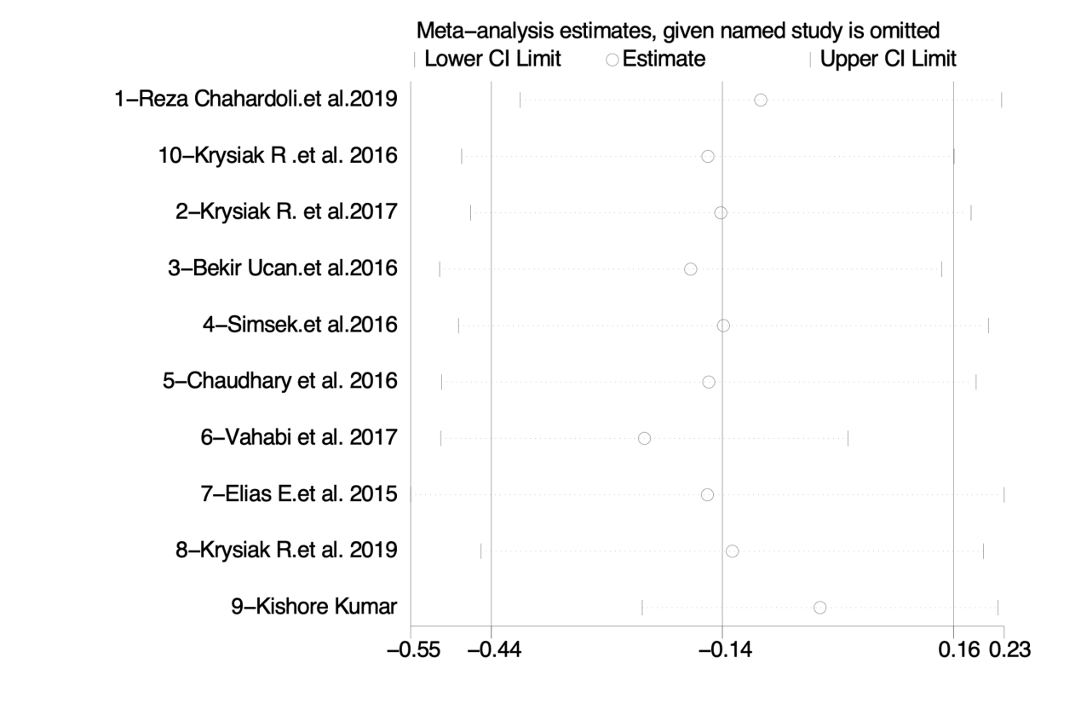

Fig 2  Sensitivity testing of thyroid-stimulating hormone levels based on the whole 10 prospective studies severity score.

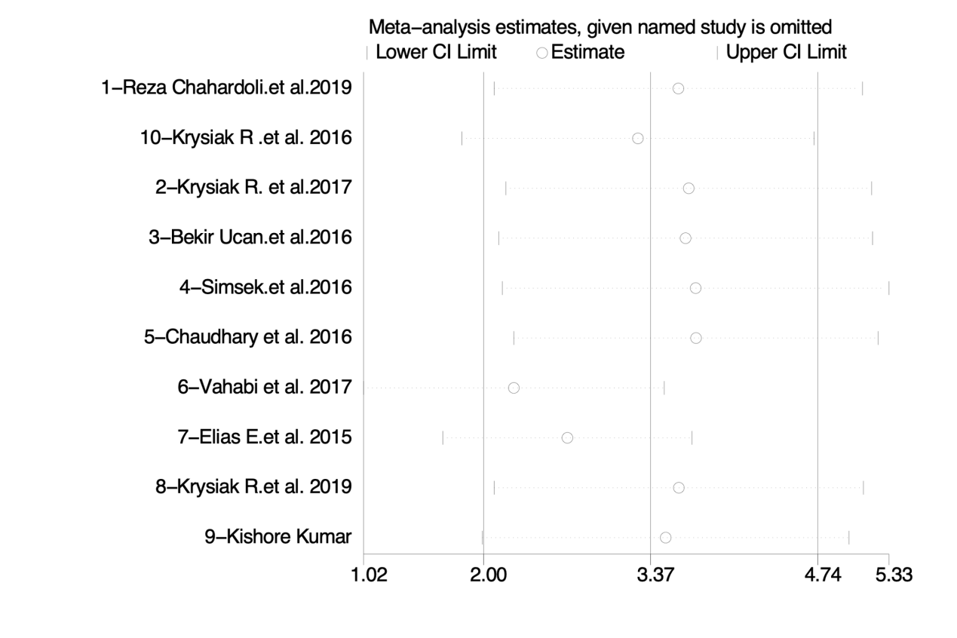

Fig 3 Sensitivity testing of 25(OH)D levels based on the whole 10 prospective studies severity score.

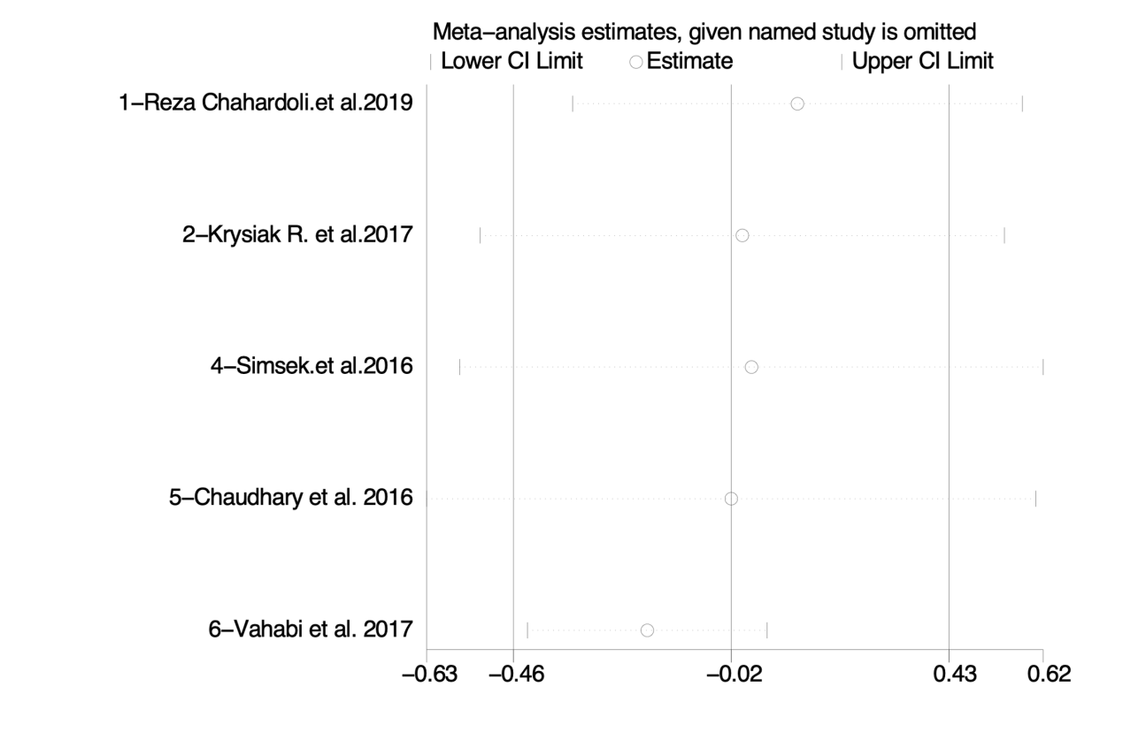

Fig 4 Sensitivity testing of thyroid-stimulating hormone levels based on the 5 randomized controlled trials severity score.

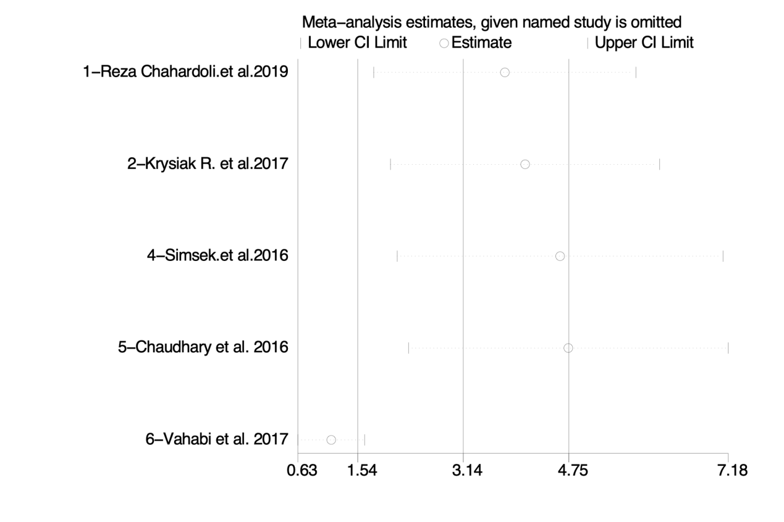Fig 5 Sensitivity testing of 25(OH)D levels based on the 5 randomized controlled trials severity score.

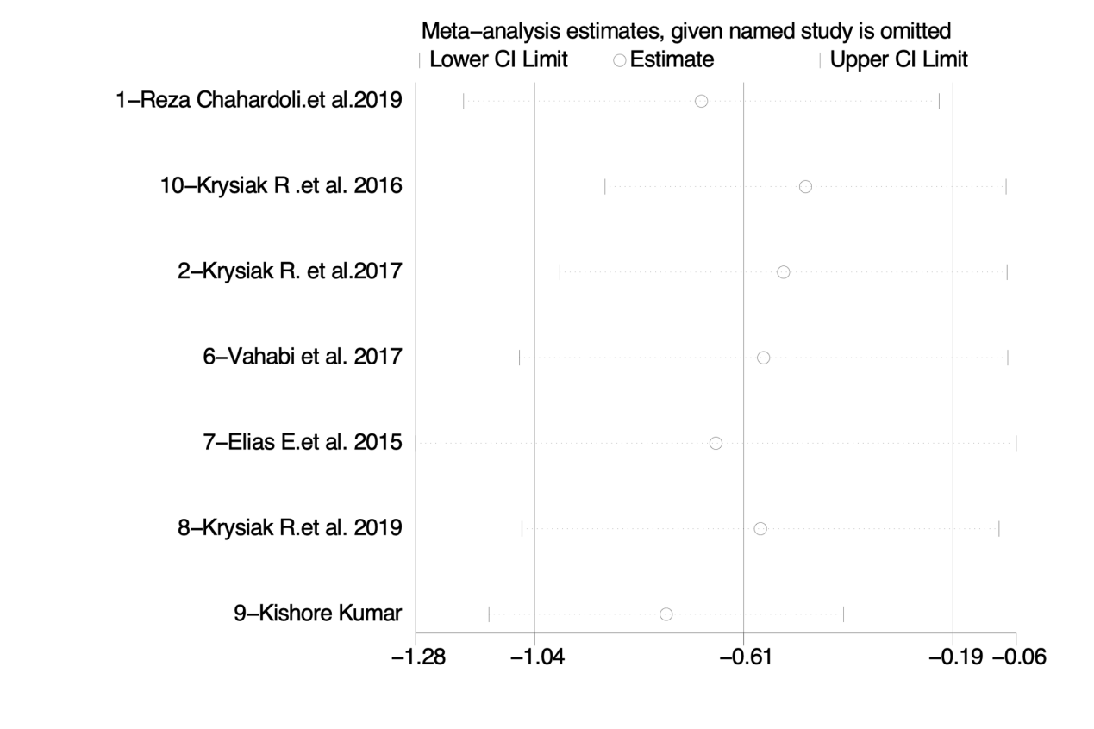

Fig 6 Sensitivity testing of Anti-thyroid peroxidase antibodies in the 10 prospective studies classified by the duration time of VitD supplementation ≥3 months severity score.

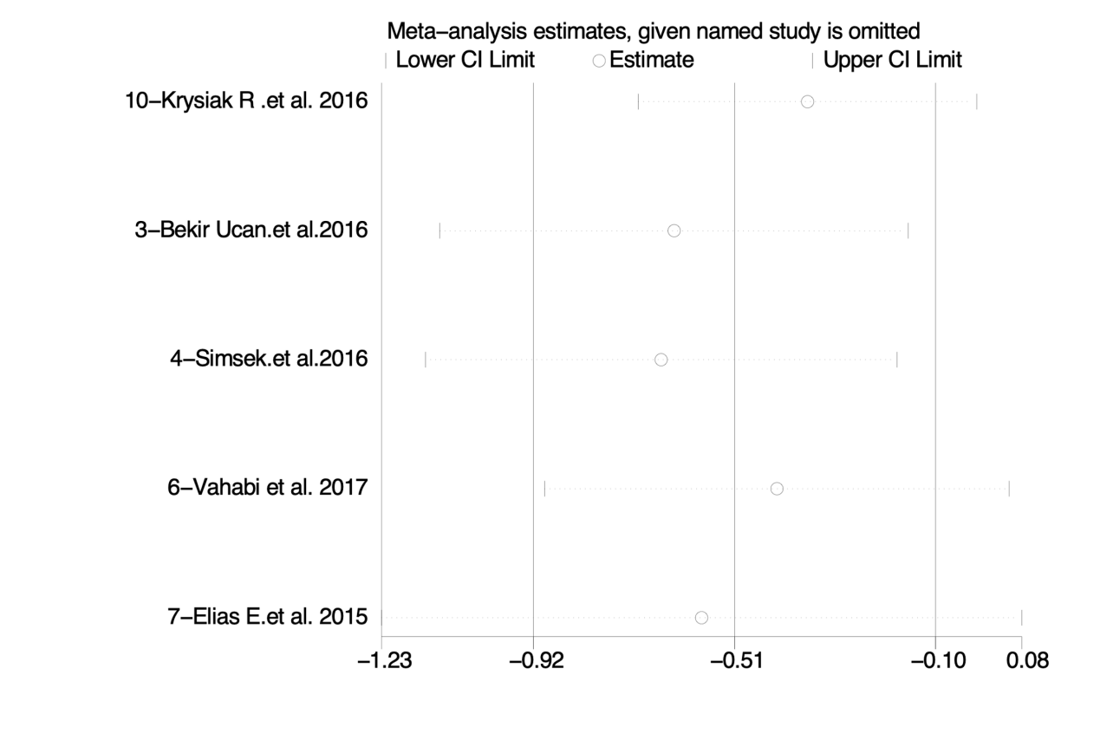

Fig 7 Sensitivity testing of anti-thyroglobulin antibody in the 10 prospective studies classified by initial serum 25(OH)D < 30ng/ml severity score.

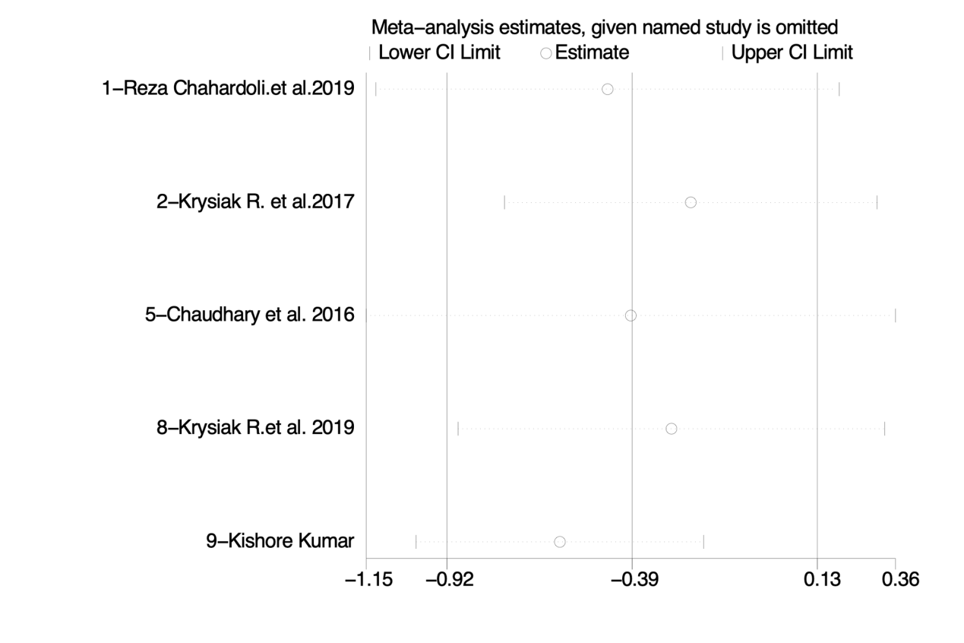

Fig 8 Sensitivity testing of anti-thyroglobulin antibody in the 10 prospective studies classified by without initial VitD status considered severity score.

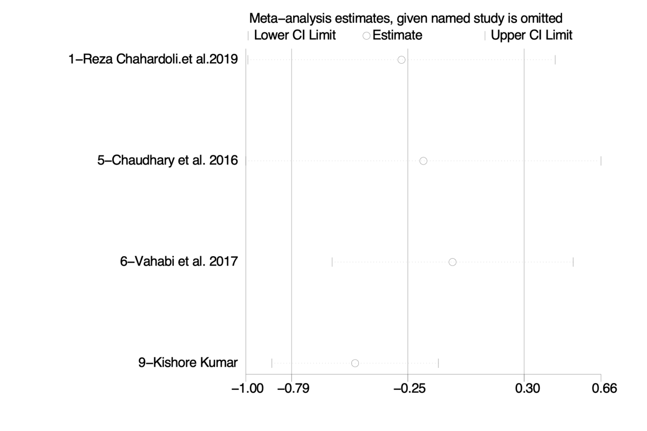

Fig 9 Sensitivity testing of anti-thyroid peroxidase antibody in AITD patients with weekly VitD supplementation severity score.

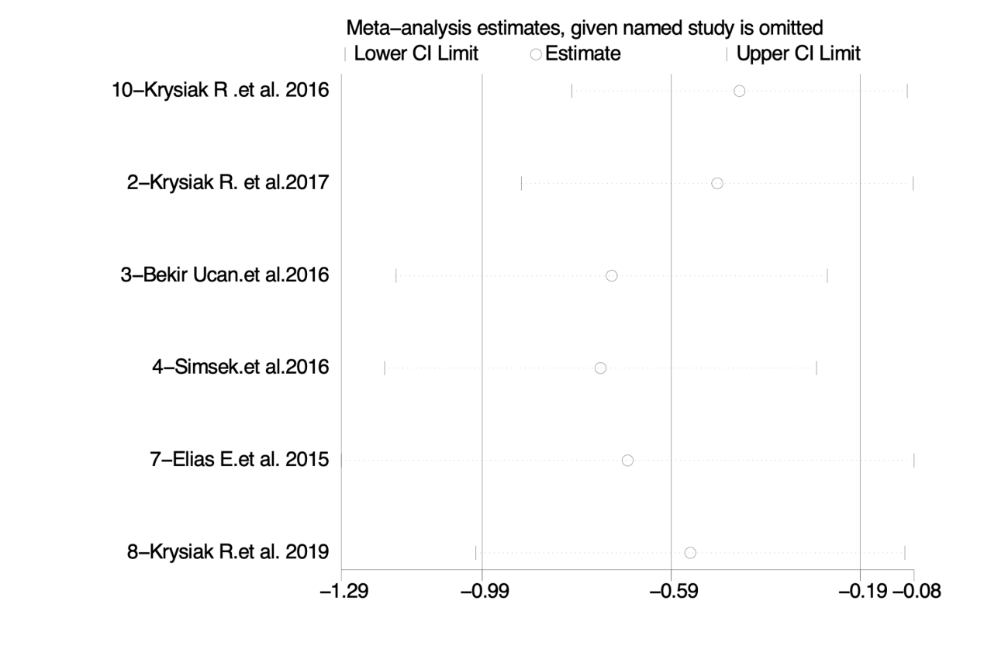

Fig 10 Sensitivity testing of anti-thyroid peroxidase antibody in AITD patients with daily VitD supplementation severity score.