Supporting Information for
Comparative gene expression analysis of Beauveria bassiana with or without host insect
Introduction
The supplementary information below includes the primers that were designed for RT-qPCR in this experiment. These primers are listed in Table S1. Additionally, the estimated LC₅₀ value for mortality in S. frugiperda is shown in Fig. S1.

Table S1 The primer used in our study

symbol | Annotation | Forward primer (5′-3′) | Reverse primer (5′-3′)
MFS2 | Siderophore iron transporter mirB | TCATGGACCGCACAGTCTTC | CCAGGTCACTTGATCGGCTT
STL1 | Sugar transporter STL1 | CTTCATTCTCGCGTTCGTGC | AGCGATGGCTGCGATAACAA
chi2 | Chitinase III | CGCAAAACGTCGTGTACTGG | GGGGATGTTGTTGTTGTCGC
CTF1-BETA | cutinase transcription factor | TAACACCGTCAACCCCAACC | CGTCAAGGCACCCTTCATCT
SLD | Fatty acid desaturase | CCCTCCTTGGCTGGACTTTG | CTTCTGCGCCTTTCGGAGAT
oca3 | tetratricopeptide-like protein | AAGCTGGCAGAGATTGTGCG | ACTTGGAAAGGAGCTCTCGC
K0381 | Catalase | CGTCTGCCCCATGATGAACT | CGAGACGTGCTCCTTGAACT
MGG-080 | metalloprotease-like protein | CGAGTTTTGCAAGACGGAGC | TTCGCCCTTGGCAATCTTGT
RV15333 | 2-nitropropane dioxygenase | GCGGTCTCGGTGTTATTGGT | AAAGGAGCCTTCTTGTCGTCG
K13524 | Amino butyrate aminotransferase | CTGTTTGGCTCCCTGTCCAC | GGTACTTGAGCTGCGGGAAG
Arc2 | β-actin | GCCTGATGGGCAAGTCAT | TGGGAGCAAGAGCAGTG

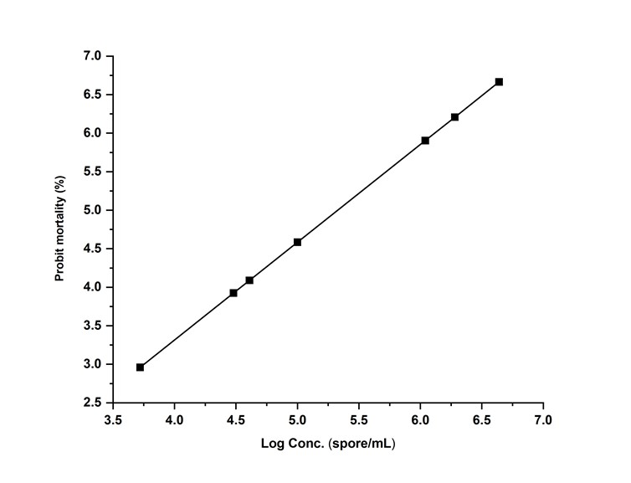
Fig. S1. Toxicity profile of B. bassiana CDL1 against FAW treated in the third larval instar.

