Supplementary Material

# Supplementary table 1. The target genes and their primer sets

|  |  |  |
| --- | --- | --- |
| Gene | Forward Primer | Reverse Primer |
| PCK1 | GGAAGCCTGGACAGCCTACC | TCCTCAGAGCCGTCACAGATG |
| GAPDH | CATGTTCGTCATGGGGTGAACCA | AGTGATGGCATGGACTGTGGTCAT |

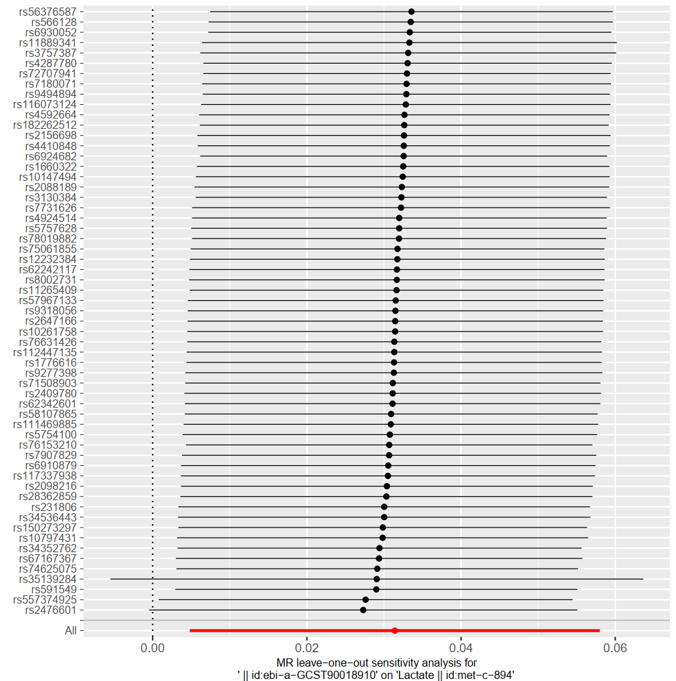**Supplementary Fig.S1.** **Leave-one-out analysis of RA**

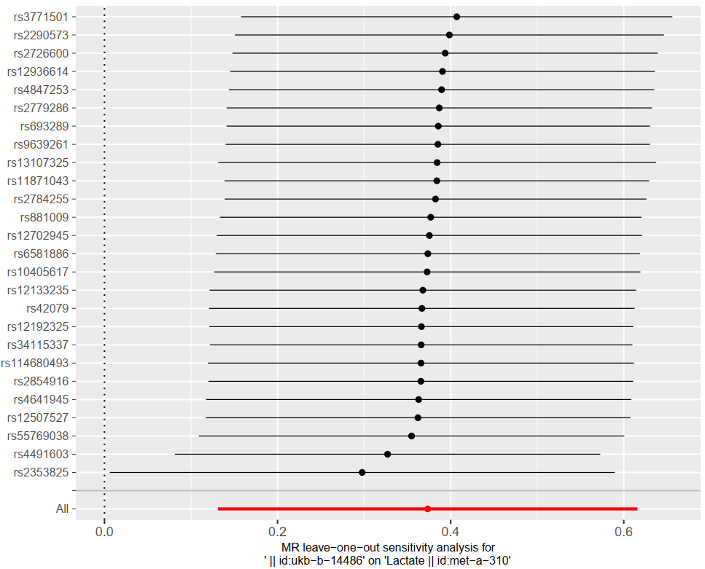**Supplementary Fig.S2.** **Leave-one-out analysis of OA**