**Supplementary material 3 for:**

An unusual early-diverging plesiosauroid from the Lower Jurassic Posidonia Shale of Holzmaden, Germany

Sven Sachs and Daniel Madzia

**Figure S1.** Parsimony analysis using equal weights. Strict consensus tree. Numbers on nodes show Bremer support values.

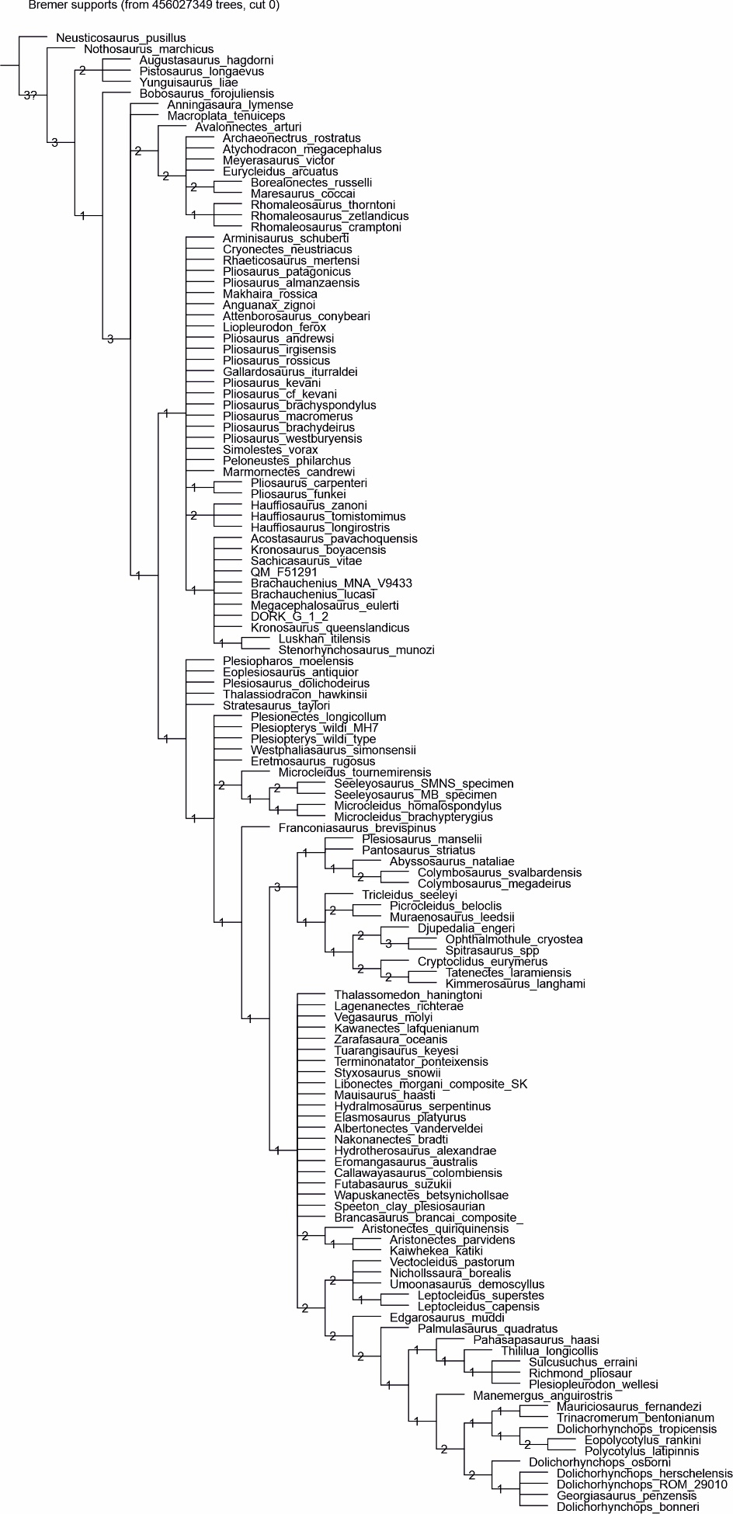

**Figure S2.** Parsimony analysis using equal weights. Majority rule consensus tree. Numbers on nodes show the percentage of the most parsimonious trees that found the nodes.

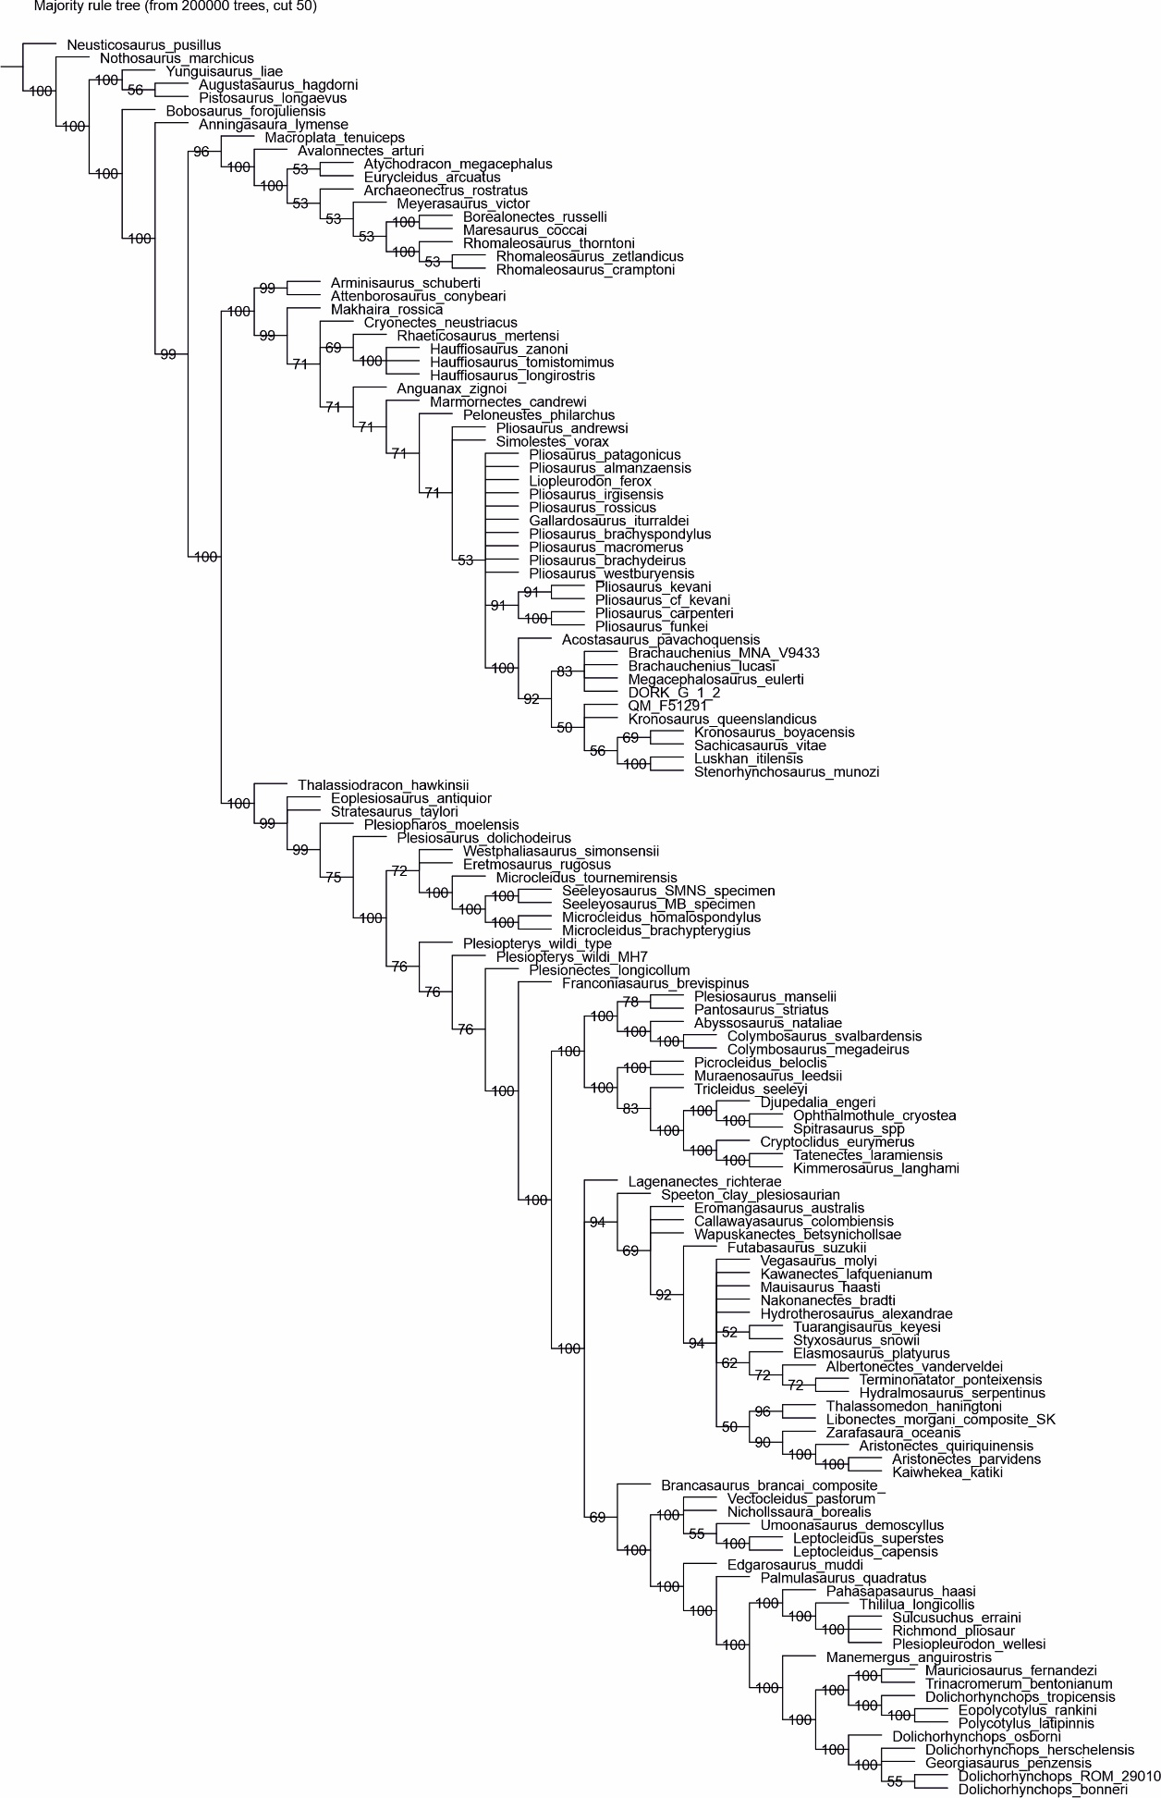

**Figure S3.** Parsimony analysis with implied weighting (*K* = 9). Strict consensus tree.

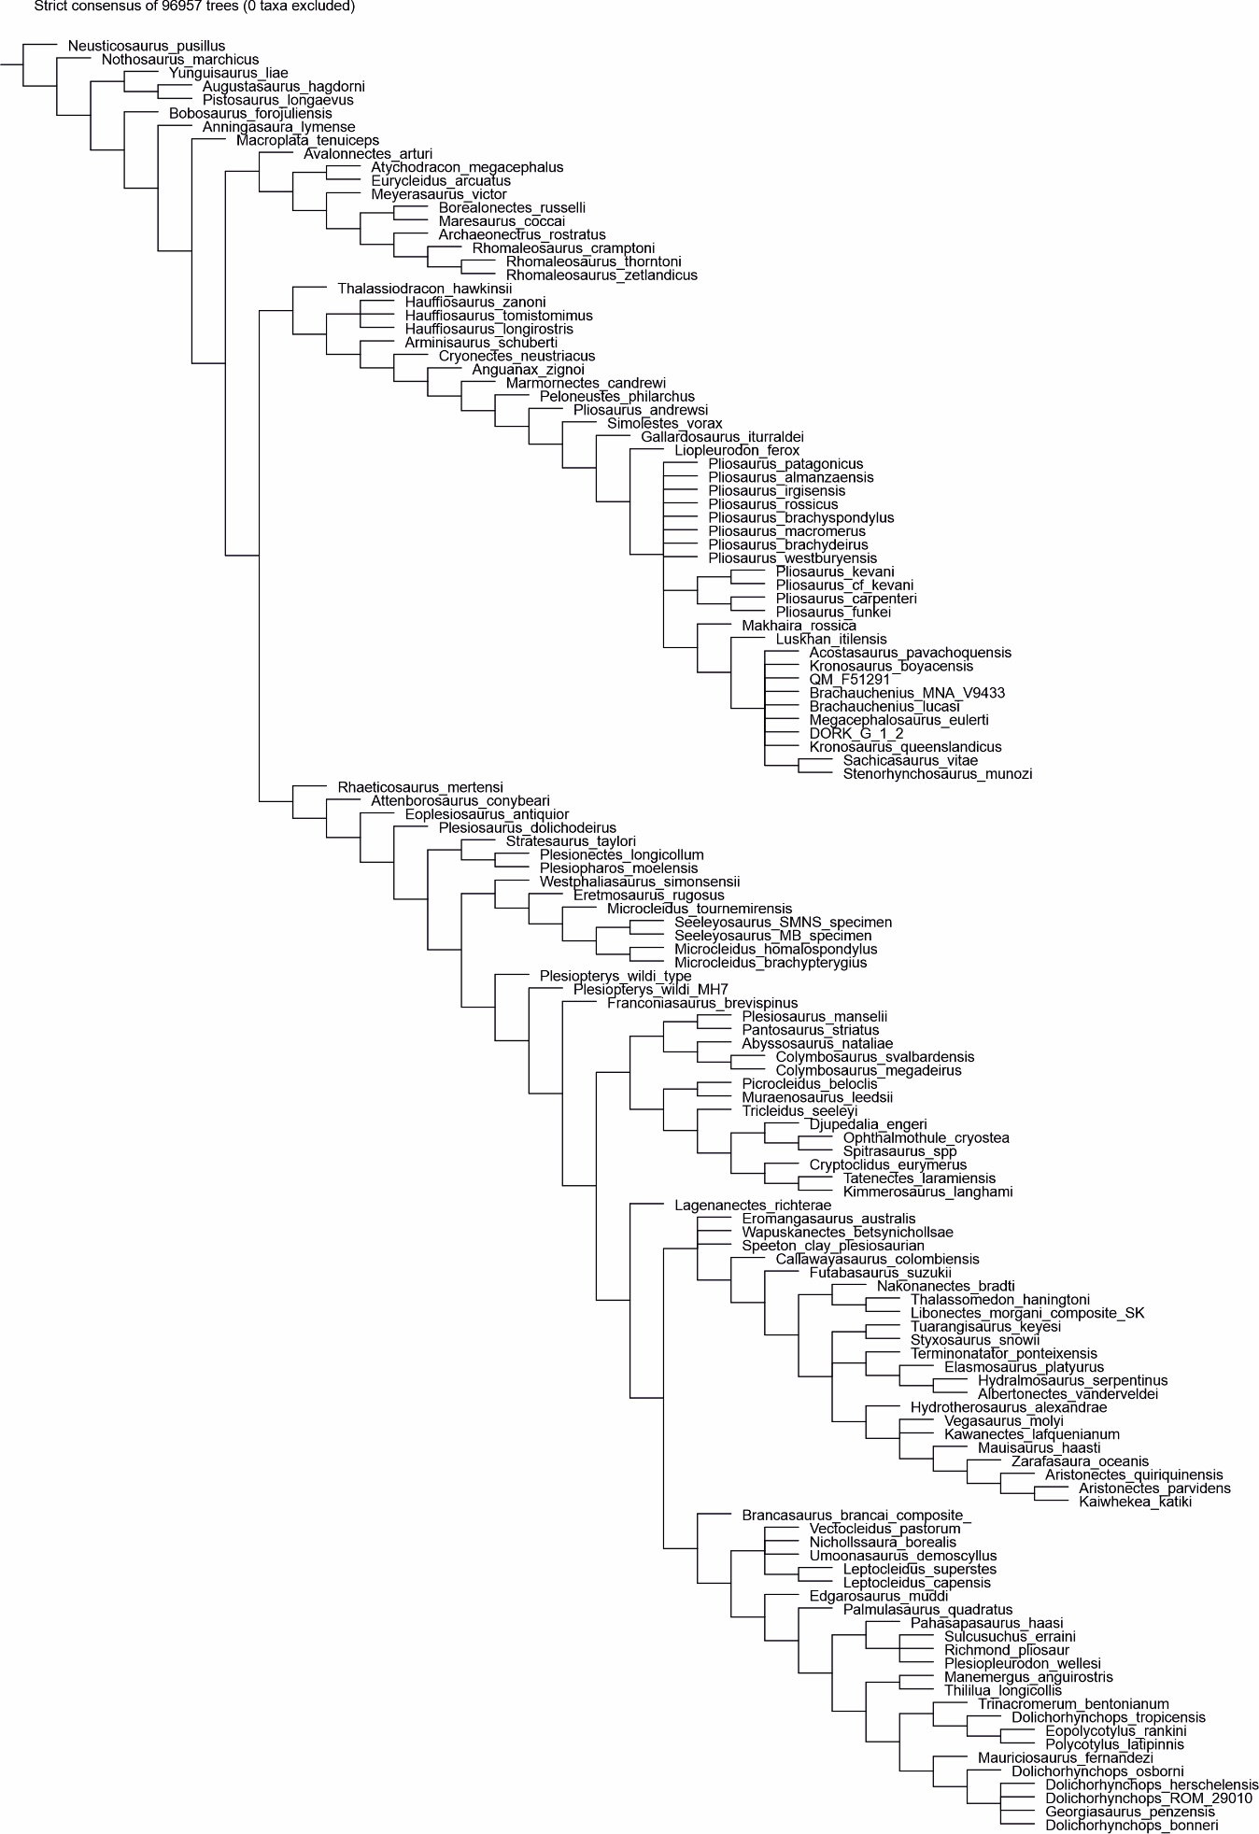

**Figure S4.** Parsimony analysis with implied weighting (*K* = 9). Symmetric Resampling.

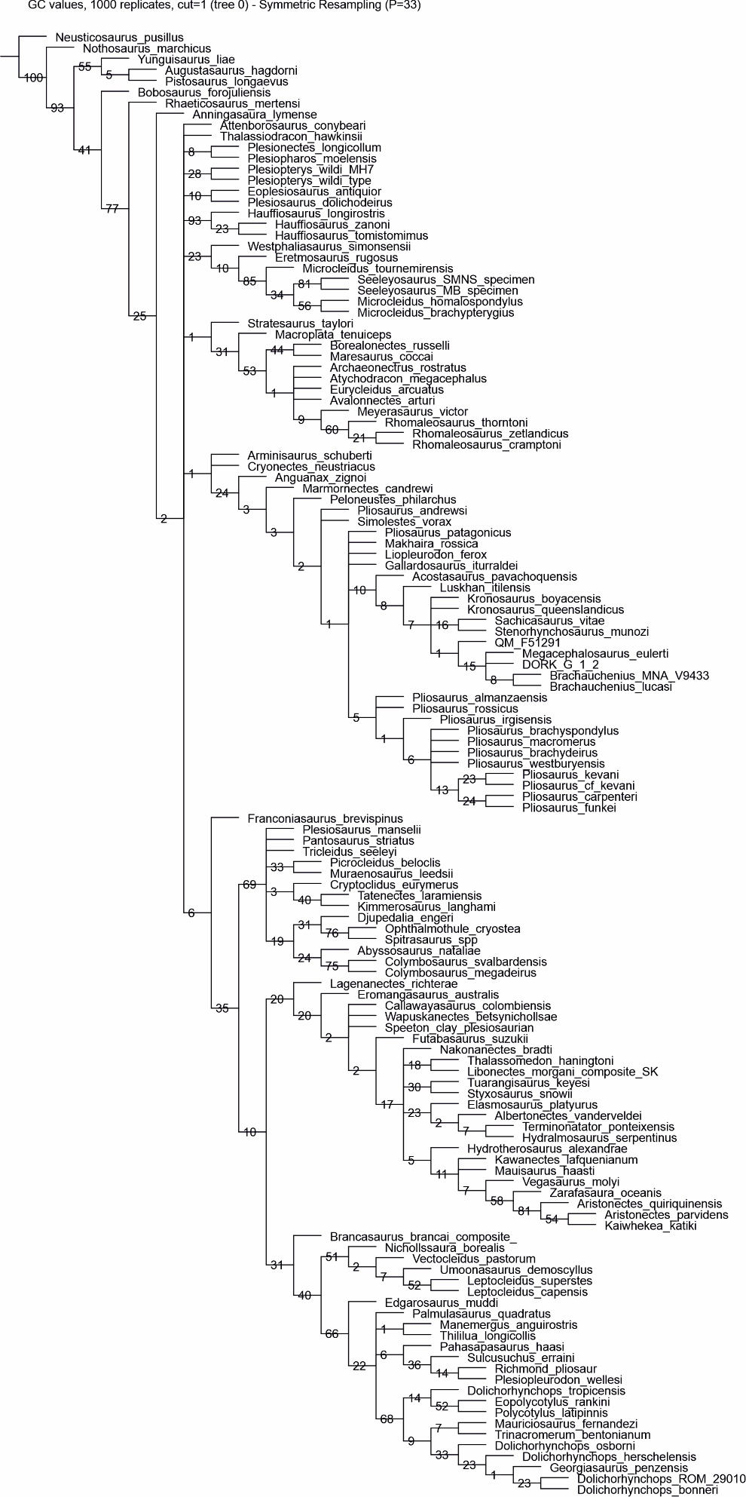

**Figure S5.** Parsimony analysis with implied weighting (*K* = 12). Strict consensus tree.

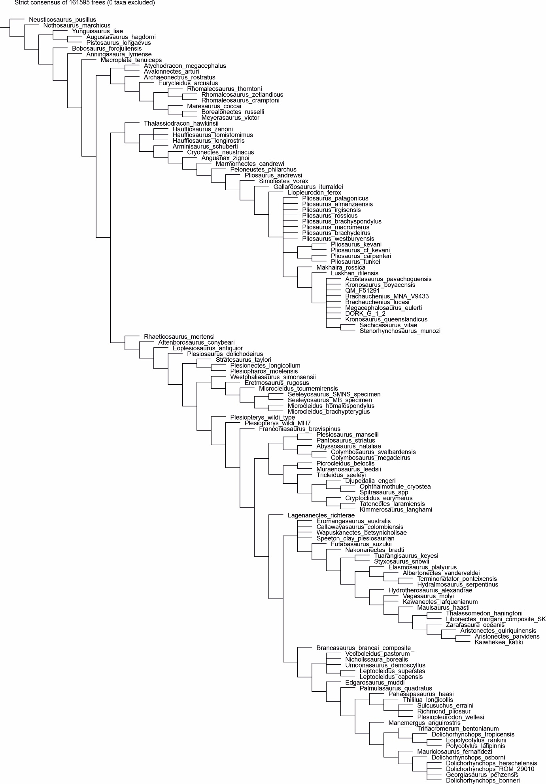

**Figure S6.** Parsimony analysis with implied weighting (*K* = 12). Symmetric Resampling.

