**Retrieval Timestamp：2025-04-13**

**PubMed（537publications）：**

(((((((((((((((((((((Mouth) OR (Cavitas Oris)) OR (Oral Cavity)) OR (Cavity, Oral)) OR (Vestibule of the Mouth)) OR (Vestibule Oris)) OR (Oral Cavity Proper)) OR (Cavitas oris propria)) OR (Mouth Cavity Proper)) OR (Esophagus)) OR ((Stomach) OR (Stomachs))) OR ((Duodenum) OR (Duodenums))) OR ((Jejunum) OR (Jejunums))) OR (Ileum)) OR (((((((Colon) OR (Appendix Epiploica)) OR (Omental Appendices)) OR (Appendices, Omental)) OR (Omental Appendix)) OR (Appendix, Omental)) OR (Taenia Coli))) OR ((Liver) OR (Livers))) OR (Pancreas)) OR ((((Bile Ducts) OR (Bile Duct)) OR (Duct, Bile)) OR (Ducts, Bile))) OR ((Gallbladder) OR (Gallbladders))) OR ((((((Biliary Tract) OR (Tract, Biliary)) OR (Biliary System)) OR (System, Biliary)) OR (Biliary Tree)) OR (Tree, Biliary))) AND (specimen) AND (((((((((((((((((Microbiota) OR (Microbiotas)) OR (Microbial Community)) OR (Community, Microbial)) OR (Microbial Communities)) OR (Microbial Community Composition)) OR (Community Composition, Microbial)) OR (Composition, Microbial Community)) OR (Microbial Community Compositions)) OR (Microbiome)) OR (Microbiomes)) OR (Human Microbiome)) OR (Human Microbiomes)) OR (Microbiome, Human)) OR (Microbial Community Structure)) OR (Community Structure, Microbial)) OR (Microbial Community Structures)))

**Scopus（256 publications）：**

( ALL ( mouth ) ) OR ( ALL ( esophagus ) ) OR ( ALL ( stomach ) ) OR ( ALL ( duodenum ) ) OR ( ALL ( jejunum ) ) AND ( ALL ( ileum ) ) OR ( ALL ( colon ) ) OR ( ALL ( liver ) ) OR ( ALL ( pancreas ) ) OR ( ALL ( gallbladder ) ) AND ( ALL ( bile AND ducts ) ) OR ( ALL ( biliary AND tract ) ) AND ( ALL ( microbiota ) ) AND ( ALL ( specimen ) )

Cochrane 64 publications

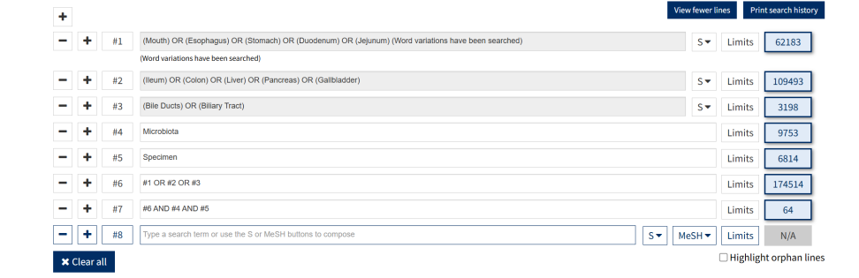

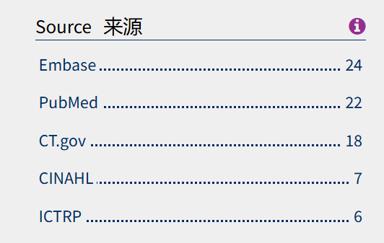

**EMbase（145 publications）**：

(mouth OR esophagus OR stomach OR duodenum OR jejunum OR ileum OR colon OR liver OR pancreas OR gallbladder OR (bile AND ducts) OR (biliary AND tract)) AND microbiota AND specimen

**Wiley Online Library（36 publications）**：

(mouth OR esophagus OR stomach OR duodenum OR jejunum OR ileum OR colon OR liver OR pancreas OR gallbladder OR (bile AND ducts) OR (biliary AND tract)) AND microbiota AND specimen

**Literature Screening Process**

Total records identified: 977

Duplicates removed: 83

→ Records after deduplication: 894

Retractions excluded: 2

→ Remaining records: 892

Exclusion criteria applied:

Irrelevant studies: 104

Animal studies: 105

Other anatomical sites: 43

Chinese-language publications: 1

Review articles: 48

No sampling/testing procedures: 499

Final included studies: 92