the effects of calf muscle length on local muscle fatigability

SUPPLEMENTAL MATERIAL

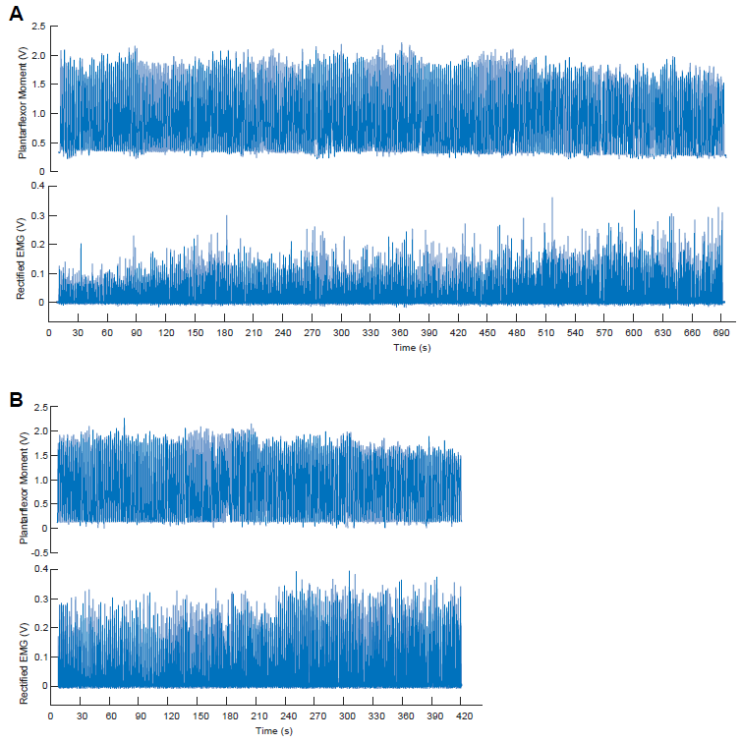
Figure S1. Time series ankle moment and rectified EMG data from a representative subject completing fixed-end contractions to fatigue at (A) 15° dorsiflexion and (B) 15° plantarflexion. These images provide three qualitative impressions from our data. The first, showing that the task failure was reached earlier in plantarflexion than at dorsiflexion. The second, showing that plantarflexor moment decreased over time at both postures, particularly leading up to task failure. Finally, the third, showing that rectified calf muscle excitations increased over time at both postures, particularly leading up to task failure.

