Western Blot results:
Name | Molecular weight | Original bands/gels  M THLE-2 MHCC97H
CBS | 72kda  100 kDa  70 kDa  55 kDa | 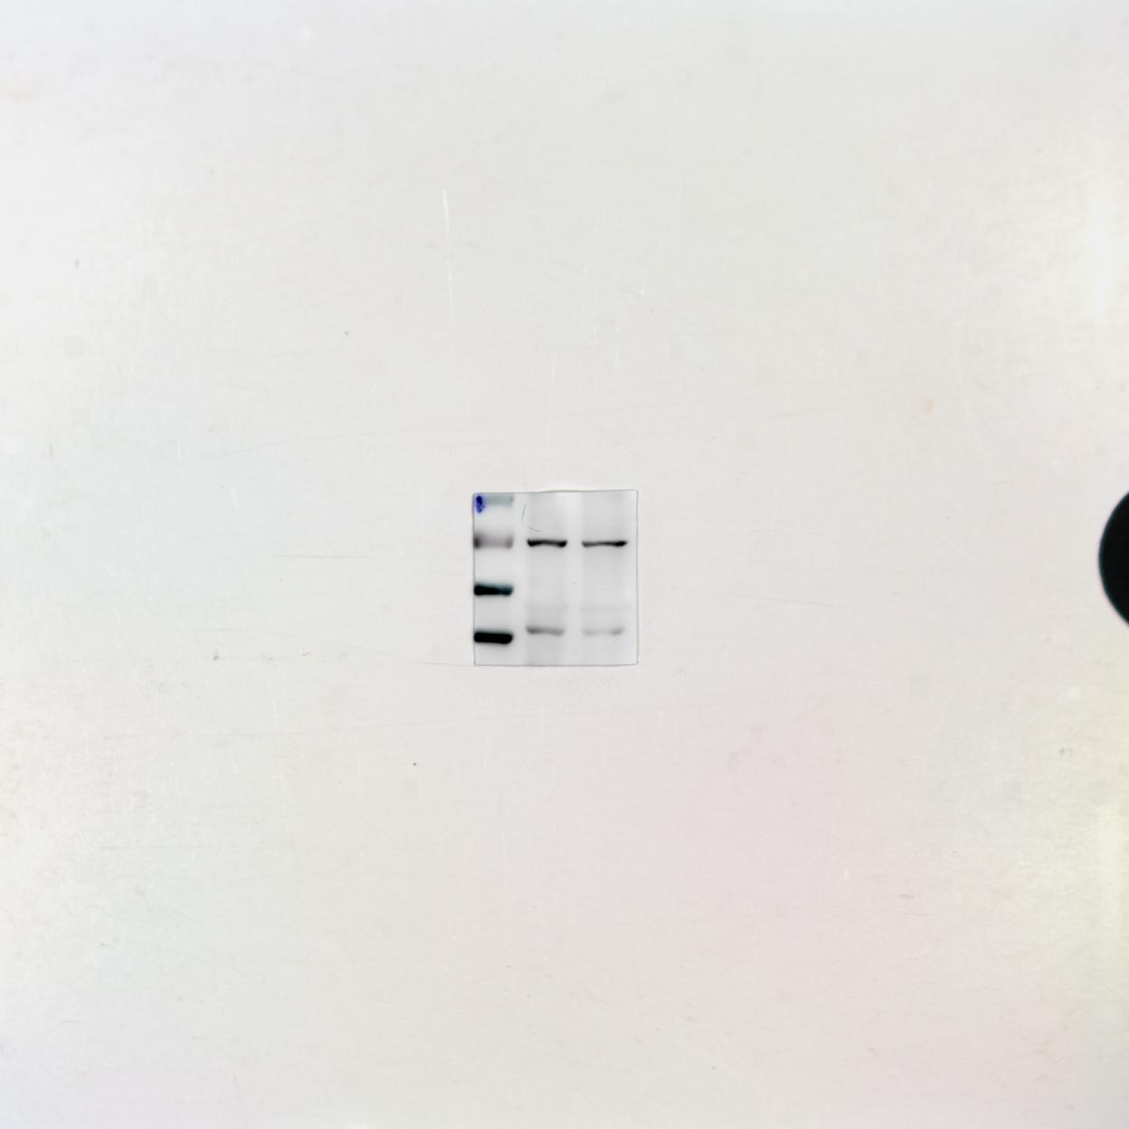  40 kDa
β-actin | 42kDa

