**Supplementary materials**

1. Figs and Tables

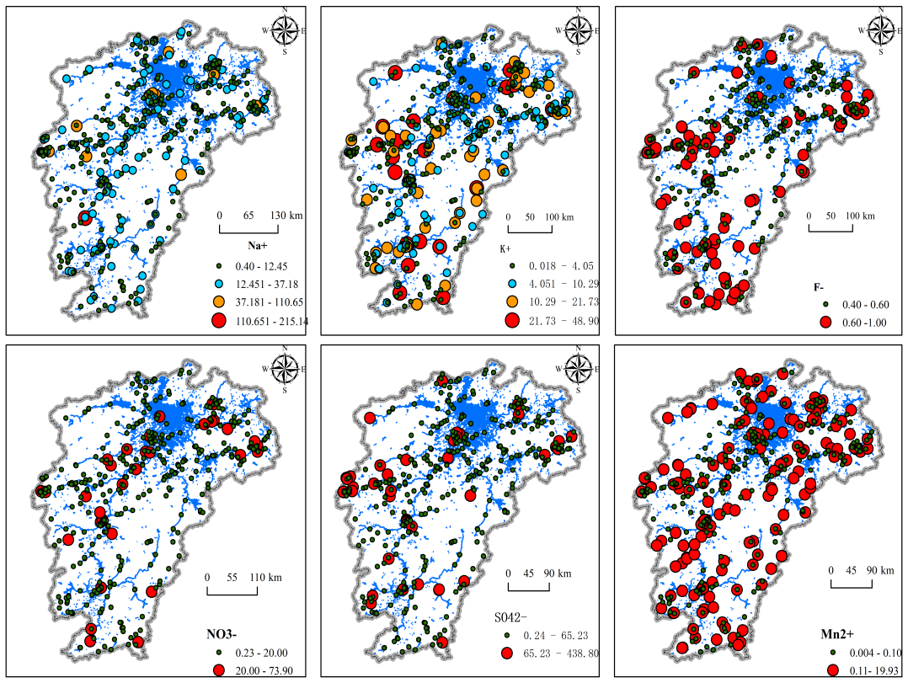

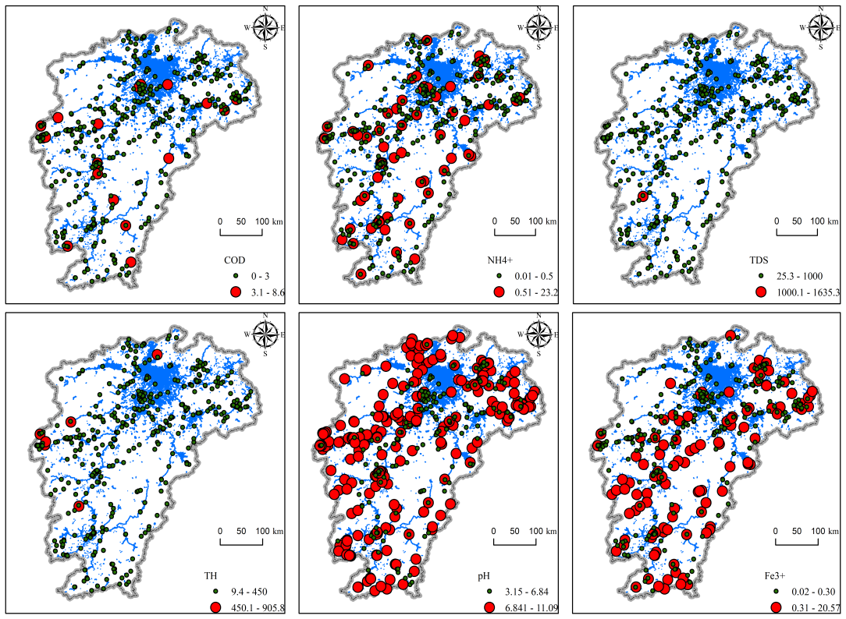

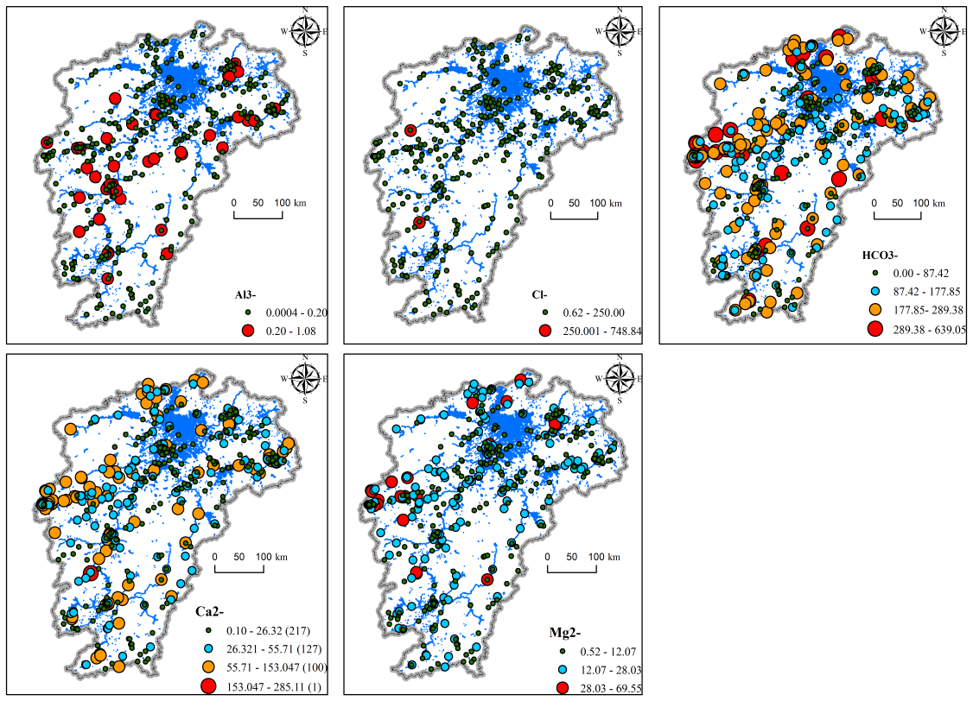

Fig. S1 The spatial distriubtion of hydrochemistry characteristics

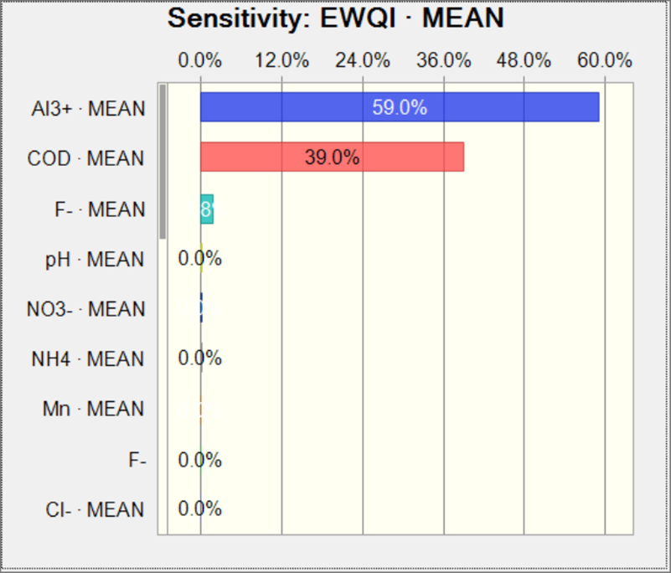

Fig. S2 Sensitivity of EWQI to hydrochemistry characteristics

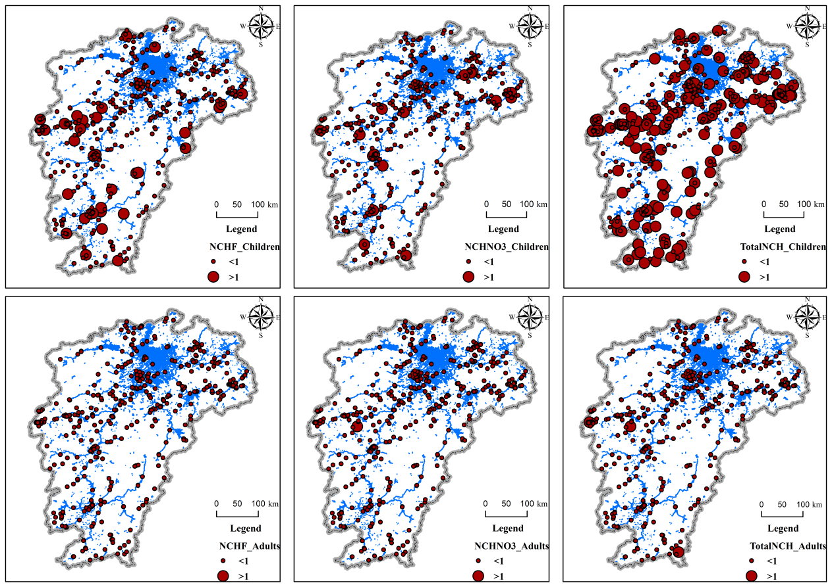

Fig. S3 Deterministic health risk assessment of F- and NO3-

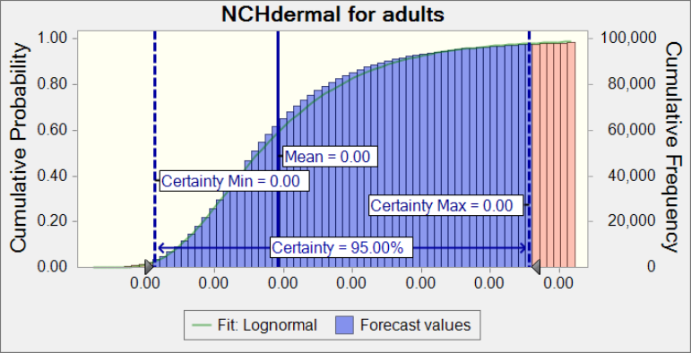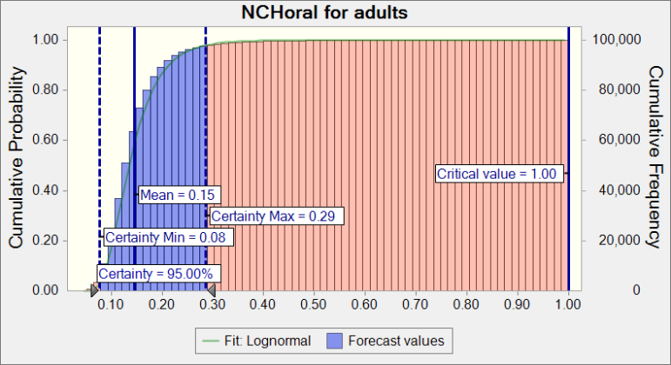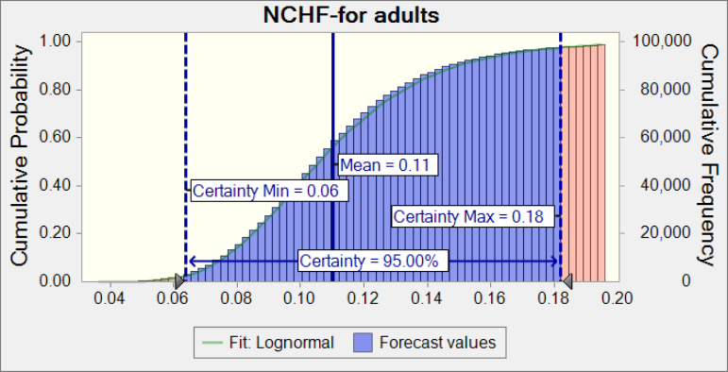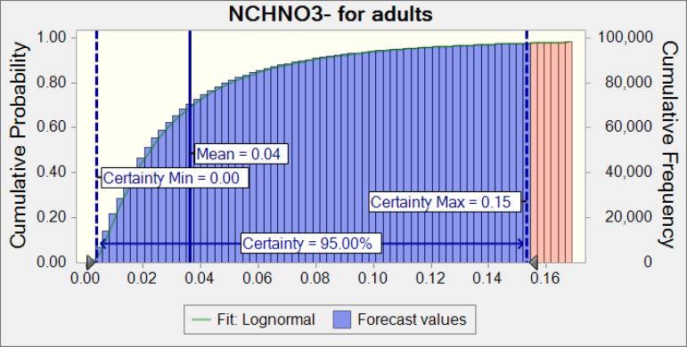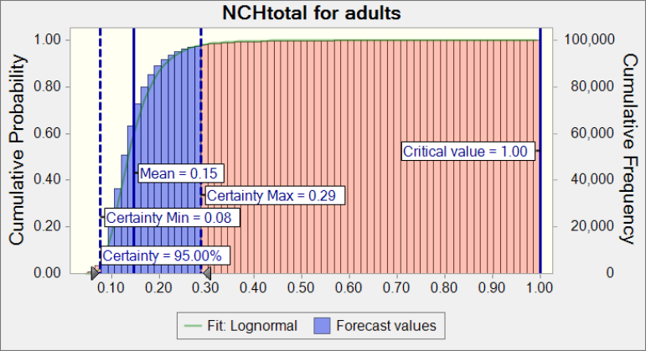

Fig. S4 Probability risk assessment for adults

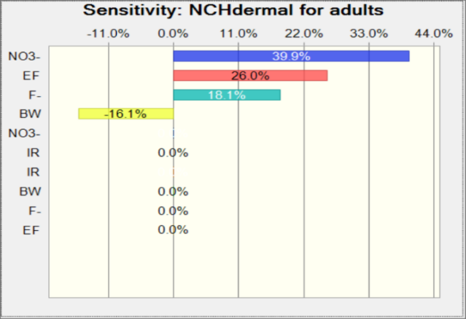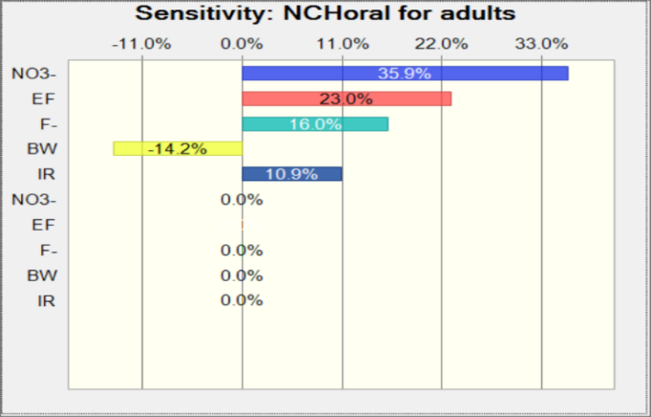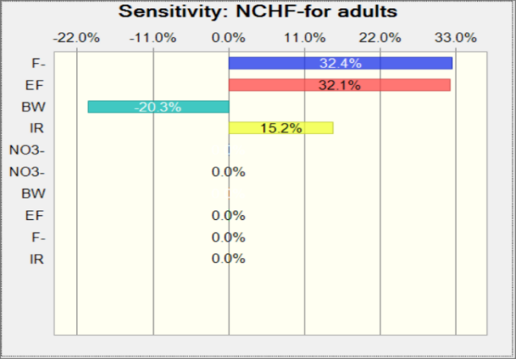

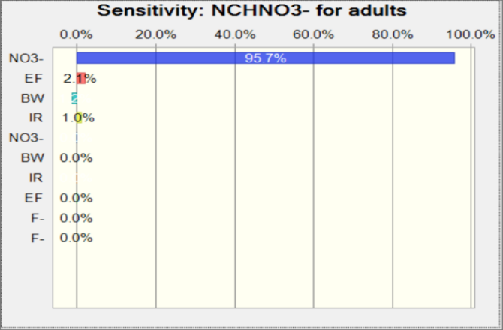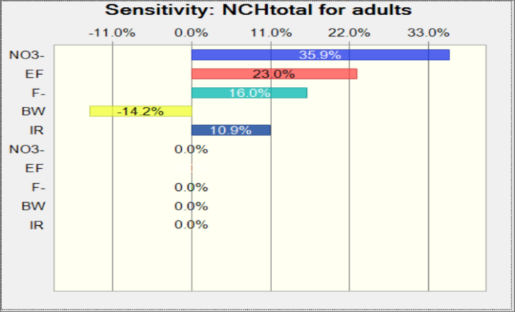

Fig. S5 Sensitivity assessment for adults

Table S1 The weight of chemical characteristics for computing EWQI

|  |  |
| --- | --- |
| Parameters | weights |
| Na+ | 0.04 |
| F- | 0.04 |
| NO3- | 0.15 |
| SO42- | 0.04 |
| Mn | 0.08 |
| COD | 0.19 |
| NH4+ | 0.06 |
| TDS | 0.05 |
| TH | 0.05 |
| pH | 0.06 |
| Fe3+ | 0.04 |
| Al3+ | 0.17 |
| Cl- | 0.02 |

**Table S2.** Daily dose calculation model parameters

|  |  |  |  |  |  |
| --- | --- | --- | --- | --- | --- |
| Item | Parameters | Unit | Children | Adults | References |
| Oral | *IR* | L/d | 0.85 | 1.5 | USEPA,2004; Gao et al., 2022 |
| *BW* | kg | 15 | 61.75 | USEPA,2004; Gao et al., 2022 |
| *EF* | d/a | 365 | 365 | USEPA,2004; Gao et al., 2022 |
| *ED* | a | 6 | 30 | USEPA,2004; Gao et al., 2022 |
| Dermal | *BW* | kg | 15 | 61.75 | USEPA,2004; Gao et al., 2022 |
| *EF* | d/a | 200 | 200 | USEPA,2004; Gao et al., 2022 |
| *ED* | a | 6 | 30 | USEPA,2004; Gao et al., 2022 |
| *AT* | d | 3650 | 27258.2 | USEPA,2004; Gao et al., 2022 |
| *SA* | cm2 | 8650 | 16110 | USEPA,2004; Gao et al., 2022 |
| *EV* | d-1 | 1 | 1 | Wang et al., 2008; Gao et al., 2022 |
| *Kp* | cm/h | 0.001 | 0.001 | USEPA,2004; Gao et al., 2022 |
| tevent | h | 0.33 | 0.25 | USEPA,2004; Gao et al., 2022 |

**Table S3** Fitted distribution of NO3--N, F- and exposure variables.

|  |  |  |
| --- | --- | --- |
| Indicator | Distribution type | |
| Children | Adults |
| NO3--N | LN((0.72, 0.38)) | |
| F- | LN((0.19, 0.03)) | |
| IR (Qiu et al., 2023) | N(0.85,0.09) | N(1.5,0.15) |
| EF(Qiu et al., 2023) | T(180, 365, 345) | T(180, 365, 345) |
| BW(Qiu et al., 2023) | LN(15.0,1.50) | LN(61.75,6.18) |

Reference:

Wang, Z.; Liu, S.; Chen, X.; Lin, C., Estimates of the exposed dermal surface area of Chinese in view of human health risk. Journal of Safety and Environment 2008, (04), 152-156.

USEPA. Risk Assessment Guidance for Superfund Volume I: Human Health Evaluation Muanual (Part e, supplemental guidance for dermal risk assessment) final. 2004.

Gao, Y. *et al.* Cumulative health risk assessment of multiple chemicals in groundwater based on deterministic and Monte Carlo models in a large semiarid basin. *J. Clean. Prod.* **352**, (2022).

Qiu, H. et al. Quantifying nitrate pollution sources of shallow groundwater and related health risks based on deterministic and Monte Carlo models: A study in Huaibei mining area, Huaibei coalfield, China. Ecotoxicology and Environmental Safety 2023(249): 114434.

Table S4 The comparison of geochemical characteris to guidelines and other studies

|  |  |  |  |  |  |  |
| --- | --- | --- | --- | --- | --- | --- |
|  | This study | Class III groundwater standards,China | WHO | Ordos Basin, China | Okinawa Island, Japan | Sargodha, Pakistan |
| Na+ | 12.14 |  | 200.00 | 301.51 | 26.20 | 177.60 |
| K+ | 5.63 |  | 12.00 | 2.79 | 78.16 | 11.30 |
| F- | 0.55 | 1.0 |  | 1.82 |  |  |
| NO3- | 7.26 | 20 | 50.00 | 40.62 | 8.31 | 7.23 |
| SO42- | 27.22 | 250 | 500.00 | 369.26 | 101.24 | 590.48 |
| Mn | 0.49 | 0.1 |  |  |  |  |
| COD | 0.73 | 3.0 |  |  |  |  |
| NH4+ | 0.52 | 0.5 |  |  |  |  |
| TDS | 213.56 | 1000 | 1000.00 | 1404.00 |  | 1272.00 |
| TH | 137.59 | 450 |  |  |  |  |
| pH | 6.96 | 6.5-8.5 | 6.5-9.5 | 7.99 | 7.50 | 7.87 |
| Fe3+ | 0.40 | 0.3 | 0.30 |  |  | 0.44 |
| Al3+ | 0.07 | 0.2 |  |  |  |  |
| Cl- | 19.72 | 250 | 250.00 | 258.32 | 14.60 | 273.56 |
| HCO3- | 137.61 |  | 500.00 | 422.99 | 437.16 | 472.42 |
| Ca2+ | 34.68 |  | 100.00 | 69.75 | 18.04 | 84.20 |
| Mg2+ | 12.38 |  | 50.00 | 77.27 | 12.38 | 20.04 |