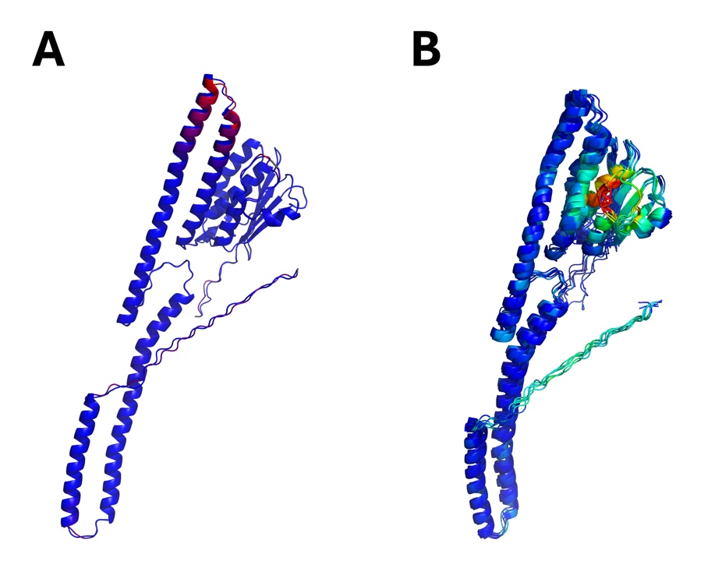
Figure S1. A comparison of the top-ranked PmrB models of Klebsiella pneumoniae in monomeric form. (A) Models ranked by binding energy from ligand-guided homology modeling. (B) Models ranked by DOPE score from conventional multi-template homology modeling. The aligned structures are highlighted by their RMSD values, with dark blue indicating low RMSD and red indicating high RMSD compared to the top-ranked model from each approach.

