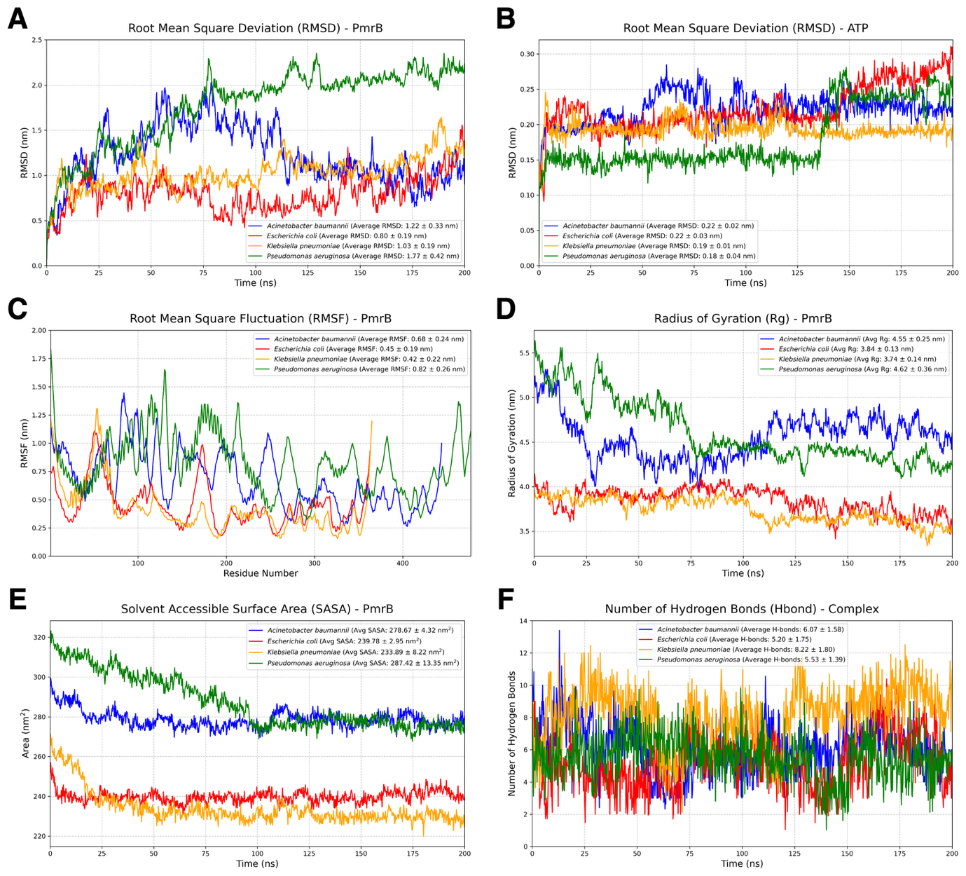

Figure S3. Analysis of the second molecular dynamics (MD) trajectory of PmrB homology models. (A) Root Mean Square Deviation (RMSD) of the PmrB protein structures for A. baumannii, E. coli, K. pneumoniae, and P. aeruginosa. (B) RMSD of the ATP ligand within the PmrB ATP-binding site. (C) Root Mean Square Fluctuation (RMSF) of PmrB residues, indicating the flexibility of different regions of the protein. (D) Radius of Gyration (Rg) of PmrB, reflecting the compactness of the protein structure over time. (E) Solvent Accessible Surface Area (SASA) of PmrB, showing the protein's exposed surface area to the solvent. (F) Number of hydrogen bonds formed between PmrB and the ATP ligand during the simulation.

