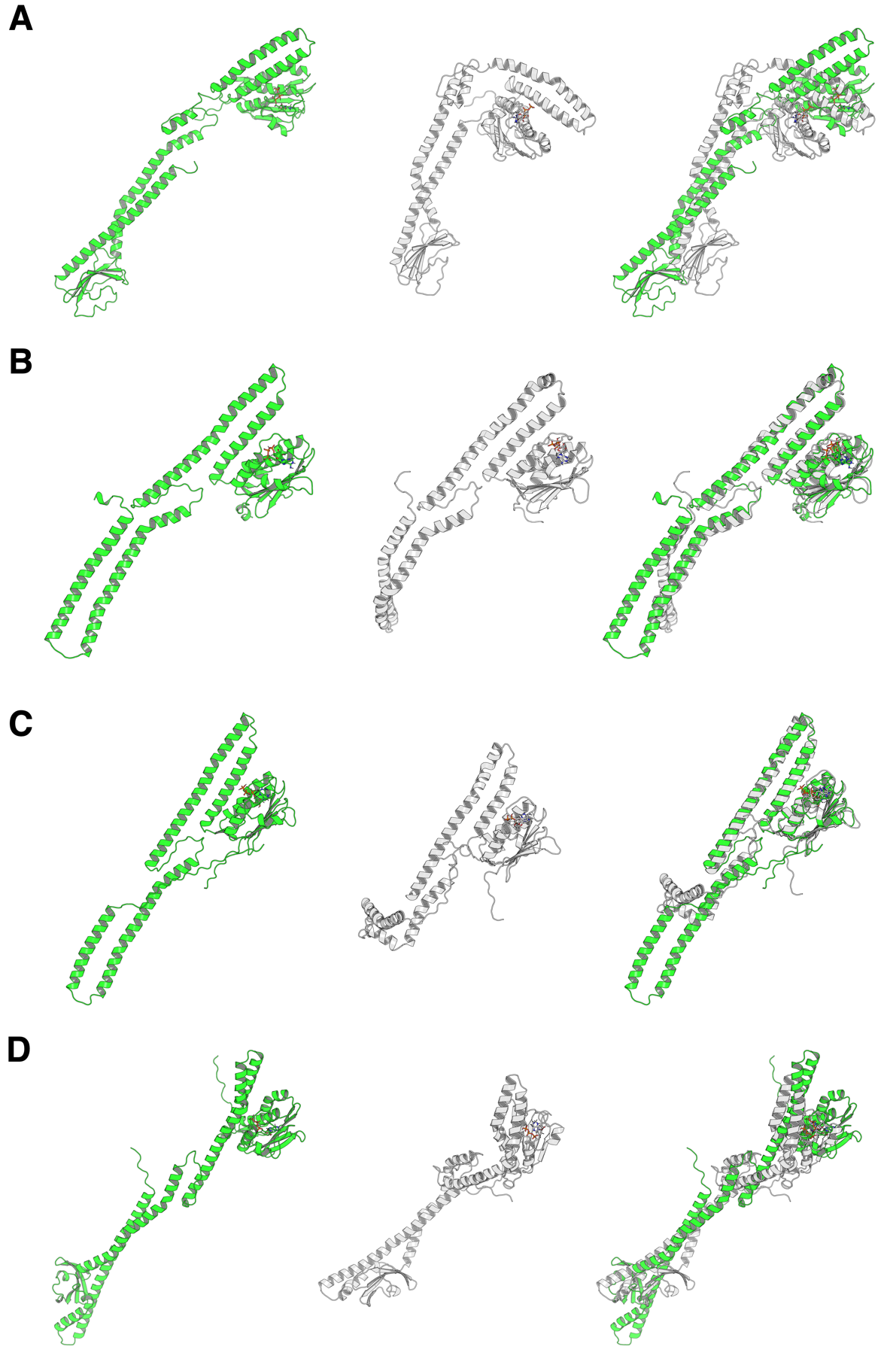
Figure S6. Comparison of initial and equilibrated PmrB homology models from MD simulations. The equilibrated structure corresponds to the frame with the lowest ΔG after 50 ns equilibration. (A) A. baumannii. (B) E. coli. (C) K. pneumoniae. (D) P. aeruginosa. Left panel: initial structure (green); Middle panel: lowest ΔG structure (white); Right panel: superimposition. This figure demonstrates the stability of the PmrB models and highlights conformational changes upon equilibration, particularly in loop regions and the ATP-binding site. The close agreement between structures supports the reliability of the models for further investigations.

