Supplementary:

Prognostic variables with p<0.2 in univariate analysis were included in the propensity score. The two groups were matched at a 1:1 ratio using a caliper width of 0.2, resulting in 66 successfully matched pairs, with the subsequent analysis as follows:.

|  |  |  |  |  |  |  |
| --- | --- | --- | --- | --- | --- | --- |
| Variable | Before PSM | | | After PSM | | |
| CHB Without NAFLD | CHB With NAFLD | P | CHB Without NAFLD | CHB With NAFLD | P |
| (n=91) | (n=67) |  | (n=66) | (n=66) |  |
| AGE, years | 40.0±8 | 39.0±8 | 0.616 | 40.1±7 | 39.1±8 | 0.411 |
| SEX, n (%) |  |  | 0.209 |  |  | 0.053 |
| Male | 75（82.4） | 60（89.6） |  | 52（78.8） | 60（90.9） |  |
| Female | 16（17.6） | 7（10.5） |  | 14（21.2） | 6（9.1） |  |
| Family history  n（%） | 15(16.5) | 15(22.4) | 0.351 | 10(15.2) | 15(22.7) | 0.267 |
| NAs-treated time  yeaes | 4.0（2.0-6.0） | 4.0（2.0-6.0） | 0.263 | 4.0（2.0-6.0） | 4.0（2.8-6.3） | 0.206 |
| HBsAg,IU/mL | 620(138-1152) | 606(209-1294) | 0.581 | 594(111-1208) | 587(206-1218) | 0.621 |
| HBsAg,n (%) |  |  |  |  |  |  |
| ＜100IU/mL | 19（20.9） | 11（16.4） | 0.480 | 15（22.7） | 11（16.7） | 0.381 |
| 100-500IU/mL | 22（24.2） | 21（31.3） | 0.317 | 15（22.7） | 21（31.8） | 0.241 |
| 500-1500IU/mL | 38（41.8） | 23（34.3） | 0.343 | 28（42.4） | 23（34.8） | 0.371 |
| ≥1500IU/mL | 12（13.2） | 12（17.9） | 0.414 | 8（12.1） | 11（16.7） | 0.457 |
| HBeAg,IU/mL | 0.32(0.03-4.77) | 0.39(0.03-11.27) | 0.512 | 0.52(0.02-8.37) | 0.38(0.03-11.97) | 0.659 |
| HBeAg(+),n (%) | 30(33.0) | 28(41.8) | 0.257 | 24(36.4) | 27(40.9) | 0.592 |
| ALT,U/L | 22.0(16.0-32.0) | 28.0(19.0-40.0) | 0.031 | 22.0(16.0-32.0) | 27.0(18.8-40) | 0.062 |
| AST,U/L | 21.0(16.0-25.0) | 21.0(18.0-26.0) | 0.315 | 21.0(16.0-25.3) | 21.0(17.8-26.0) | 0.552 |
| GGT,U/L | 22.0(17.0-29.0) | 26.0(19.0-38.0) | 0.023 | 22.5(17.0-30.3) | 26.0(19.0-38.0) | 0.105 |
| ALP,U/L | 70.0(60.0-79.0) | 74.0(60.0-85.0) | 0.227 | 69.0(60.0-77.5) | 73.5(60.0-85.0) | 0.167 |
| TP,g/L | 75.8±3.8 | 76.4±4.2 | 0.353 | 76.3±4.0 | 76.4±4.2 | 0.923 |
| ALB,g/L | 48.4±2.4 | 48.9±2.7 | 0.223 | 48.8±2.5 | 49.0±2.8 | 0.791 |
| TBIL,µmol/L | 13.0(8.6-16.8) | 12.5(9.6-15.5) | 0.915 | 13.3(8.4-17.3) | 12.4(9.6-15.5) | 0.815 |
| DBIL,µmol/L | 4.6(3.5-6.0) | 4.6(3.6-5.5) | 0.675 | 4.5(3.4-6.1) | 4.6(3.6-5.5) | 0.897 |
| AFP,ng/mL | 3.3(2.2-4.5) | 2.8(2.3-3.6) | 0.152 | 3.4(2.3-4.9) | 2.9(2.3-3.6) | 0.138 |
| CREA,µmol/L | 66.5±12.3 | 70.3±12.7 | 0.059 | 66.3±11.9 | 70.2±12.8 | 0.074 |
| UA,µmol/L | 322.3±64.5 | 346.7±71.5 | 0.026 | 329.7±62.2 | 345.9±7.7 | 0.168 |
| GLU,mmol/L | 5.7(5.2-5.9) | 5.7(5.1-6.0) | 0.975 | 5.7(5.1-5.9) | 5.7(5.1-6.0) | 0.816 |
| WBC,×109/L | 5.6(4.7-6.5) | 5.8(4.8-6.9) | 0.301 | 5.5(4.4-6.2) | 5.9(4.8-6.9) | 0.078 |
| NLR | 1.8(1.4-2.3) | 1.7(1.2-2.2) | 0.367 | 1.8(1.4-2.3) | 1.7(1.2-2.2) | 0.332 |
| PLT,×109/L | 202.1±51.0 | 227.2±48.7 | 0.002 | 200.4±54.4 | 228.2±48.4 | 0.056 |

T able S1. Baseline Characteristics of Patients Before and After Propensity Matching

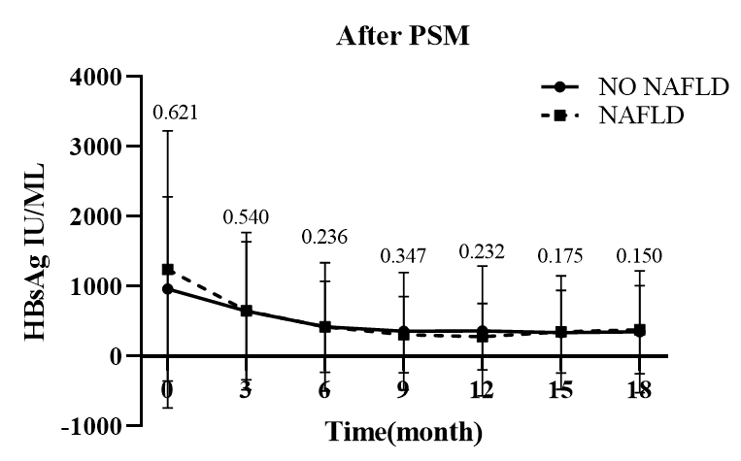

FigureS1 .Changes in HBsAg levels between groups after PSM

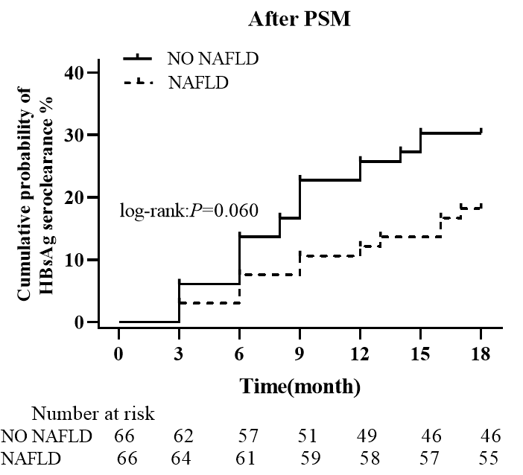

FigureS2 .Cumulative probability of HBsAg seroclearance between groups after PSM

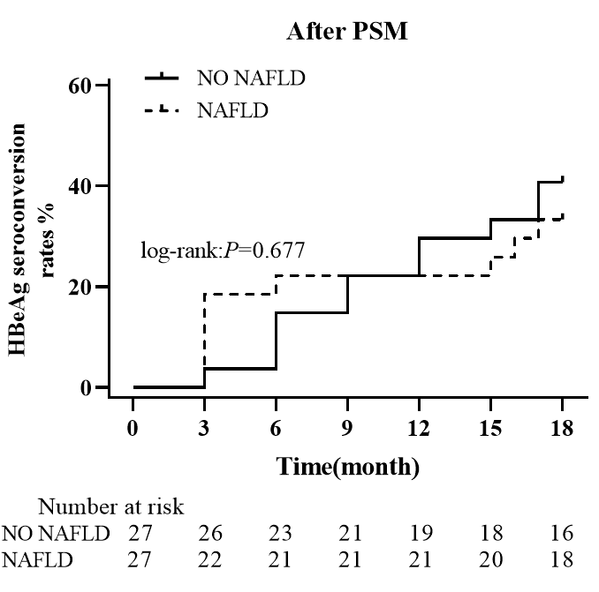

FigureS3. Cumulative probability of HBeAg seroclearance between groups after PSM

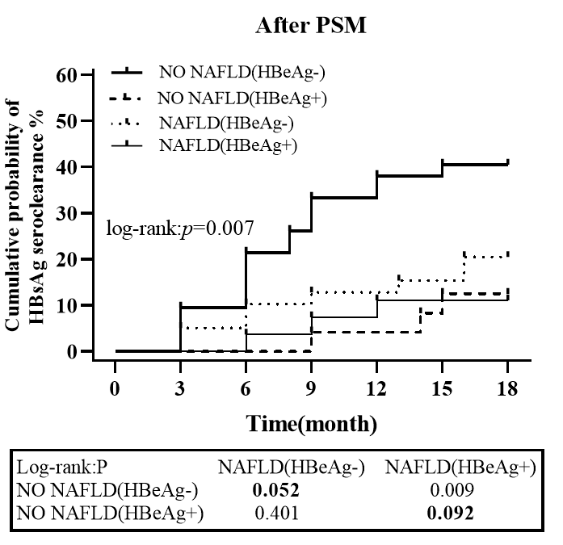

FigureS4. Cumulative probability of HBsAg seroclearance stratified by baseline NAFLD and HBeAg (+/-) after PSM