FIGURE 2
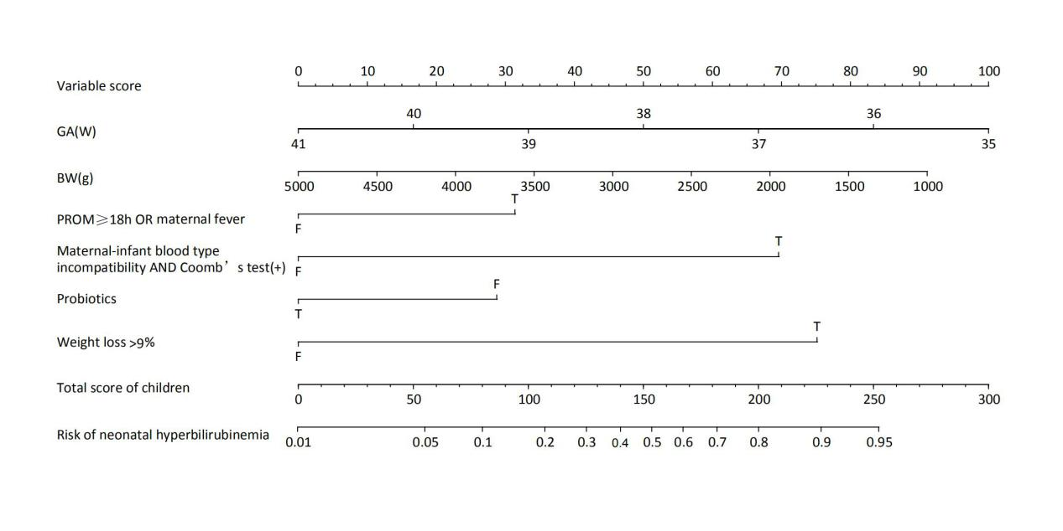
> rm(list = ls(all = TRUE))
> ####Work Path Setting
> setwd("C:/Users/23983/Desktop/R results")
> ####Data import
> #It is recommended to use UTF-8 csv format to import data
> data <- read.csv("trainTotal data (+ disaggregated information) (10 risk factors).csv",header = TRUE)
> library(rms)
> dist.train <- datadist(train)
> options(datadist="dist.train")
> fit.full <- lrm(END ~ V2_num+V3_num+V8+V17+V20+V21,
+ data = train,x = T,y = T)
> #Line Chart Generation
> nom.ss <- nomogram(fit.full,fun=plogis, fun.at=c(.001,.01, .05,
+ seq(.1,.9, by=.1), .95, .99, .999),lp=F,
+ funlabel="Risk of neonatal hyperbilirubinaemia")
> #Line drawing
> plot(nom.ss,vnames='labels',points.label = "Variable score",total.points.label = "Total score of the children")

