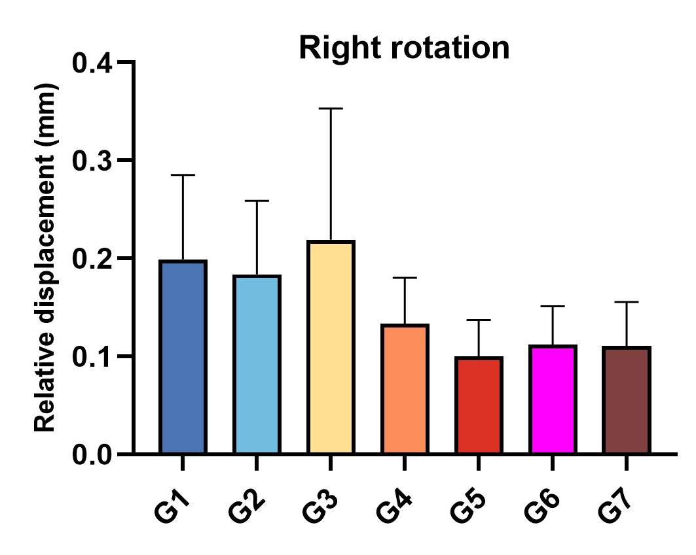
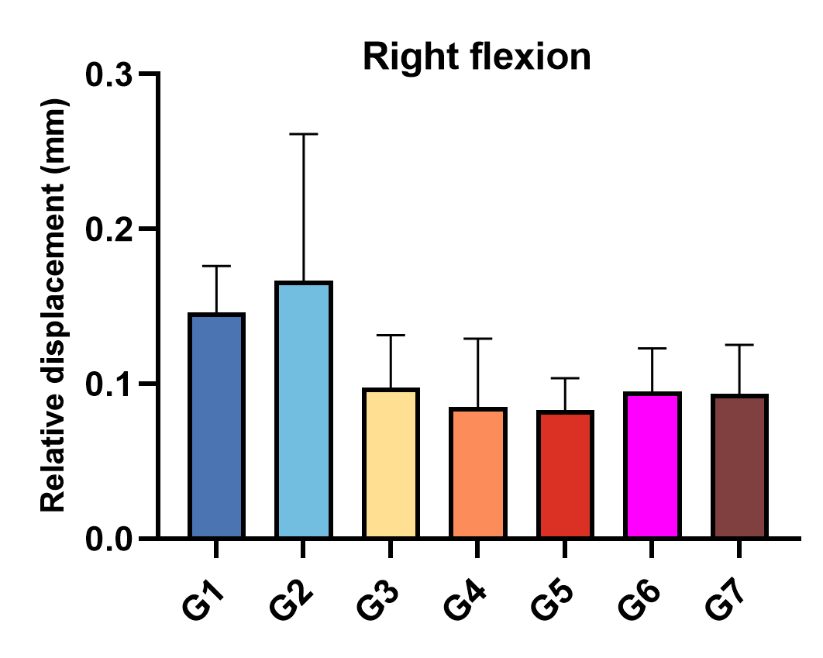
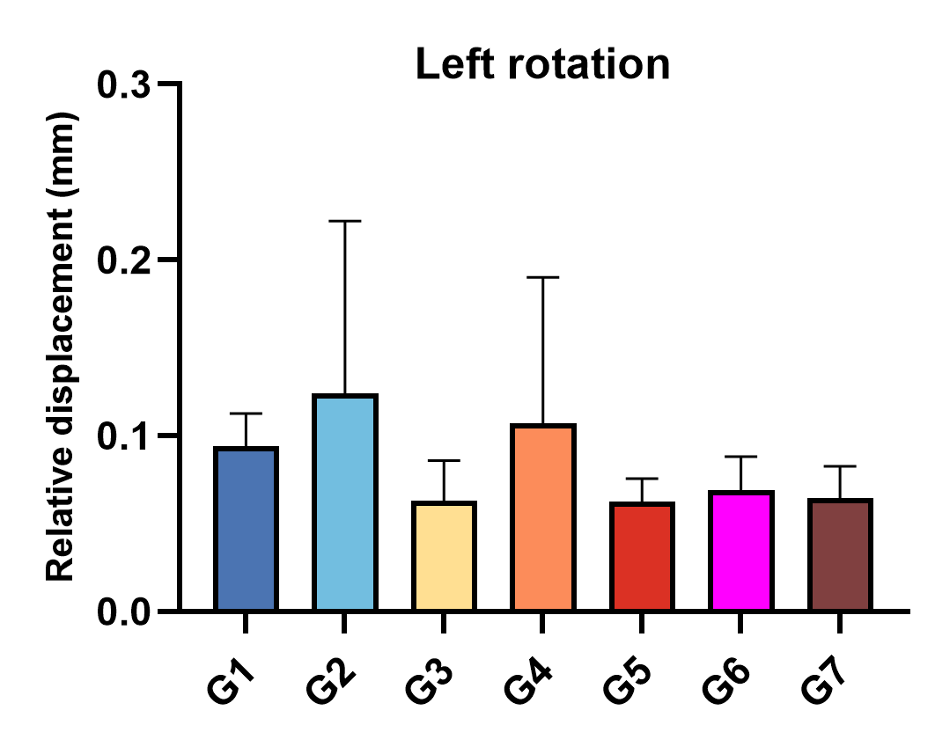
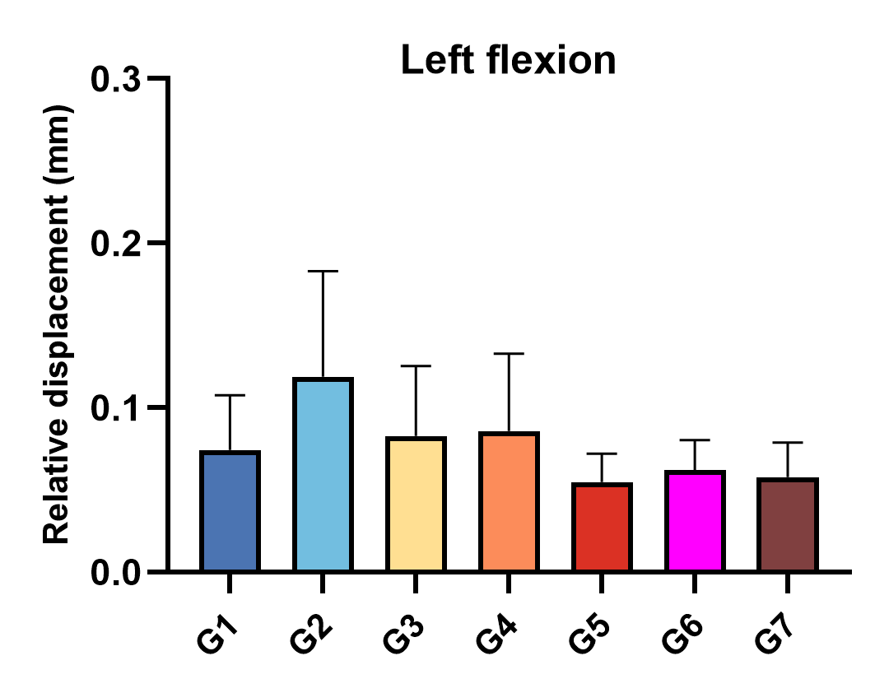
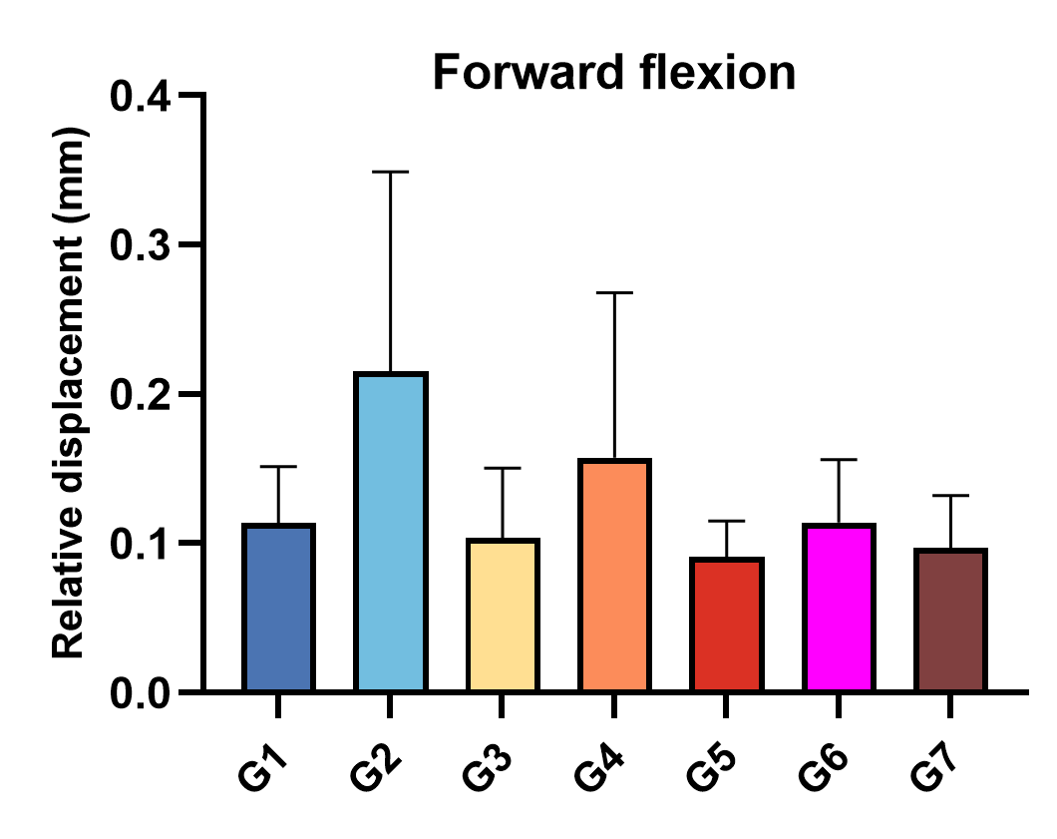
Supplementary 3 Figure 1: Comparison of the relative displacement on the anterior surface of the sacral under seven fixed conditions while forward flexion, left flexion, right flexion, left rotation, and right rotation.

