The MVC testing methodology was based on standard for specific muscles (<https://www.seniam.org/>) as shown on Figure3.11：**A,** Biceps Femoris (long head and short head) MVC: Supine position. Knee joint flexed at 30°, resistance applied at the back of the ankle joint, requiring the subject to flex the knee. **B, C,** Adductor and abductor muscles MVC: Sitting position. Resistance applied at the front of the ankle joint, trunk and thigh at 90°, knee joint at 135°, requiring the subject to extend the knee. **D,** Quadriceps MVC: Supine position. Knee joint at 90° placed at the edge of the bed, resistance applied at the front of the ankle joint, requiring the subject to extend the knee. **E, F,** Gastrocnemius (medial and lateral head) MVC: Supine position. Foot at 90° to the leg, resistance applied at the bottom of the forefoot, requiring the subject to dorsiflex.

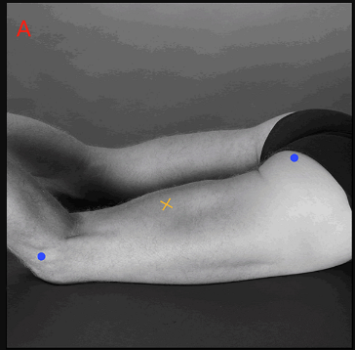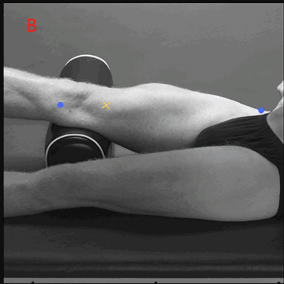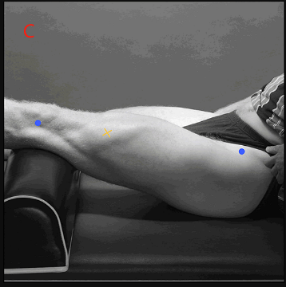

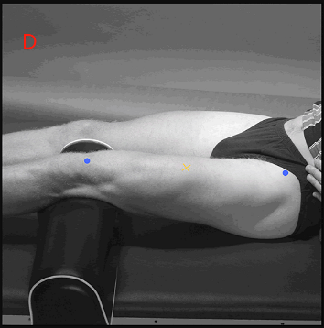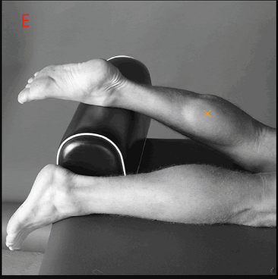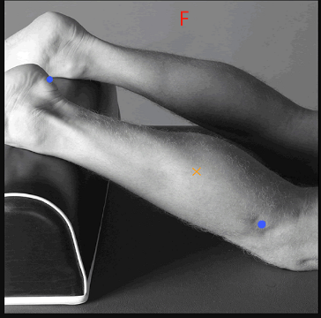

Figure 3.11 MVC testing.