**AUDEXCEL User Manual**

Step 1: Key in the audiometric readings for each individual, in the order of baseline, annual, and repeated (for STS).

Step 2: The diagnoses for both left and right ears will be automatically generated.

Step 3: Please take note of the actions required to take for each individual (e.g., to repeat audiometry within 3 months, repeat audiometry annually and/or to notify the authority).

Step 4: To visualise the audiogram for each individual, click the line plot of the audiogram and move the blue bar to highlight the audiometric readings of interest.

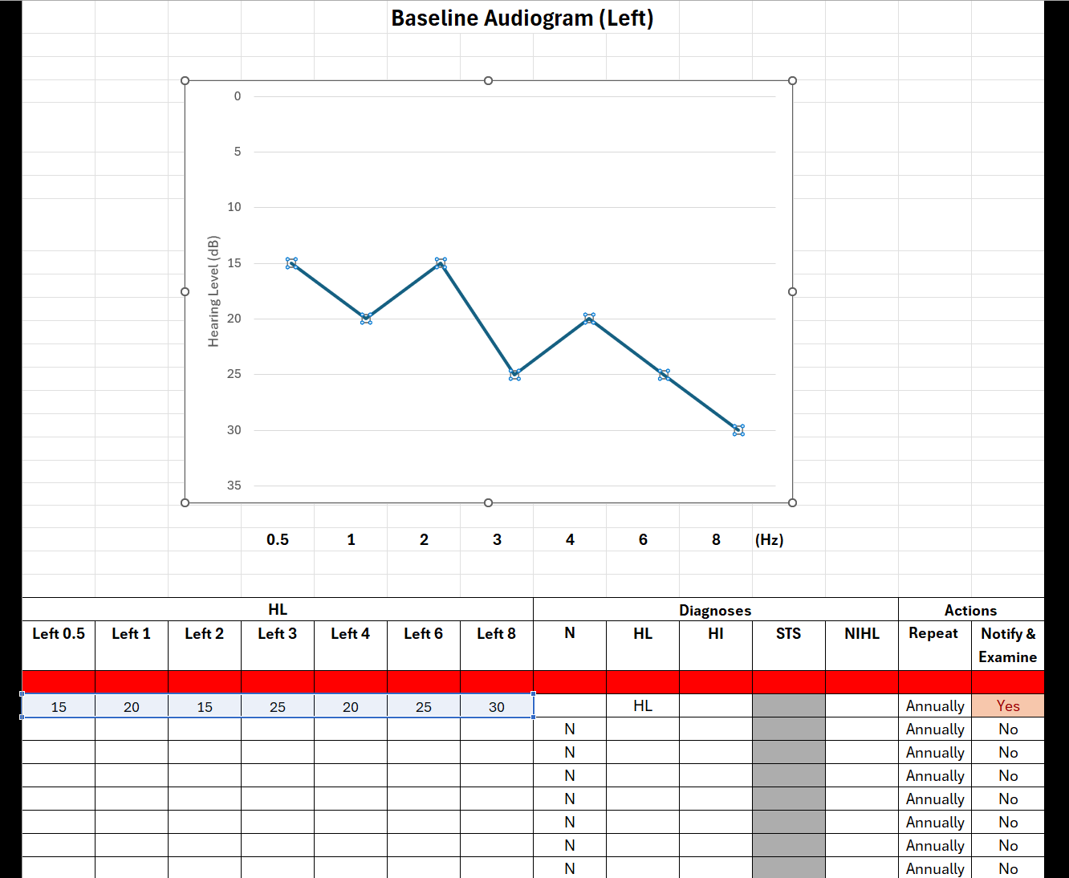

Line Plot

**Step 5: Key in the audiometric readings for another individual at the next line.**



Next individual