Tutorial for the FastST software

- Introduction
FastST is a microbial source tracking tool which makes fast inference for the relative contributions of source environments to sink microbiomes.

- Preparation
Before running the script, you need to
- make sure R packages "npreg" and "gtools" have been installed. If not, please run the following lines in R:
install.packages("npreg")
install.packages("gtools")
- make sure "FastST" is the current working directory. If not, please modify the following line using your home directory and run it in R:
setwd("C:/Users/username/Documents/Work/FastST")
- make sure environment variables are correctly set, e.g., for windows “C:\Program Files\R\R-4.5.1\bin” is included.
- If you are running our tools in Linux or Mac, please change the permission for the standalone files running “chmod +x standalone_file” command, for example :
chmod +x ./Code/FastST
chmod +x ./Code/Demo_GenData
chmod +x ./Code/Demo_EstProp

- Code description
All code, including R scripts and standalone commands, are listed in the following table:
For demonstration | For simulation | For real data analysis
Demo.R  Demo_GenData  Demo_EstProp | Simu_Scen1a.R  Simu_Scen1b.R  Simu_Scen2.R | Real.R  FastSt

--Demo.R: R script for demonstrating a simple example of generating sink/source data and estimating proportions of source contribution.
--Demo_GenData: standalone command for demonstrating the data generation procedure.
--Demo_EstProp: standalone command for demonstrating the proportion estimation procedure.
--Simu_Scen1a.R: R script for Scenario 1a (proportion estimation) with fully simulated microbiome data.
--Simu_Scen1b.R: R script for Scenario 1b (directionality inference) with fully simulated microbiome data.
--Simu_Scen2.R: R script for Scenario 2 with semi-synthetic data generated from the Knights et al. dataset.
study.
--Real.R: R script for real data analysis based on the Knights et al. dataset.
--FastSt: standalone command for analyzing user specified data.

Note: Users may simply run “./Code/FastST userdata.txt” to analyze their own microbiome data. The file “userdata.txt” contains an N by K matrix where the 1st column is the observed sink counts on N taxa, and the rest columns are the counts of the observed K sources.

After running FastST, a “Result” directory will be created in the current working directory, containing the output file “./Result /results.txt”. In this file, the first column represents the estimated proportions computed by FastST, and the second column shows the standard errors. The first row corresponds to the unknown source.

- Demonstration.
The demo code contains two parts: generating sink data and estimating source proportions. It can be executed in two different modes:
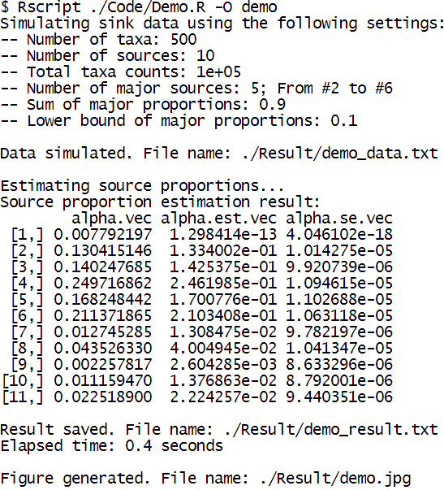
- as one R script, please run "./Code/Demo_FastST.R". For example, in RStudio terminal pane (first, you will need to set correct environment variables in the Shell for the Rscript command),
Below is the generated figure “demo.jpg”
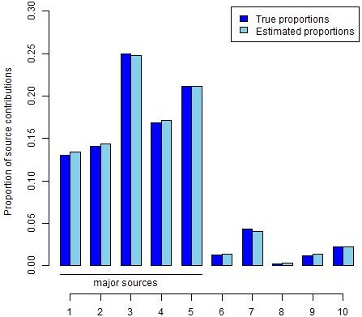

For more help, please see
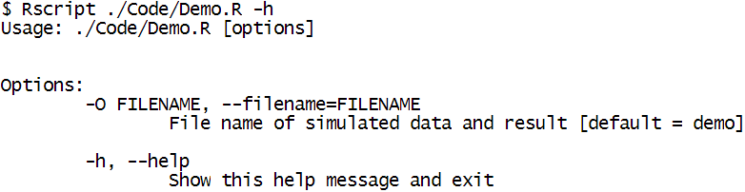

- as two standalone commands which allow the specification of input arguments, please run the following commands in RStudio terminal pane:
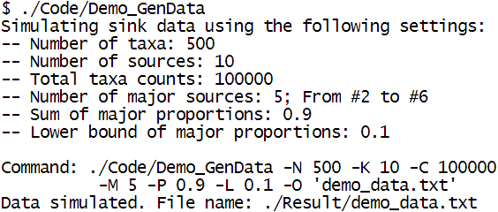
After running Demo_GenData, “./Result/demo_data.txt”,
will be created, where the first column represents the
sink and the rest column represent the sources.

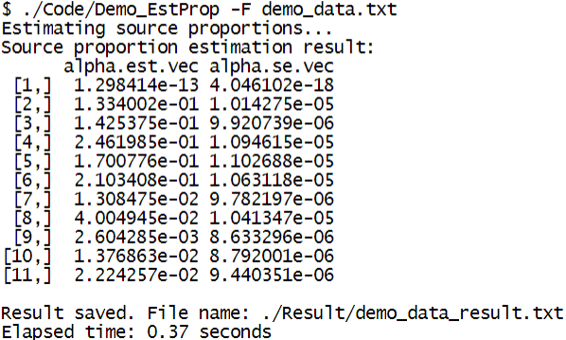

- Simulation.
The simulation study contains three parts:
- Scenario 1a (proportion estimation) with fully simulated microbiome data, please run the following commands in RStudio terminal pane:
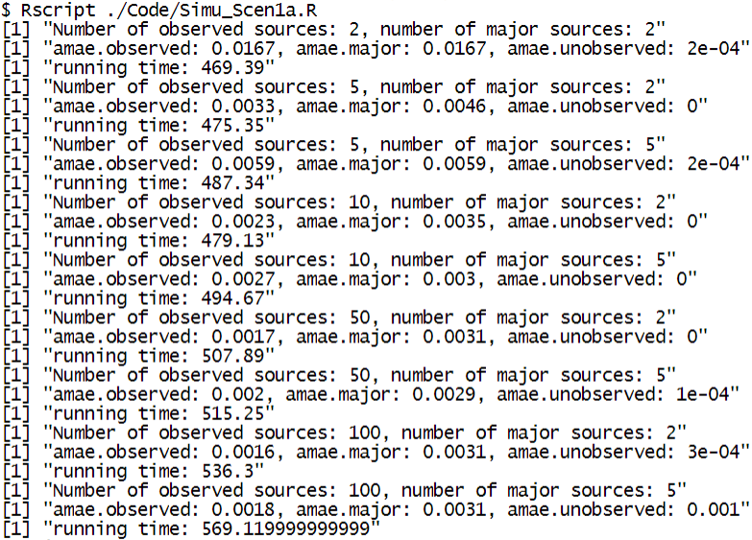
- Scenario 1b (directionality inference) with fully simulated microbiome data, please run the following commands in RStudio terminal pane:
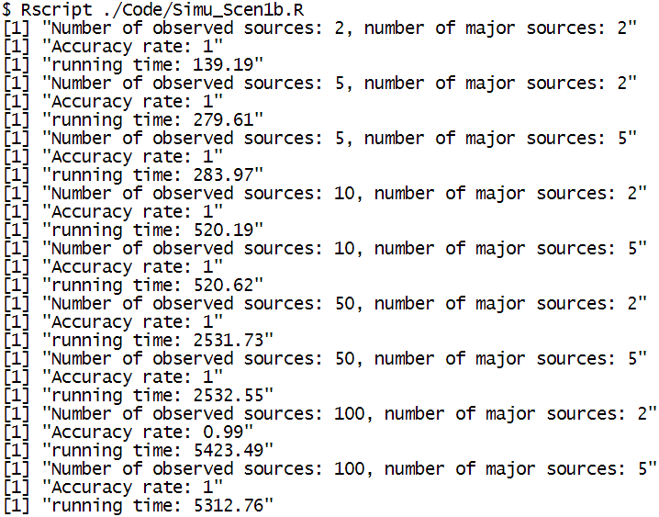
- Scenario 2 with semi-synthetic data generated from the Knights et al. dataset, please run the following commands in RStudio terminal pane:
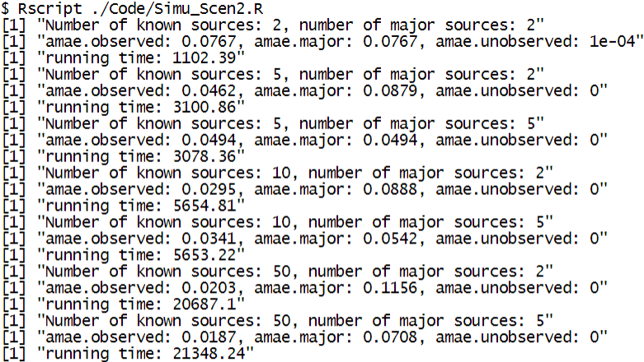
- Real data analysis using the Knights et al. dataset. Please run the following commands in RStudio terminal pane:
