Soil storage temperature and air-drying did not significantly change bacterial taxa in the short-term
Mingming Du^{a,b *}, Peipei Xue^{a,b}, Budiman Minasny^{a,b}

ªSchool of Life and Environmental Sciences, The University of Sydney, NSW 2015, Australia
^{b}Sydney Institute of Agriculture, The University of Sydney, NSW 2006, Australia
*Corresponding author: mingming.du@sydney.edu.au

Supplementary materials:

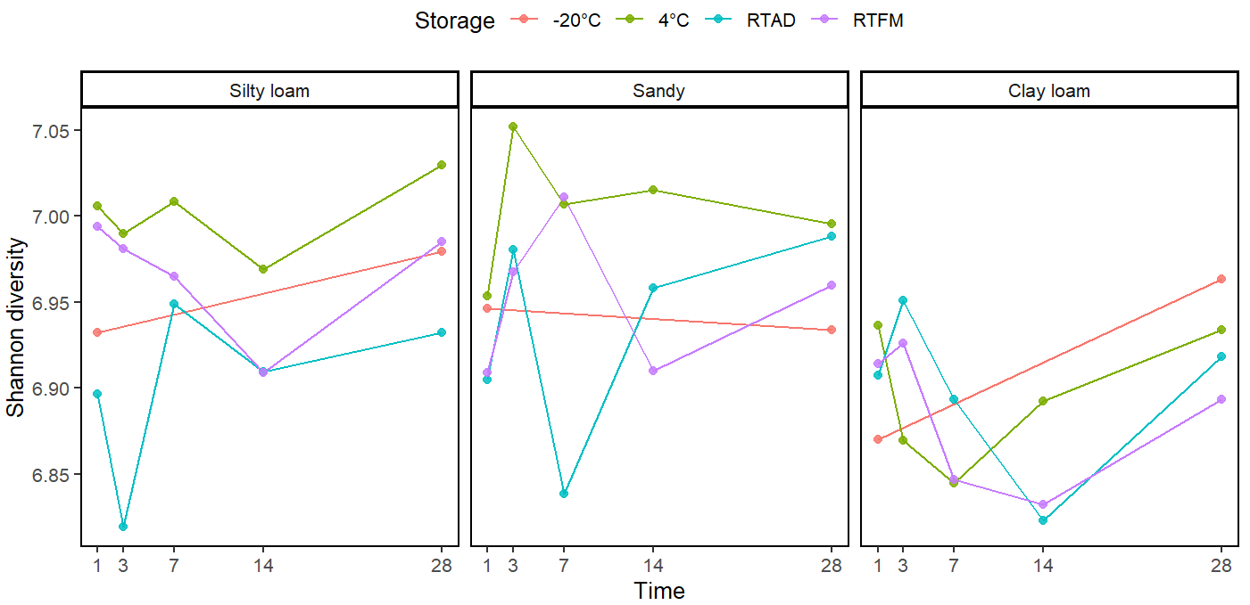
Fig.S1 The Shannon diversity for each soil type under different storage methods
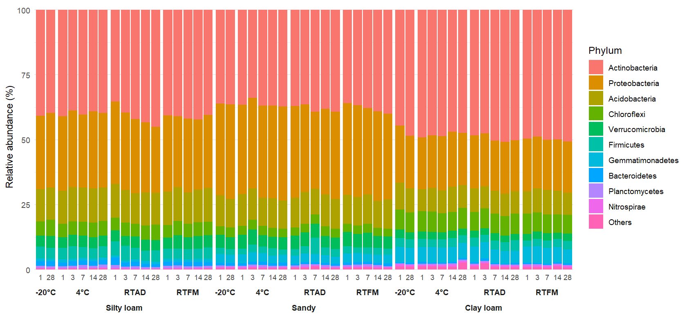

Fig.S2. The relative abundance of the total taxa at the phylum level for each soil type under different storage methods

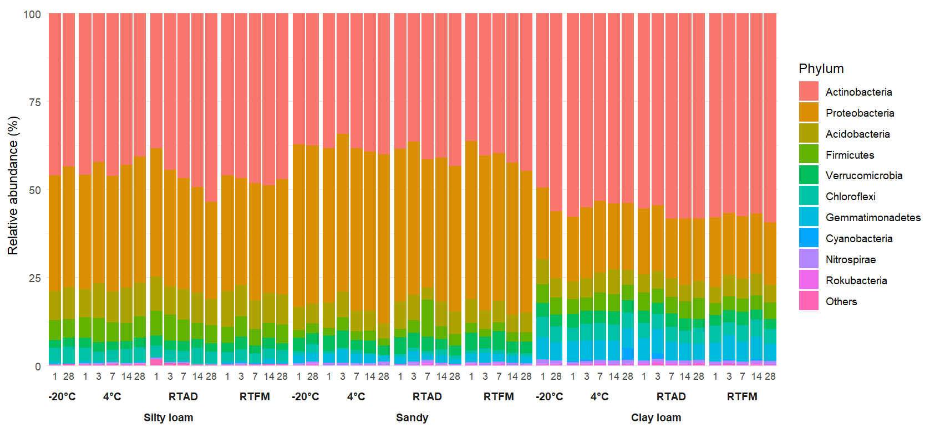

Fig.S3. The relative abundance of the abundant taxa at the phylum level for each soil type under different storage methods

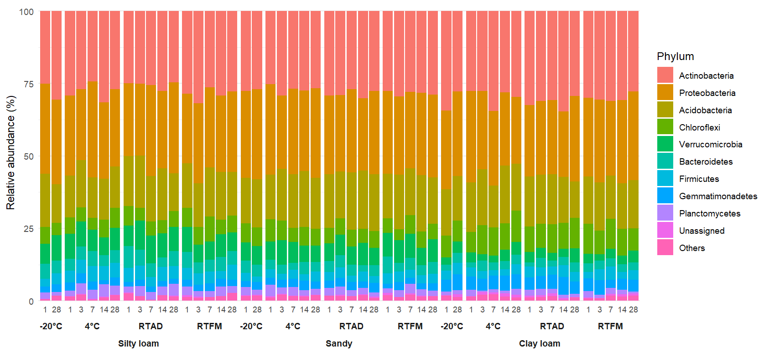
Fig.S4. The relative abundance of the rare taxa at the phylum level for each soil type under different storage methods

