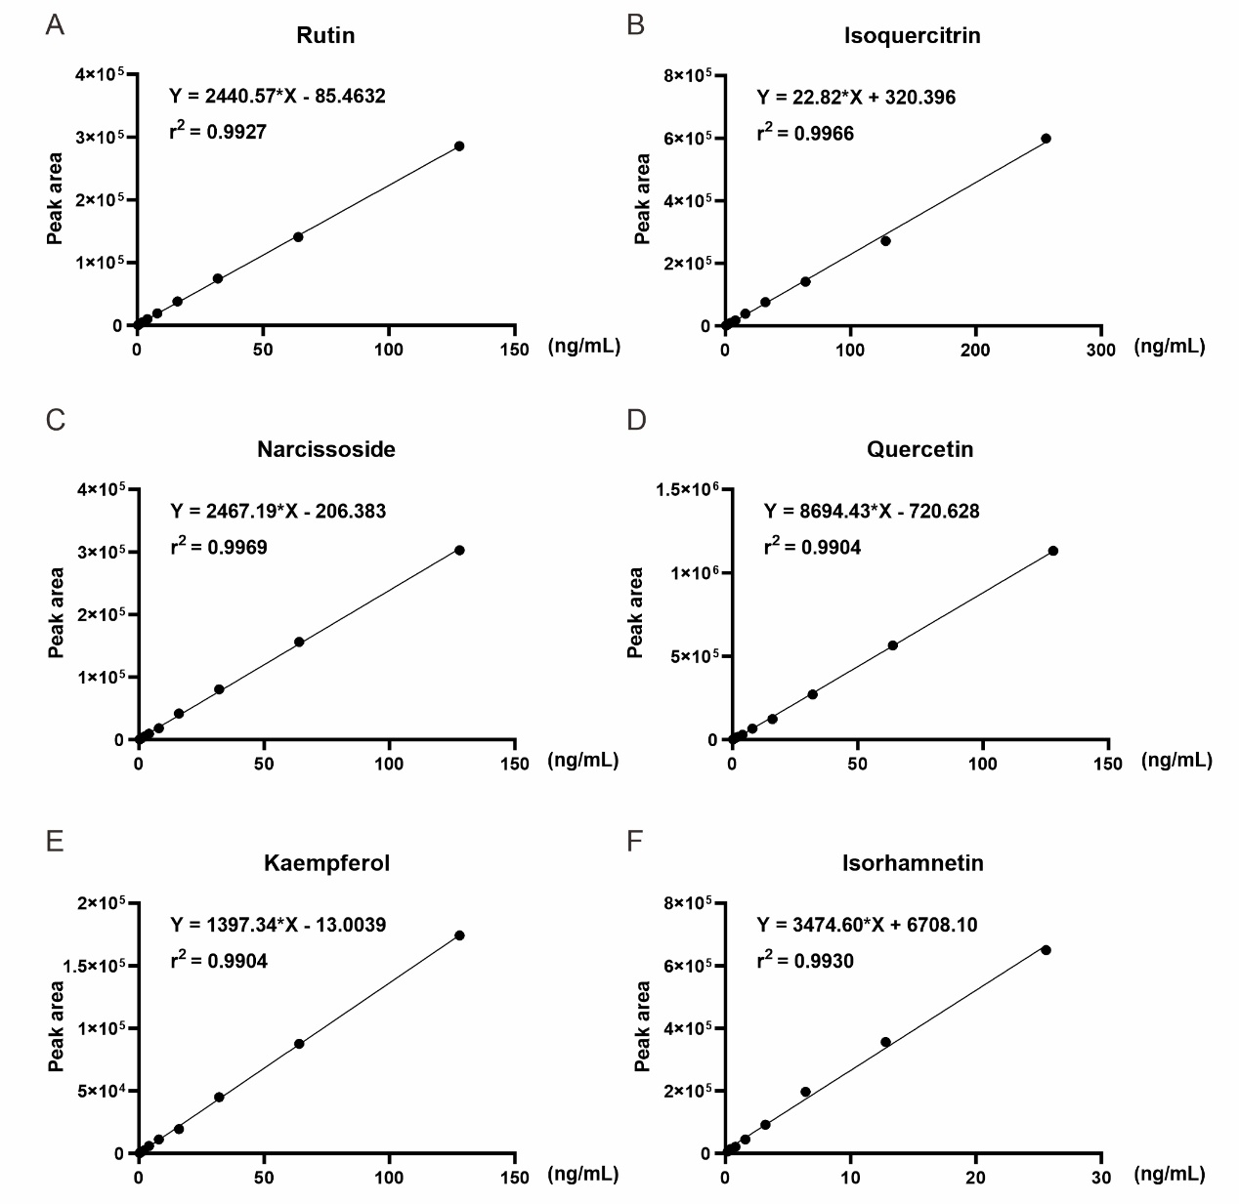

Figure S1. Standard curve and its corresponding standard equation of the six analytes. (A) Rutin. (B) Isoquercitrin. (C) Narcissoside. (D) Quercetin. (E) Kaempferol. (F) Isorhamnetin.