Residual Diagnostics for ANOVA

For each trait, we fitted a one-way ANOVA model with Group (Control, PH2%, PH4%, PH6%) as the factor. We evaluated the model residuals as required by ANOVA assumptions: normality using the Shapiro-Wilk test on studentized residuals (with Q-Q plots), and homogeneity of variances using Levene’s test (median-centered) on the raw response across groups. Kruskal-Wallis tests were additionally reported as a robustness check for endpoints with significant departures from residual normality. Percentages are two-sided p-values; pass/fail thresholds are 0.05.
Table S1. Shapiro–Wilk and Levene’s tests on ANOVA studentized residuals for each trait shown in Table 1; ANOVA and Kruskal-Wallis p-values for Group.
Sheet | N | k  Groups | Shapiro–Wilk W | Shapiro p | Levene stat | Levene p | ANOVA p | Kruskal H | Kruskal p
ILW | 108 | 4 | 0.977 | 0.057 | 0.657 | 0.581 | 0.315 | 3.95 | 0.267
FLW | 96 | 4 | 0.958 | 0.004 | 0.686 | 0.563 | 0.026 | 7.336 | 0.062
EW | 581 | 4 | 0.994 | 0.021 | 0.484 | 0.693 | 0.000 | 24.07 | 0.000
DEP | 12 | 4 | 0.934 | 0.427 | 0.144 | 0.931 | 0.057 | 6.111 | 0.106
EM | 12 | 4 | 0.947 | 0.596 | 0.211 | 0.886 | 0.090 | 5.821 | 0.121
AFC | 12 | 4 | 0.979 | 0.980 | 0.498 | 0.694 | 0.009 | 8.401 | 0.038
FCR | 12 | 4 | 0.951 | 0.655 | 0.541 | 0.667 | 0.044 | 6.795 | 0.079
IWB: Initial Live Weight; FLW: Final Live Weight; EW: Egg Weight; DEP: Daily Egg Performance; EM: Egg Mass; AFC: Awerage Feed Consumption: FCR: Feed Conversion Ratio
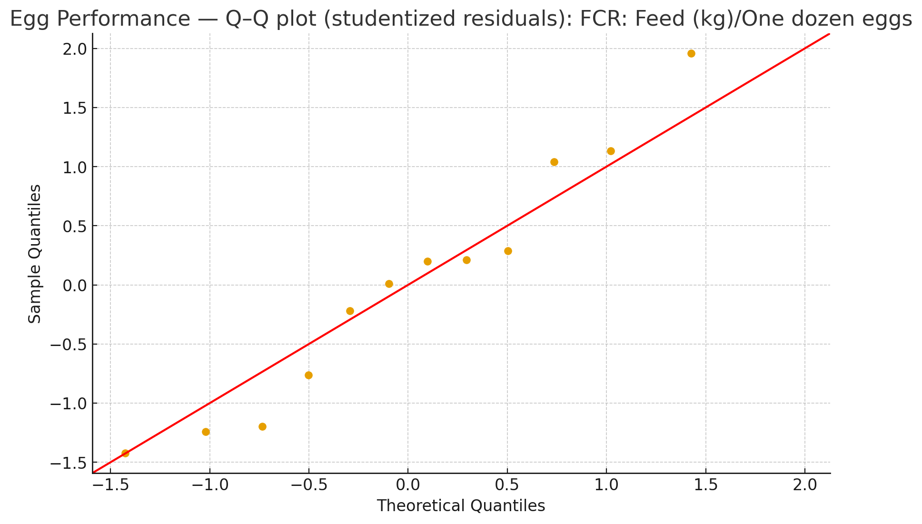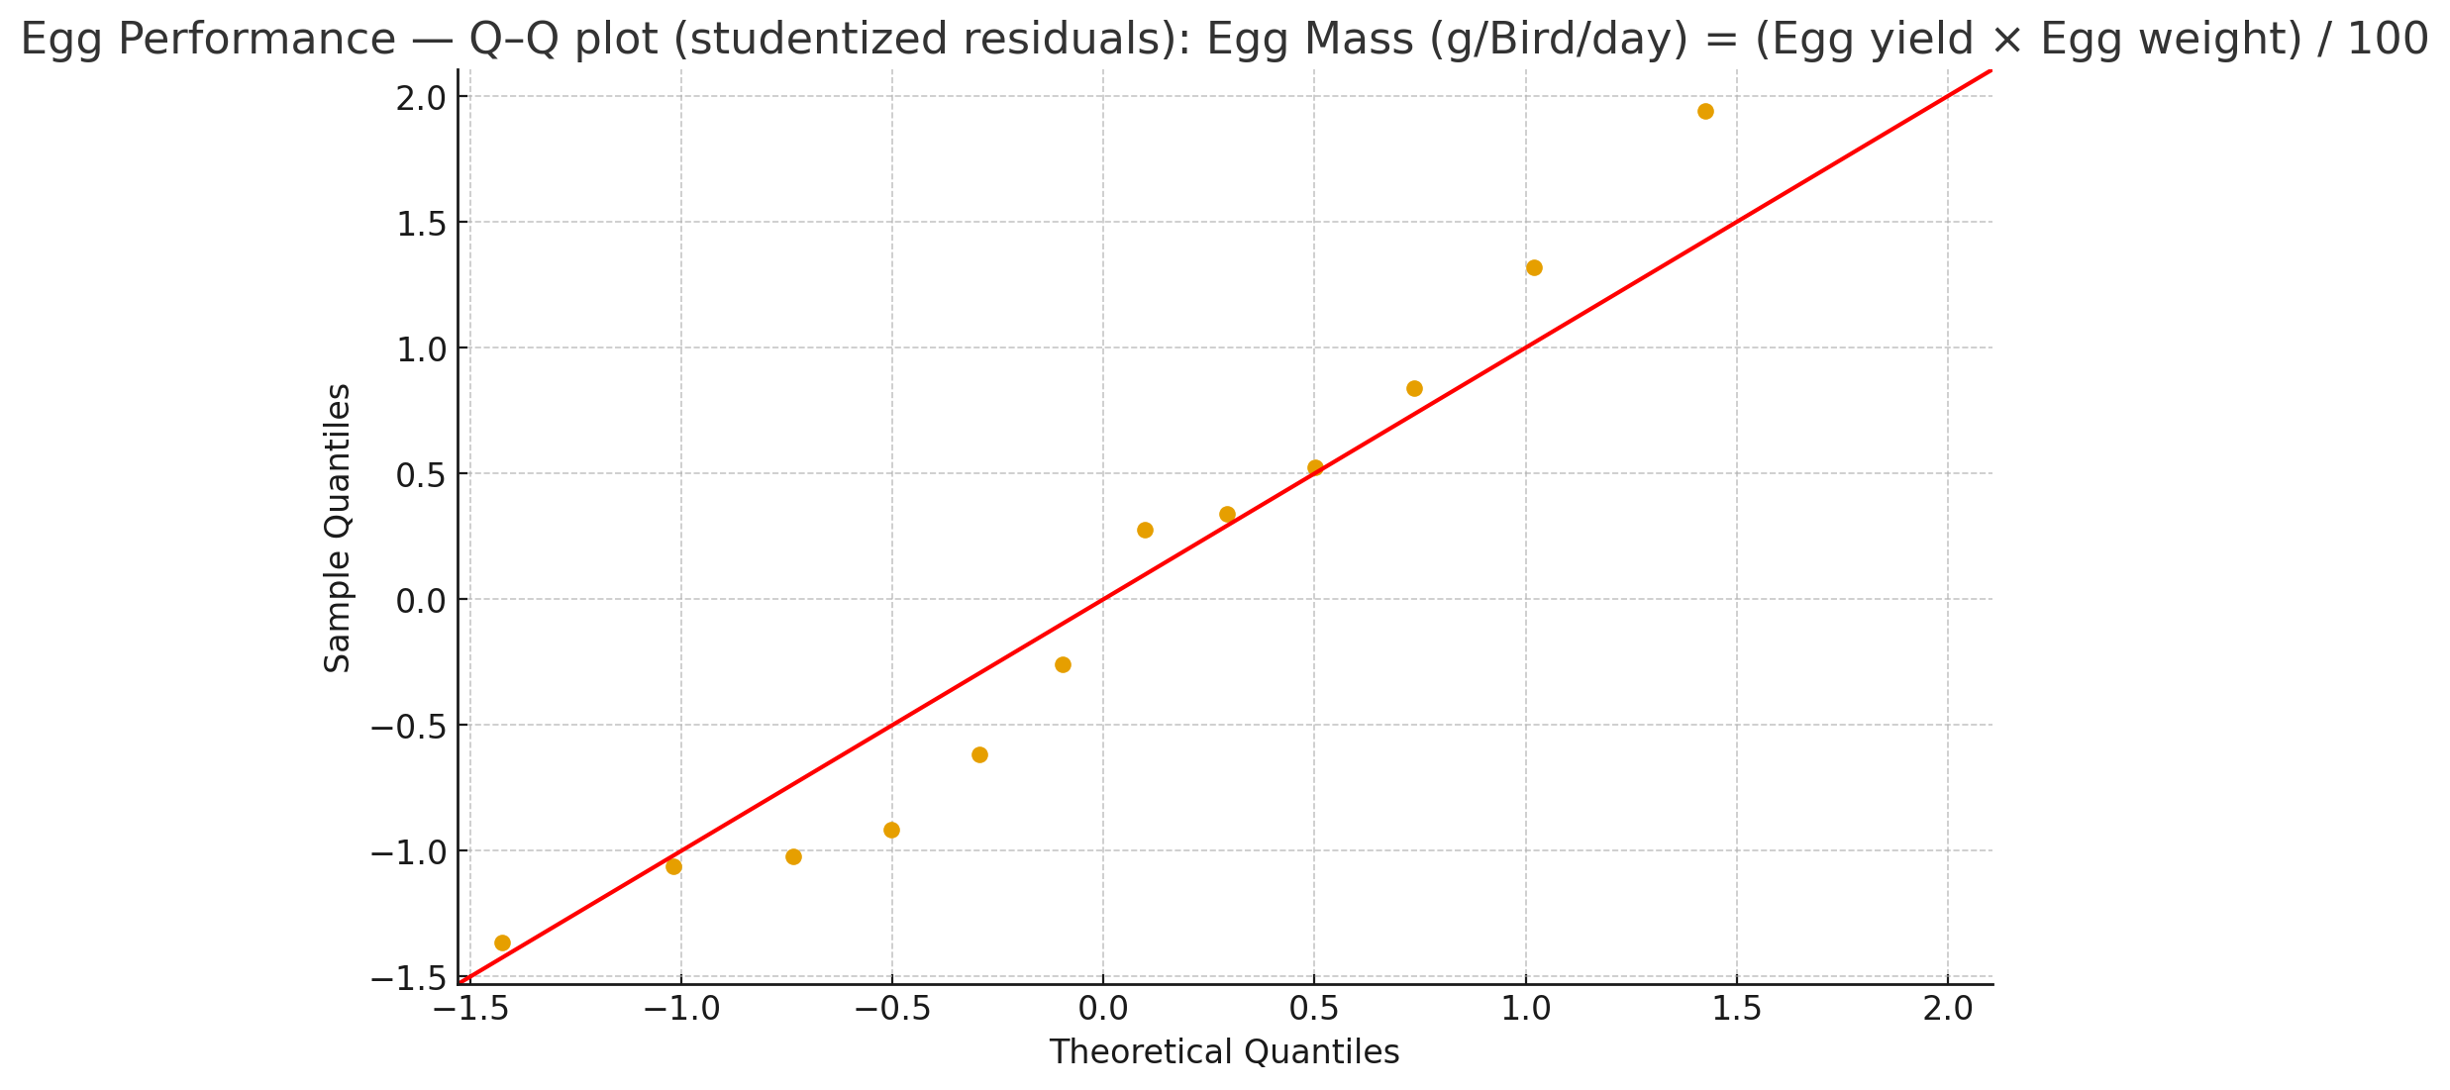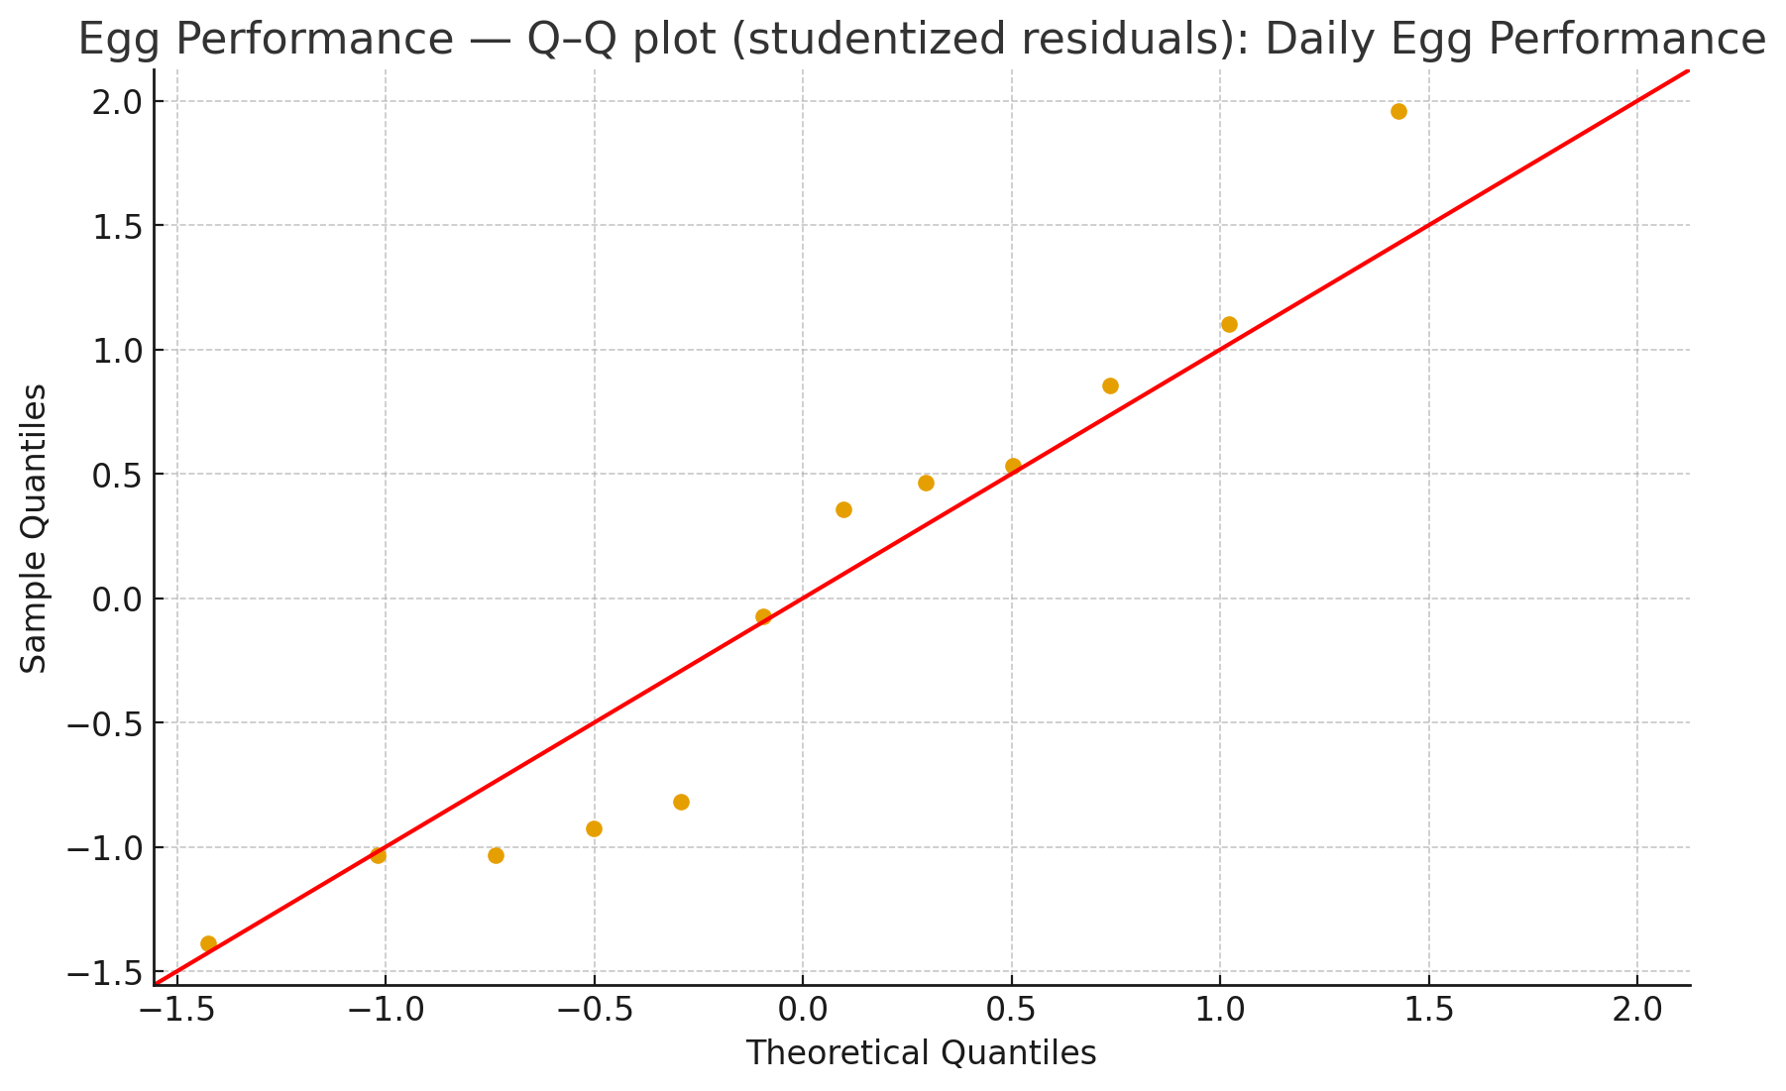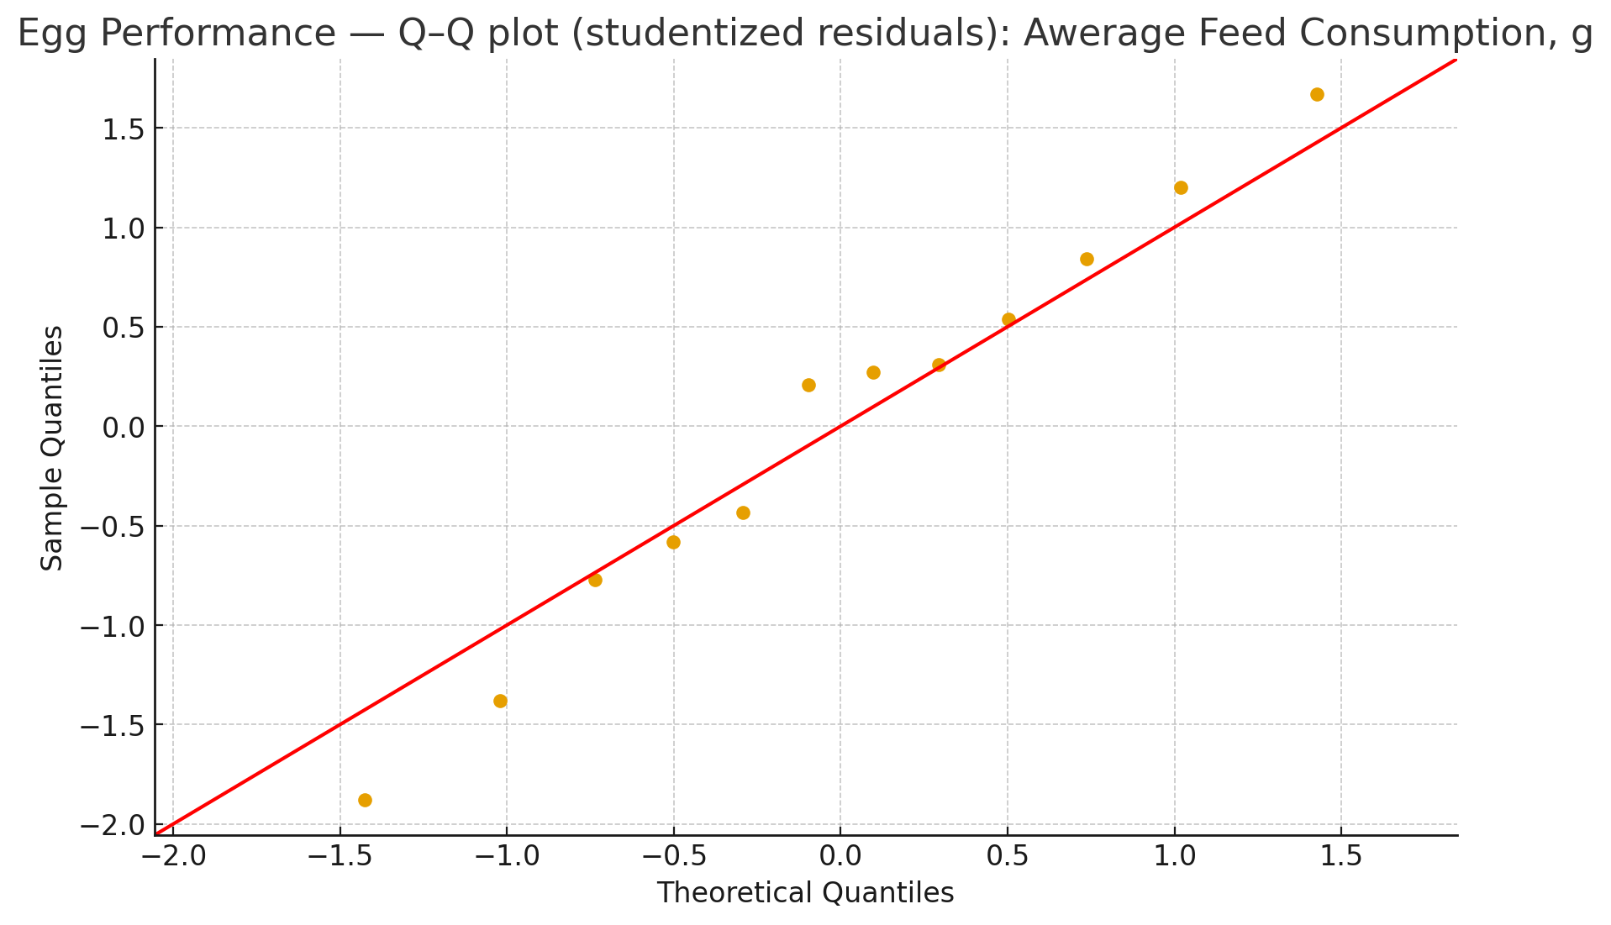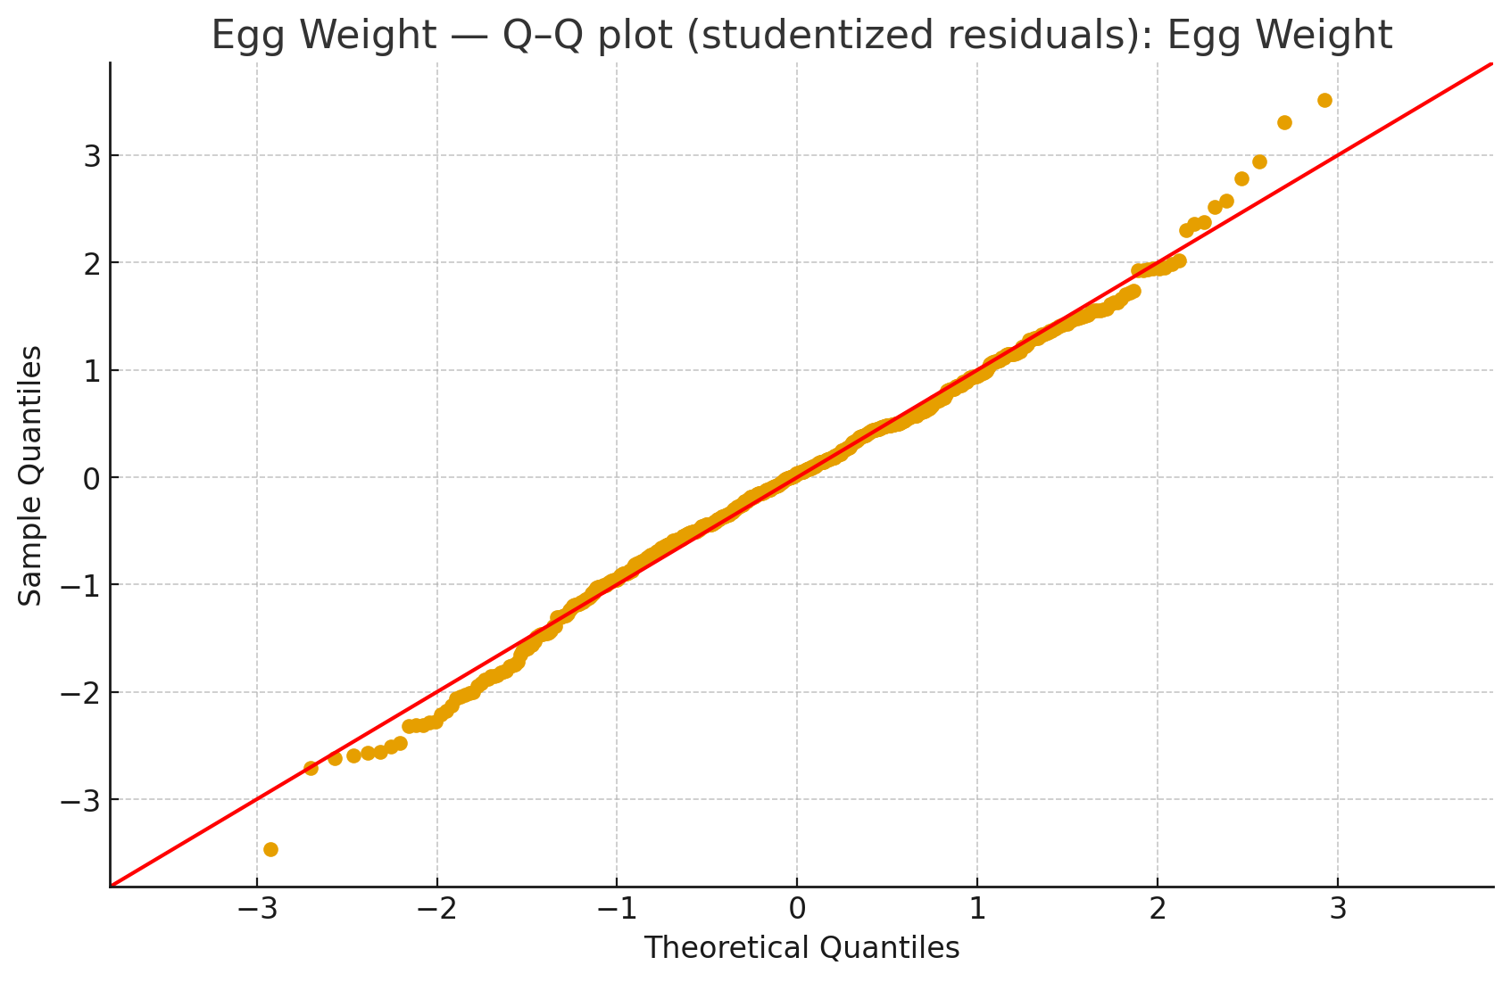
Fig. S1. Q–Q plots of studentized residuals for each trait shown in Table 1.

Table S2. Shapiro–Wilk and Levene’s tests on ANOVA studentized residuals for each trait shown in Table 2; ANOVA and Kruskal-Wallis p-values for Group.
Response | N | k Groups | Shapiro-Wilk W | Shapiro p | Levene stat | Levene p | ANOVA p | Kruskal H | Kruskal p
EG | 120 | 4 | 0.985 | 0.192 | 1.930 | 0.130 | 0.287 | 3.920 | 0.270
SI | 120 | 4 | 0.959 | 0.001 | 0.320 | 0.810 | 0.002 | 16.840 | 0.000
EWI | 120 | 4 | 0.995 | 0.932 | 0.411 | 0.745 | 0.079 | 8.154 | 0.043
YI | 120 | 4 | 0.987 | 0.281 | 1.351 | 0.261 | 0.930 | 0.649 | 0.885
HU | 120 | 4 | 0.999 | 0.532 | 0.721 | 0.541 | 0.085 | 7.222 | 0.065
YC | 120 | 4 | 0.893 | 0.000 | 2.109 | 0.103 | 0.000 | 87.010 | 0.000
YW | 120 | 4 | 0.986 | 0.253 | 1.584 | 0.197 | 0.076 | 4.319 | 0.229
SW | 120 | 4 | 0.795 | 0.000 | 1.165 | 0.326 | 0.276 | 6.394 | 0.094
ST | 120 | 4 | 0.990 | 0.563 | 1.786 | 0.153 | 0.660 | 1.684 | 0.641
EG: Egg Weight; SI: Shape Index; EWI: Egg Weight Index; YI: Yellow Index; HU: Yellow Index; YC: Yellow Index; YW: Yellow Weight; SW: Shell Weight; ST: Shell Thickness
Q–Q plots of studentized residuals for each trait are as follows:
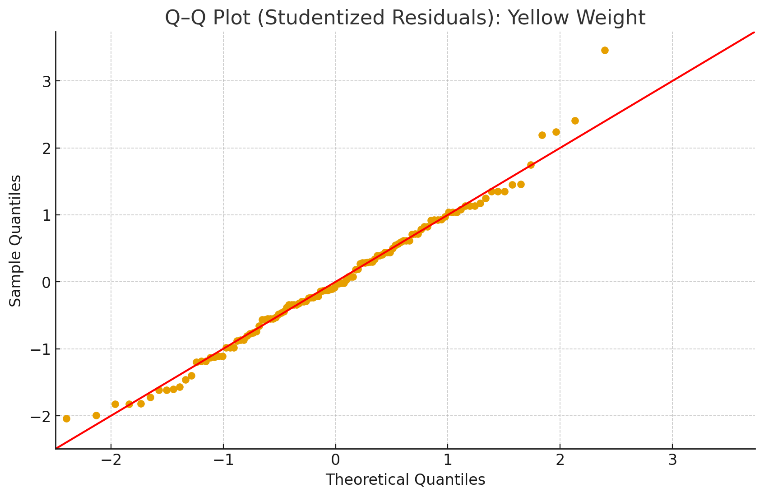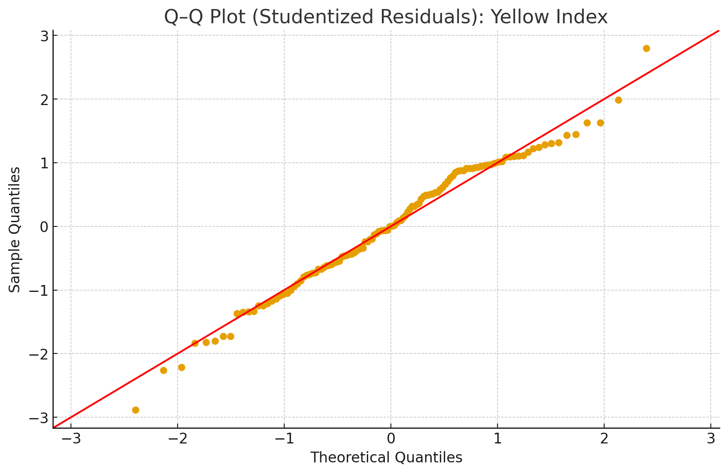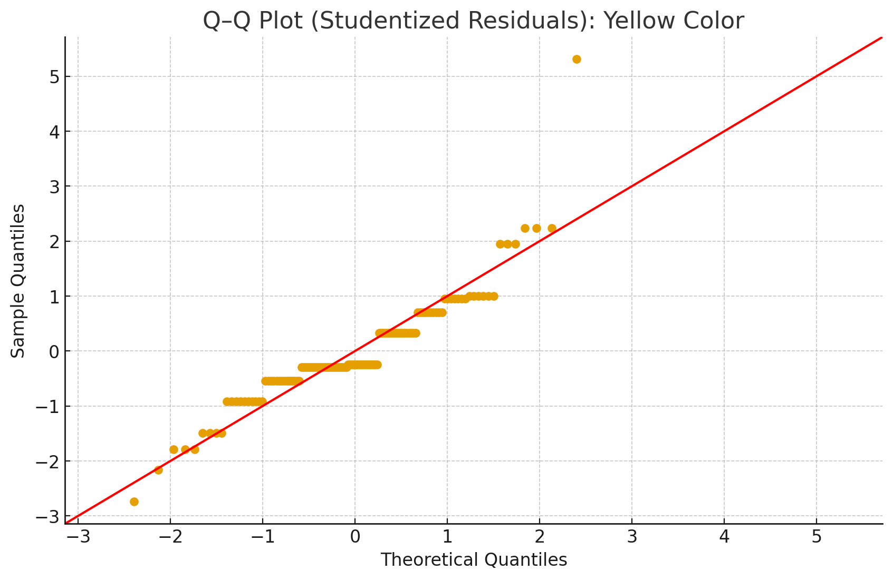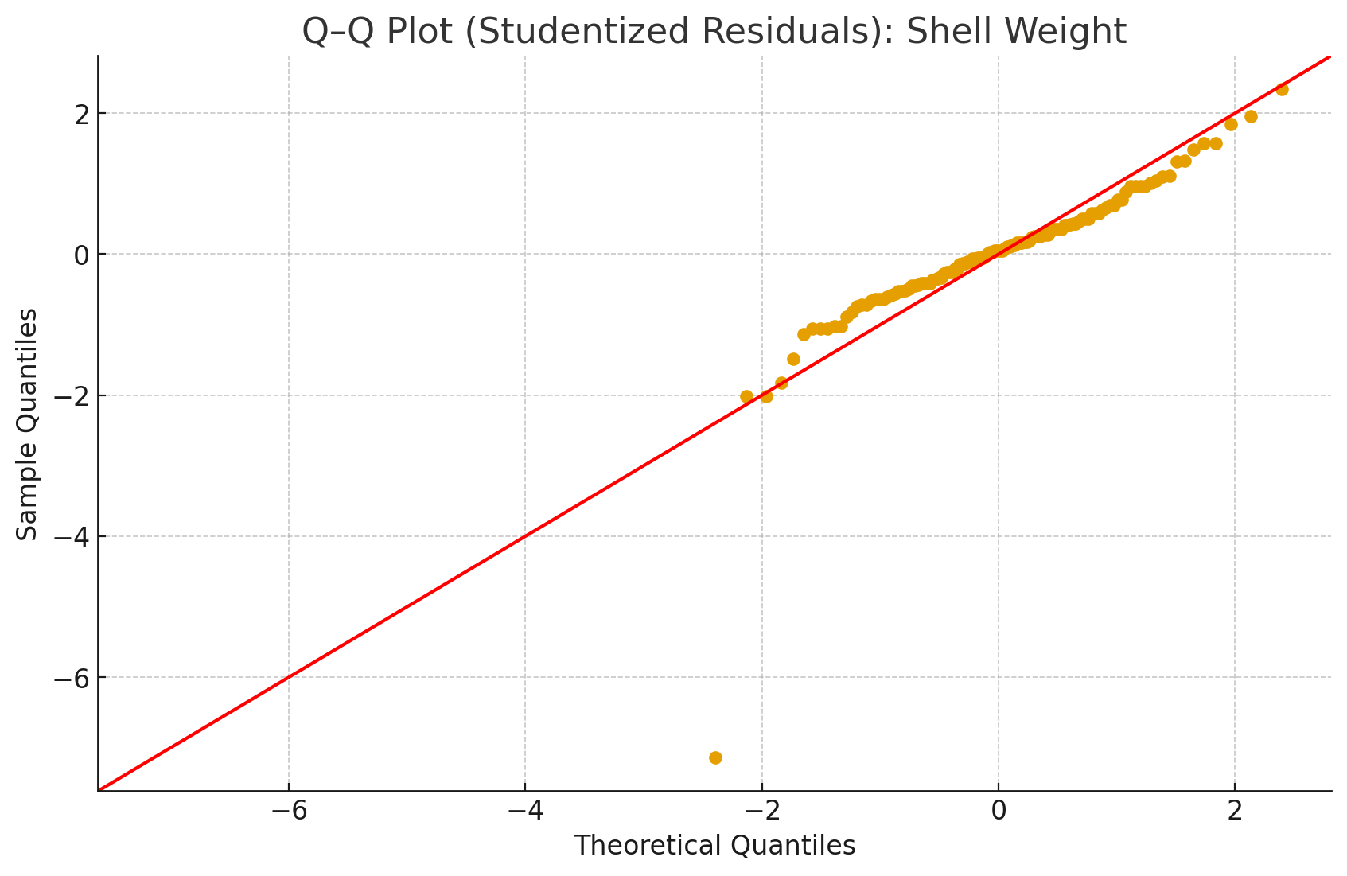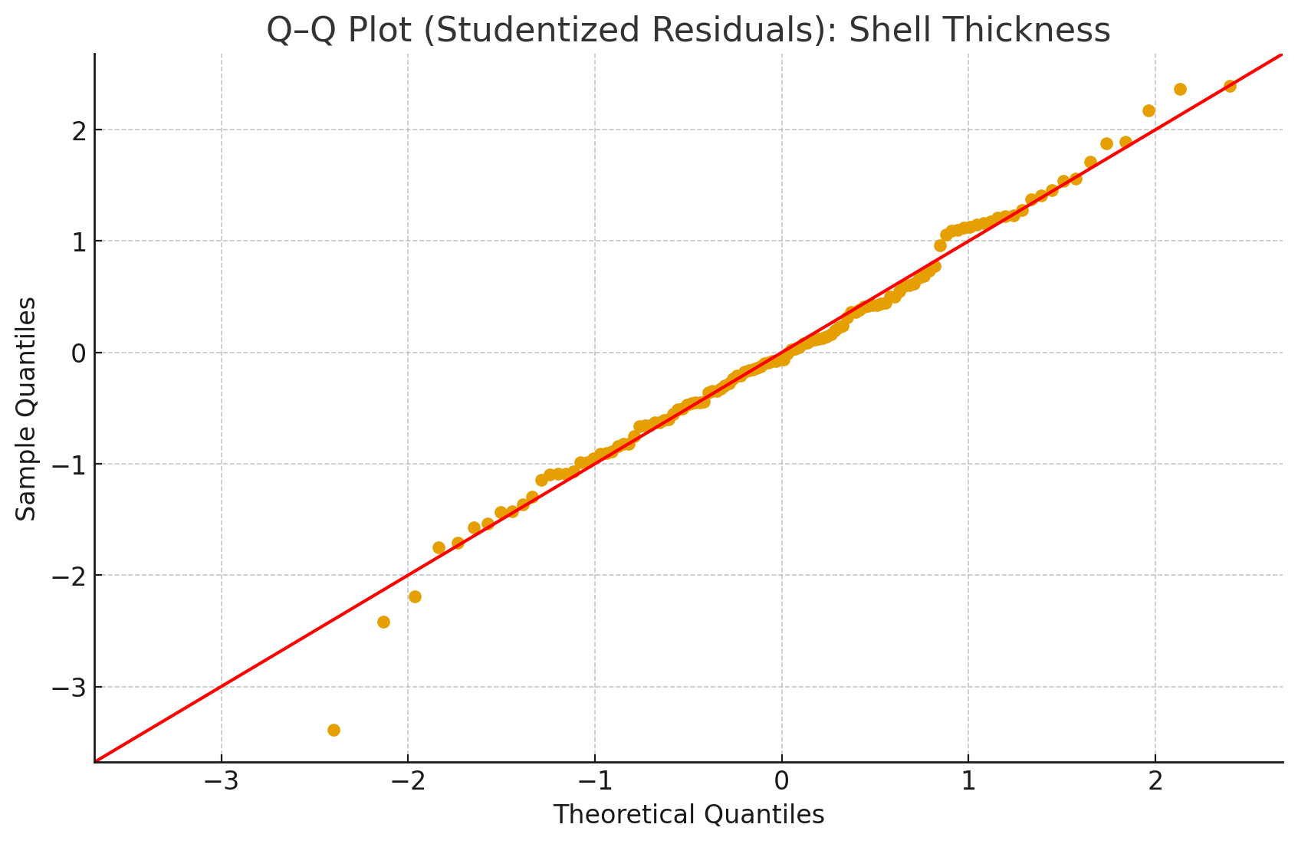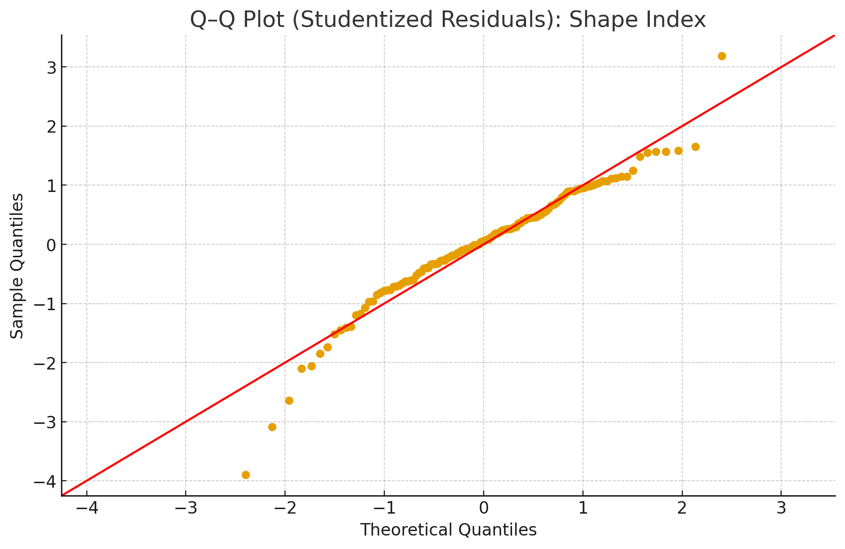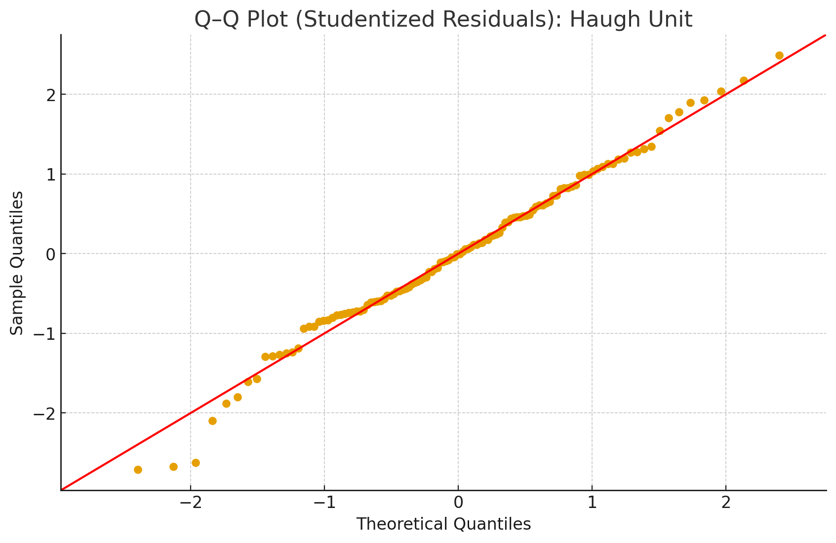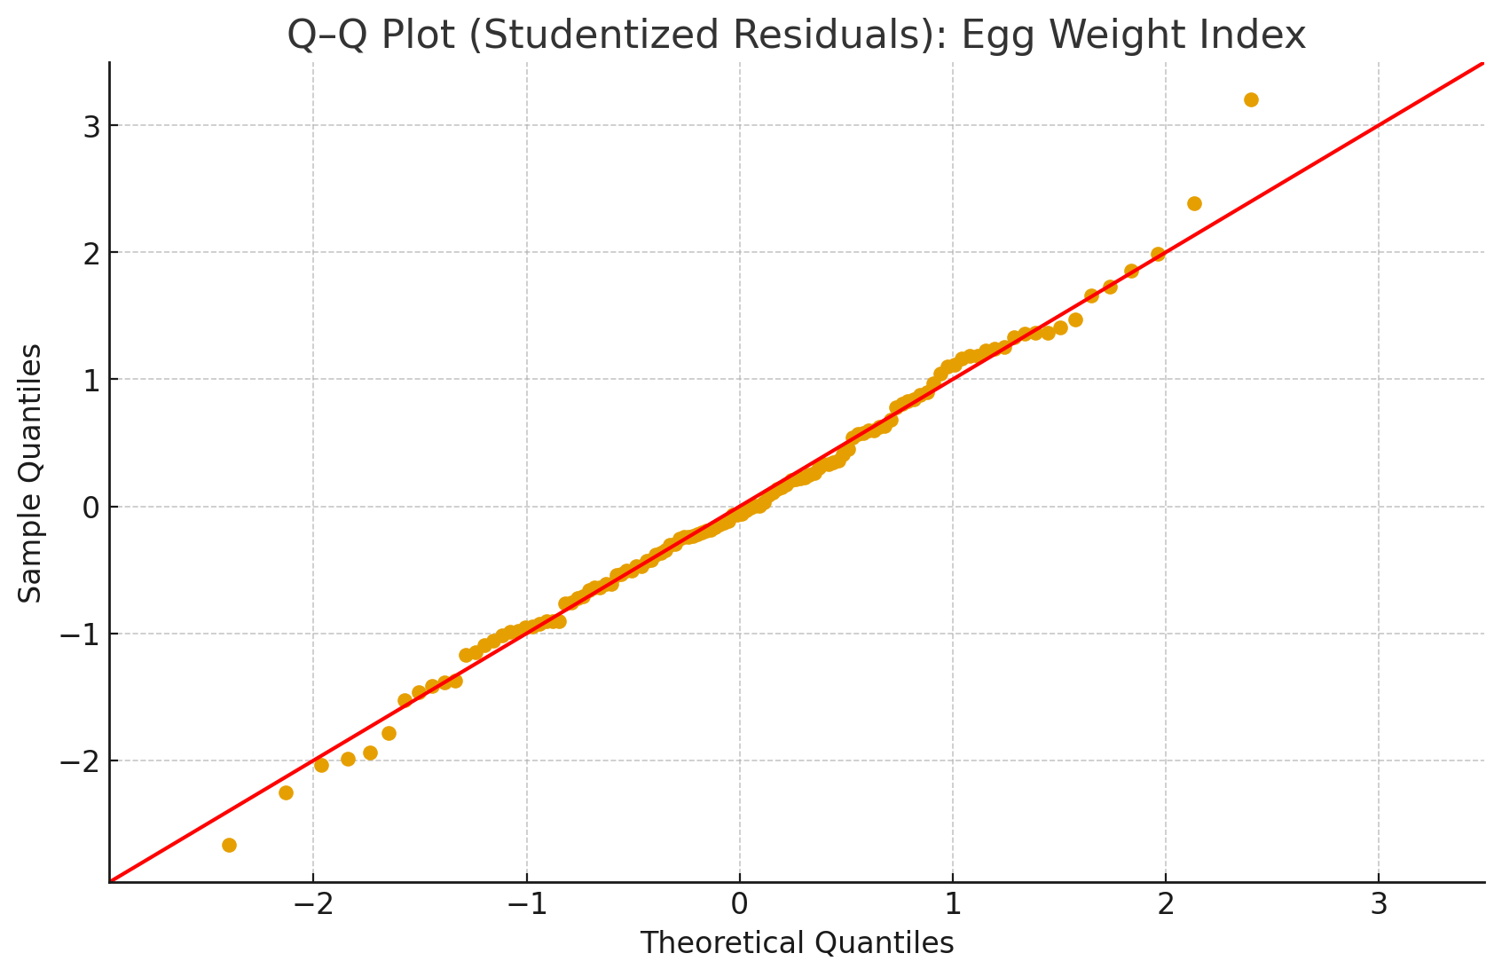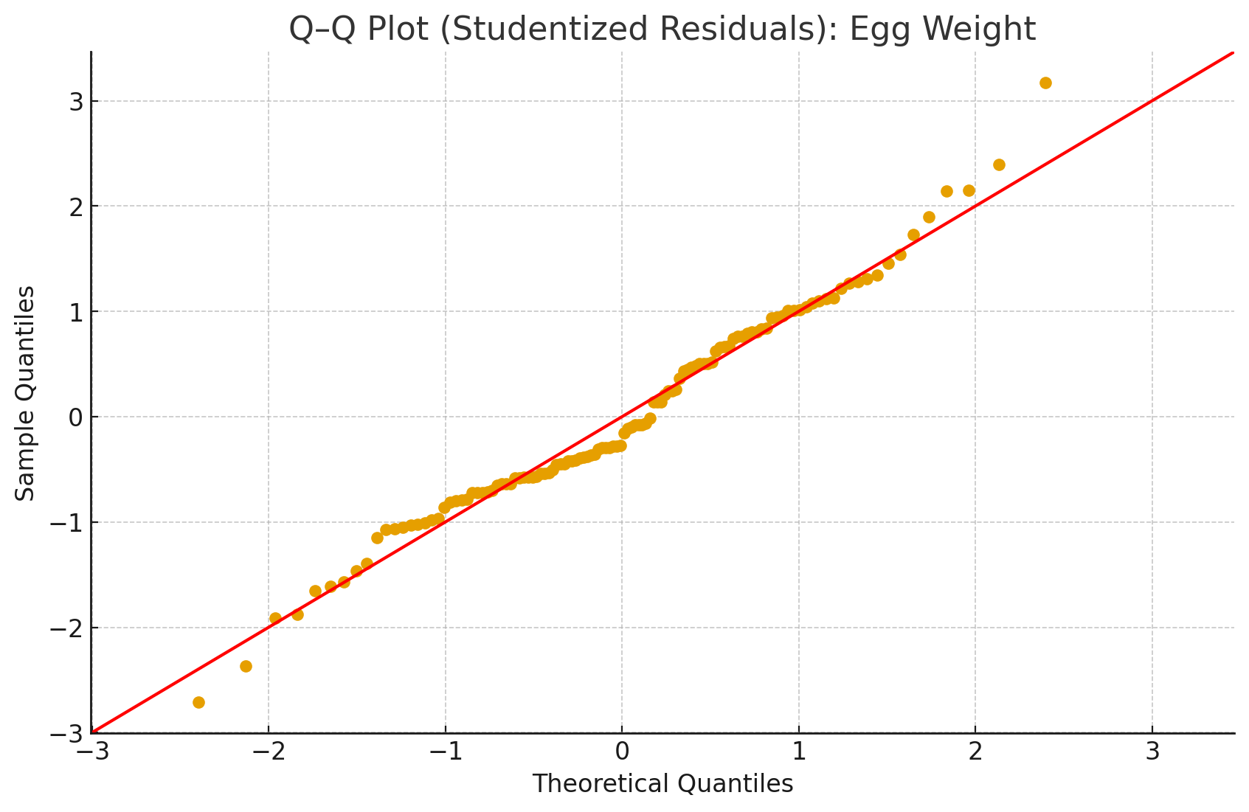
Fig. S2. Q–Q plots of studentized residuals for each trait shown in Table 2.

