Supplement 1.

< No initial parameters provided >

Column Classifications:
--------------------------------------------------
ID Column: Subject
Time Column: Time
Concentration Column: conc
Covariate Columns:
- Wt
- Dose
NCA analysis completed. Success rate: 12/12 subjects
Metrics calculated using 132 valid data points

===============================================
PK Analysis Summary
===============================================

FINAL PARAMETER ESTIMATES
-----------------------------------------------
Parameter Estimate CV% [95% CI]
-----------------------------------------------
Ka 1.284 121.8 [0.555, 8.179]
CL 2.794 23.3 [1.627, 3.869]
V 31.732 17.8 [23.648, 41.263]

BETWEEN-SUBJECT VARIABILITY (CV%)
-----------------------------------------------
Ka 79.8%
CL 26.3%
V 18.0%

RESIDUAL VARIABILITY
-----------------------------------------------
Proportional Error (CV%): 14.4%

GOODNESS-OF-FIT STATISTICS
-----------------------------------------------
R-squared: 0.933
RMSE: 0.740
MAE: 0.428
Mean Residual: 0.098

NCA PARAMETERS SUMMARY
-----------------------------------------------
Cmax Tmax AUC AUMC MRT half_life clearance \
count 12.000 12.000 12.000 12.000 12.000 12.000 12.000
mean 8.759 1.788 103.807 883.057 8.410 8.149 3.222
std 1.473 1.112 23.645 262.982 0.594 2.119 0.679
min 6.440 0.630 73.776 609.152 7.707 6.287 2.149
25% 7.890 1.015 88.002 706.247 8.135 6.927 2.660
50% 8.465 1.135 95.407 792.803 8.304 7.670 3.360
75% 9.865 2.385 120.307 987.689 8.483 8.409 3.637
max 11.400 3.550 148.923 1459.071 9.797 14.304 4.337

Vss Subject_ID Ka CL V
count 12.000 12.000 12.000 12.000 12.000
mean 26.840 5.500 2.054 2.884 32.346
std 4.735 3.606 2.613 0.702 6.002
min 21.052 0.000 0.541 1.528 22.872
25% 22.027 2.750 0.799 2.512 28.597
50% 26.532 5.500 1.143 3.057 31.792
75% 30.312 8.250 1.666 3.248 37.819
max 35.814 11.000 9.842 3.948 41.773
NCA Success Rate: 100.0%

SIGNIFICANT COVARIATES
-----------------------------------------------
Ka-Dose: power
V-Wt: power

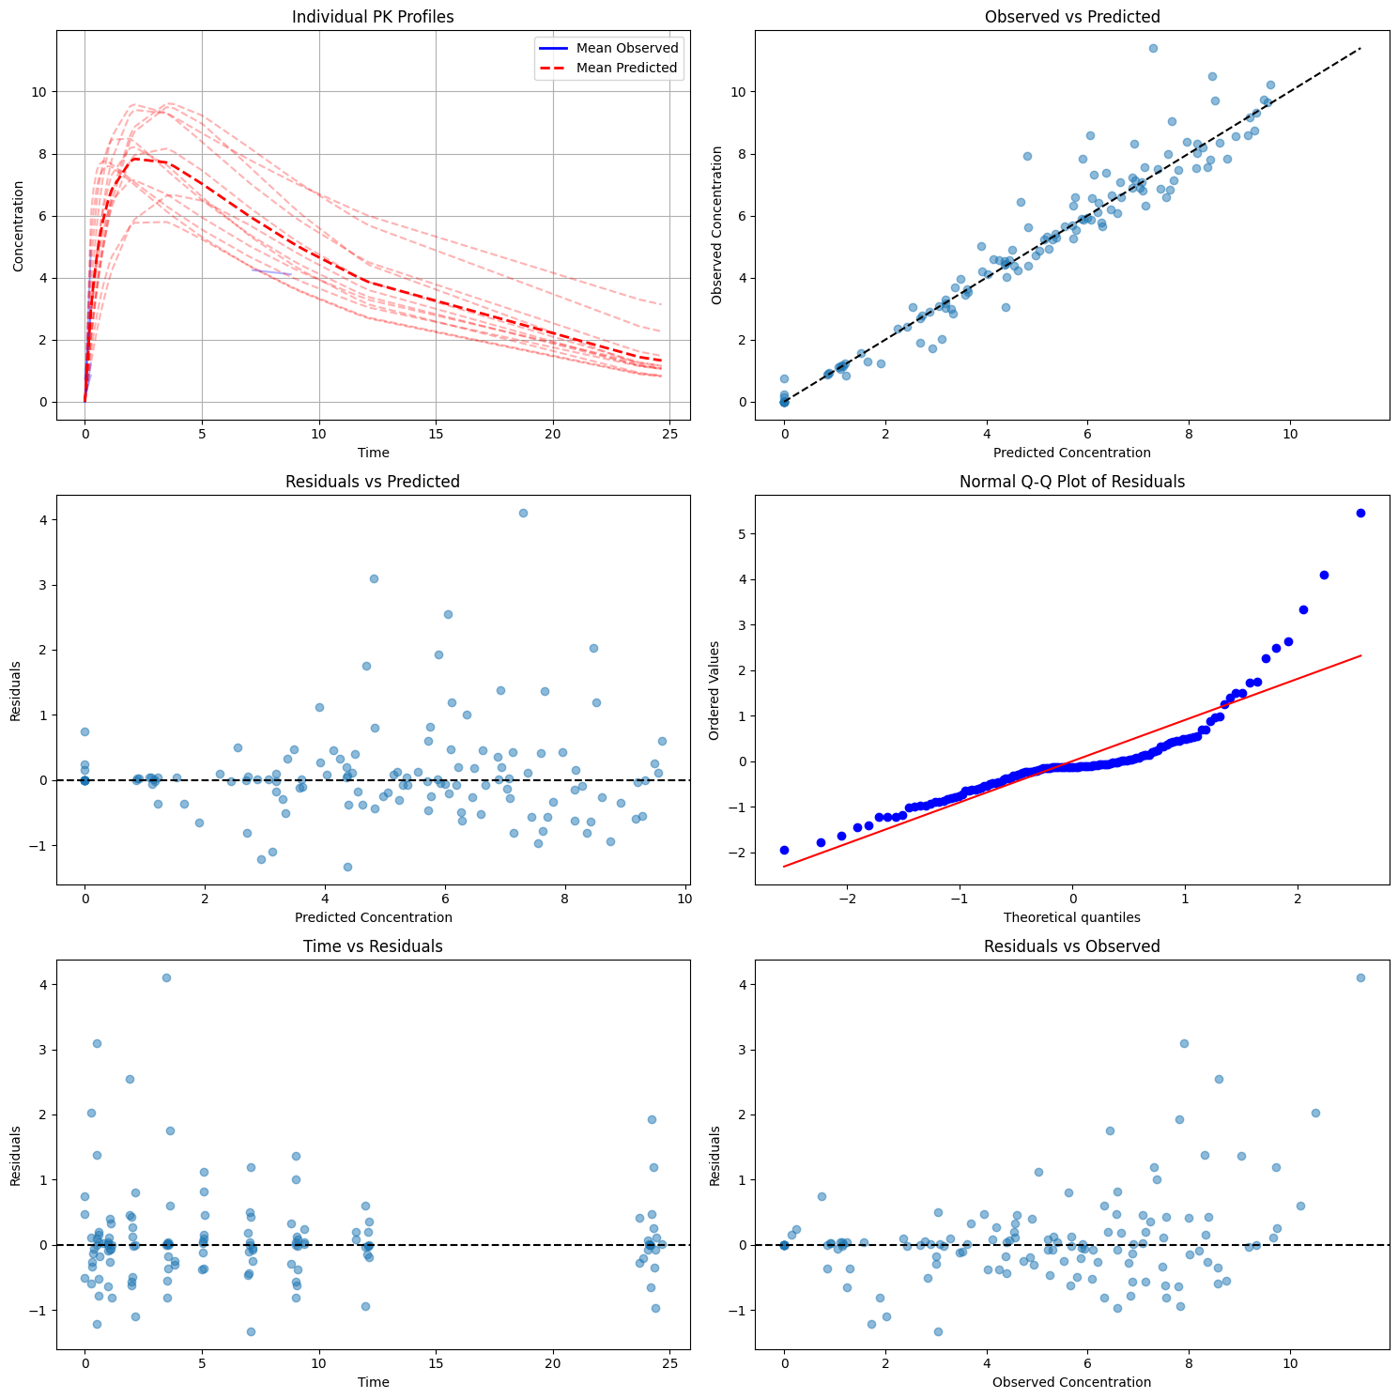

< Provide initial parameters >
Column Classifications:
--------------------------------------------------
ID Column: Subject
Time Column: Time
Concentration Column: conc
Covariate Columns:
- Wt
- Dose
NCA analysis completed. Success rate: 12/12 subjects
Metrics calculated using 132 valid data points

===============================================
PK Analysis Summary
===============================================

FINAL PARAMETER ESTIMATES
-----------------------------------------------
Parameter Estimate CV% [95% CI]
-----------------------------------------------
Ka 1.284 80.5 [0.555, 4.668]
CL 2.794 23.3 [1.627, 3.869]
V 31.732 17.4 [23.648, 40.865]

BETWEEN-SUBJECT VARIABILITY (CV%)
-----------------------------------------------
Ka 67.0%
CL 26.3%
V 17.7%

RESIDUAL VARIABILITY
-----------------------------------------------
Proportional Error (CV%): 14.4%

GOODNESS-OF-FIT STATISTICS
-----------------------------------------------
R-squared: 0.933
RMSE: 0.740
MAE: 0.428
Mean Residual: 0.098

NCA PARAMETERS SUMMARY
-----------------------------------------------
Cmax Tmax AUC AUMC MRT half_life clearance \
count 12.000 12.000 12.000 12.000 12.000 12.000 12.000
mean 8.759 1.788 103.807 883.057 8.410 8.149 3.222
std 1.473 1.112 23.645 262.982 0.594 2.119 0.679
min 6.440 0.630 73.776 609.152 7.707 6.287 2.149
25% 7.890 1.015 88.002 706.247 8.135 6.927 2.660
50% 8.465 1.135 95.407 792.803 8.304 7.670 3.360
75% 9.865 2.385 120.307 987.689 8.483 8.409 3.637
max 11.400 3.550 148.923 1459.071 9.797 14.304 4.337

Vss Subject_ID Ka CL V
count 12.000 12.000 12.000 12.000 12.000
mean 26.840 5.500 1.650 2.884 32.225
std 4.735 3.606 1.387 0.702 5.848
min 21.052 0.000 0.541 1.528 22.873
25% 22.027 2.750 0.799 2.512 28.597
50% 26.532 5.500 1.143 3.057 31.791
75% 30.312 8.250 1.666 3.250 37.819
max 35.814 11.000 5.000 3.948 41.774
NCA Success Rate: 100.0%

SIGNIFICANT COVARIATES
-----------------------------------------------
Ka-Dose: power
V-Wt: power

===============================================

============================================
NCA Analysis Summary
============================================

Analysis Success Rate: 100.0%

Parameter Estimates
--------------------------------------------

Cmax:
N = 12 (missing: 0)
Arithmetic mean ± SD: 8.759 ± 1.410
CV%: 16.1
Geometric mean (CV%): 8.646 (16.2%)
Median: 8.465
Range: [6.440, 11.400]

Tmax:
N = 12 (missing: 0)
Arithmetic mean ± SD: 1.788 ± 1.065
CV%: 59.6
Geometric mean (CV%): 1.515 (61.4%)
Median: 1.135
Range: [0.630, 3.550]

AUC:
N = 12 (missing: 0)
Arithmetic mean ± SD: 103.807 ± 22.639
CV%: 21.8
Geometric mean (CV%): 101.482 (21.3%)
Median: 95.407
Range: [73.776, 148.923]

half_life:
N = 12 (missing: 0)
Arithmetic mean ± SD: 8.149 ± 2.029
CV%: 24.9
Geometric mean (CV%): 7.955 (20.9%)
Median: 7.670
Range: [6.287, 14.304]

clearance:
N = 12 (missing: 0)
Arithmetic mean ± SD: 3.222 ± 0.650
CV%: 20.2
Geometric mean (CV%): 3.153 (21.3%)
Median: 3.360
Range: [2.149, 4.337]

MRT:
N = 12 (missing: 0)
Arithmetic mean ± SD: 8.410 ± 0.569
CV%: 6.8
Geometric mean (CV%): 8.392 (6.6%)
Median: 8.304
Range: [7.707, 9.797]

Vss:
N = 12 (missing: 0)
Arithmetic mean ± SD: 26.840 ± 4.533
CV%: 16.9
Geometric mean (CV%): 26.462 (17.0%)
Median: 26.532
Range: [21.052, 35.814]

Quality Checks
--------------------------------------------

AUC extrapolation:
Mean %: nan
Subjects with >20% extrapolation: 0

Sampling Schedule:
Minimum time gap (absorption): 0.02 h
Maximum time gap (elimination): 0.22 h
Total observation period: 24.6 h

