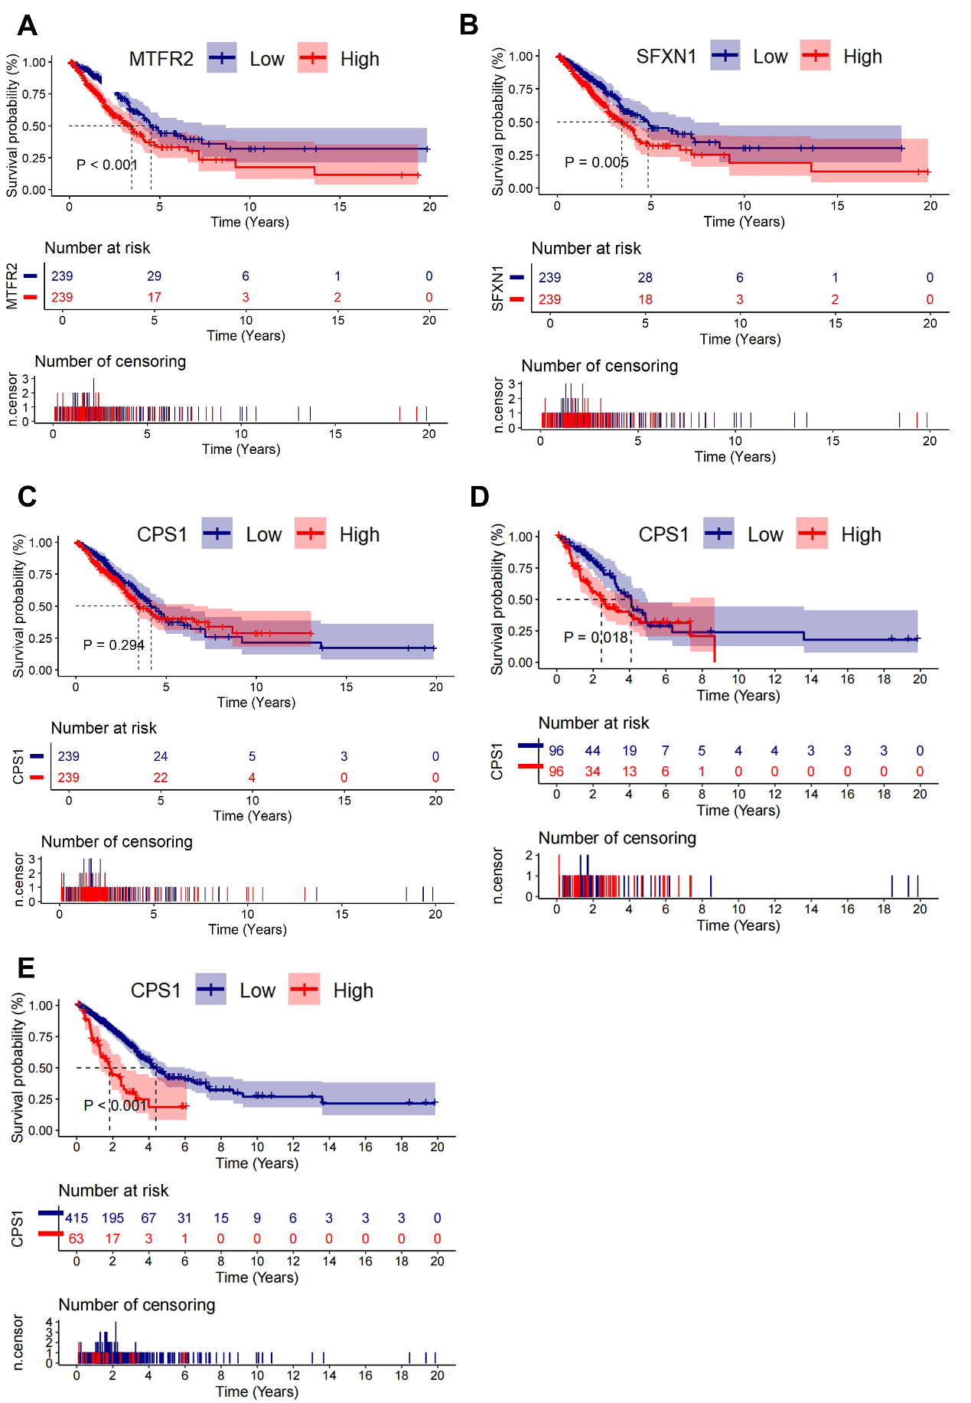
Fig.S1 Kaplan-Meier curves comparing OS between LUAD patients with high versus low MTR genes expression.
- Kaplan-Meier curves comparing OS between LUAD patients with high versus low MTFR2 expression (log-rank P<0.001).
- Kaplan-Meier curves comparing OS between LUAD patients with high versus low SFXN1 expression (log-rank P=0.005).
- Kaplan-Meier curves comparing OS between LUAD patients with high versus low CPS1 expression, using the median value as the cutoff (log-rank P=0.294).
- Kaplan-Meier curves comparing OS between LUAD patients with high versus low CPS1 expression, using the 20th and 80th percentiles as the cutoffs (high expression: ≥80th percentile; low expression: ≤20th percentile; log-rank P=0.018).
- Kaplan-Meier curves comparing OS between LUAD patients with high versus low CPS1 expression, using the optimal cutoff value (7.33) identified by X-tile (high expression: ＞7.33; low expression: ≤7.33; log-rank P＜0.001)
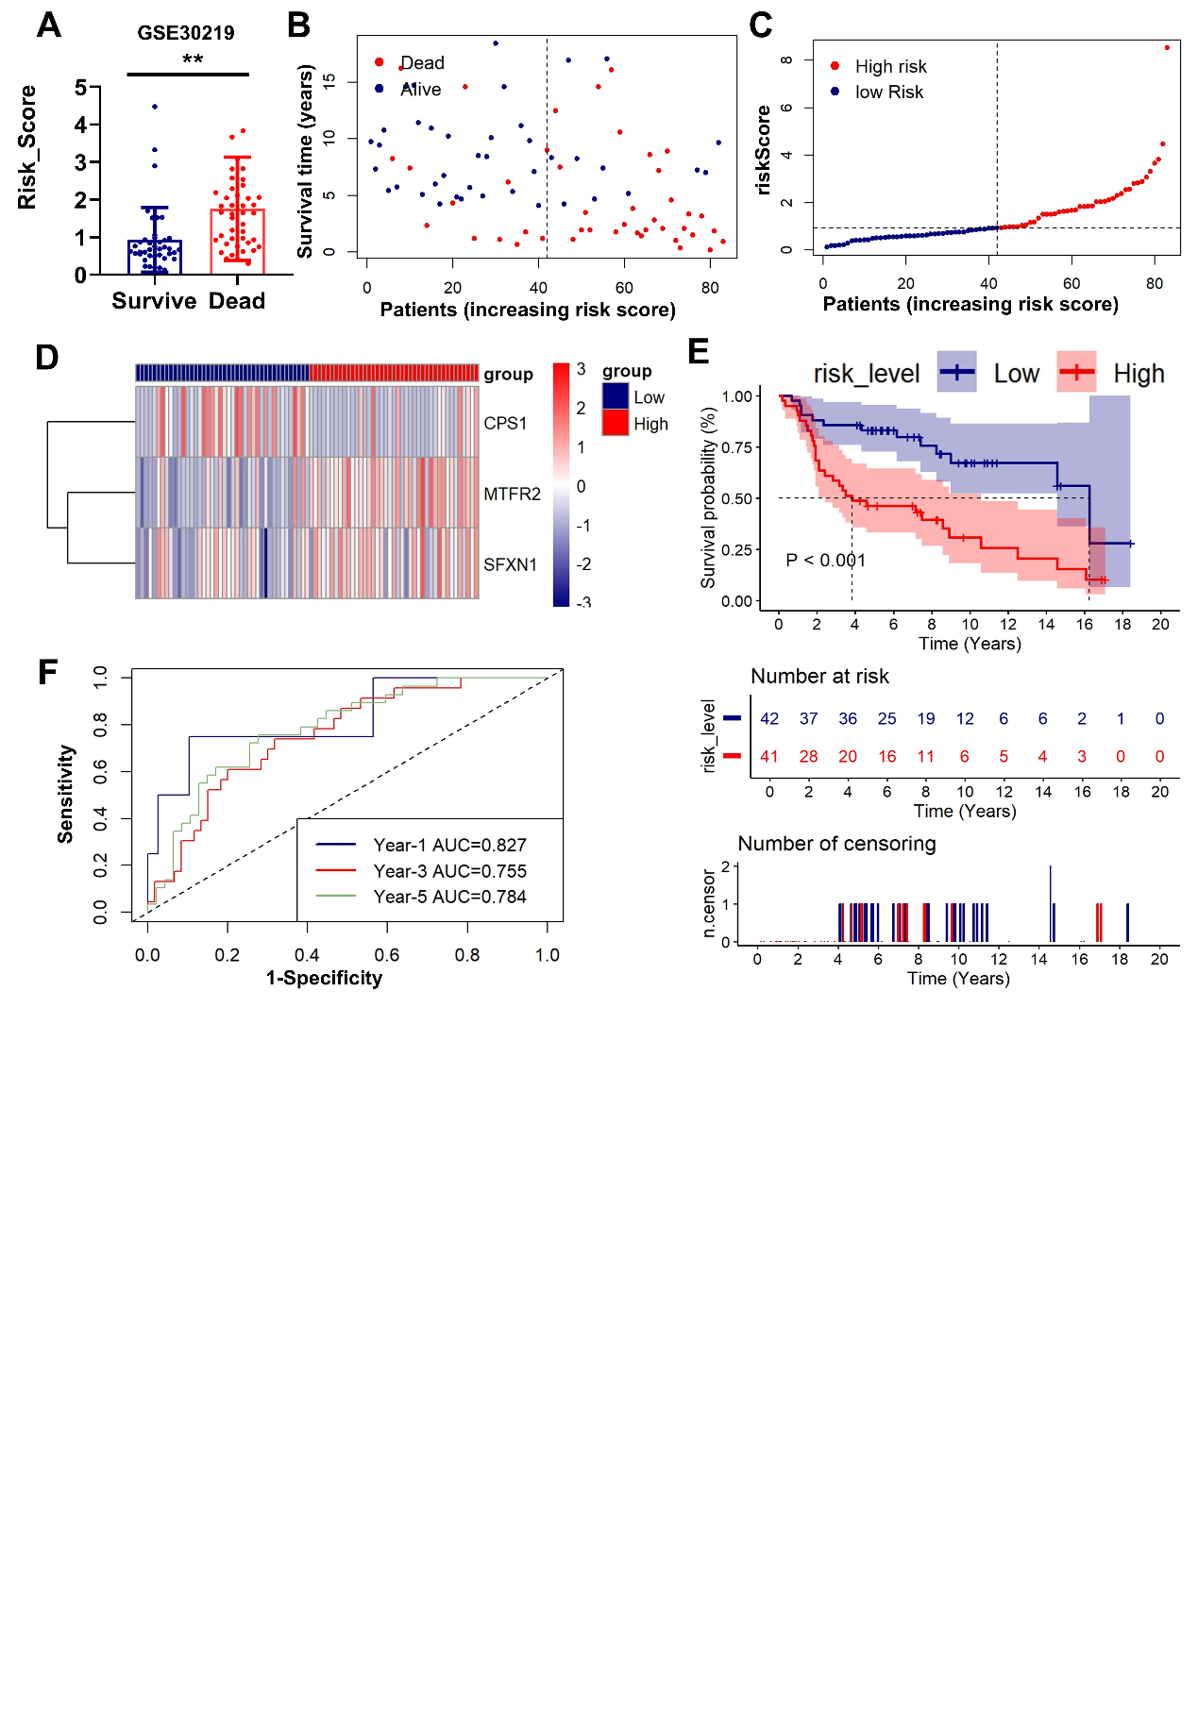
Fig. S2 External validation of the risk stratification model (GSE30219).
(A) The bar chart compares the risk scores of patients with different prognostic outcomes.
(B) Survival status/time matrix.
(C) Risk score distribution ordered by prognostic value.
(D) Three-gene expression heatmap. Dashed line indicates median risk cutoff.
(E) Kaplan-Meier curves comparing OS between risk subgroups (log-rank P=0.001).
(F) Time-dependent ROC curves with AUC values at 1-/3-/5-year intervals.
**P <0.01, ****P <0.0001.
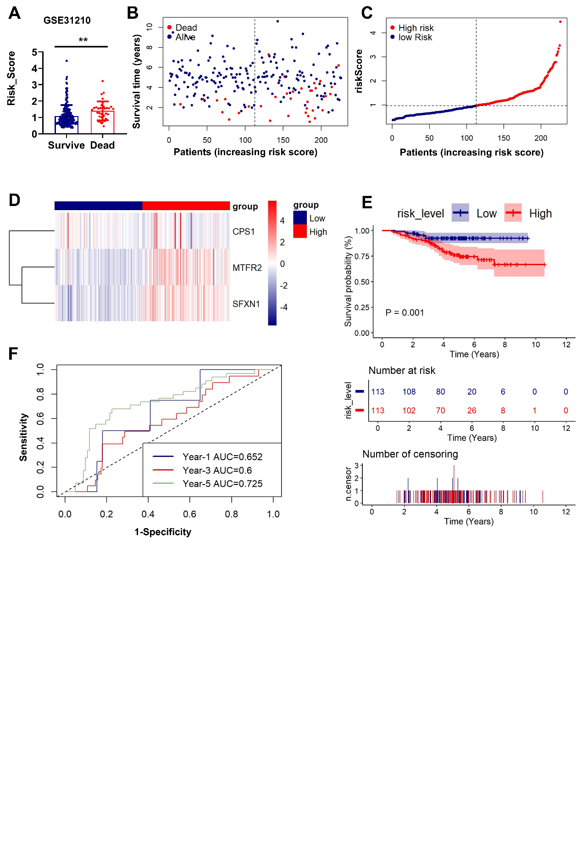
Fig. S3 External validation of the risk stratification model (GSE31210).
(A) The bar chart compares the risk scores of patients with different prognostic outcomes.
(B) Survival status/time matrix.
(C) Risk score distribution ordered by prognostic value.
(D) Three-gene expression heatmap. Dashed line indicates median risk cutoff.
(E) Kaplan-Meier curves comparing OS between risk subgroups (log-rank P=0.001).
(F) Time-dependent ROC curves with AUC values at 1-/3-/5-year intervals.
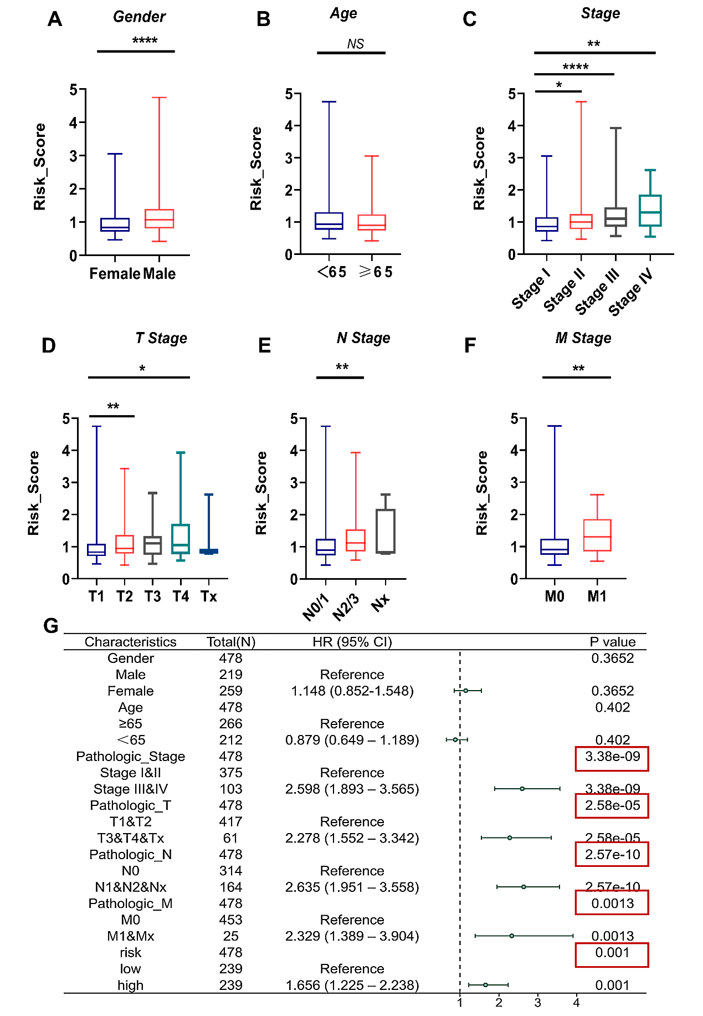
Fig. S4 Comparative risk score stratification across demographic and pathologic subgroups.
Horizontal bar plots comparing prognostic risk scores (y-axis: continuous z-score) among:
(A) Gender cohorts (Female vs Male);
(B) Age-stratified groups (<65 vs ≥65 years);
(C) Pathologic stage categories (Stage I vs II vs III vs IV);
(D) Pathologic stage T (T1 vs T2 vs T3 vs T4 vs Tx);
(E) Pathologic stage N (N0/1 vs N2/3 vs Nx);
(F) Pathologic stage M (M0 vs M1);
(G) Forest plots from univariate Cox regression analyses. Red boxes highlight risk score significance. NS represents no significance, *P <0.05, **P <0.01, ***P <0.001, ****P <0.0001.
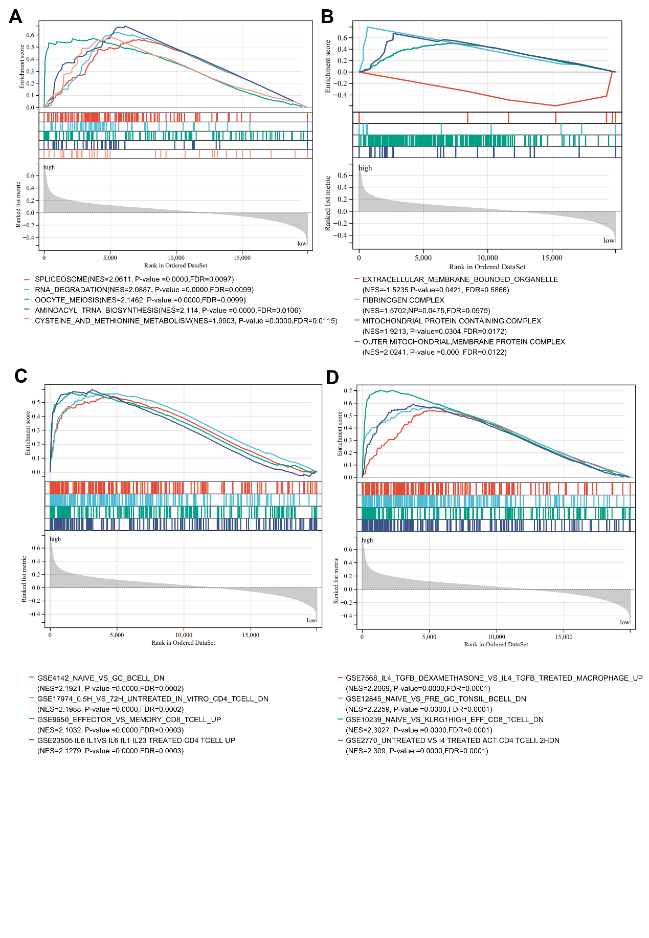
Fig. S5 Gene Set Enrichment Analysis (GSEA) of risk-associated pathways.
Enrichment plots from the GSEA. Several pathways and biological processes were differentially enriched in the low- and high-risk groups, including Extracellular Membrane Bounded Organelle, Fibrinogen Complex, Mitochondrial Protein Containing Complex, Outer Mitochondrial Membrane Protein Complex and Immune related pathways; NES, normalized enrichment score; FDR, false discovery rate.

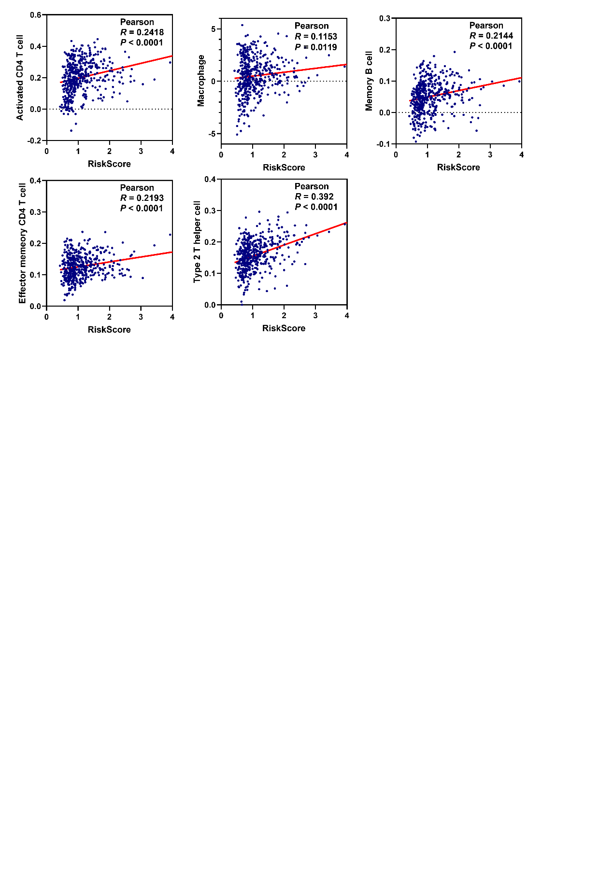
Fig.S6 Correlation analysis of risk scores and immune cells in LUAD (positive correlation).
Pearson correlation analysis diagrams and scatter plots indicating correlation between different immune cells infiltration levels and risk scores (positive correlation).

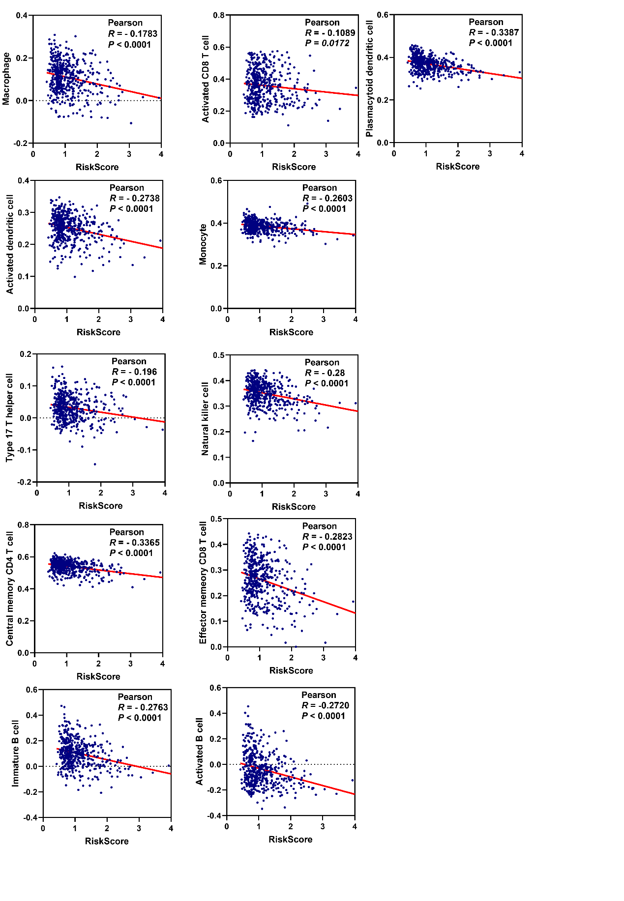
Fig.S7 Correlation analysis of risk scores and immune cells in LUAD (negative correlation).
Pearson correlation analysis diagrams and scatter plots indicating correlation between different immune cells infiltration levels and risk scores (negative correlation).

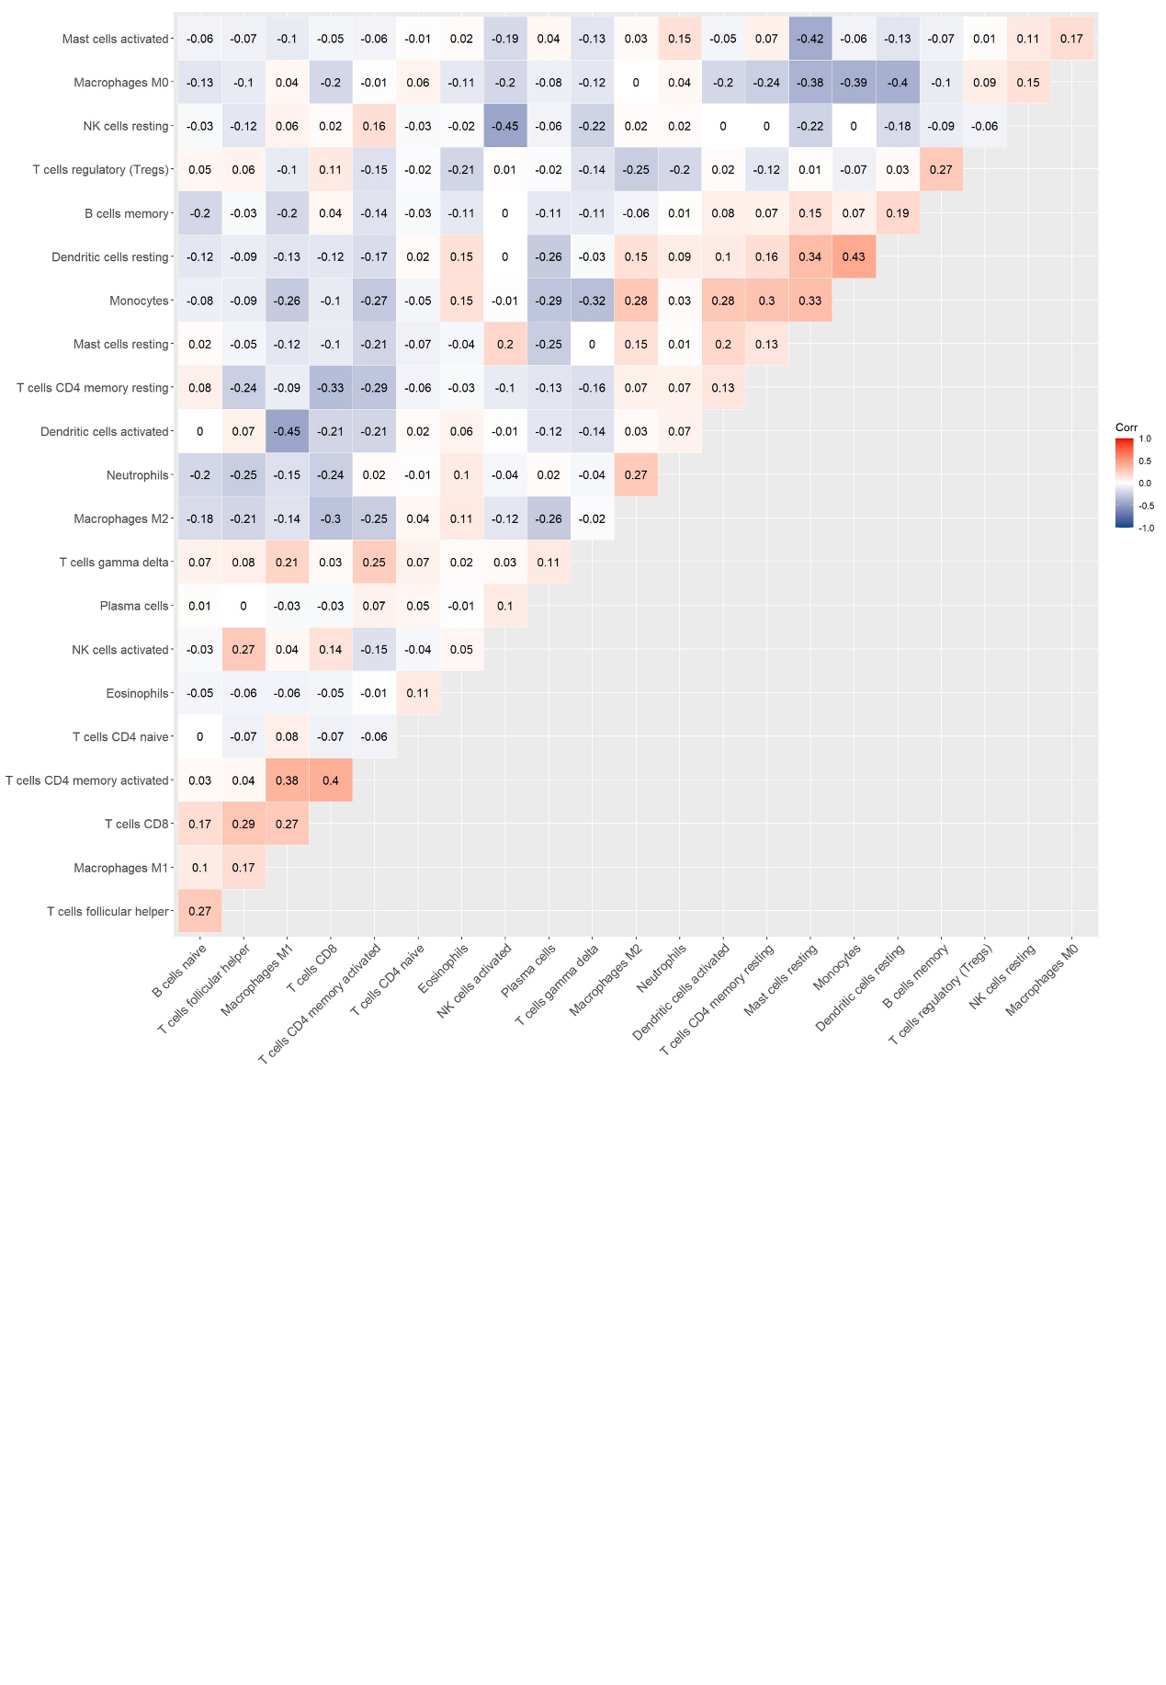
Fig.S8 Heatmap of correlation analysis.
Heatmap showing the correlation between 21 kinds of TICs and numeric in each tiny box indicating the P value of correlation between two kinds of cells. The shade of each tiny color box represented corresponding correlation value between two cells, and Pearson coefficient was used for significance test.
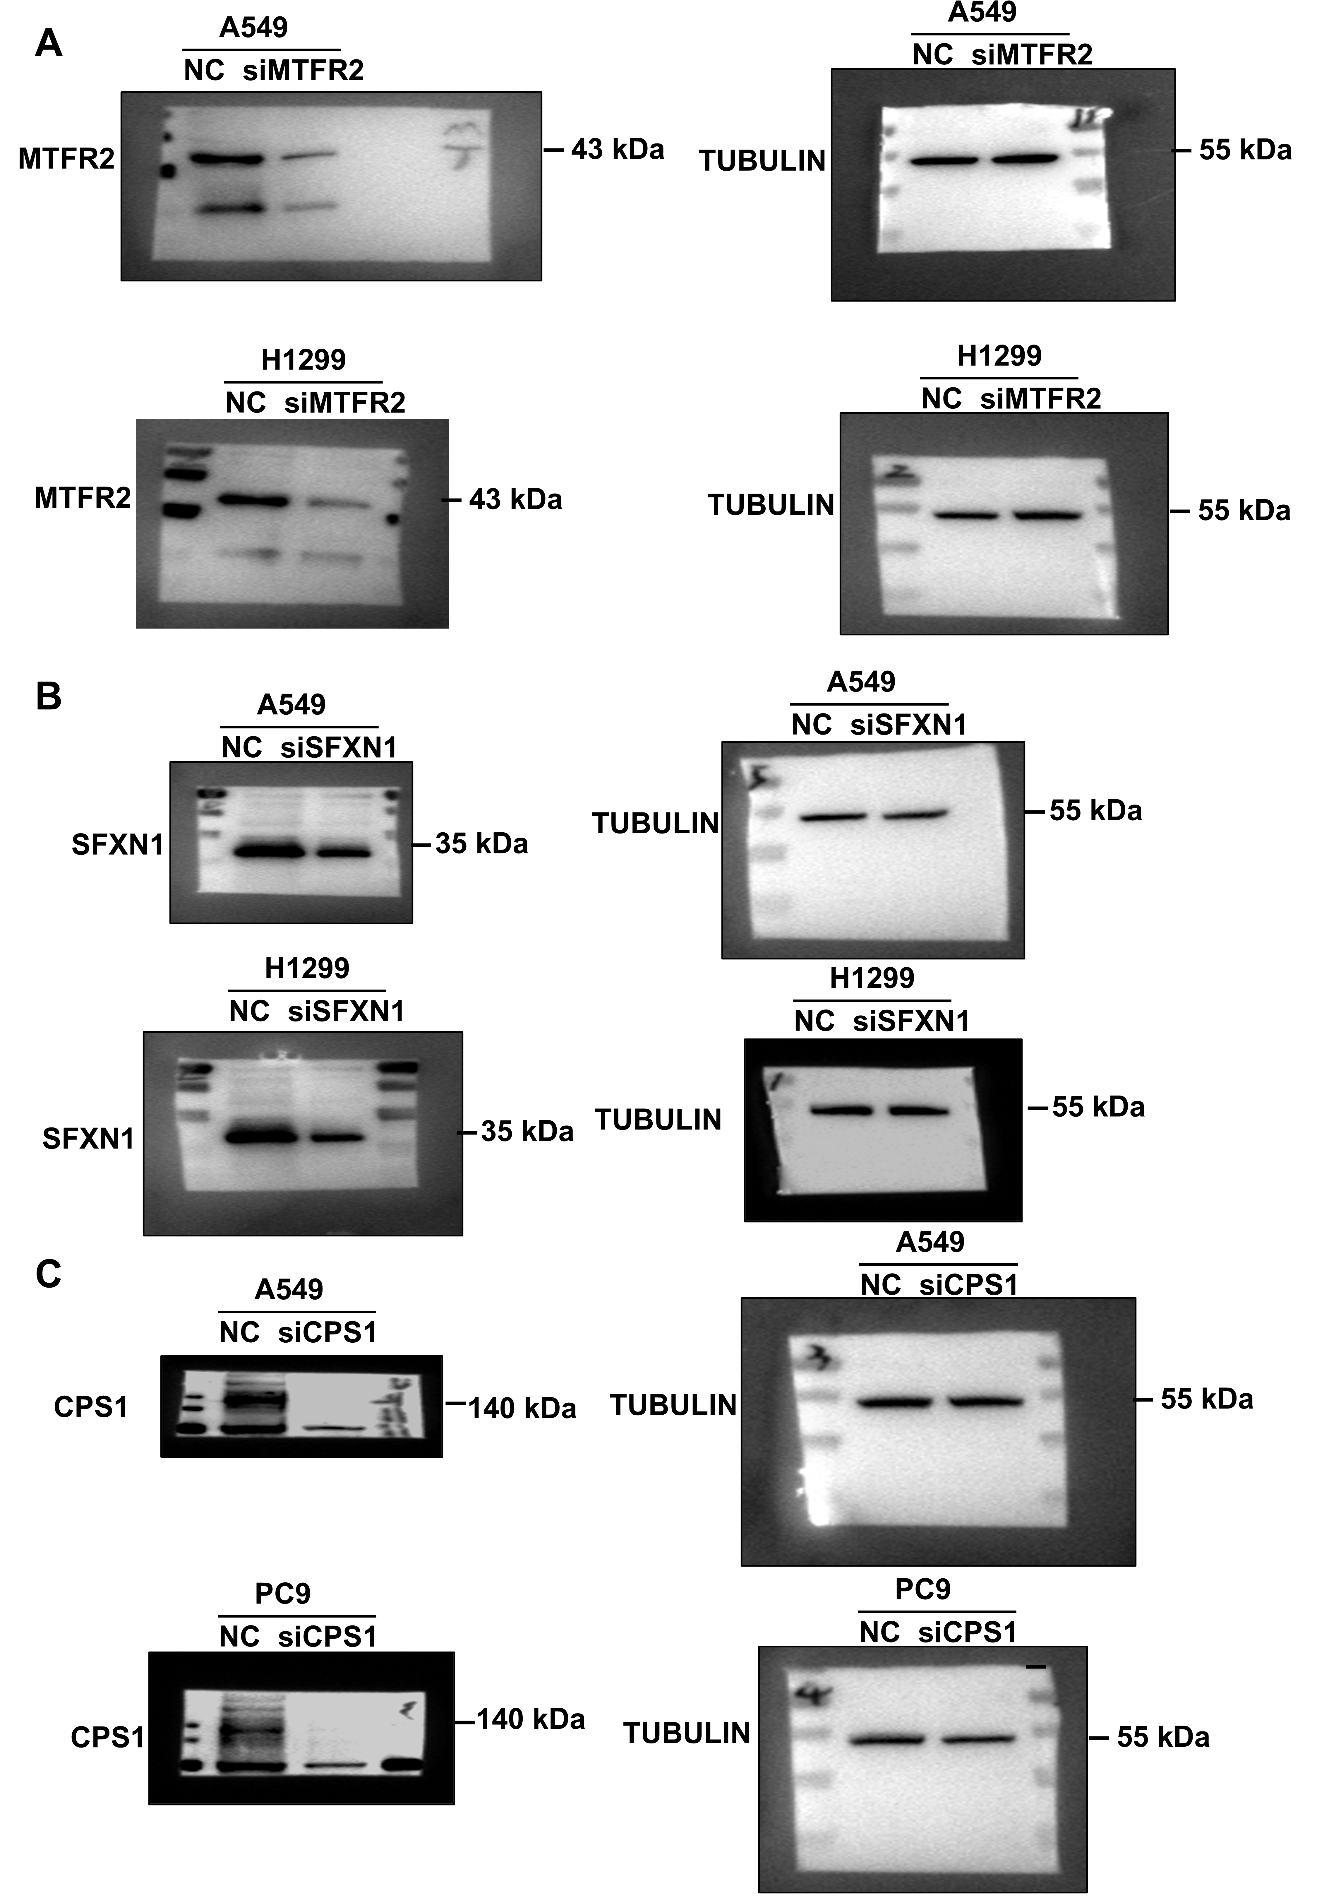
Fig.S9 Raw bright-field images of Western Blot.
Raw bright-field images of Western Blot of figure 8.

Table S1
siRNA | siRNA sequence, 5’–3’
siRNA | Sense | Anti-sense
CPS1 | GCAUUGACCUAGUGAUUAAdTdT | UUAAUCACUAGGUCAAUGCdTdT
MTFR2 | GUACAACCAGGAUCUAAUA | UAUUAGAUCCUGGUUGUAC
SFXN1 | GCUGCUAAUUGCAUUAAUATT | UAUUAAUGCAAUUAGCAGCTT

Table S2
Gene | Primer sequence, 5’–3’
Gene | Forward | Reverse
CPS1 | CTAGCCTGGATTACATGGTCACC | CCTCAAAGGTACGACCAATAGCC
MTFR2 | TGCTTCCACTGGAACCTTGTCG | CGAAATCTGAGATAACTGGCTTCT
SFXN1 | ACCAGTCCTTCAATGCCGTCG | GAGTCCTAGAGCTGTTGCTACG
ND1 | CACCCAAGAACAGGGTTTGT | TGGCCATGGGTATGTTGTTAA
TERT | TCACGGAGACCACGTTTCAAA | TTCAAGTGCTGTCTGATTCCAAT

