Supplementary Table 1：
id | HR | HR.95L | HR.95H | pvalue
ADARB2 | 1.313153745 | 1.141522853 | 1.510589781 | 0.000137786
B3GALT1 | 1.292687547 | 1.125336314 | 1.484925949 | 0.000284214
C17orf75 | 0.790715493 | 0.688550772 | 0.908039053 | 0.00087911
CYP11B2 | 1.30287178 | 1.141365471 | 1.48723167 | 8.92E-05
FER | 0.811477751 | 0.72646564 | 0.906438108 | 0.000215832
GHSR | 1.334229212 | 1.170589962 | 1.520743939 | 1.57E-05
ITIH1 | 1.20740238 | 1.080354877 | 1.349390407 | 0.000892269
LTB4R2 | 1.311781175 | 1.144669817 | 1.503289267 | 9.49E-05
N6AMT1 | 0.818734269 | 0.749626322 | 0.894213268 | 8.79E-06
NDUFAF7 | 0.826245244 | 0.745481013 | 0.915759343 | 0.000276073
PGGT1B | 0.833904312 | 0.7617607 | 0.912880385 | 8.34E-05
SCN9A | 0.860975842 | 0.795150432 | 0.932250516 | 0.000225364
SORCS3 | 1.282732536 | 1.120977598 | 1.467828405 | 0.000293999
THAP9 | 0.829149453 | 0.753450877 | 0.9124534 | 0.00012525
TWSG1 | 0.848648952 | 0.784776641 | 0.917719776 | 3.94E-05
ZBTB10 | 0.798941923 | 0.71330263 | 0.894863091 | 0.000104368

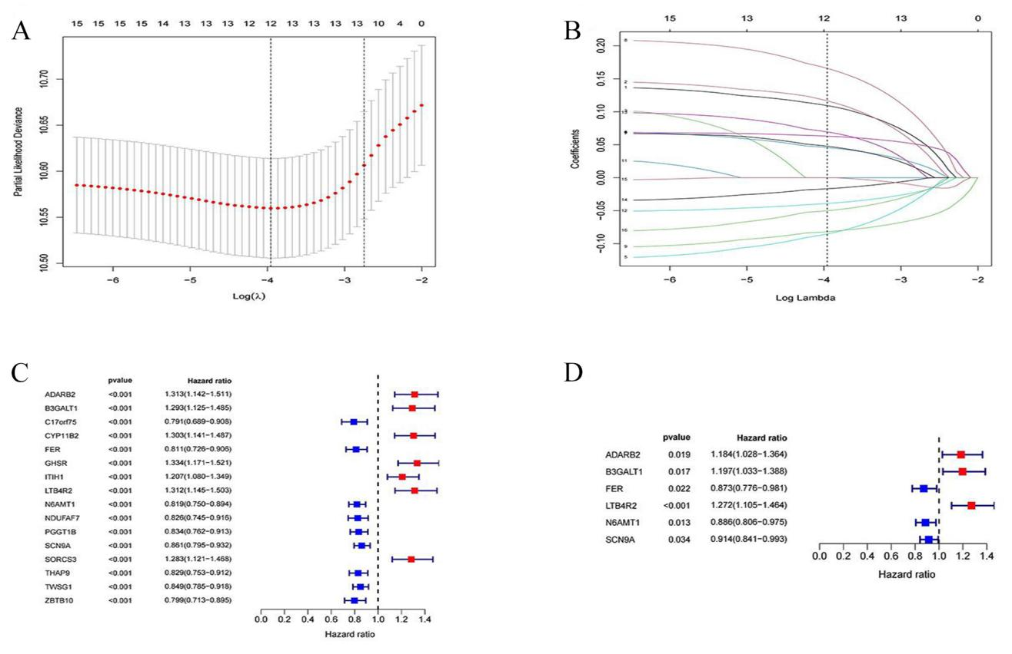
Supplementary Figure 1:Development of Treg-related prognostic models: (A, B) Prognostic features constructed by LASSO regression. (C) forest plots with univariate Cox regression analysis (D) forest plots with multivariate Cox regression analysis

