Supplemental Material: Methods Details
1. Search Strategy
Full search strategies (including Boolean operators and filters) for each database:
tsRNAs or tRFs or tiRNAs and kidney disease
2. Information Sources
- Databases: PubMed, Web of Science.
- Search Date: All searches were conducted up to 31 December 2024
- Supplementary Sources: Reference lists of included studies and relevant reviews were manually screened.
3. Eligibility Criteria
Studies were included if they:
- Investigated the role of tsRNAs, tRFs, tiRNAs, or tRNA-derived fragments in the context of kidney disease (including acute kidney injury, chronic kidney disease, diabetic nephropathy, etc.).
- Were original research articles (e.g., experimental, observational, or clinical studies).
Exclusion criteria:
- Reviews, Meta-Analysis，Systematic Review，Editorials.
- Studies lacking direct relevance to tRNA-derived fragments or kidney disease.
4. Selection Process
- Automated Screening: All retrieved records were imported into Rayyan for deduplication and initial title/abstract screening.
- Independent Screening: Two reviewers (initials: Jialing Wang and Yanzhe Wang) independently screened titles/abstracts against inclusion criteria.
- Conflict Resolution: Disagreements were resolved through discussion or consultation with a third reviewer (initials:Fengqin Li).
- Full-Text Review: Potentially eligible studies underwent full-text assessment by the same two reviewers.
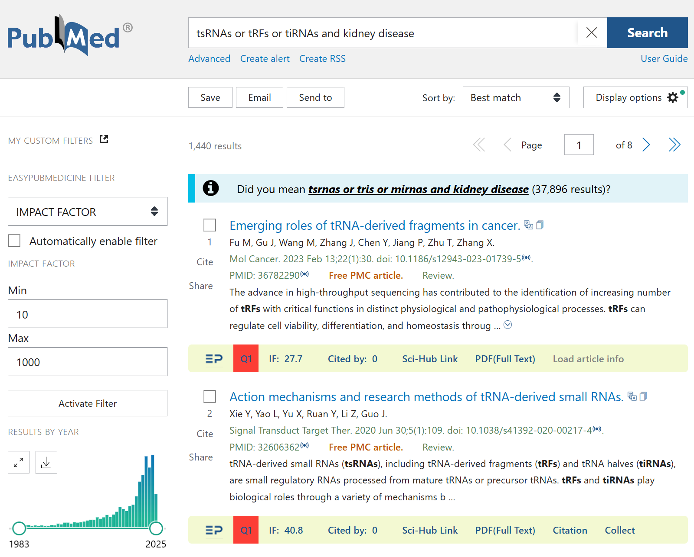
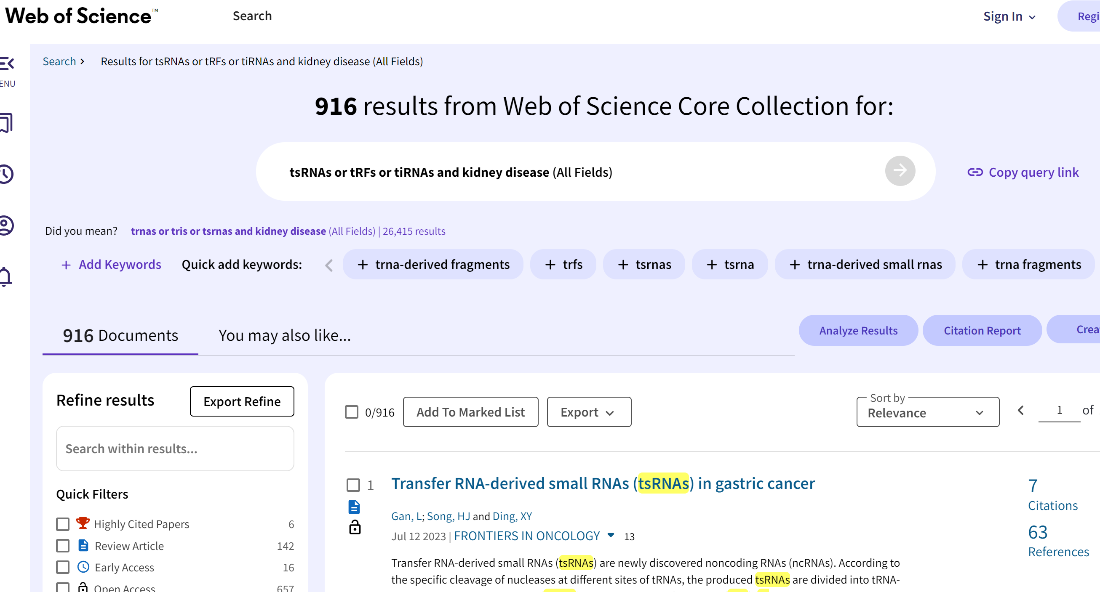

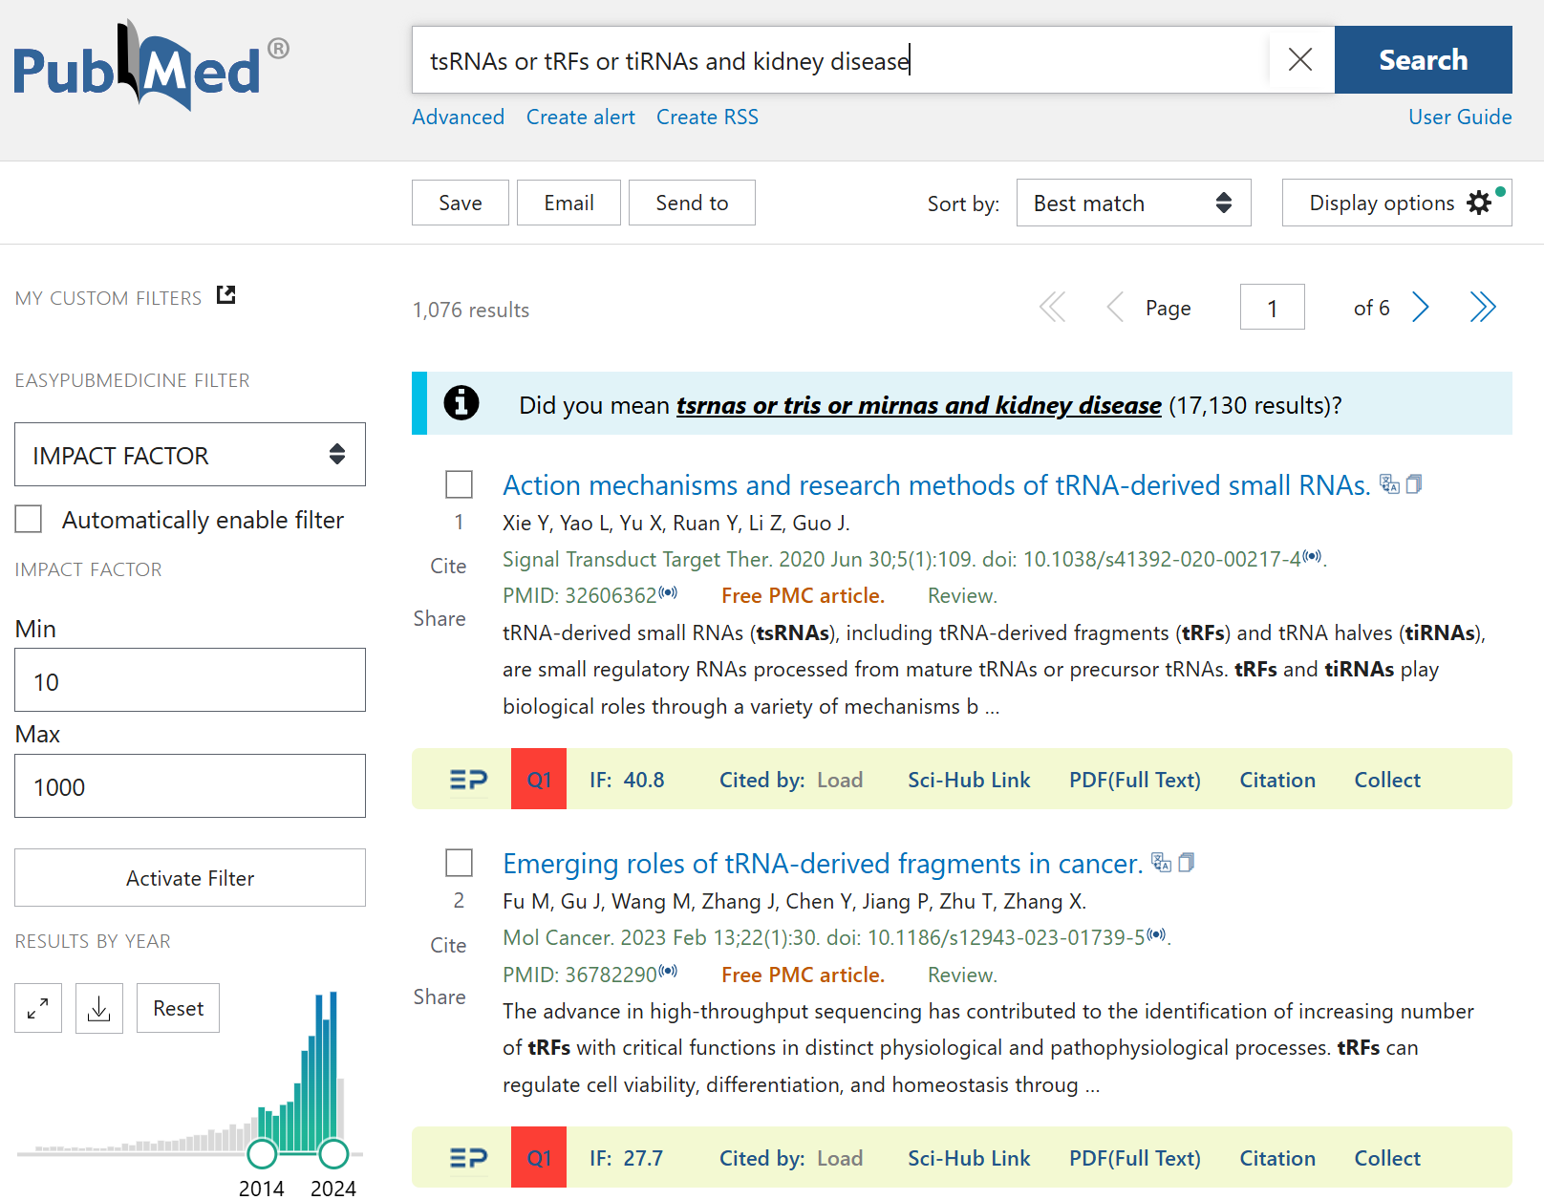
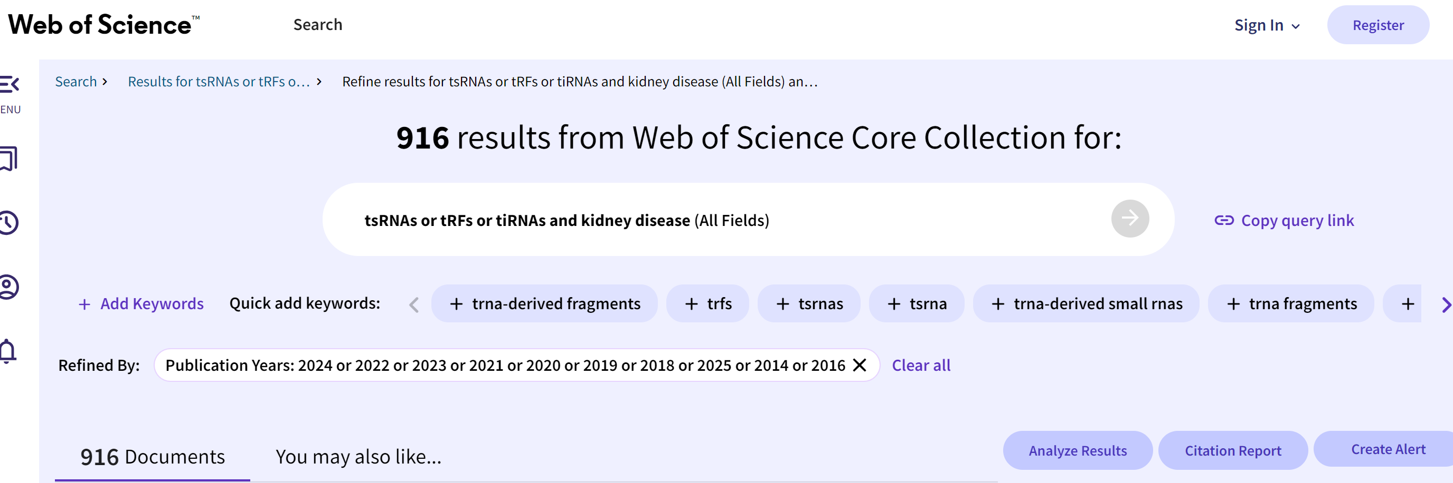


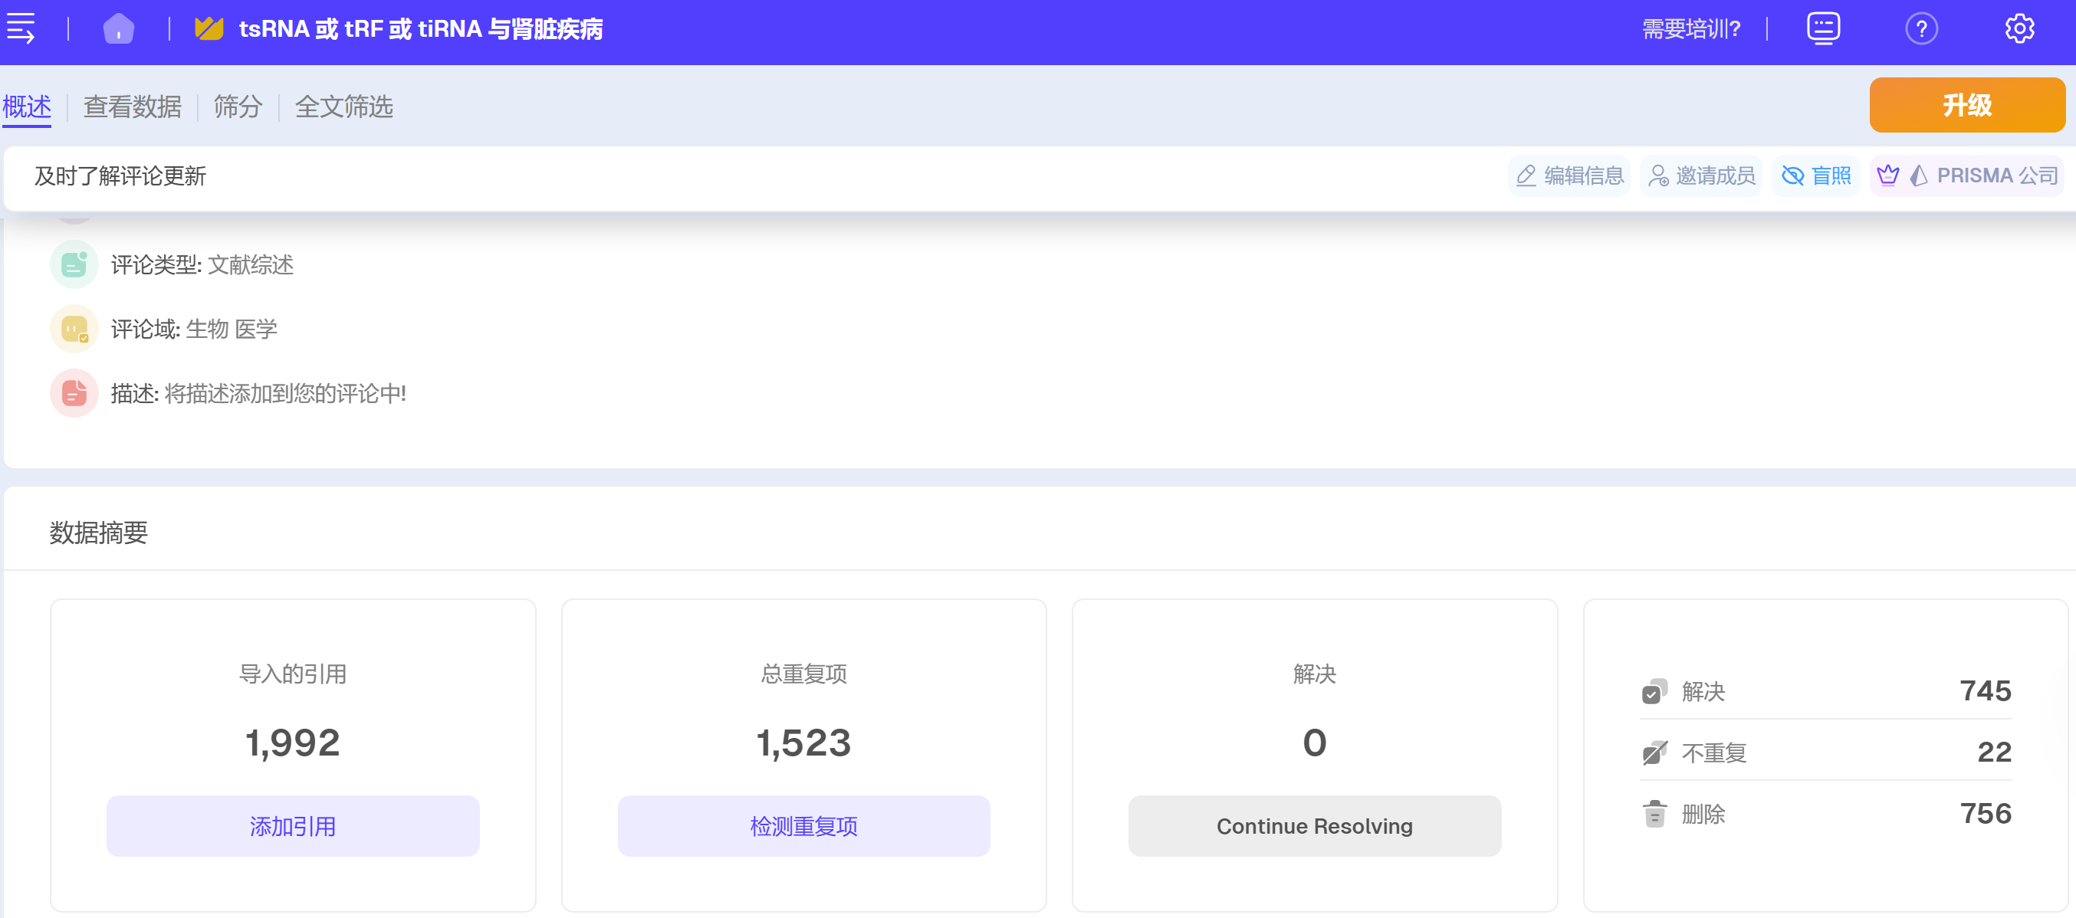
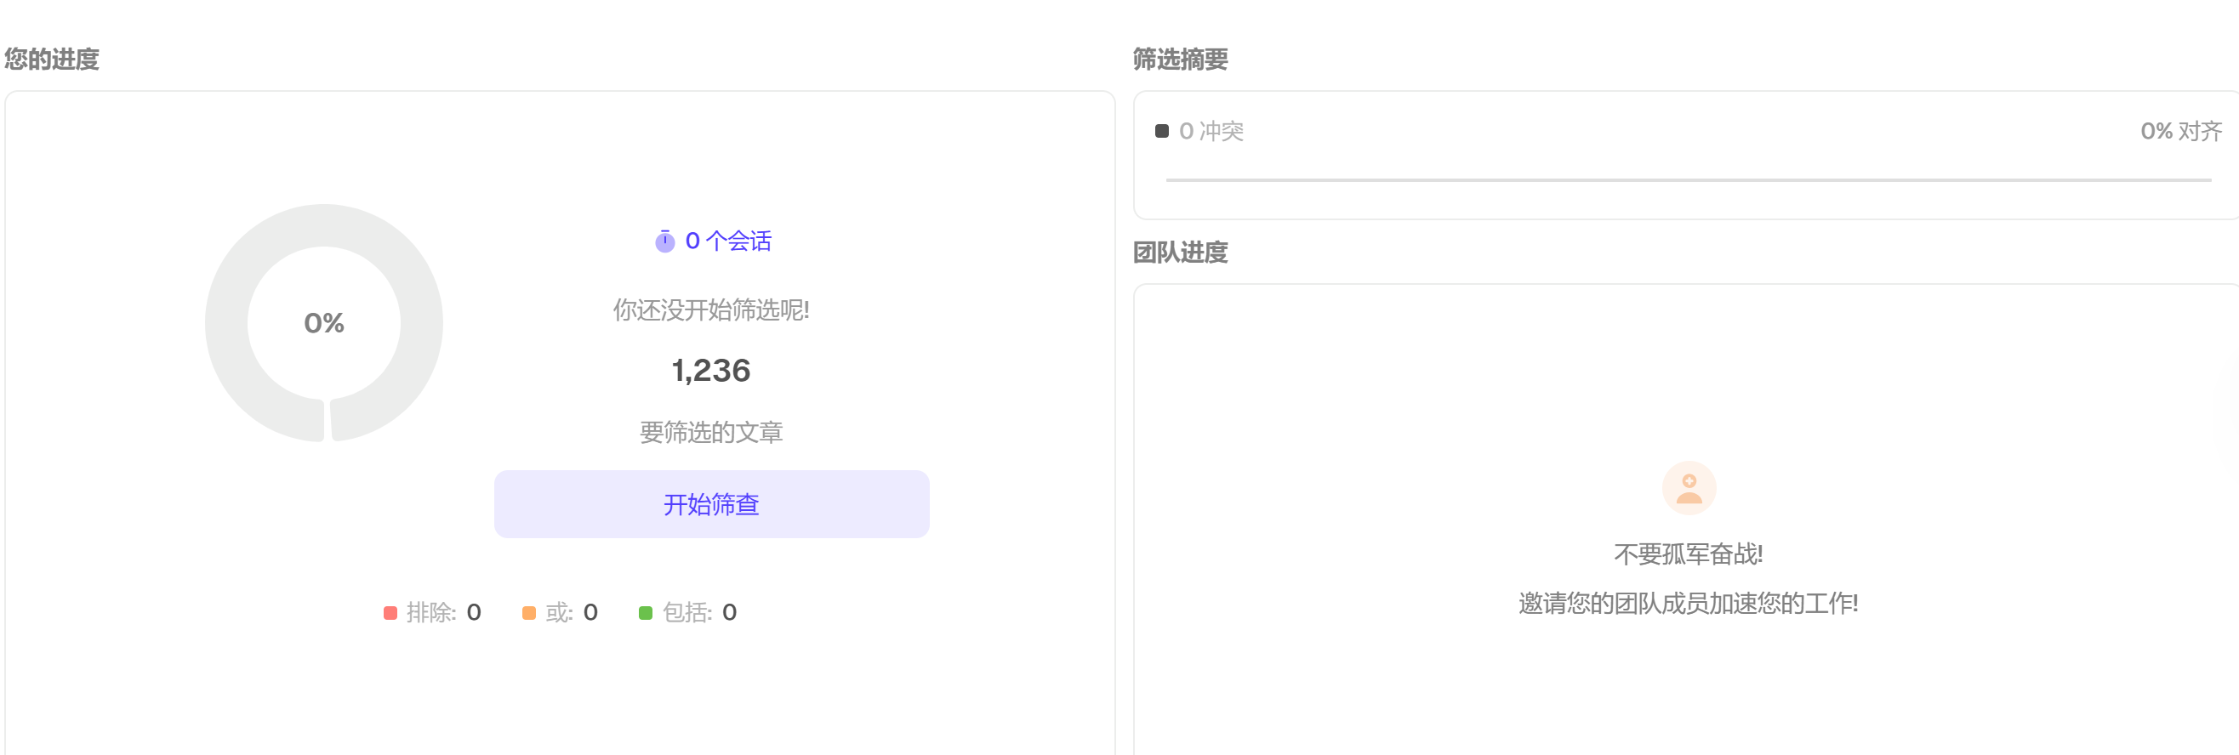

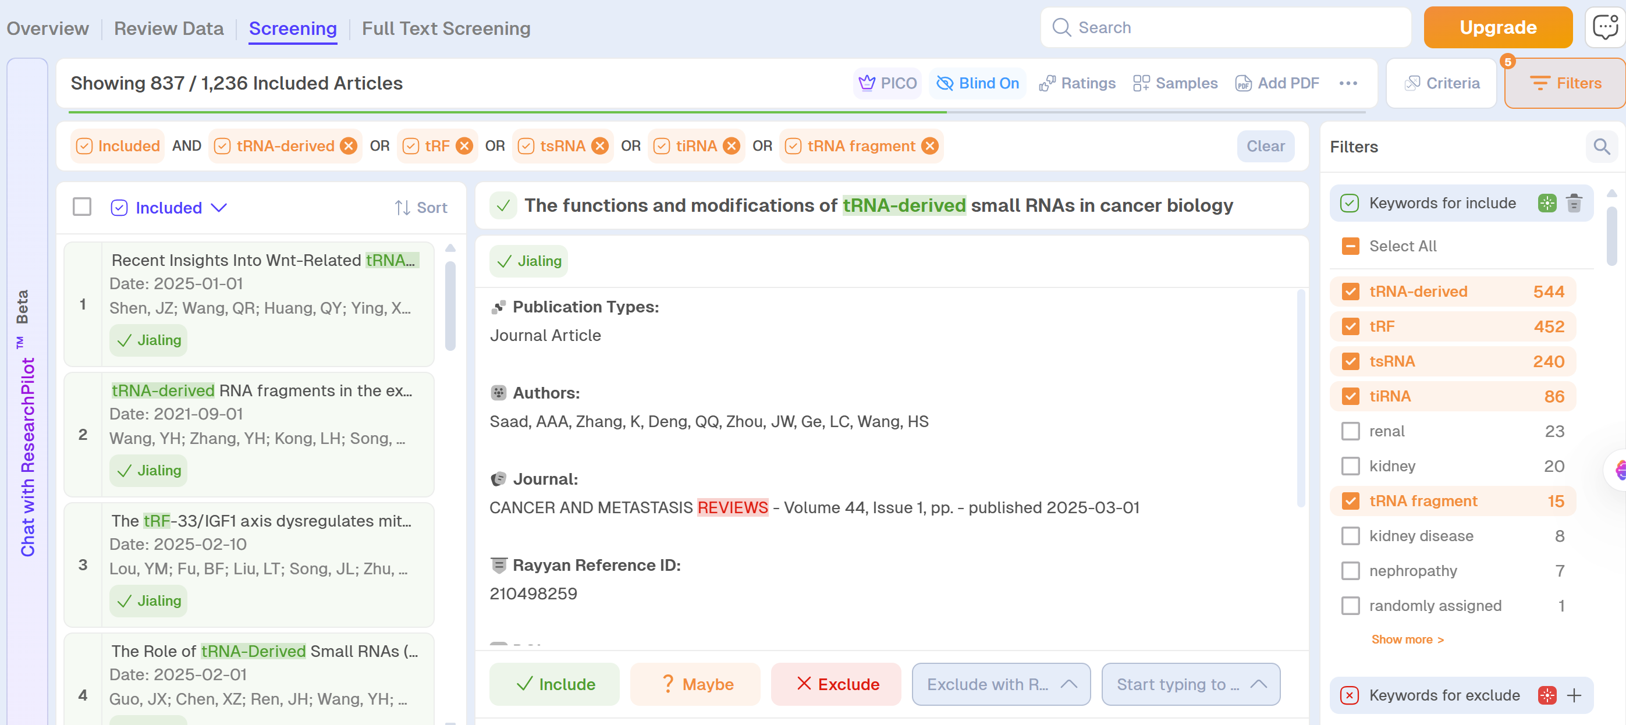
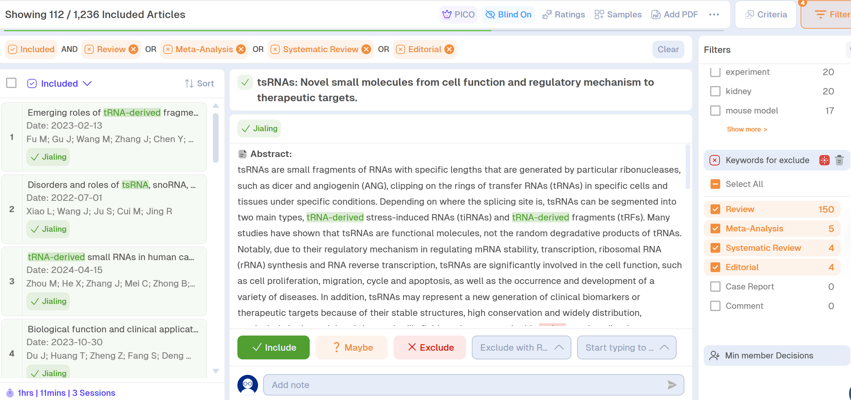
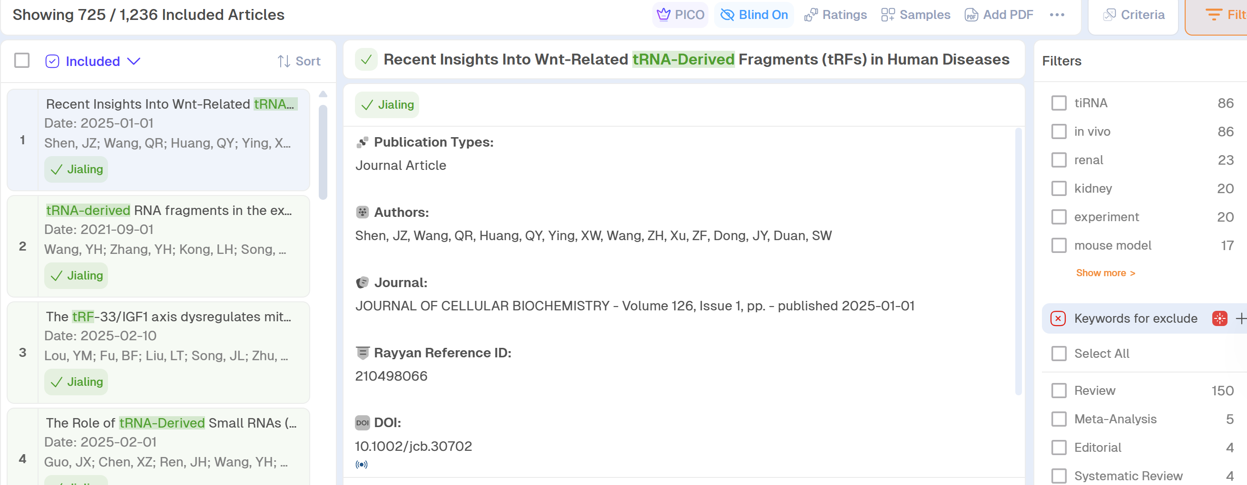
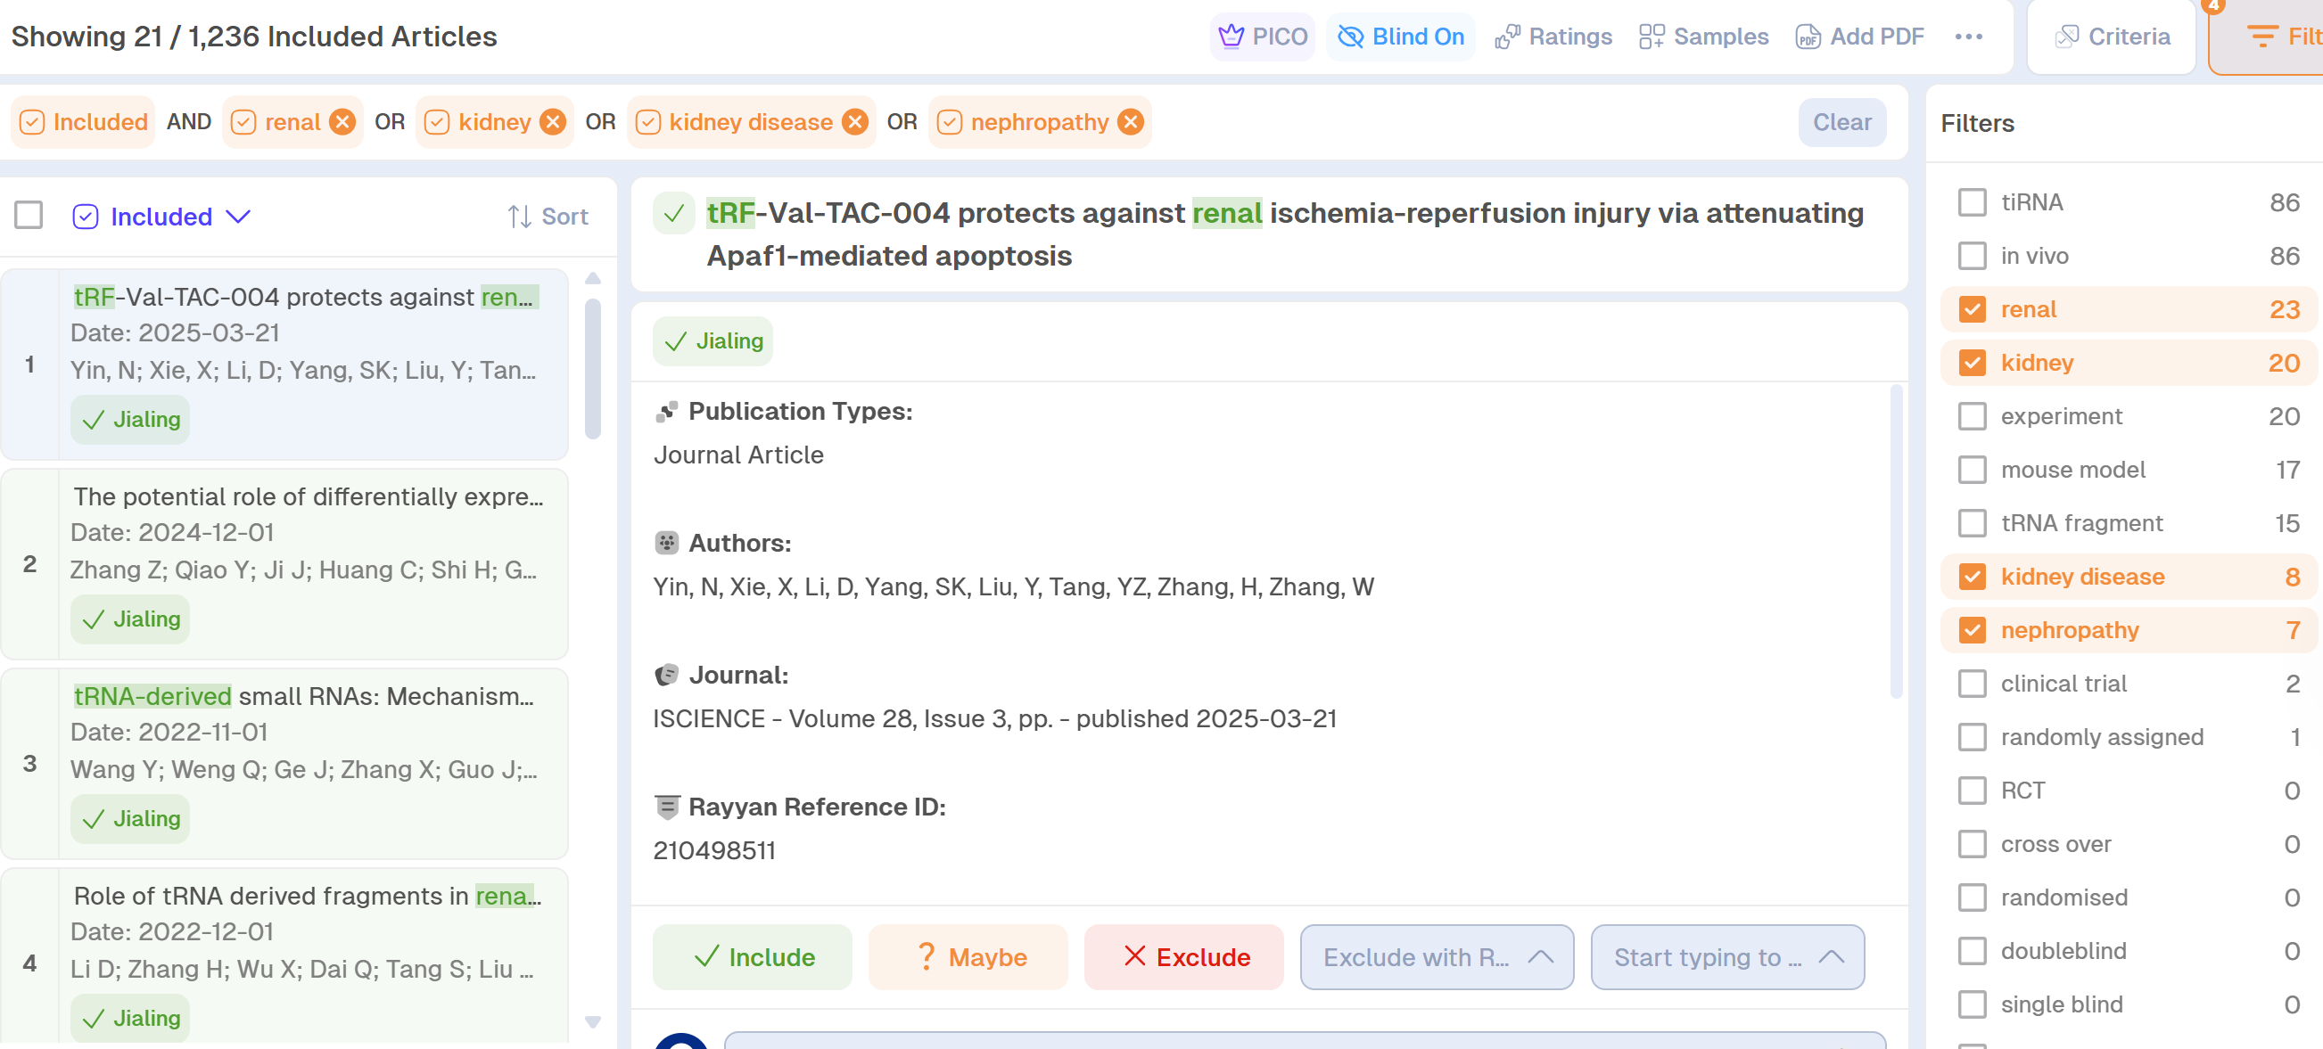
* Statement:
Among the 40 cited references, 32 were retrievable in both PubMed and Web of Science, resulting in reports of included studies (n = 72).

