Supplementary Materials
Quantitative PCR Report No.2

1. Materials and Methods

1.1 Primer design
Gene |  | Sequence
h-ACTB | F primer | AAACGTGCTGCTGACCGAG
h-ACTB | R primer | TAGCACAGCCTGGATAGCAAC
h-ACTB | Size: 119bp
h-DHCR7 | F primer | GCTATGCCGTCTCCACCTTC
h-DHCR7 | R primer | TCCCGATCCGAGGGTTAAAC
h-DHCR7 | Size: 129bp

1.2 Reagents and instruments
General reagent (Cat # GMRS-001 Gemma, Shanghai)
ABI 7500 Real-time quantitative PCR instrument

1.3 Total RNA extraction
1) Add 1ml Ezol lysate to the collected cell sample and mix with vortex shock.
2) Add 0.2ml of trichloromethane, shake vigorously for 10s, and leave it at room temperature for 1 minute.
3) 4℃, and centrifuged at 12,000 xg for 15 min.
4) Transfer the upper clear water phase to another new RNA enzyme-free centrifuge tube and add an equal volume of 100% ethanol.
5) Draw all the samples and add a mini-spin centrifuge column with a 2ml collecting tube.8,000 xg, centrifugation at room temperature for 15s, discard the drain.
6) Transfer the remaining samples to the centrifugal column and repeat step 5.
7) Add 700 μ l WB to the centrifugal column, gently cover the lid, 8,000 xg, centrifuge at room temperature for 15s, discard and drain the liquid.
8) Repeat step 7 and wash the centrifuge column twice with 500 μ l WB.
9) The centrifugal column was transferred to a new 1.5ml centrifuge tube without RNA enzyme, dropping 50 μl DEPC water to the center of the silicone film, and the RNA was eluted by centrifugation at 4℃ and 1 0,000 x g for 3 min.

1.4 fluorescence quantitative PCR
1) Reverse recording reaction system
component | final concentration | dosage
2 Reverse transcription buffer | 2× | 10 μl
Reverse recording primer (1 uM) | 50 n M | 1.2 μl
overall RNA | — | X μl*
MMLV reverse transcriptase (200 U / μ l) | 2 U/μl | 0.2 μl
DEPC water |  | To 20 μl

Note: * To normalize the amount of template, the volume of X was calculated from the OD measurement of each sample, see RNA Extraction Quality Test.

2) Reverse recording program
42ºC 30 min; 85 ºC10 min.

3) Real-time quantitative reaction system
component | final concentration | dosage
2 for the quantification of PCR Master Mix | 1× | 10μl
Upstream primer set (20 uM) | 0.08μM | 0. 08μl
Downstream primer set (20 uM) | 0. 08μM | 0. 08μl
cDNA templet | — | 2μl
Taq DNA Polymerase (2.5 U / μ l) | 0. 05 U/μl | 0. 4μl
dd H_{2 O} |  | Add to 20 μ l

4) Quantitative fluorescence PCR reaction procedure
95 C, with a 3-min denaturation session
95 C, 12 seconds; 62 C, 40 seconds. 40 recurrence

2. Results

2.1 RNA extraction quality testing
Sample ID |  | Sample Type | 260/280 | Concentration(ng/ul)
1 | LV3NC | RNA | 2.12 | 701.296
2 | DHCR7-Homo-288 | RNA | 2.14 | 650.828
3 | DHCR7-Homo-821 | RNA | 2.14 | 684.71
4 | DHCR7-Homo-962 | RNA | 2.14 | 486.477
5 | DHCR7-Homo-1064 | RNA | 2.1 | 572.452
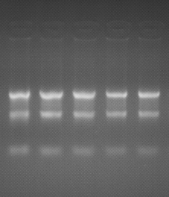
1 2 3 4 5

1. The 28s rRNA and 18s rRNA bands were clearly visible by sample RNA electrophoresis, indicating that the RNA is not degraded;
2. Quality determination criteria:
A. Sample OD measurement A260 / A280 is between 1.9 and 2.1, with no contamination during the extraction process and the best quality;
B. The OD value of the sample A260 / A280 is between 1.8 and 1.9, and trace contamination may occur during the extraction process, which is within the acceptable range of the experiment;
C. Sample OD determination of A260 / A280 was less than 1.8, and protein or organic reagent phenol residues remained during the extraction.

2.2 Amplification curve
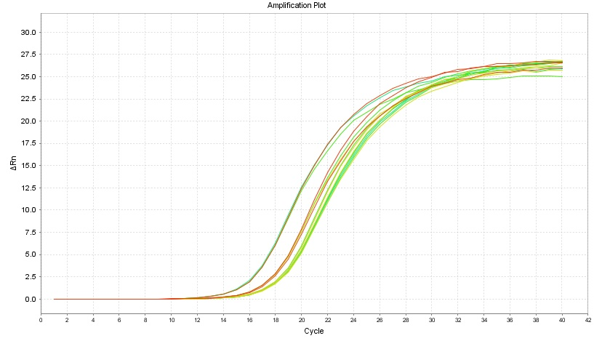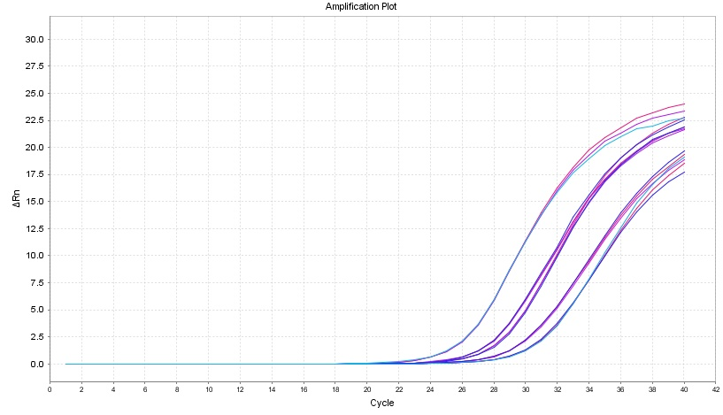
Figure 1. h-ACTB / h / DHCR7 amplification curve

The 2.3 SYBR Green melting curve
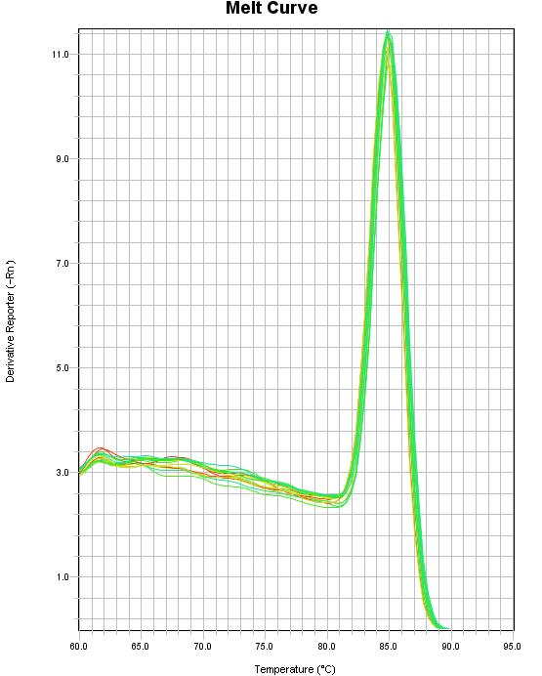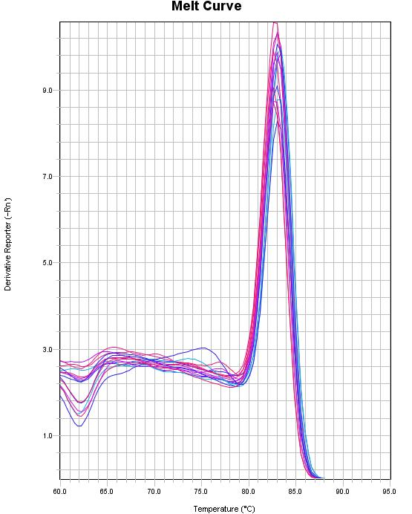
Figure 1. h-ACTB / h-DHCR7 melting curve

2.4 Bar chart analysis
 | LV3NC | DHCR7-Homo  -288 | DHCR7-Homo  -821 | DHCR7-Homo  -962 | DHCR7-Homo  -1064
Repeat1 | 0.7701131 | 1.474995862 | 1.11200843 | 0.2310325 | 0.4248041
Repeat2 | 1.1411126 | 1.562055776 | 1.0998074 | 0.2193595 | 0.4439521
Repeat3 | 1.1379338 | 1.546236813 | 1.15701322 | 0.2161122 | 0.4377861
Mean | 1.00  (0.71~1.42) | 1.53  (1.19~1.96) | 1.12  (0.87~1.44) | 0.22  (0.17~0.29) | 0.44  (0.34~0.56)

Figure 1. LV3NC as the calibrated h-ACTB as the internal reference h-DHCR 7 gene expression level

2.5, electrophoregram
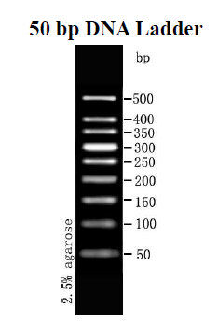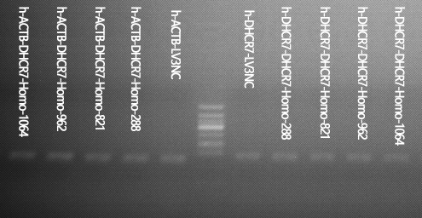

[conclusion]
Electrophoresis showed that the PCR products were of correct size and the absence of the mixed band indicated no specific amplification.

2.6 Raw data and relative quantitative calculations
 | LV3NC
 | h-ACTB | h-DHCR7
Repeat1 | 18.35 | 28.97
Repeat2 | 18.99 | 28.90
Repeat3 | 18.93 | 28.91
Mean CT | 18.76±0.35 | 28.93±0.04
Δ ΧΤ | — | 10.17±0.36
ΔΔ ΧΤ | — | 0.00±0.50
2^{-ΔΔCT} | — | 1.00(0.71~1.42)

 | DHCR7-Homo-288
 | h-ACTB | h-DHCR7
Repeat1 | 16.97 | 26.48
Repeat2 | 16.96 | 26.51
Repeat3 | 16.87 | 26.49
Mean CT | 16.93±0.06 | 26.49±0.02
Δ ΧΤ | — | 9.56±0.06
ΔΔ ΧΤ | — | -0.61±0.36
2^{-ΔΔCT} | — | 1.53(1.19~1.96)

 | DHCR7-Homo-821
 | h-ACTB | h-DHCR7
Repeat1 | 18.50 | 28.43
Repeat2 | 18.39 | 28.46
Repeat3 | 18.39 | 28.41
Mean CT | 18.43±0.06 | 28.43±0.03
Δ ΧΤ | — | 10±0.07
ΔΔ ΧΤ | — | -0.17±0.36
2^{-ΔΔCT} | — | 1.12(0.87~1.44)

 | DHCR7-Homo-962
 | h-ACTB | h-DHCR7
Repeat1 | 19.11 | 31.52
Repeat2 | 19.11 | 31.39
Repeat3 | 19.14 | 31.47
Mean CT | 19.12±0.02 | 31.46±0.06
Δ ΧΤ | — | 12.34±0.07
ΔΔ ΧΤ | — | 2.17±0.36
2^{-ΔΔCT} | — | 0.22(0.17~0.29)

 | DHCR7-Homo-1064
 | h-ACTB | h-DHCR7
Repeat1 | 19.21 | 30.50
Repeat2 | 19.16 | 30.58
Repeat3 | 19.08 | 30.49
Mean CT | 19.15±0.07 | 30.52±0.05
Δ ΧΤ | — | 11.37±0.08
ΔΔ ΧΤ | — | 1.20±0.37
2^{-ΔΔCT} | — | 0.44(0.34~0.56)

Attached: relative quantitative calculation
give an example:

 | sample
 | The reference gene | Target gene
Repeat 1 | 8.59 | 22.35
Repeat 2 | 8.85 | 22.50
Repeat 3 | 9.10 | 22.58
average C_{T} | 8.85±0.26 | 22.48±0.12
ΔC_{T} | — | 13.63±0.28
1. " The average of the CT "represents the mean of the three replicate Ct, and the number after" ± " indicates the standard deviation standard deviation (SD) of the three replicate Ct, and the SD is calculated as follows
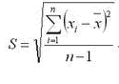
- ΔCT represents the difference between the average Ct value of the target gene and the reference gene in the same sample, calculated as follows:
microRNA/gene CΔT= the target average, CT-internal reference mean CT=22.48-8.85=13.63

- ΔΔCT represents the difference sample and test sample of the calibration sample Ct for a specific target gene, calculated as follows:Δ

 | Samples to be inspected |  | calibration sample
 | The reference gene | Target gene | The reference gene | Target gene
Repeat 1 | 8.59 | 22.35 | 8.50 | 21.92
Repeat 2 | 8.85 | 22.50 | 8.72 | 22.09
Repeat 3 | 9.10 | 22.58 | 9.00 | 22.37
Mean C_{T} | 8.85±0.26 | 22.48±0.12 | 8.74±0.25 | 22.13±0.23
ΔC_{T} | — | 13.63±0.28 | — | 13.39±0.34
ΔΔC_{T} | — | 0.24±0.44 | — | 0.00±0.48
2^{-ΔΔC}_{T} | — | 0.85(0.62~1.15) | — | 1.00(0.72~1.39)

pay attention to:CΔΔFor T calculation, the value of after "±" is defined as S4, S 4 = Sqr (S3^{2+S}₀^{2). In this formula, the " S}3 indicates the sample C to be testedΔThe SD value of T, " S0 indicates the calibration sample CΔThe SD value of the T. is shown.

- Finally, 2-ΔΔBoth CT and parentheses are derived from CT values, with red markers indicating low relative calibration sample expression, and opposite blue markers indicating high relative calibration expression.ΔΔ

