The association of maternal pre-pregnancy body mass index with macrosomia: a birth cohort study from China

Mingxin Yan ^{1,2†}, Yunbo Zhang ^{2†}, Doudou Zhao ³, Yan Zhao ⁴, Danmeng Liu ³, Li Shan ³, Yang Mi ³, Leilei Pei ^{2,*} and Pengfei Qu ^{3,5**}

¹ Institute for Hygiene of Ordnance Industry, Xi'an 710065, China
² Department of Epidemiology and Biostatistics, School of Public Health, Xi'an Jiaotong University Health Science Center, Xi'an 710061, China
³ Translational Medicine Center Northwest Women's and Children's Hospital, Xi'an 710061, China
⁴ The First Affiliated Hospital of Xi'an Jiaotong University Dermatology, Xi'an 710061, China
⁵ Central Laboratory, Beijing Obstetrics and Gynecology Hospital, Capital Medical University, Chaoyang, Beijing 100026, China.
*Corresponding author: Department of Epidemiology and Biostatistics, School of Public Health, Xi'an Jiaotong University Health Science Center, Xi'an 710061, China.
**Corresponding author: Translational Medicine Center Northwest Women's and Children's Hospital, Xi'an 710061,China.
E-mail addresses: pll_paper@126.com (L. Pei), xinxi3057@163.com (P. Qu).
†These authors have contributed equally to this work

Supplementary Table 1 Association between pre-pregnancy BMI and three subgroups macrosomia according to logistic regression analysis.
Variable | Grade 1 macrosomia | Grade 2 macrosomia | Grade 3 macrosomia
Variable | Adjusted OR (95%CI), P | Adjusted OR (95%CI), P | Adjusted OR (95%CI), P
Pre-pregnancy BMI
Under weight | 0.57(0.42~0.76), <0.001 | 0.42(0.13~1.39), 0.154 | 0.27(0.04~2.04), 0.203
Normal weight | 1.00 | 1.00 | 1.00
Overweight | 1.62(1.31~2.01), <0.001 | 2.80(1.47~5.32), 0.002 | 0.70(0.16~3.10), 0.637
Obesity | 1.55(1.02~2.35), 0.041 | 3.46(1.19~10.10), 0.023 | 1.61(0.21~12.45), 0.647
P for trend | <0.001 | <0.001 | 0.104
Adjusted for maternal age, education level, ethnicity, family financial situation, drinking before or during pregnancy, passive smoke before or during pregnancy, cold/fever before or during pregnancy, folic acid supplementation before or during pregnancy, parity, current GDM, fetal sex.

Supplementary Table 2 The association between pre-pregnancy BMI and macrosomia in subgroups.
Variable | OR (95%CI) ª
Variable | Under weight | Normal weight | Overweight | Obesity
Maternal age, years
≤24 | 0.48(0.21~1.13) | 1.00 | 0.93(0.37~2.34) | 0.69(0.09~5.40)
25~29 | 0.69(0.48~0.99) | 1.00 | 2.00(1.47~2.71) | 2.04(1.15~3.63)
30~34 | 0.47(0.27~0.82) | 1.00 | 1.66(1.21~2.28) | 1.58(0.87~2.89)
≥35 | -^{b} | 1.00 | 1.67(0.88~3.18) | 2.16(0.62~7.56)
Educational level
Below high school | 0.17(0.04~0.72) | 1.00 | 1.23(0.68~2.22) | 2.00(0.85~4.70)
College/university | 0.64(0.42~0.88) | 1.00 | 1.92(1.52~2.43) | 1.84(1.16~2.91)
Postgraduate | 0.57(0.28~1.17) | 1.00 | 1.46(0.84~2.53) | 0.87(0.20~3.76)
Family financial situation
Poor | 0.60(0.25~1.46) | 1.00 | 1.19(0.62~2.28) | 2.71(1.27~5.77)
Moderate | 0.61(0.43~0.86) | 1.00 | 1.86(1.47~2.36) | 1.56(0.94~2.57)
Rich | 0.46(0.24~0.88) | 1.00 | 1.79(1.10~2.91) | 1.14(0.35~3.76)
Parity
Nulliparous | 0.62(0.45~0.85) | 1.00 | 1.66(1.30~2.13) | 1.67(1.03~2.69)
Multiparous | 0.40(0.19~0.83) | 1.00 | 1.92(1.35~2.72) | 1.95(1.01~3.77)
Current GDM
Yes | 0.56(0.40~0.76) | 1.00 | 1.65(1.28~2.14) | 1.45(0.84~2.49)
No | 0.62(0.32~1.21) | 1.00 | 1.98(1.42~2.77) | 2.19(1.24~3.85)
Fetal sex
Male | 0.50(0.34~0.74) | 1.00 | 1.66(1.28~2.15) | 1.64(0.98~2.72)
Female | 0.70(0.45~1.07) | 1.00 | 1.89(1.36~2.61) | 1.98(1.09~3.58)
ª Adjusted for covariates other than subgroup variables. ^{b} Missing data.

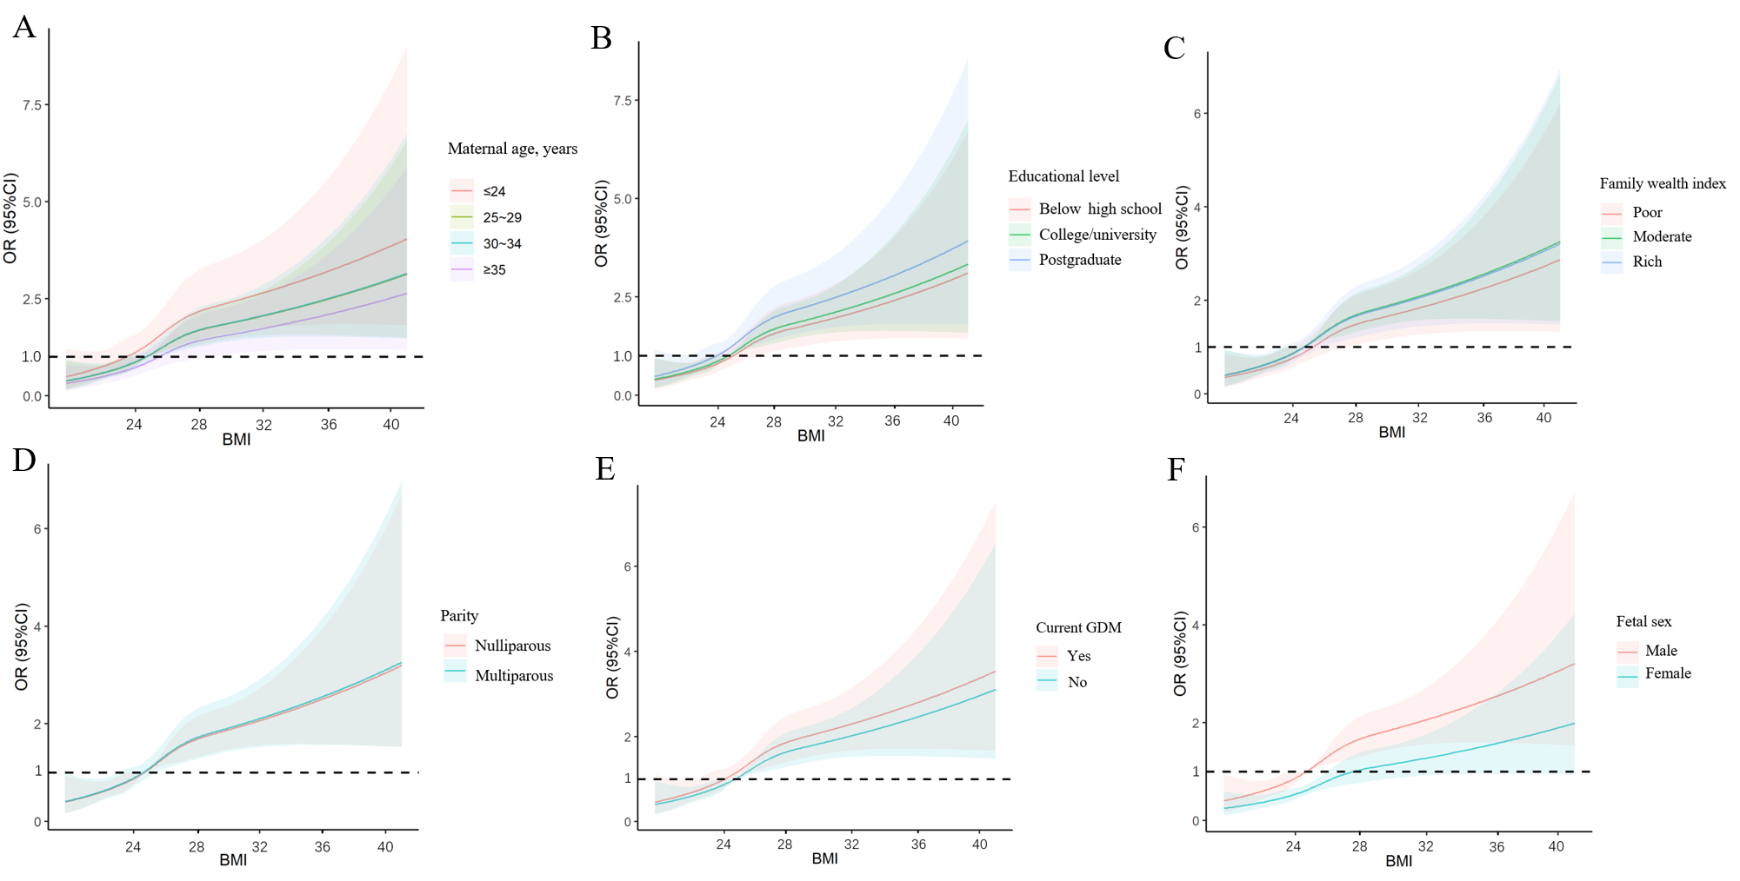
Supplementary Figure 1 Association of pre-pregnancy BMI with macrosomia: maternal age (A)、maternal education (B)、family wealth index (C)、parity (D)、current GDM (E)、fetal sex (F). Adjusted for covariates other than subgroup variables.
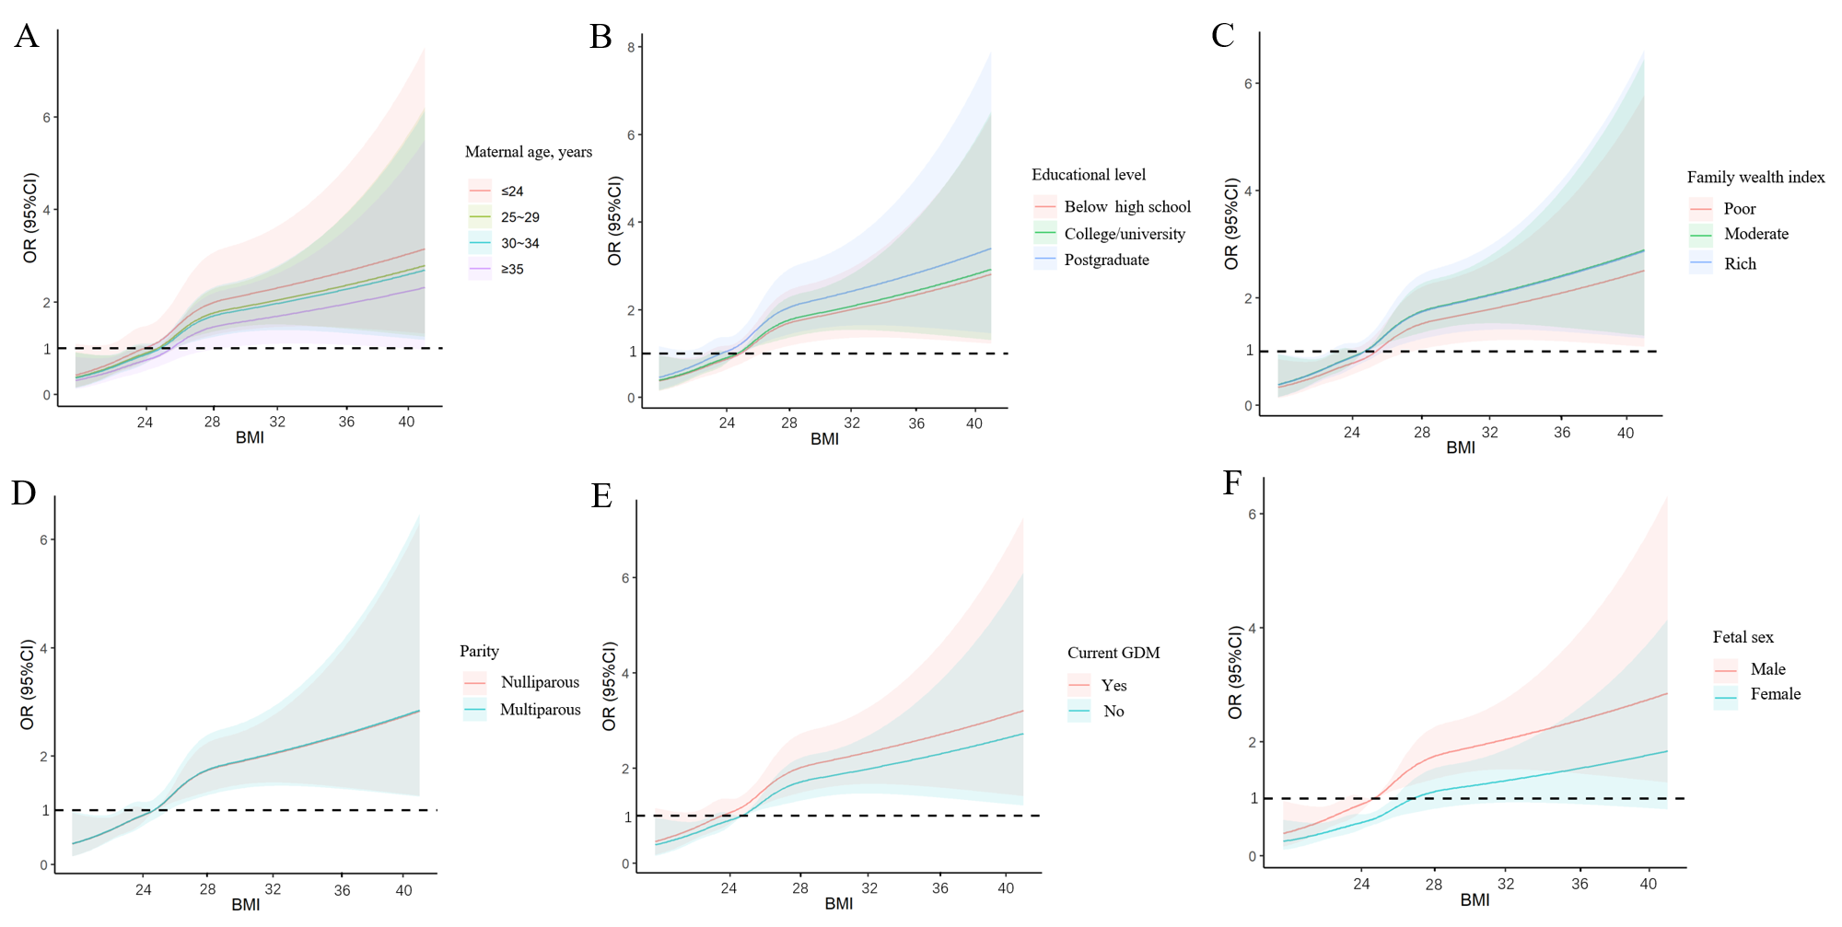
Supplementary Figure 2 Association of pre-pregnancy BMI with grade 1 macrosomia: maternal age (A)、maternal education (B)、family wealth index (C)、parity (D)、current GDM (E)、fetal sex (F). Adjusted for covariates other than subgroup variables.

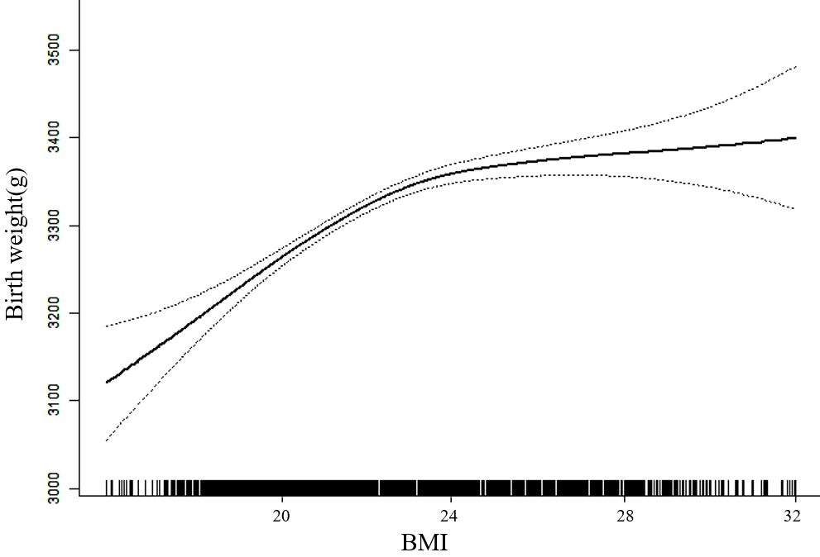
Supplementary Figure 3 Analysis of the linear relationship between pre-pregnancy BMI and birth weight. Adjusted for maternal age, education level, ethnicity, family financial situation, drinking before or during pregnancy, passive smoke before or during pregnancy, cold/fever before or during pregnancy, folic acid supplementation before or during pregnancy, parity, current GDM, fetal sex.

