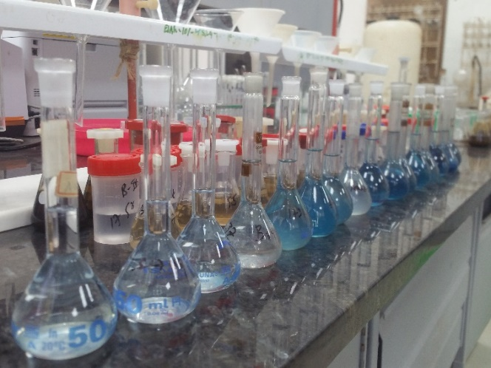 | 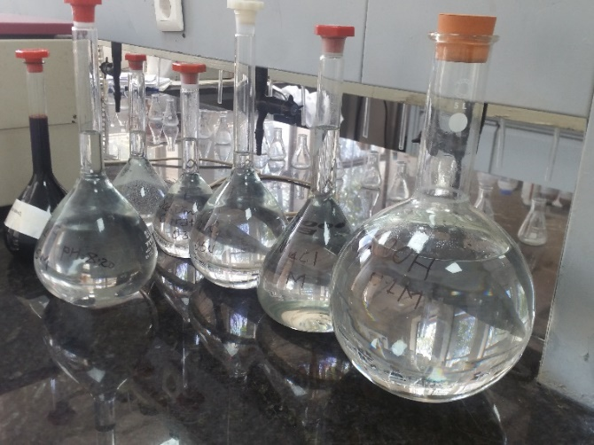
Batch-I Samples varied color intensity at reading | Prepared extractants for sequential P extraction
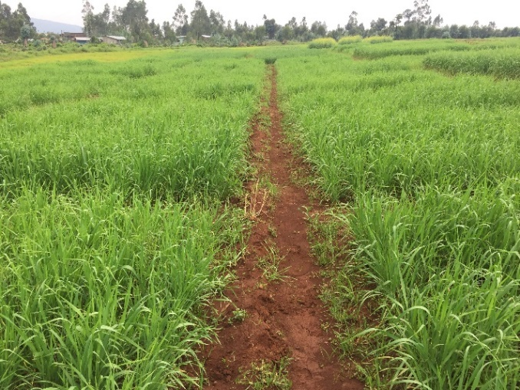 | 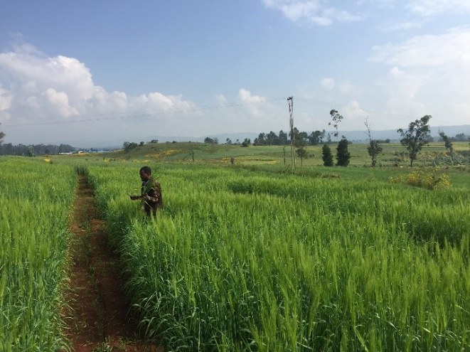
3rd week after traement application at Damotu | Tissue sample collection at booting, Holeta
Supplementary figure 1. Phosphorus fractionation study at field and laboratory condition.

