Raw Data

The code for MSSA is available at GitHub (https://github.com/SQAbin/MSSA)

IMG_256

The screenshot of the experimental results is as follows:

1. BCSD results on classification performance



2. BCSD results on retrieval metric MRR and Recall@1



3. Results on complexity and efficiency

Number of Model Parameters

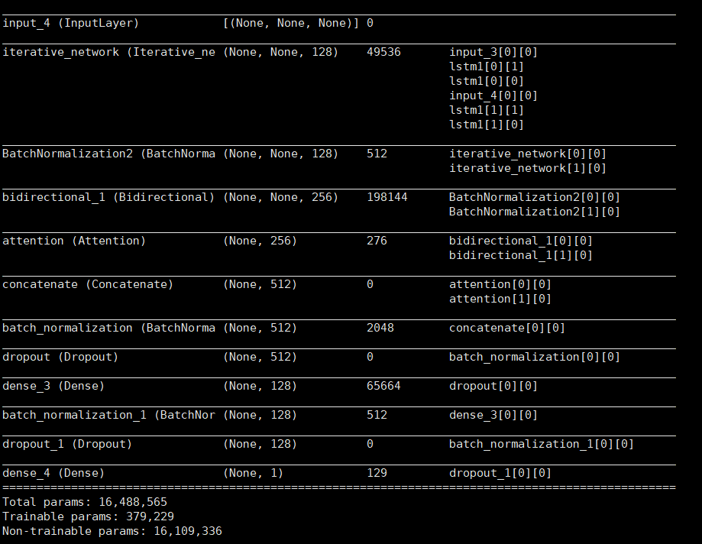

Execution Speed

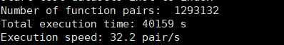

4. BCSD results on ablation study of MSSA

MSSA-NIB



MSSA-NAM



MSSA-NA

