Here are some typical examples of palmprint samples.

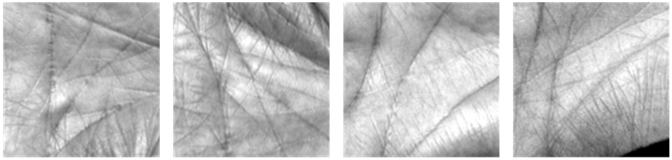

Fig. 1 respectively show four palmprint ROI images from different palms in PolyU II database.

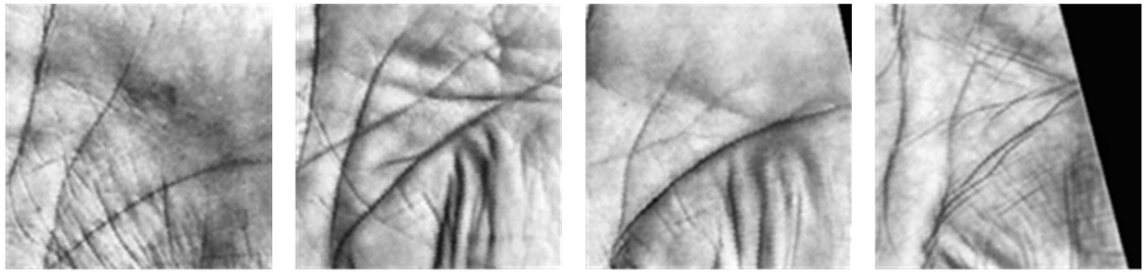

Fig. 2 respectively show four palmprint ROI images from different palms in IIT Delhi database.

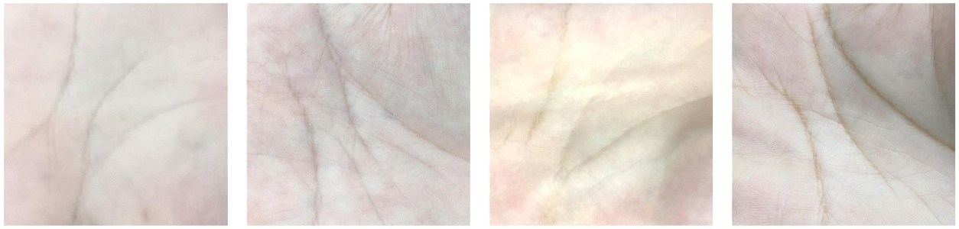Fig. 3 respectively show four palmprint ROI images from different palms in XINHUA database.

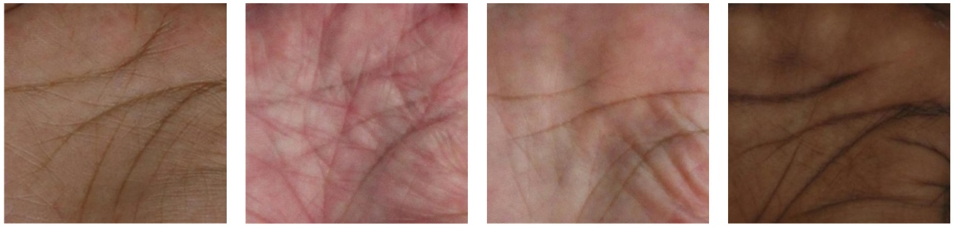Fig. 4 respectively show four palmprint ROI images from different palms in NTU-CP-V1 database.

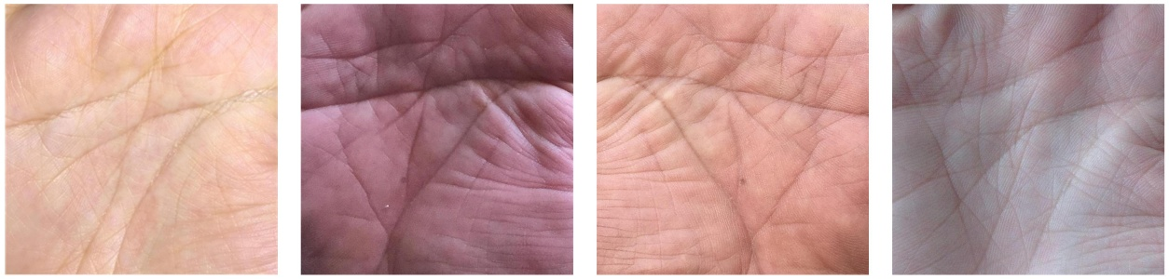

Fig. 5 respectively show four palmprint ROI images from different palms in BJTU-CP-V2 database.

