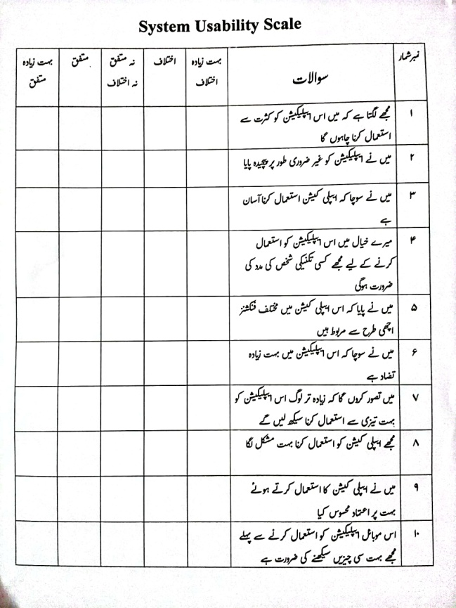
Appendix C: SUS Questionnaire (Urdu and English)
System Usability Scale: English version
Number | Questions | Strongly Disagree | Disagree | Neutral | Agree | Strongly Agree
1 | I think that I would like to use this application frequently.
2 | I found the application unnecessarily complex.
3 | I thought the application was easy to use.
4 | I think that I would need the support of a technical person to be able to use this application.
5 | I found the various functions in this application well integrated.
6 | I thought there was too much inconsistency in this application.
7 | I would imagine that most people would learn to use this application very quickly.
8 | I found the application very cumbersome to use.
9 | I felt very confident using the application.
10 | I needed to learn a lot of things before I could get going with this application.

