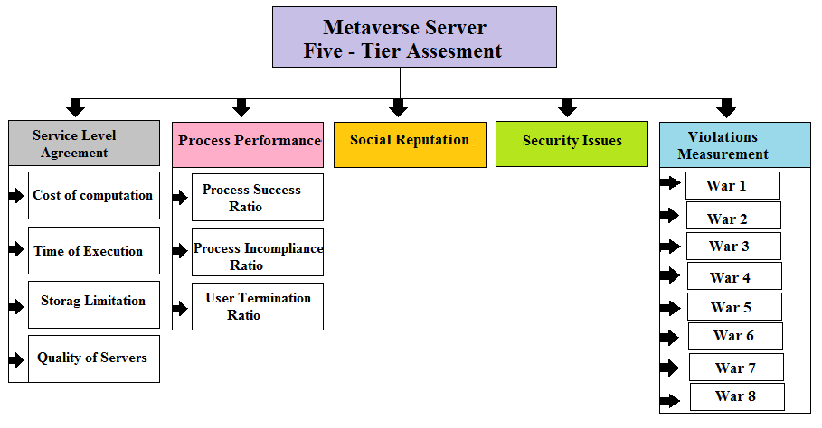
Section I- five -tier trust computation attributes.

