Supplementary Materials

S1. Methodology

S1.1: Reliability checks of sample annotation.
For each index (MGI, PFI), we randomly sampled 10 images (with 98 units for MGI and 100 units for PFI per annotator) from the database. To simplify the process, annotators graded units in a fixed clockwise order, while each unit was labeled and recorded independently. The process repeated one month later. Within-annotator accuracy was summarized as a 5×5 crosstabulation, and cross- and inter-annotator agreements were both summarized by Cohen’s κ (with asymptotic standard error). Annotation qualities ranged from 0.855-0.967 during calibration.

S1.2: Hyperparameter values

Supplement Table S1. The hyperparameter value used in YOLOv8.
Hyperparameter | Value
Epoch | 200
Batch | 16
Image size | 640×640
lr0 | 0.001

S1.3: Statistic analysis and equations

S1.3.1. Basic metrics in Five-Fold cross validation and real-world test
Precision (Positive predicted valiue, PPV) emphasizes the accuracy of positive predictions, ensuring alignment with actual indications and gradings. High precision implies reliable identification of true positives while minimizing false positives in inflammation and other gingival abnormalities.
(S1)
$$PPV=\frac{TP}{TP+FP}$$

Recall (Sensitivity) is crucial as well, measuring the model’s sensitivity to capture all relevant illness representation. High recall indicates effective identification, minimizing oversight.
(S2)
$$SEN=\frac{TP}{TP+FN}$$

F1-Score, a harmonic mean of precision and recall, is vital, offering a balanced assessment of overall accuracy in gingivitis related detection, highlighting the trade-off between precision and recall. In particular, the peak region of the curve indicates the threshold range where the model achieves an optimal balance between false positives and false negatives.
(S3)
$$F1- Score=\frac{2*PPV*SEN}{PPV+SEN}=\frac{TP}{TP+(FN+FP)/2}$$

Accuracy (ACC) is the number of samples correctly classified divided by the total number of samples and is the percentage of gum grades correctly predicted by the model. However, for multi-classification task, high accuracy is not enough, so comprehensive analysis enrolling other indicators needs to be conducted.
(S4)
$$Accuracy=\frac{TP+TN}{TP+FP+TN+FN}$$

mAP (mean Average Precision), specialized for gingival detection, considers precision-recall curves for each grade, providing nuanced evaluation across manifestations. This metric calculates the average precision (AP_{k}) for each grade (k), where n represents the number of gradings. The average precision of each grade is then averaged to compute the mean Average Precision. The Average Precision when IoU=50% was analyzed, and the model performance was comprehensively better synergistically evaluated with F1.
(S5)
$$AP=\int_{0}^{1}{Precision}\left(Recall\right)d\left(Recall\right)$$
(S6)
$$mAP=\frac{1}{N}\sum_{k=1}^{N}{AP_{k}}$$

NPV (Negative predicted value) reflects the probability that the sample is actually negative when the test result is negative.
(S7)
$$NPV=\frac{TN}{TN+FN}$$

Specificity is the proportion of a specificity that has been correctly diagnosed as negative among all actual negative samples, representing the ability of a model to avoid misdiagnosing a healthy individual as a disease, and can be used as a reference for evaluating the model’s performance.
(S8)
$$SPEC=\frac{TN}{TN+FP}$$

S1.3.2. Specific processing for AI-assisted evaluation upon real world test
A. M_{EI} Transforming Based on the machine-generated predictions, the confusion matrices were reconstructed and aligned to represent expert and junior dentist assessments. Specifically, the confusion matrix comparing senior annotations to machine predictions (denoted as M_{EC}) reflected the model’s agreement with the gold standard, while the matrix comparing juniors’ judgments to machine predictions (denoted as M_{IC}) captured their alignment with the AI outputs. Using these two matrices, the final confusion matrix representing the comparison between expert guidance (True) and junior predictions (Predicted) were computed, referred to as the M_{EI}.
$$M_{EI}\left(i,j\right)=\sum_{k=0}^{5}{\frac{M_{EC}\left(i,k\right)×M_{IC}\left(j,k\right)}{N_{k}}}$$
Here, N_{k} denotes the total number of samples predicted by the model as class k. For each machine-predicted class k，the probability that the true label is class i is derived from M_{EC} (i, k), while the probability that a junior dentist assigned it to class j is derived from the M_{IC} (j, k). The product of these probabilities yields the joint distribution between expert (i) and junior (j) predictions, which is normalized to construct the final evaluation matrix. To mitigate background bias introduced by the model predictions (especially backgrounds), we extracted only the 5×5 classification-relevant portions from both M_{EC} and M_{IC} matrices. For each predicted class k, the total number N_{k​} was used to compute the contribution of each (i, j) element according to the formula above, ultimately generating a normalized 5×5 confusion matrix for final analysis.
(S9)
B. Cohen’ s κ analysis. Cohen’ s κremoves the agreement between the raters from the agreement due to chance and reveals the true level of agreement with the results. It measures the agreement of the predicted classes with the actual classes.
(S10)
$$κ=\frac{\frac{TP+TN}{N}-\left[\frac{\left(TP+FP\right)⋅\left(TP+FN\right)}{N^{2}}+\frac{\left(TN+FN\right)⋅\left(TN+FP\right)}{N^{2}}\right]}{1-\left[\frac{\left(TP+FP\right)⋅\left(TP+FN\right)}{N^{2}}+\frac{\left(TN+FN\right)⋅\left(TN+FP\right)}{N^{2}}\right]}$$
$$N=TP+TN+FP+FN$$

C. Weighted κ analysis. Both unweighted (Cohen’s κ) and weighted κ analyses were performed on the five-class classification results under AI-assisted and unassisted conditions. The code for calculations is available at: https://www.kaggle.com/datasets/jiaweihong2032/enpat-prospective-dataset.

- For the five-class classification task of PFI (Figure 9), the misclassification penalties for adjacent levels were defined as follows: misjudging between grades 0 and 1 was penalized more heavily (0.75), between grades 1 and 2 moderately (0.5), between grades 2 and 3 less severely (0.25), and between grades 3 and 4 again more heavily (0.75). Penalties for non-adjacent (cross-grade) misclassifications increased progressively with grade distance.
- The penalty scheme of MGI (Figure 8) was as follows: misclassification between grades 0 and 1, and between grades 1 and 2, were assigned lower penalties (0.25), while the misjudgment between grades 2 and 3 incurred a higher penalty (0.75), and between grades 3 and 4, a lower penalty again (0.25). Similar to PFI, penalties for cross-grade errors were scaled progressively based on the severity gap.

D. Time efficiency. Due to high inter-individual variability in raw evaluation time, absolute time comparisons (paired or independent-sample t-tests) did not reach significance. Therefore, efficiency gains were assessed using the relative reduction in evaluation time (ΔTime%).
(S11)
$$ΔTime\%=\frac{{\text{T}}_{\text{manual}}-{\text{T}}_{\text{AI-assisted}}}{{\text{T}}_{\text{manual}}}×100\%$$

S2. Results: loss functions and convergence upon model performance

Supplement Table S2. ResNet-50 performance of Modified gingival index and Papillae filling index in model training.
Grades | Metrics
 | Accuracy | AP50 | F1-Score | Precision | Recall | NPV | Specificity
MGI0 | 0.826 | 0.818 | 0.742 | 0.769 | 0.717 | 0.853 | 0.884
MGI1 | 0.715 | 0.482 | 0.509 | 0.490 | 0.530 | 0.812 | 0.787
MGI2 | 0.777 | 0.445 | 0.432 | 0.427 | 0.436 | 0.864 | 0.860
MGI3 | 0.880 | 0.527 | 0.547 | 0.536 | 0.559 | 0.934 | 0.928
MGI4 | 0.961 | 0.541 | 0.505 | 0.573 | 0.451 | 0.975 | 0.984
Mean±SD | 0.832±0.094 | 0.563±0.148 | 0.547±0.117 | 0.559±0.129 | 0.539±0.112 | 0.888±0.065 | 0.888±0.074
PFI0 | 0.978 | 0.553 | 0.755 | 0.826 | 0.695 | 0.985 | 0.993
PFI1 | 0.922 | 0.520 | 0.663 | 0.658 | 0.667 | 0.957 | 0.955
PFI2 | 0.796 | 0.751 | 0.792 | 0.773 | 0.812 | 0.818 | 0.781
PFI3 | 0.836 | 0.679 | 0.695 | 0.711 | 0.680 | 0.880 | 0.895
PFI4 | 0.963 | 0.545 | 0.740 | 0.768 | 0.714 | 0.977 | 0.983
Mean±SD | 0.899±0.080 | 0.610±0.100 | 0.729±0.051 | 0.747±0.064 | 0.713±0.058 | 0.923±0.072 | 0.921±0.087
NPV, Negative predictive value; SD, Standard deviation.

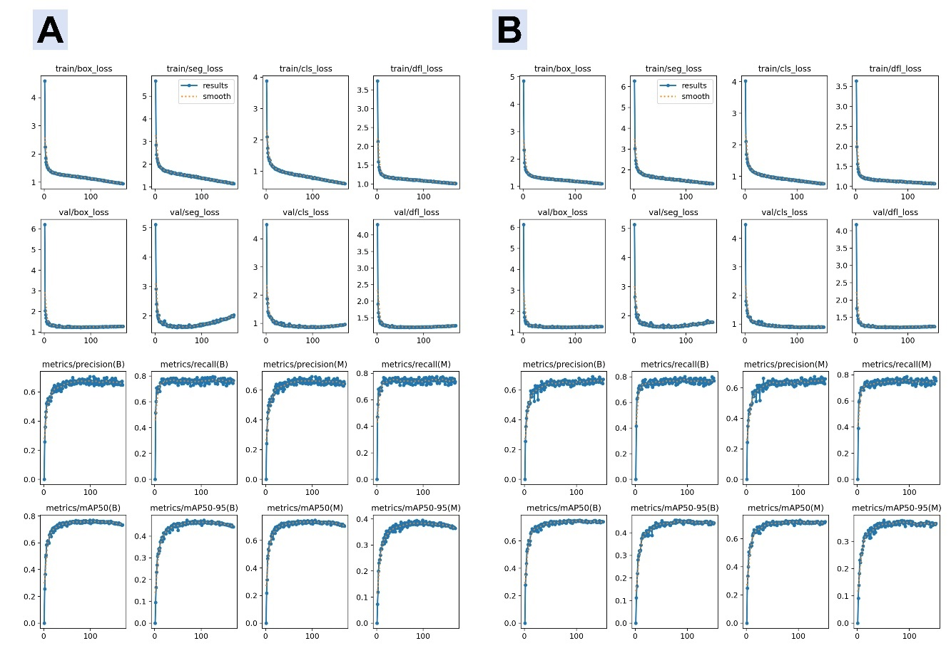
Supplement Figure S1. Training set and testing set loss functions and convergence of precision, recall, and mean Accuracy precision for Modified gingival index (MGI): (A) YOLOv8-based Model; (B) YOLOv8-Ghost-Based Model.
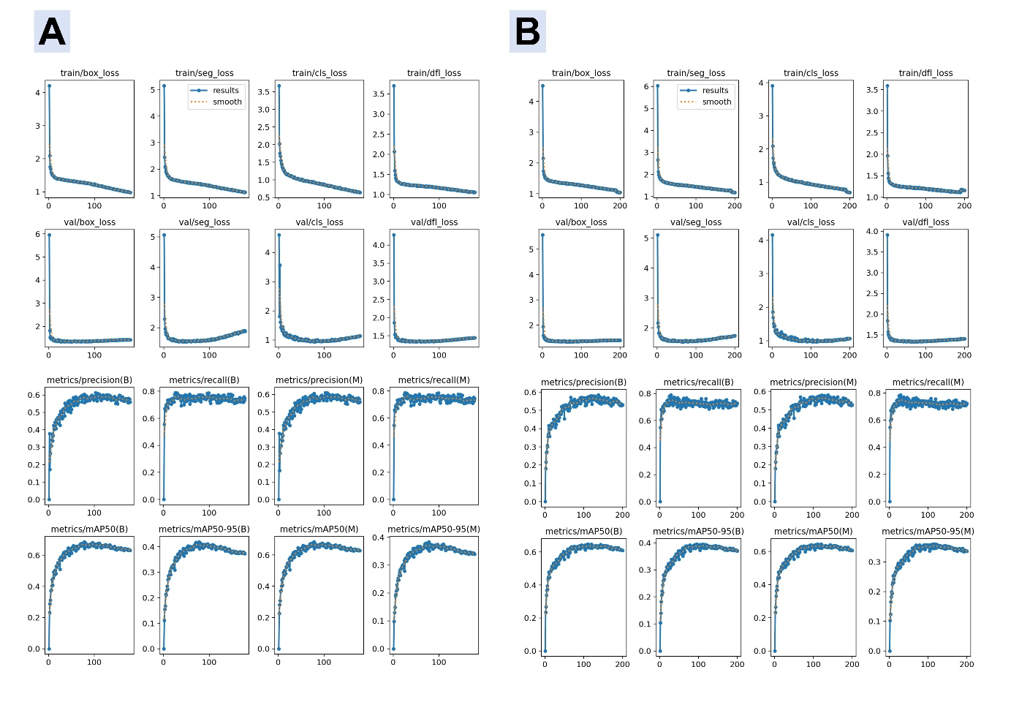
Supplement Figure S2. Training set and testing set loss functions and convergence of precision, recall, and mean Accuracy precision for Papillae filling index (PFI): (A) YOLOv8-based Model; (B) YOLOv8-Ghost-Based Model.

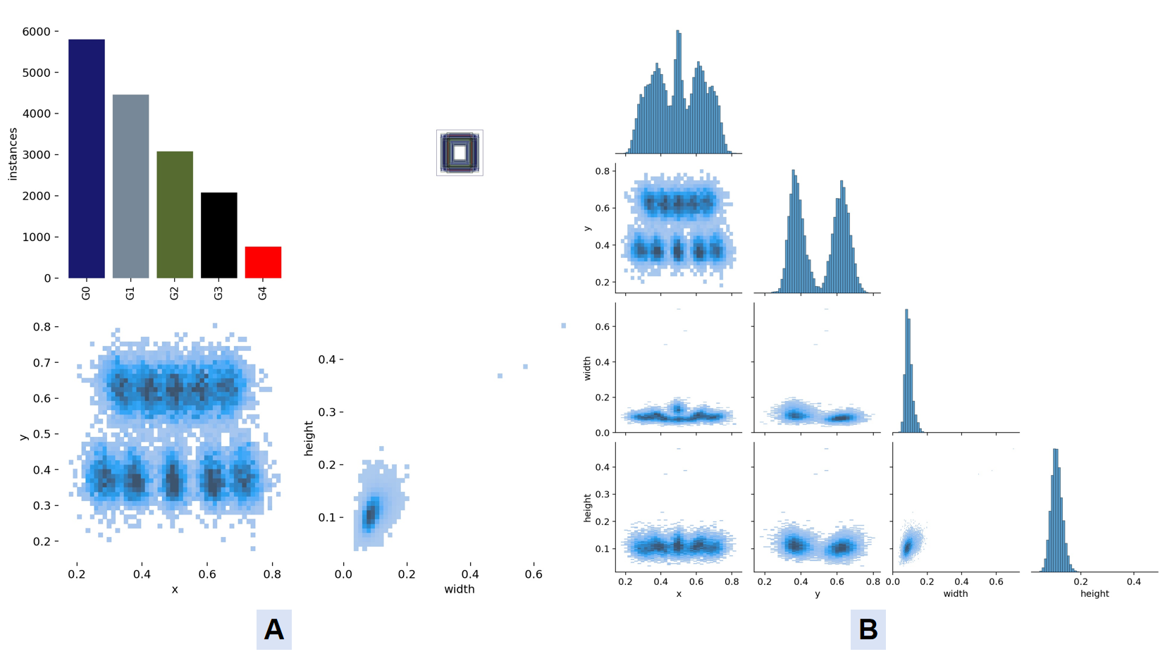
Supplement Figure S3. Labels of gingival units in five-fold cross validation: (A) Labels distribution; (B) Labels correlogram of Modified gingival index.

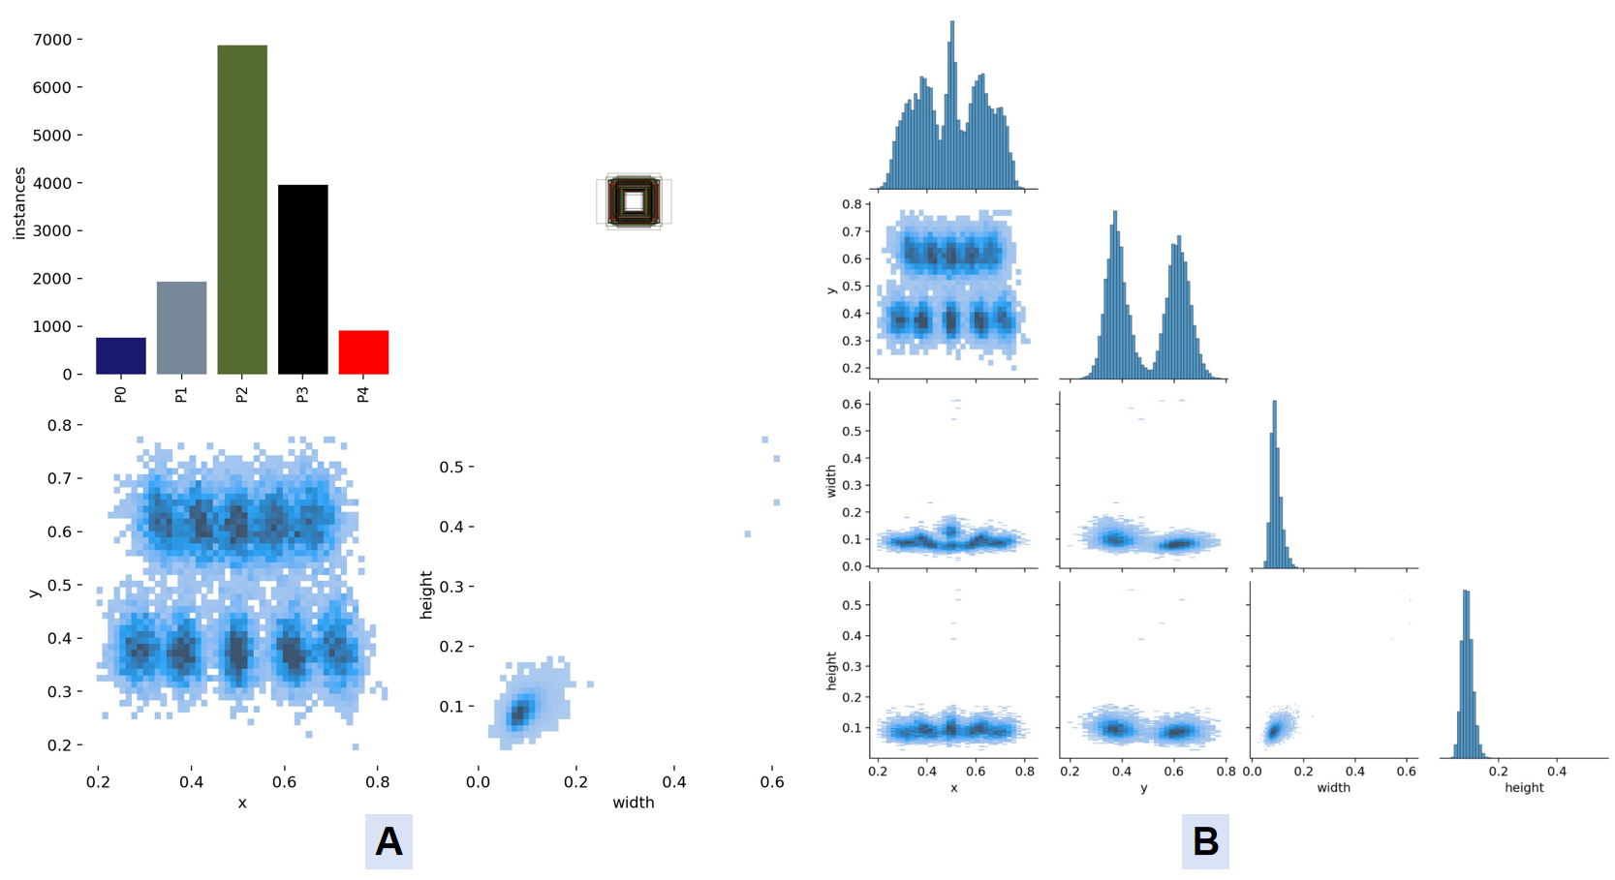
Supplement Figure S4. Labels of gingival units in five-fold cross-validation: (A) Labels distribution; (B) Labels correlogram of Papillae filling index.

Supplement Figure S5. Confusion matrix normalized of YOLOv8-based models. (A) YOLOv8-seg for Oral Health Grading (OHG); (B) YOLOv8-seg for Modified gingival index (MGI); (C) YOLOv8-seg for Papillae filling index (PFI); (D) YOLOv8-Ghost-seg for MGI; (E) YOLOv8-Ghost-seg for PFI.

S3. Real World validation test for dental education
Supplement Table S3. Papillae filling index predicted by machine, and evaluated by primary dentists and AI-assisted or AI-unassisted.
 |  | Round 1 |  |  |  |  |  | Round 2
Observers | Grades | F1 | P | R | ACC | Cohen’s κ | Weighted κ | F1 | P | R | ACC | Cohen’s κ | Weighted κ
Junior 1 ª | PFI0 | 0.597 | 0.574 | 0.623 | 0.973 | 0.507 | 0.560 | 0.630 | 0.738 | 0.549 | 0.969 | 0.514 | 0.567
 | PFI1 | 0.656 | 0.631 | 0.682 | 0.879 |  |  | 0.640 | 0.589 | 0.702 | 0.880
 | PFI2 | 0.743 | 0.769 | 0.719 | 0.758 |  |  | 0.747 | 0.768 | 0.727 | 0.764
 | PFI3 | 0.431 | 0.358 | 0.539 | 0.816 |  |  | 0.452 | 0.389 | 0.539 | 0.816
 | PFI4 | 0.657 | 0.806 | 0.555 | 0.899 |  |  | 0.667 | 0.805 | 0.569 | 0.904
Mean ± SD ^{b} |  | 0.617± 0.116 | 0.628± 0.178 | 0.624± 0.078 | 0.865± 0.082 |  |  | 0.627± 0.108 | 0.658± 0.171 | 0.617± 0.090 | 0.866± 0.080
Junior 2 ª | PFI0 | 0.108 | 0.059 | 0.623 | 0.969 | 0.325 | 0.360 | 0.508 | 0.363 | 0.844 | 0.977 | 0.390 | 0.443
 | PFI1 | 0.290 | 0.203 | 0.504 | 0.833 |  |  | 0.410 | 0.306 | 0.623 | 0.853
 | PFI2 | 0.688 | 0.788 | 0.611 | 0.662 |  |  | 0.706 | 0.788 | 0.638 | 0.689
 | PFI3 | 0.487 | 0.519 | 0.459 | 0.774 |  |  | 0.485 | 0.496 | 0.474 | 0.783
 | PFI4 | 0.532 | 0.441 | 0.668 | 0.916 |  |  | 0.591 | 0.545 | 0.646 | 0.917
Mean ± SD |  | 0.421± 0.225 | 0.402± 0.283 | 0.573± 0.088 | 0.831± 0.121 |  |  | 0.540± 0.113 | 0.500± 0.188 | 0.645± 0.132 | 0.844± 0.113
Junior 1 + AI assisted ª | PFI0 | 0.850 | 0.893 | 0.810 | 0.990 | 0.640 | 0.672 | 0.893 | 0.920 | 0.867 | 0.993 | 0.647 | 0.706
 | PFI1 | 0.789 | 0.762 | 0.817 | 0.927 |  |  | 0.671 | 0.574 | 0.808 | 0.903
 | PFI2 | 0.815 | 0.831 | 0.799 | 0.823 |  |  | 0.796 | 0.822 | 0.771 | 0.801
 | PFI3 | 0.567 | 0.499 | 0.657 | 0.858 |  |  | 0.682 | 0.719 | 0.649 | 0.868
 | PFI4 | 0.693 | 0.795 | 0.614 | 0.912 |  |  | 0.828 | 0.810 | 0.847 | 0.960
Mean ± SD |  | 0.743± 0.114 | 0.756± 0.152 | 0.739± 0.097 | 0.902± 0.064 |  |  | 0.774± 0.096 | 0.769± 0.130 | 0.788± 0.086 | 0.905± 0.758
Junior 2 +AI assisted ª | PFI0 | 0.937 | 0.974 | 0.903 | 0.996 | 0.754 | 0.799 | 0.805 | 0.733 | 0.894 | 0.989 | 0.616 | 0.668
 | PFI1 | 0.836 | 0.834 | 0.838 | 0.942 |  |  | 0.661 | 0.573 | 0.781 | 0.898
 | PFI2 | 0.855 | 0.862 | 0.843 | 0.861 |  |  | 0.798 | 0.840 | 0.760 | 0.800
 | PFI3 | 0.731 | 0.704 | 0.761 | 0.901 |  |  | 0.624 | 0.614 | 0.635 | 0.856
 | PFI4 | 0.857 | 0.866 | 0.847 | 0.963 |  |  | 0.778 | 0.809 | 0.748 | 0.945
Mean ± SD |  | 0.843± 0.074 | 0.848± 0.097 | 0.838± 0.051 | 0.932± 0.053 |  |  | 0.733± 0.084 | 0.714± 0.118 | 0.764± 0.092 | 0.897± 0.739
a Confusion matrix calculation based on machine prediction result transformation.
b Averaged results in Mean-F1 not being between P and R.
P, Precision; R, Recall; F, F1-Score; ACC, Accuracy.
SD, Standard deviation.

Supplement Table S4. Modified gingival index predicted by machine, and evaluated by primary dentists and AI-assisted or AI-unassisted.
 |  | Round 1 |  |  |  |  |  | Round 2
Observers | Grades | F1 | P | R | ACC | Cohen’s κ | Weighted κ | F1 | P | R | ACC | Cohen’s κ | Weighted κ
Junior 1 ª | MGI0 | 0.523 | 0.463 | 0.599 | 0.718 | 0.178 | 0.217 | 0.576 | 0.549 | 0.606 | 0.731 | 0.241 | 0.362
 | MGI1 | 0.512 | 0.624 | 0.434 | 0.554 |  |  | 0.506 | 0.576 | 0.451 | 0.580
 | MGI2 | 0.237 | 0.239 | 0.235 | 0.734 |  |  | 0.270 | 0.250 | 0.294 | 0.764
 | MGI3 | 0.186 | 0.124 | 0.369 | 0.924 |  |  | 0.286 | 0.226 | 0.391 | 0.922
 | MGI4 | 0.105 | 0.058 | 0.625 | 0.952 |  |  | 0.437 | 0.362 | 0.550 | 0.954
Mean ± SD |  | 0.313± 0.193 | 0.302± 0.237 | 0.453± 0.163 | 0.777± 0.739 |  |  | 0.415± 0.134 | 0.393± 0.164 | 0.458± 0.124 | 0.790± 0.152
Junior 2 ª | MGI0 | 0.564 | 0.712 | 0.467 | 0.616 | 0.121 | 0.199 | 0.571 | 0.694 | 0.485 | 0.637 | 0.167 | 0.262
 | MGI1 | 0.226 | 0.170 | 0.339 | 0.581 |  |  | 0.288 | 0.239 | 0.364 | 0.574
 | MGI2 | 0.296 | 0.365 | 0.249 | 0.701 |  |  | 0.299 | 0.351 | 0.260 | 0.718
 | MGI3 | 0.158 | 0.113 | 0.262 | 0.915 |  |  | 0.160 | 0.111 | 0.281 | 0.916
 | MGI4 | 0.054 | 0.030 | 0.271 | 0.950 |  |  | 0.076 | 0.042 | 0.357 | 0.951
 | Mean | 0.260± 0.192 | 0.278± 0.272 | 0.318± 0.090 | 0.753± 0.170 |  |  | 0.279± 0.188 | 0.287± 0.256 | 0.349± 0.088 | 0.759± 0.167
Junior 1 + AI assisted ª | MGI0 | 0.718 | 0.687 | 0.753 | 0.820 | 0.478 | 0.552 | 0.800 | 0.817 | 0.783 | 0.863 | 0.639 | 0.722
 | MGI1 | 0.646 | 0.707 | 0.595 | 0.711 |  |  | 0.735 | 0.756 | 0.715 | 0.797
 | MGI2 | 0.512 | 0.516 | 0.509 | 0.830 |  |  | 0.660 | 0.616 | 0.710 | 0.889
 | MGI3 | 0.528 | 0.446 | 0.647 | 0.943 |  |  | 0.705 | 0.664 | 0.751 | 0.961
 | MGI4 | 0.580 | 0.454 | 0.803 | 0.968 |  |  | 0.799 | 0.758 | 0.844 | 0.981
Mean ± SD |  | 0.599± 0.086 | 0.562± 0.126 | 0.661 ± 0.119 | 0.902± 0.064 |  |  | 0.740± 0.061 | 0.722± 0.081 | 0.761± 0.055 | 0.790± 0.152
Junior 2+AI assisted ª | MGI0 | 0.767 | 0.845 | 0.703 | 0.822 | 0.584 | 0.669 | 0.823 | 0.860 | 0.789 | 0.872 | 0.673 | 0.749
 | MGI1 | 0.683 | 0.640 | 0.733 | 0.786 |  |  | 0.749 | 0.735 | 0.763 | 0.822
 | MGI2 | 0.623 | 0.609 | 0.638 | 0.873 |  |  | 0.705 | 0.688 | 0.722 | 0.901
 | MGI3 | 0.675 | 0.642 | 0.711 | 0.957 |  |  | 0.710 | 0.675 | 0.749 | 0.961
 | MGI4 | 0.712 | 0.640 | 0.804 | 0.975 |  |  | 0.806 | 0.783 | 0.831 | 0.982
Mean ± SD |  | 0.692± 0.053 | 0.675± 0.096 | 0.718± 0.060 | 0.883± 0.082 |  |  | 0.759± 0.054 | 0.748±  0.076 | 0.771 ± 0.042 | 0.908±  0.065
a Confusion matrix calculation based on machine prediction result transformation.
P, Precision; R, Recall; F, F1-Score; ACC, Accuracy.
SD, Standard deviation.

