Appendix A: Implementation Notes for the Biological Pathway Module
To enhance the biological interpretability of the model, MultCPM incorporates a biological pathway module at the input end to establish the mapping relationship between omics features and biological pathways, as shown in Fig. 1 A. This module introduces a knowledge-driven structure to form connections between the omics feature layer and the pathway layer, thereby extracting more biologically meaningful pathway feature representations.
1. Module structure
(1) Let the raw feature matrix of the preprocessed data for the $i$-th type of omics (such as mRNA, miRNA, or SNV) be $X^{i}∈R^{N×F}$, where $N$ denotes the number of samples and $F$ denotes the number of features for the $i$-th type of omics.
(2) Let the connection between the group and the pathway be represented by a binary matrix $A^{i}∈\{0,1\}^{N×L}$, where $L$ represents the number of selected pathways. The connection between the $k$-th group feature $x_{k }^{i}$and the $p$-th pathway node $p$ is defined as follows:
$$\begin{aligned}A_{k,p}^{i}=\left\{\begin{aligned}1 ,if x_{k }^{i}∈p \\ 0,otherwise\end{aligned}\right.\#\left(1\right) \end{aligned}$$
If $A_{k,p}^{i}=1$, it indicates that the $k$-th feature belongs to the $p$-th biological pathway (e.g., a pathway in KEGG); otherwise, it indicates no connection. Taking mRNA as an example, the logic for constructing matrix A is shown in Fig. 5.
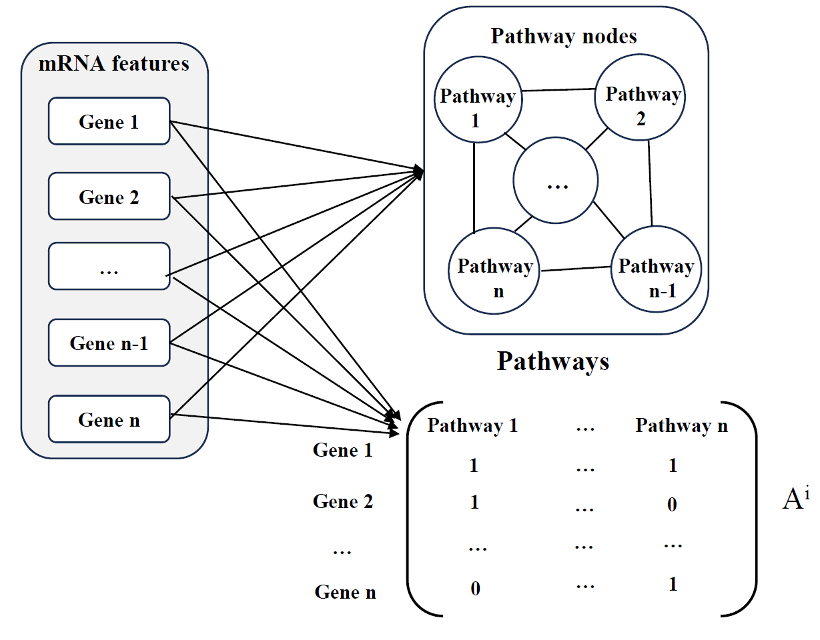
Fig. 5. Construction logic of matrix A
2. Pathway feature construction
The core task of the biological pathway module is to project raw omics features onto the pathway space and generate pathway-level feature representations $p^{i}∈R^{N×L}$. The mapping process is as follows:
$$\begin{aligned}P^{i}=X^{i}A^{T}+b\#\left(2\right)\end{aligned}$$
Where $b∈R^{L}$ is the trainable bias term. This process essentially aggregates features belonging to the same pathway through a feedforward network and outputs the active features of each sample across different pathways.
3. Biological interpretation
The final $P^{i}$ represents the comprehensive expression level or activity value of the $i$-th type of omics across all pathway nodes, with each row corresponding to a sample and each column representing a pathway node. This feature matrix will be used in subsequent attention mechanisms and multi-omics fusion modules to further enhance the model's biological perception capabilities. Through this module, MultCPM effectively integrates pathway knowledge to assist the model in identifying biological pathways closely associated with cancer recurrence in high-dimensional heterogeneous omics data, thereby improving predictive performance and interpretability.

Appendix B: Impact of Imputation Strategies on Model Performance
To validate the effectiveness of the random forest imputation method, we compared and evaluated four commonly used imputation strategies on the BRCA, BLCA, and LIHC datasets: Random Forest, K-Nearest Neighbors (KNN), Soft-Impute, and Non-Negative Matrix Factorization (NMF). After imputation, we assessed the impact of each method on predictive performance using the same model structure (MultCPM), with evaluation metrics including ACC, F1-score, AUC, and AUPR.
As shown in Table 8, the random forest imputation strategy outperformed the other methods in most metrics, particularly in terms of ACC, REC, and F1-Score, demonstrating superior robustness and predictive ability. Therefore, this paper adopts the random forest method as the final missing value imputation strategy during the model training stage.
Table 8: Impact of imputation strategies on MultCPM performance across different datasets.
DataSets | Methods | ACC | AUC | F1-Score | REC | AUPR
BRCA | Random Forest | 0.814±0.004 | 0.900±0.005 | 0.733±0.013 | 0.632±0.006 | 0.893±0.006
BRCA | KNN | 0.801±0.003 | 0.900±0.002 | 0.645±0.011 | 0.553±0.005 | 0.899±0.004
BRCA | Soft-Impute | 0.782±0.004 | 0.899±0.003 | 0.624±0.005 | 0.515±0.007 | 0.886±0.002
BRCA | NMF | 0.810±0.002 | 0.897±0.004 | 0.688±0.003 | 0.576±0.009 | 0.885±0.005
BLCA | Random Forest | 0.903±0.004 | 0.964±0.011 | 0.863±0.013 | 0.877±0.025 | 0.949±0.005
BLCA | KNN | 0.873±0.005 | 0.956±0.003 | 0.823±0.007 | 0.832±0.011 | 0.938±0.003
BLCA | Soft-Impute | 0.888±0.003 | 0.956±0.005 | 0.845±0.005 | 0.860±0.005 | 0.938±0.002
BLCA | NMF | 0.880±0.006 | 0.954±0.003 | 0.830±0.003 | 0.818±0.004 | 0.932±0.005
LIHC | Random Forest | 0.937±0.008 | 0.979±0.006 | 0.935±0.005 | 0.929±0.007 | 0.979±0.005
LIHC | KNN | 0.932±0.003 | 0.982±0.002 | 0.928±0.003 | 0.918±0.005 | 0.983±0.003
LIHC | Soft-Impute | 0.923±0.004 | 0.980±0.003 | 0.920±0.002 | 0.906±0.003 | 0.978±0.002
LIHC | NMF | 0.909±0.006 | 0.977±0.003 | 0.905±0.004 | 0.900±0.006 | 0.976±0.001
Note：The bold indicates the best performance for each dataset.

Appendix C: Bilinear Fusion Implementation Code (Bilinear Fusion Layer)

class BilinearFusion(tf.keras.layers.Layer):
def __init__ (self, output_dim, **kwargs):
super (BilinearFusion, self). __init__(**kwargs)
self.output_dim = output_dim
def build (self, input_shape):
self.W = self.add_weight (name='W',
shape=(input_shape[0][-1], input_shape [1][-1], self.output_dim),
initializer='random_normal',trainable=True)
self.b = self.add_weight (name='b',
shape=(self.output_dim,),
initializer='zeros',
trainable=True)
def call(self, inputs):
input1, input2 = inputs
bilinear_product = tf.tensordot(input1, self.W, axes= [[1], [0]])
bilinear_product = tf.tensordot(bilinear_product, input2, axes= [[1], [0]])
return bilinear_product

Experimental Setup Description:
Fusion pairs: SNV and mRNA, SNV and miRNA
Output dimension: 256
Activation function: None (linear structure maintained to preserve bilinear interaction)
Splicing method: Concatenation of the two fusion results as the final feature input

