Article S1
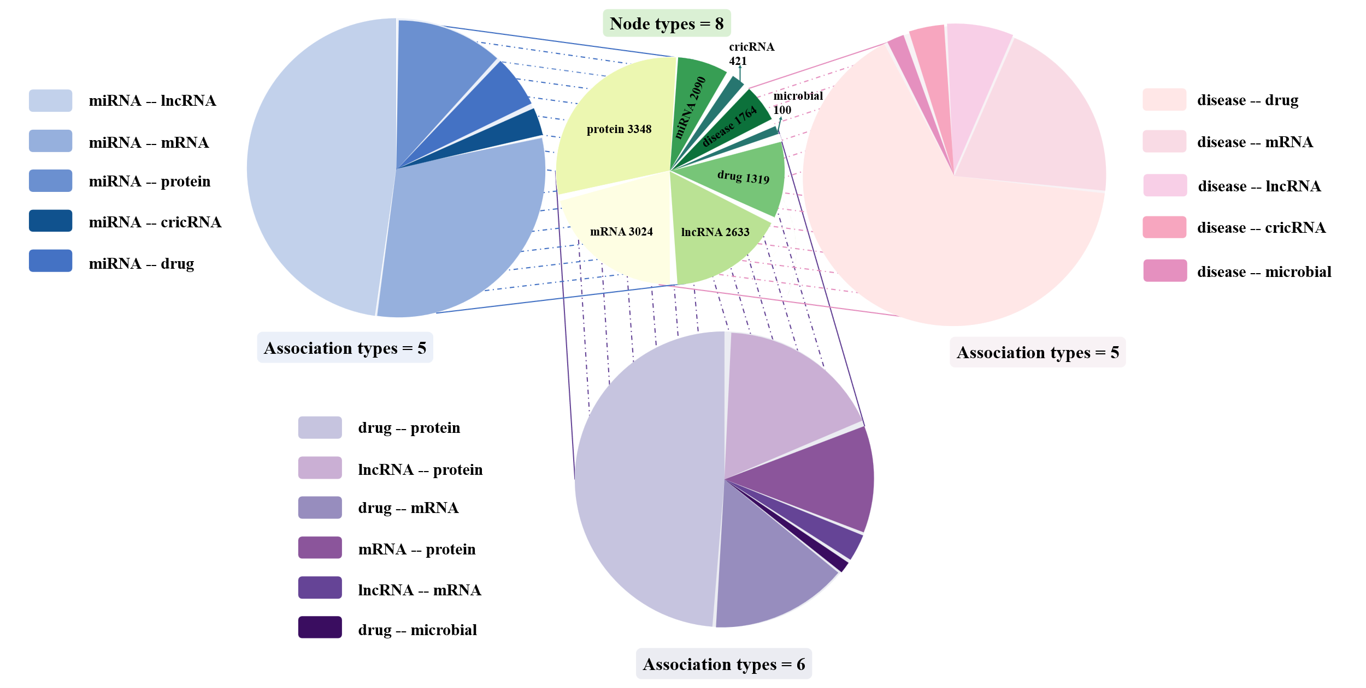
Figure 1 Node and edge types included in the constructed heterogeneous graph features.

Tabel 1. The details of 16 types of associations used in heterogeneous graph features.
Association types | number
miRNA-lncRNA | 8634
miRNA-mRNA | 5186
miRNA-protein | 2042
miRNA-circRNA | 1378
miRNA-drug | 269
disease-drug | 17414
disease-mRNA | 3416
disease-lncRNA | 874
disease-circRNA | 421
disease-microbe | 175
drug-protein | 11396
lncRNA-protein | 5115
drug-mRNA | 3915
mRNA-protein | 3012
lncRNA-mRNA | 525
drug-microbe | 8
The 16 associations consisting of 8 types of nodes are detailed in Figure 1 and Table 1.

