Article S2
To intuitively assess the contribution of each entity type to the overall information flow, we design a series of node-level ablation experiments. Specifically, while retaining miRNA and disease, we remove each of the six node types-protein, drug, lncRNA, mRNA, circRNA and microbe-together with all their associated edges. Compared to conventional edge-level deletion, this strategy provides a more realistic evaluation of the overall impact of each entity class on model performance. The ablation results are shown in the following figures:
Figure 1 Ablation experiments of AUC values and p-values.
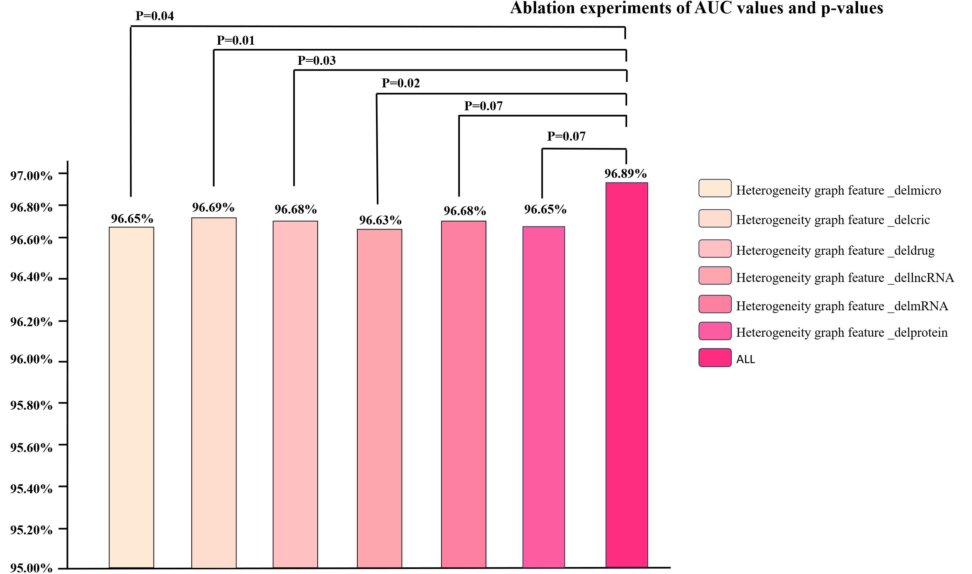
Figure 2 Ablation experiments of AUPR values and p-values.
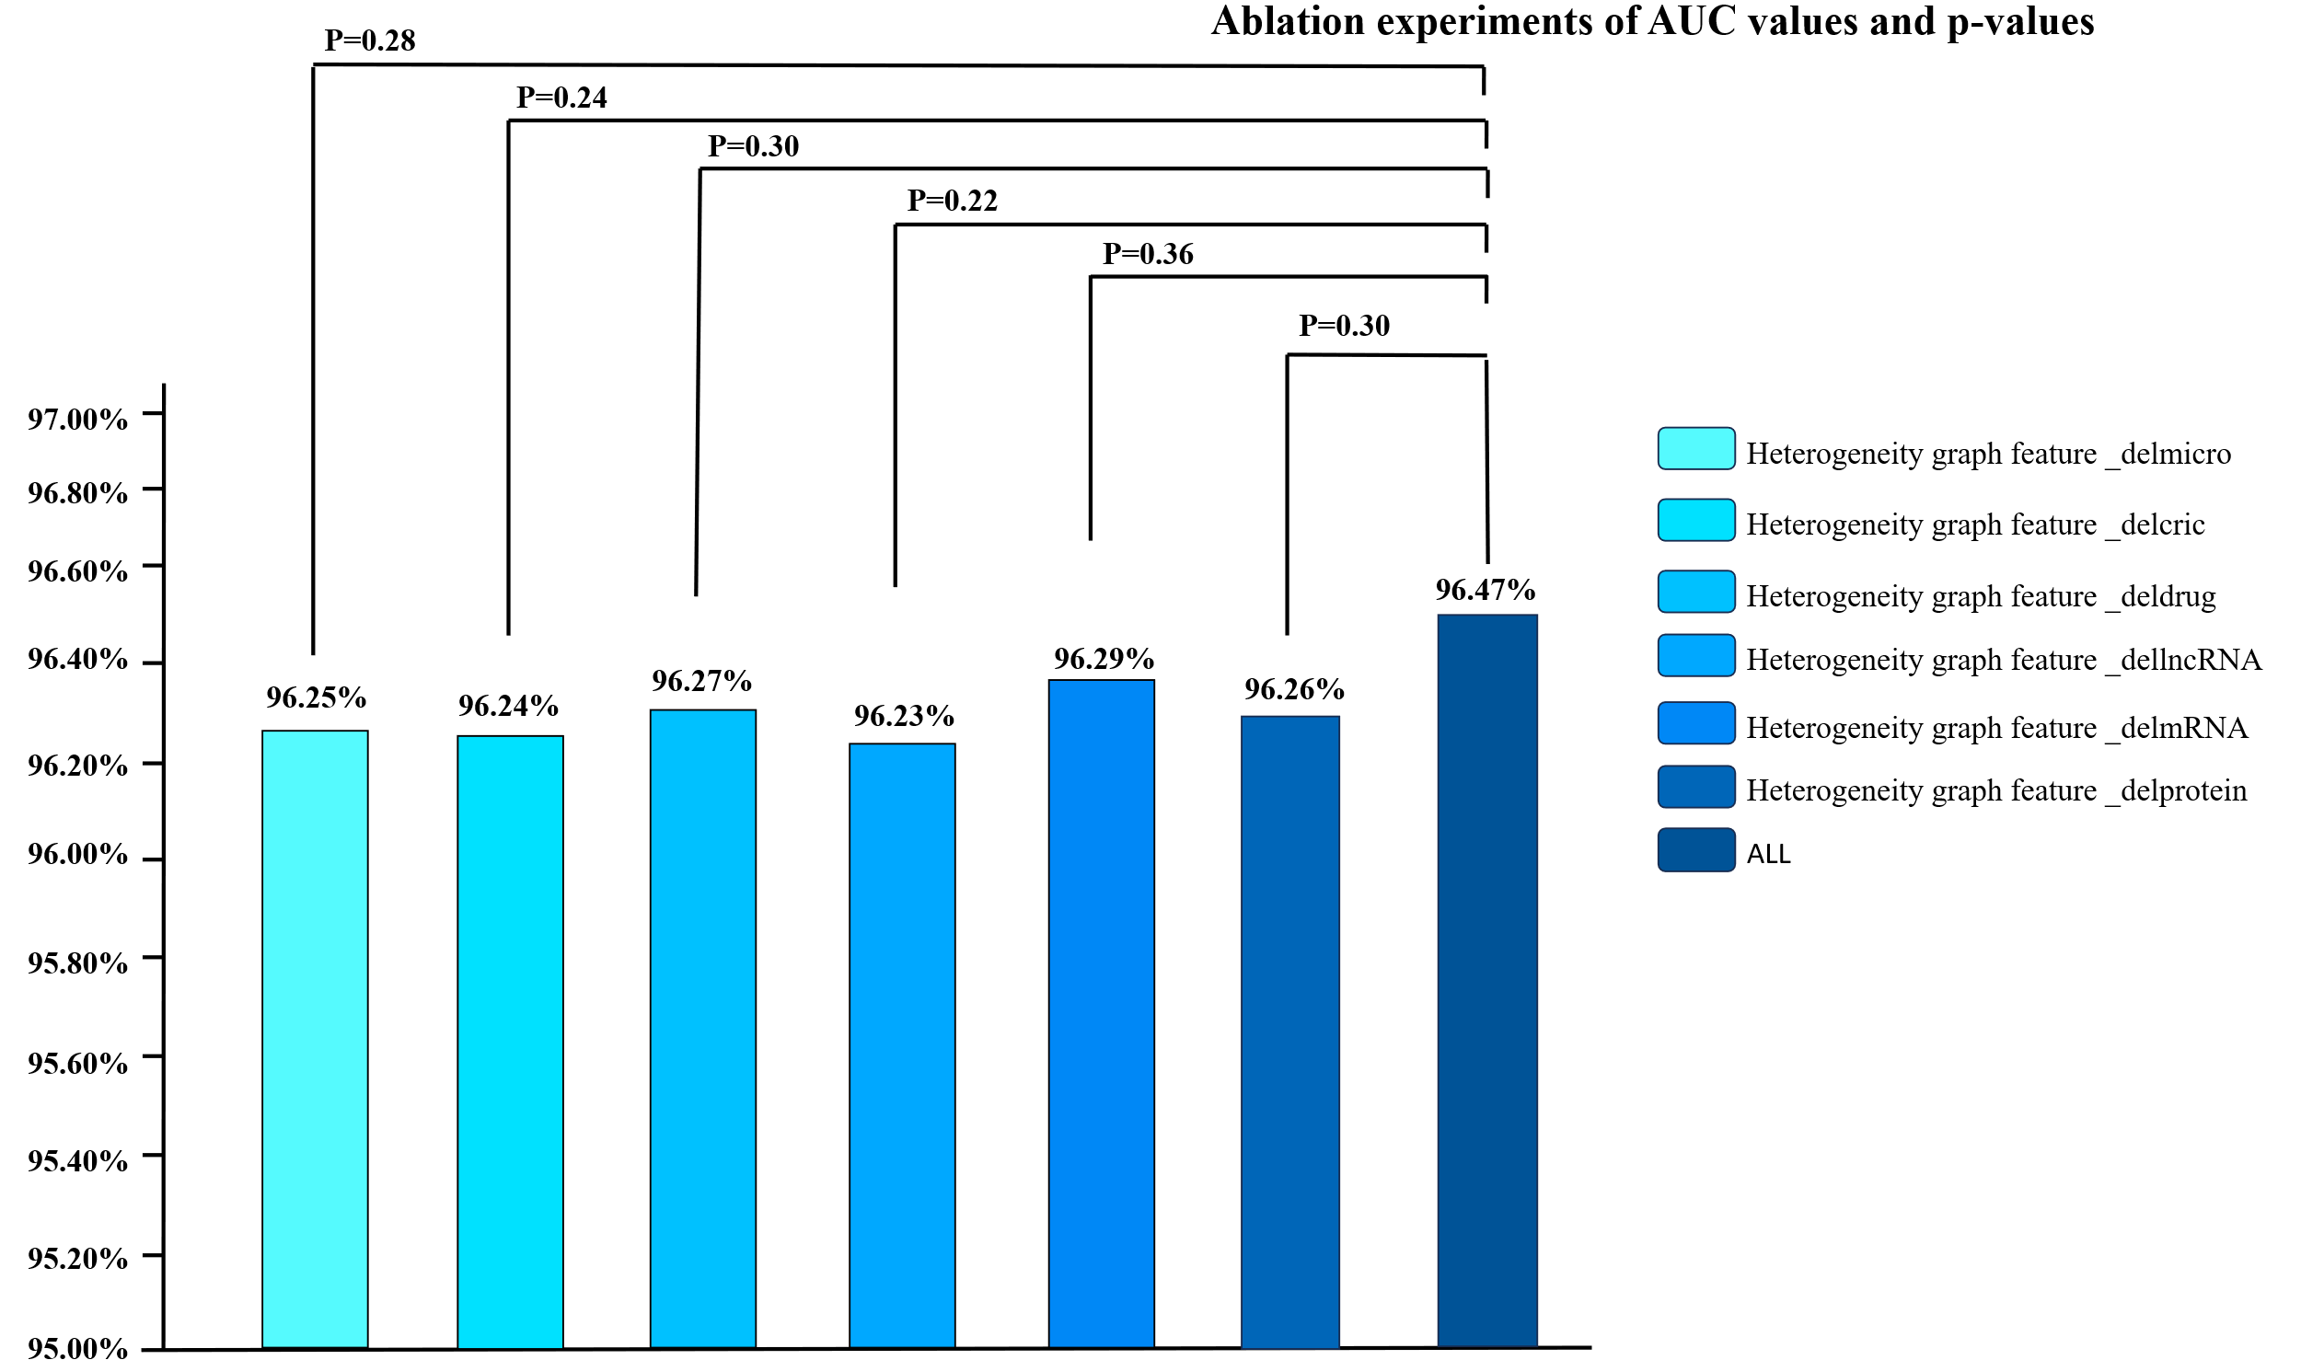
The full model achieves the best performance, with an AUC of 96.89% and an AUPRC of 96.47%.
When removing individual node types, both AUC and AUPRC decrease by 0.20-0.26 percentage points. Among them, the removal of lncRNA leads to the greatest drop in AUC ($∆$AUC $-$0.26, $∆$AUPRC $-$0.24), followed by microbe ($∆$AUC $-$0.24, $∆$AUPRC $-$0.22) and protein ($∆$AUC $-$0.24, $∆$AUPRC $-$0.21).
This result suggests that during training, heterogeneous graph transformation (HGT) automatically assigns near-zero attention weights to low-confidence or noisy relations, such as drug-microbe. In contrast, it retains higher weights for information-rich lncRNA-associated ceRNA pathways. When lncRNA nodes are entirely removed, the model loses this critical regulatory signal, leading to the most significant performance drop. In comparison, the removal of noisy edges has a limited impact, as their weak attention weights can be quickly compensated by remaining informative paths.
We then perform paired t-tests to examine the AUC differences between each ablation variant and the full model. The results indicate that only a few comparisons reach statistical significance (p < 0.05), which is mainly due to two reasons: 1.The attention mechanism in HGT automatically redistributes weights to other meta-relations when a certain node type is removed, thereby partially mitigating the performance drop; 2.The heterogeneous graph features are ultimately concatenated with the attribute similarity features of miRNAs and diseases, allowing the attribute signals to partially compensate when the heterogeneity is weakened.
Taken together, although the performance variations in the ablation study are small, this in fact highlights HGT’s ability to suppress noise and focus on key signals in a multi-source, highly sparse biological network. In contrast, traditional hand-crafted meta-paths or simple relation-sharing strategies lack both interpretability and scalability at this level of complexity. Therefore, we argue that using HGT to construct heterogeneous features is not only necessary, but also essential to the effectiveness of the dual-channel contrastive fusion framework.

