Article S3
To quantitatively examine whether computing Gaussian interaction profile (GIP) kernel similarity from the complete miRNA-disease association (MDA) matrix introduces label leakage during cross-validation, we design a leakage-free control experiment. In each fold, we temporarily mask all positive samples in the validation set within the MDA matrix, recompute the GIP kernel similarity, and then train and evaluate the model with this recomputed similarity in parallel with the original setting, in which the complete matrix is used.
Figure 1 The Performance of the Leakage-free Control Experiment.
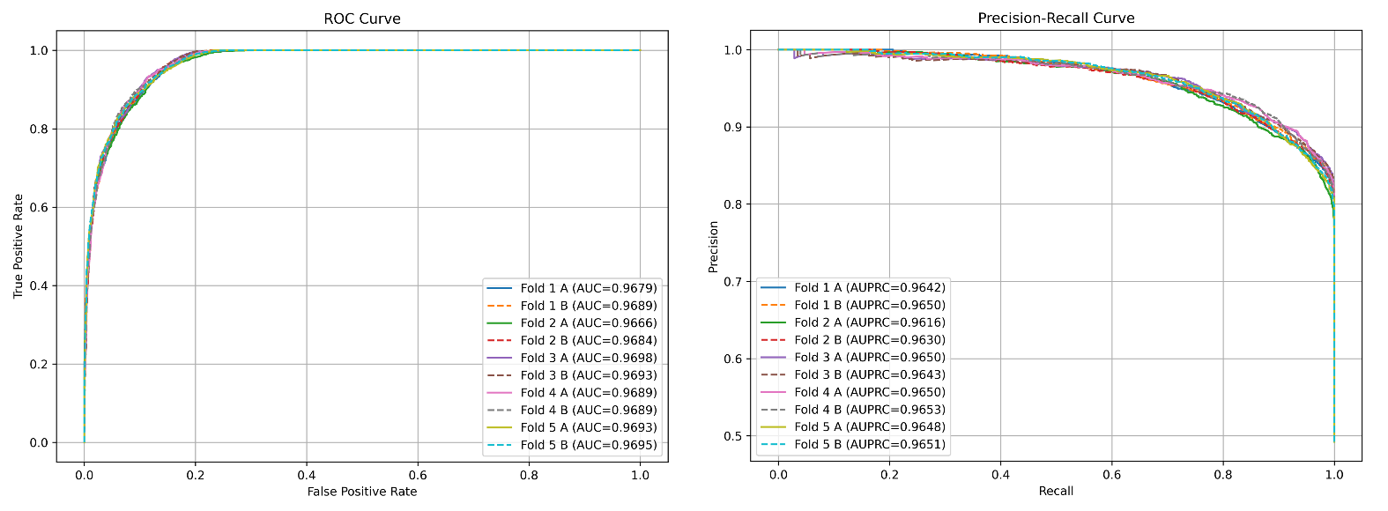
Table 1. Performance comparison between original GIP and leakage-free control experiment.
Fold | AUC (Orig, A) | AUC (Masked, B) | ΔAUC (A–B) | AUPRC (Orig, A) | AUPRC (Masked, B) | ΔAUPRC (A–B)
1 | 0.967948 | 0.968892 | –0.000944 | 0.964166 | 0.964993 | –0.000827
2 | 0.966570 | 0.968417 | –0.001847 | 0.961557 | 0.963008 | –0.001451
3 | 0.969776 | 0.969302 | +0.000474 | 0.965005 | 0.964261 | +0.000744
4 | 0.968939 | 0.968903 | +0.000037 | 0.965036 | 0.965318 | –0.000282
5 | 0.969322 | 0.969502 | –0.000179 | 0.964774 | 0.965114 | –0.000340
Mean | 0.9689 | 0.9690 | –0.000492 | 0.9643 | 0.9647 | –0.000431
Std | — | — | 0.000819 | — | — | 0.000722

The results show that the performance under the two settings remains nearly identical, with differences at the ${10}^{-3}$ level. Across the five folds, the mean $∆$AUC is $-$0.000492 and the mean $∆$AUPRC is $-$0.000431, with standard deviations of 0.000819 and 0.000722, respectively. At the fold level, $∆$AUC ranges from $-$0.001847 to $+$0.000474, while $∆$AUPRC ranges from $-$0.001451 to 0.000744, indicating minimal fluctuations across folds. Furthermore, paired t-tests confirm that the observed differences are not statistically significant (p > 0.2 for both AUC and AUPRC), thereby providing additional evidence that GIP kernel similarity does not induce performance inflation in our evaluation. These negligible differences can be consistently explained by underlying mechanisms. First, this study does not rely solely on features containing MDA information. We entirely discard miRNA functional similarity, which represents the primary leakage pathway, and we impose strict gating on GIP kernel similarity: it is used only when sequence or semantic similarity equals zero, and it is omitted whenever such information is available. As a result, GIP serves only as an auxiliary interpolation in a very small fraction of cases. Finally, we concatenate the GIP-patched similarity matrices with heterogeneous similarity features that contain no MDA information, thereby constructing a unified comprehensive similarity matrix that further dilutes any residual leakage signal.
Taken together, under the multiple safeguards adopted in this study, GIP similarity does not cause substantive inflation of cross-validation performance. The differences in AUC and AUPRC consistently remain at the ${10}^{-3}$ level, reinforcing the robustness of our conclusions and the reliability of the evaluation procedure.

