Article S4
To further validate the effectiveness of the proposed model, we conduct a systematic comparison between DCCM-MSIF and five representative state-of-the-art models published during 2023-2024. As shown in the table, DCCM-MSIF achieves the best overall performance on both the HMDD v3.2 and HMDD v2.0 datasets, exhibiting consistently strong results across all evaluation metrics.
Figure 1 The result of performance comparison among different methods
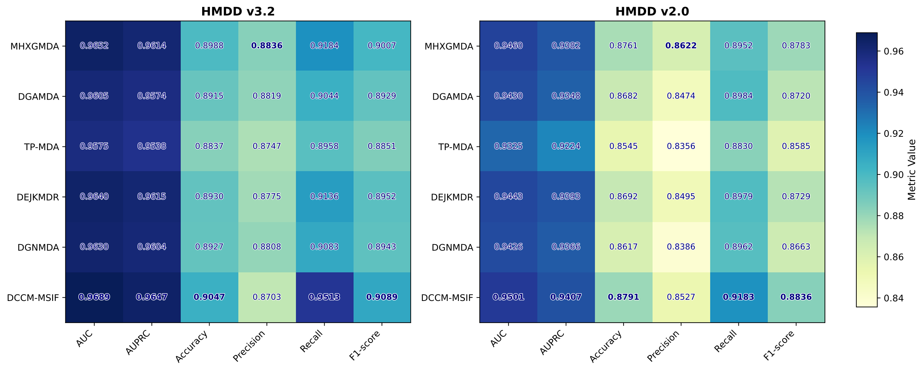

Table 1. The results of different methods on the HMDD v3.2 dataset.
Methods | AUC |  | AUPRC |  | Accuracy |  | Precision |  | Recall |  | F1-score
MHXGMDA (Wen et al., 2024) |  | 0.9652 |  | 0.9614 |  | 0.8988 |  | 0.8836 |  | 0.9184 |  | 0.9007
DGAMDA (Jia et al., 2024) |  | 0.9605 |  | 0.9574 |  | 0.8915 |  | 0.8819 |  | 0.9044 |  | 0.8929
TP-MDA (Hou et al., 2024) |  | 0.9575 |  | 0.9538 |  | 0.8837 |  | 0.8747 |  | 0.8958 |  | 0.8851
DEJKMDR (Gao et al., 2023) |  | 0.9640 |  | 0.9615 |  | 0.8930 |  | 0.8775 |  | 0.9136 |  | 0.8952
DGNMDA (Lu et al., 2024) |  | 0.9630 |  | 0.9604 |  | 0.8927 |  | 0.8808 |  | 0.9083 |  | 0.8943
DCCM-MSIF |  | 0.9689 |  | 0.9647 |  | 0.9047 |  | 0.8703 |  | 0.9513 |  | 0.9089

Table 2. The results of different methods on the HMDD v2.0 dataset.
Methods | AUC |  | AUPRC |  | Accuracy |  | Precision |  | Recall |  | F1-score
MHXGMDA (Wen et al., 2024) |  | 0.9460 |  | 0.9382 |  | 0.8761 |  | 0.8622 |  | 0.8952 |  | 0.8783
DGAMDA (Jia et al., 2024) |  | 0.9430 |  | 0.9348 |  | 0.8682 |  | 0.8474 |  | 0.8984 |  | 0.8720
TP-MDA (Hou et al., 2024) |  | 0.9325 |  | 0.9224 |  | 0.8545 |  | 0.8356 |  | 0.8830 |  | 0.8585
DEJKMDR (Gao et al., 2023) |  | 0.9443 |  | 0.9393 |  | 0.8692 |  | 0.8495 |  | 0.8979 |  | 0.8729
DGNMDA (Lu et al., 2024) |  | 0.9426 |  | 0.9366 |  | 0.8617 |  | 0.8386 |  | 0.8962 |  | 0.8663
DCCM-MSIF |  | 0.9501 |  | 0.9407 |  | 0.8791 |  | 0.8527 |  | 0.9183 |  | 0.8836

On the HMDD v3.2 dataset, DCCM-MSIF attains an AUC of 0.9689 and an AUPRC of 0.9647, both representing the highest values among all methods. Compared with the second-best model MHXGMDA (AUC = 0.9652, AUPRC = 0.9614), our approach still shows a noticeable improvement. Moreover, its recall (0.9513) and F1-score (0.9089) are substantially higher than those of other competitors, indicating stronger sensitivity and a better overall balance in identifying potential associations.
On the HMDD v2.0 dataset, DCCM-MSIF achieves an AUC of 0.9501 and an AUPRC of 0.9407, again outperforming all comparison methods. In particular, it improves upon DEJKMDR (AUC = 0.9443, AUPRC = 0.9393) by approximately 0.5-0.6%. The consistent superiority of DCCM-MSIF across both the earlier and updated versions of the database demonstrates its strong generalization ability and robustness under varying data scales and sparsity levels.
Overall, DCCM-MSIF achieves comprehensive superiority over all five representative models in this comparative analysis.
References
Gao SY, Kuang ZF, Duan T, and Deng L. 2023. DEJKMDR: miRNA-disease association prediction method based on graph convolutional network. Frontiers in Medicine 10:12 DOI: 10.3389/fmed.2023.1234050.
Hou BY, Li MS, Hou YX, Zeng M, Wang N, and Guan LX. 2024. A miRNA-disease association prediction model based on tree-path global feature extraction and fully connected artificial neural network with multi-head self-attention mechanism. Bmc Cancer 24:18 DOI: 10.1186/s12885-024-12420-5.
Jia CX, Wang FY, Xing BX, Li SN, Zhao Y, Li Y, and Wang Q. 2024. DGAMDA: Predicting miRNA-disease association based on dynamic graph attention network. International Journal for Numerical Methods in Biomedical Engineering 40:15 DOI: 10.1002/cnm.3809.
Lu DY, Zhang Q, Zheng CH, Li J, and Yin Z. 2024. DGNMDA: Dual Heterogeneous Graph Neural Network Encoder for miRNA-Disease Association Prediction. Bioengineering-Basel 11:18 DOI: 10.3390/bioengineering11111132.
Wen SJ, Liu YB, Yang G, Chen WX, Wu HT, Zhu XL, and Wang YM. 2024. A method for miRNA-disease association prediction using machine learning decoding of multi-layer heterogeneous graph Transformer encoded representations. Scientific Reports 14:1 DOI: 10.1038/s41598-024-76003-x.

