Supplemental Information

**Zinc-reinforced ZSM-5 subject to a rare-earth magnet and the presence of a legume yields considerable copper extraction**

Mouhammad Shadi Khudr1*, Cristian Baleca2*, Nasser Alqahtani2,3, Hassan Alhassawi2, Arthur Garforth2, Gordon Tiddy†2, Abdullatif Alfutimie2

1 School of Biological Sciences, Faculty of Biology, Medicine and Health, Manchester Academic Health Science Centre, The University of Manchester, Manchester, M13 9PT, UK

2 Department of Chemical Engineering, Faculty of Science and Engineering, The University of Manchester, M13 9PL, UK

3 Advanced Materials Technologies Institute, KACST, Riyadh, 11442, Saudi Arabia

* Contribute equally as the first author.

†Deceased, 06 October 2024

Corresponding author: Abdullatif Alfutimie email: abdullatif.alfutimie@manchester.ac.uk

**Running title:** Zinc-reinforced ZSM-5 yields considerable copper extraction

This work is peer-reviewed based on our revised preprint (Khudr *et al.,* 2023).

**Author Contributions**

All authors wrote and approved the final manuscript.

* **Mouhammad Shadi Khudr (MSK)** conceptualisation, supervision, experimental design, methodology, formal analysis, visualisation, writing – original draft, writing – review & editing.
* **Cristian Baleca (CB)** lab work, formal analysis, methodology, visualisation, writing – original draft.
* **Nasser Alqahtani (NA)** further supportive formal analysis, visualisation, writing – review & editing.
* **Hassan Alhassawi (HA)** further supportive formal analysis, visualisation, writing – review & editing.
* **Arthur Garforth (AG)** supportive materials and resources, validation, writing – review & editing.
* **Gordon Tiddy (GT)** validation, writing – review & editing.
* **Abdullatif Alfutimie (AA)** supervision, project administration, methodology, validation, writing – review & editing.

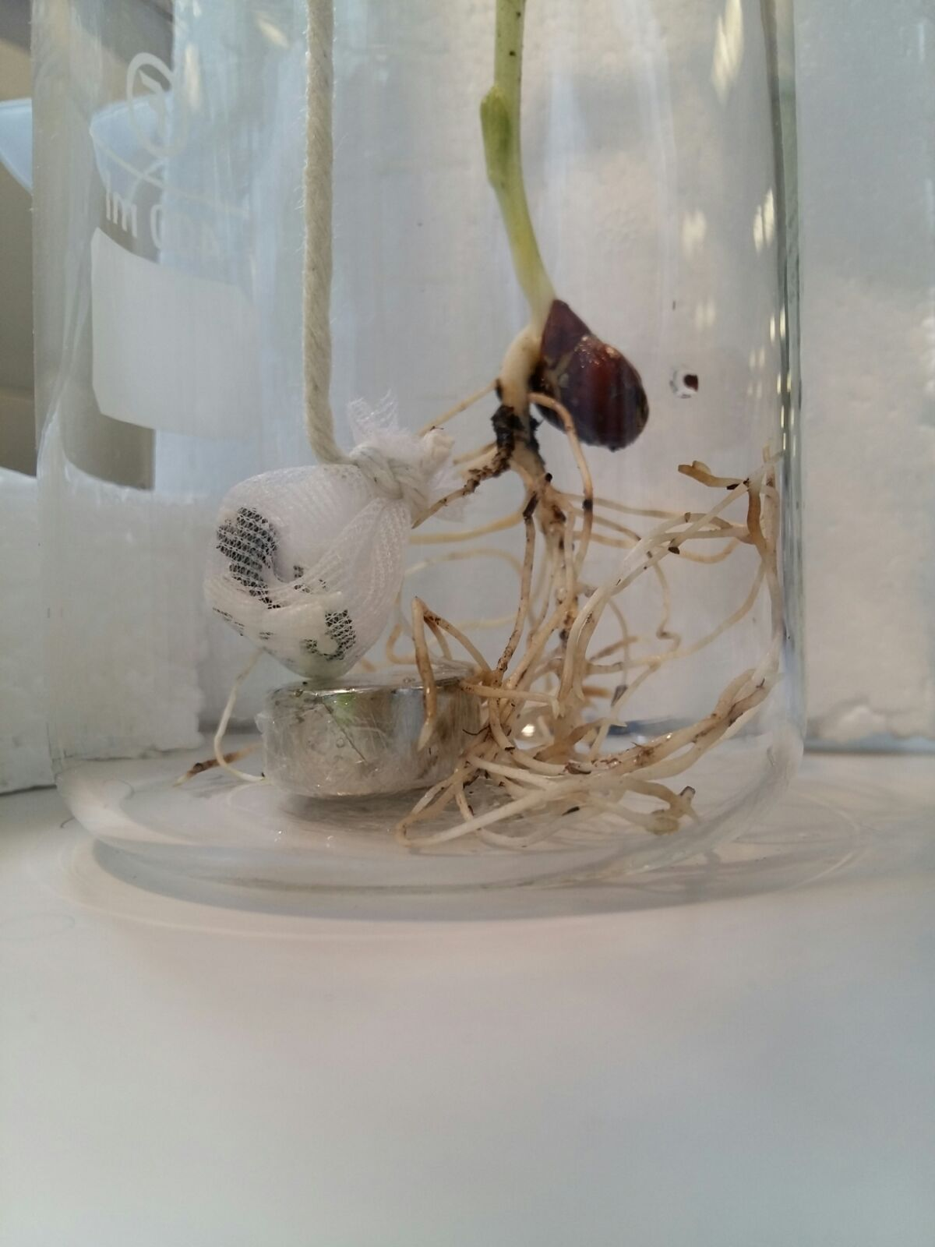

**Fig. S1. Experimental device.** The picture shows the aquacultured faba bean (*Vicia faba*) bio-trap next to the permeable drum containing 1g of zinc-reinforced ZSM-5 zeolite pellets, and a cling-filmed neodymium magnet before adding 300ml of copper sulphate CuSO4.5H2O. These components comprise the treatment [ZnGZ+M+F].

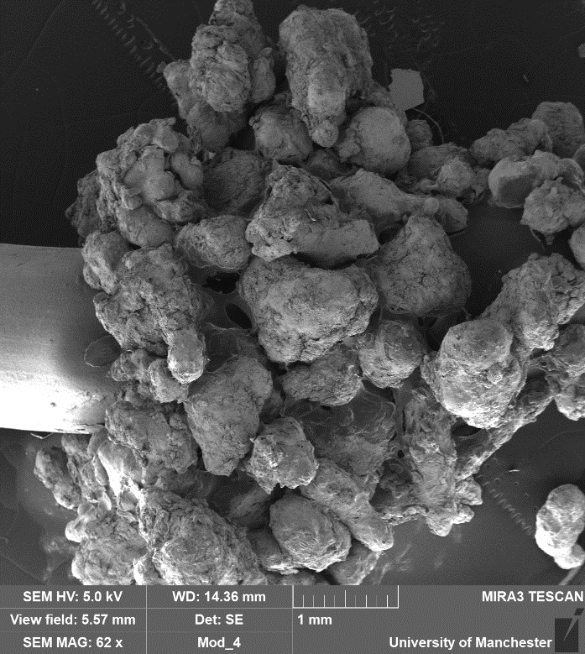

**Fig. S2. SEM image of zinc-reinforced ZSM-5 pre-treatment.** Scanning electron microscope surface image (at 1mm) is displayed showing the zinc-coated part of the reinforced surface of the ZSM-5 zeolite pellet with agar and zinc before treatment of the polluted medium with copper sulphate pentahydrate CuSO4.5H2O (0.7 g/L). Refer to the main text Methods.

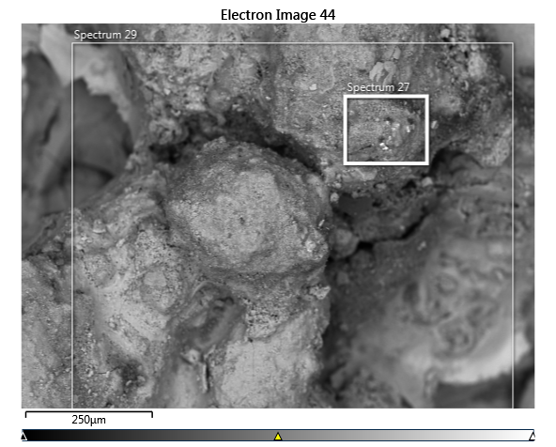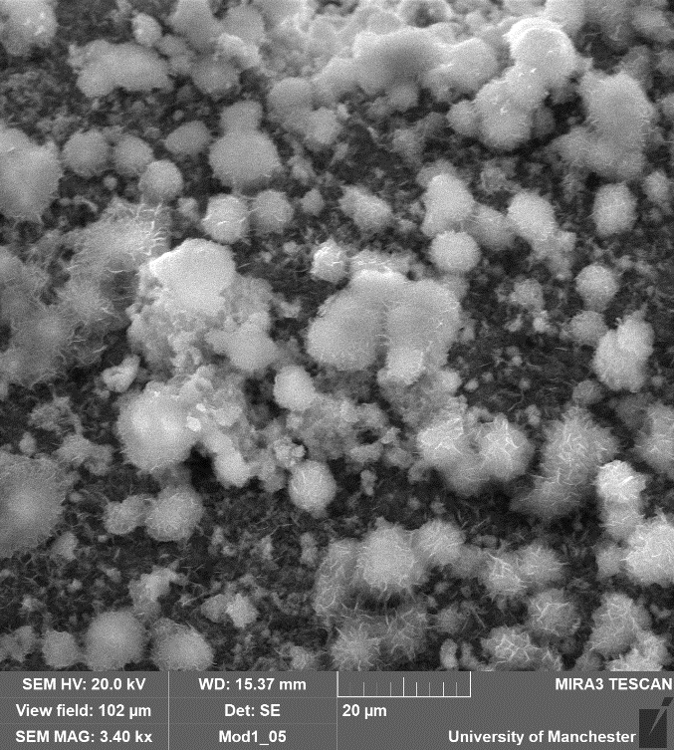

**Fig. S3. SEM image of copper deposition on the zinc-coated part of the reinforced ZSM-5 post-treatment.** The scanning electron microscope surface images of Panel (A) at a resolution of250 µm and Panel (B) at aresolution of20 µm display depositions of copper solid Cu(s) on the reactive crevices of the zinc-coated part of the zeolite ZSM-5 pellet following treatment of the polluted medium with copper sulphate pentahydrate CuSO4.5H2O (0.7 g/L).

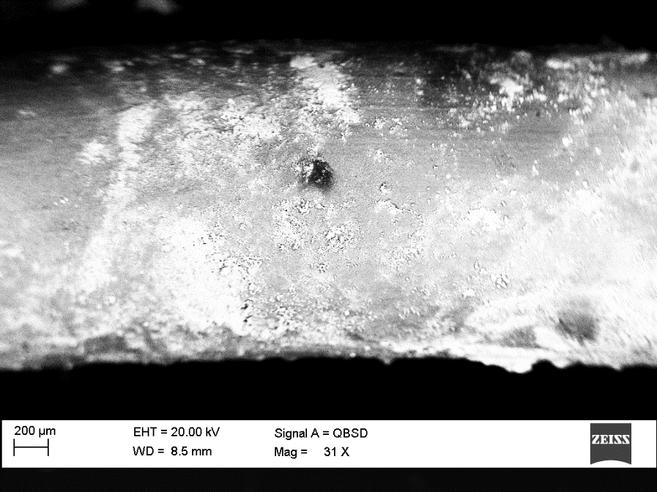

**Fig. S4. SEM image of the surface of the uncoated area of ZSM-5 pellet post-treatment.** Scanning electron microscope surface image (at 200 µm) is displayed showing the zinc-free (un-coated/non-reinforced) surface of the ZSM-5 zeolite pellet, following adsorption of copper from the polluted medium with copper sulphate pentahydrate CuSO4.5H2O (0.7 g/L). Refer to the main text Methods.

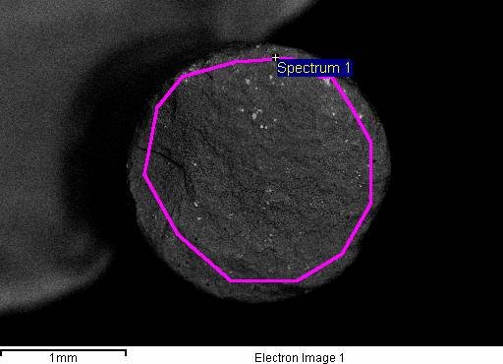

**Fig. S5. Cross-section of the uncoated part ZSM-5 pellet post-treatment.** The SEM image at a resolution of1mm shows the internal area of the zeolite pellet with copper adsorption, following treatment of the polluted medium with copper sulphate pentahydrate CuSO4.5H2O (0.7 g/L).

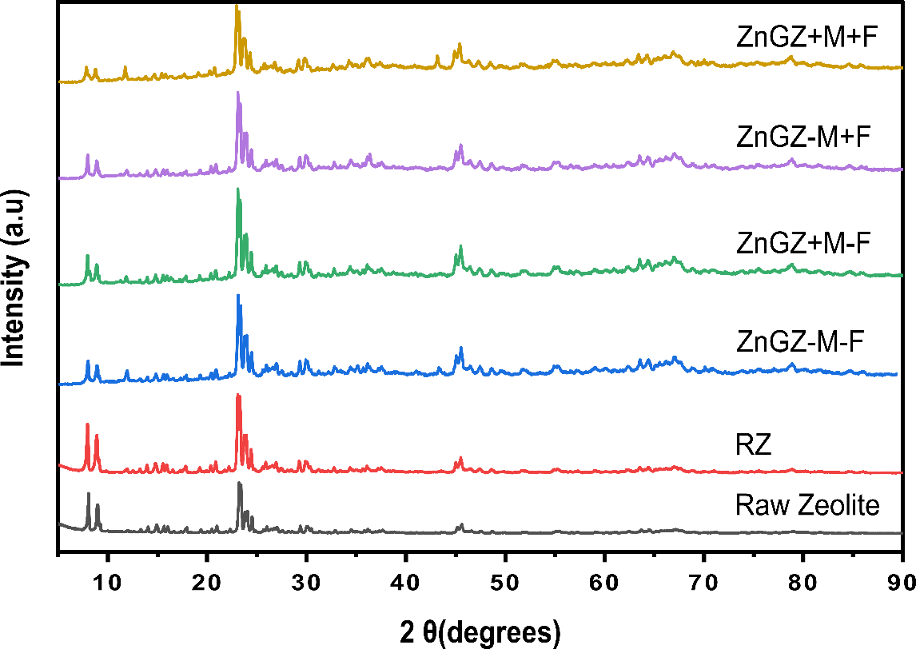

**Fig. S6. XRD analysis of ZSM-5.** The X-ray diffractogram is shown for zeolite ZSM-5 before application and across treatments of the target medium polluted with copper sulphate pentahydrate CuSO4.5H2O (0.7 g/L). Raw zeolite, in dark grey, refers to ZSM-5 before treatment/application, [RZ], in red, refers to raw zeolite after treatment, [ZnGZ-M-F], in blue, refers to zinc-gel-reinforced zeolite minus neodymium magnet without the bio-trap *V. faba*, [ZnGZ+M-F], in green, refers to zinc-gel-reinforced zeolite plus the magnet without *V. faba*, [ZnGZ-M+F], in purple, refers to zinc-gel-reinforced zeolite plus the magnet with *V. faba*, and [ZnGZ+M+F], light brown, refers to zinc-gel-reinforced zeolite plus the magnet with *V. faba*. Noticeable changes in peak intensities were observed for the following ranges: 2θ = 7.449° – 9.898°, when compared to the cases of the raw (unmodified) zeolite before and after treatment of the polluted medium, the peak intensity decreased for all the other treatments having partial zinc-surface-reinforcement. For the range, 2θ = 22.387° – 27.857°, the peak intensity increased in general in all treatments except the case of raw zeolite before treatment. For the range 2θ = 43.204° – 49.489°, apart from the case of raw zeolite before treatment, the intensity slightly increased across the other treatments, with another minor peak appearing in the treatment where the neodymium magnet and the bio-trap accompanied the reinforced zeolite. Additionally, for the range, 2θ = 62.244° – 71.428°, the peak range was flattened in the cases of raw zeolite before and after treatment, compared to the rest of the treatments having the reinforced zeolite.

*Note 1: The effects of exposure to copper pollution on faba bean bio-trap*

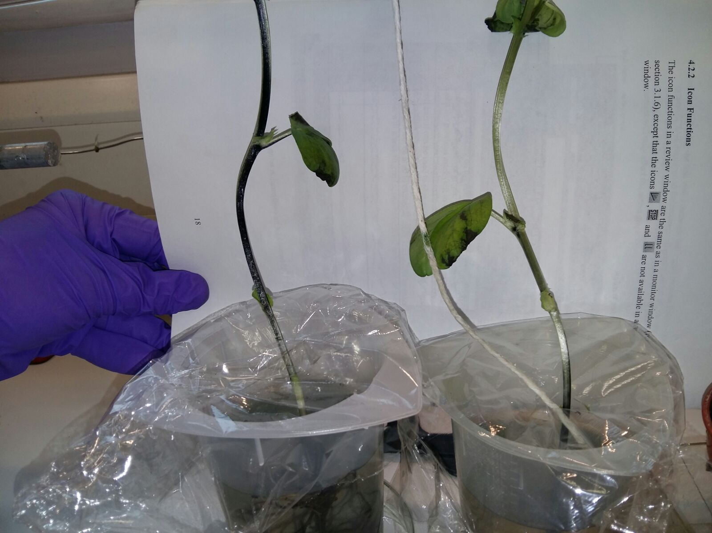 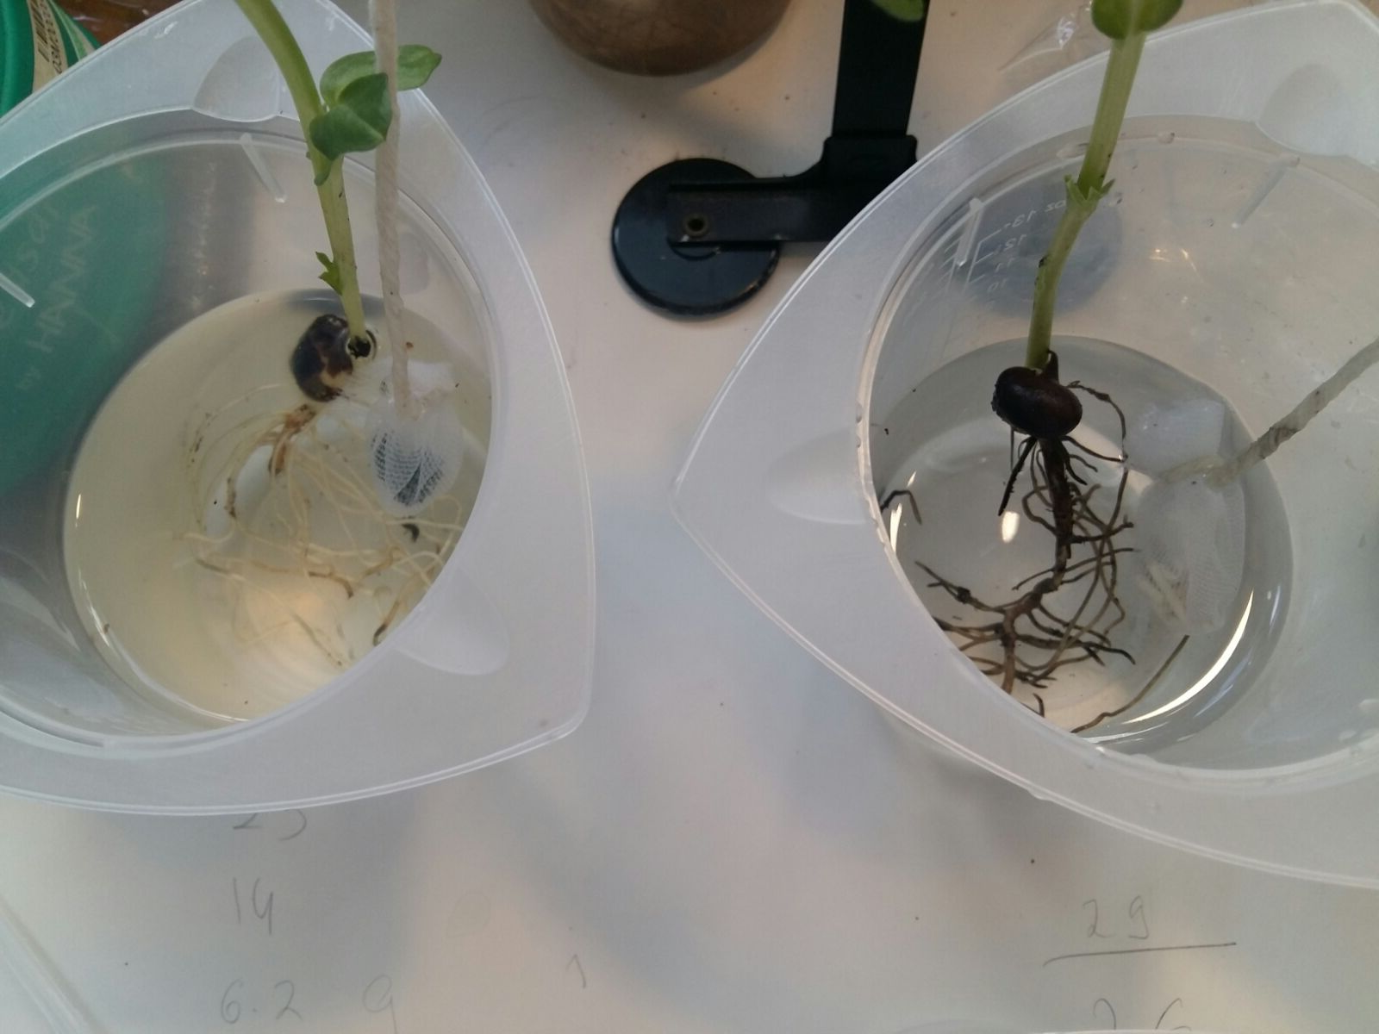

**Fig. S7. Effect of exposure to copper pollution on the bio-trap.** The left side of the image collagepictures aquacultured faba bean, *Vicia faba*, bio-trap alone in [F]. Exposure to the polluted medium with copper sulphate pentahydrate CuSO4.5H2O (7 g/L) negatively affected the well-being of the plant over time, as the root system darkened, while the shoot wilted, and necrosis spread. The middle part of the image collage displays the bio-trap next to a permeable drum that contained 1g of raw zeolite pellets; this was applied to compare the performance of the faba bean when the zinc-reinforcement of the zeolite was absent. The negative impact was less severe. The right side of the image collage shows the bio-trap next to a permeable drum containing 1 g of zinc-reinforced ZSM-5 zeolite pellets comprising the treatment [ZnGZ-M+F], whereby contrast the plant showed remarkable endurance and tolerance.

Dry weight

When compared to the control, the faba bean bio-trap showed growth inhibition, visible necrosis, and subsequently decreased dry biomass during exposure to the polluted medium with copper sulphate pentahydrate CuSO4.5H2O (7 g/L). The biomass notably decreased under pollution (x̄ = 0.28 g ± 0.02) compared to the control (x̄ = 0.46 g ± 0.07), indicating reduced protein production under severe environmental stress.

Biochemical responses

Individual specimens (leaves and roots) of the faba bean bio-trap were collected at the end of the experiment (the experiment lasted 15480 minutes), using a standardised circular plastic stamp (1 cm in diameter). We weighed and freeze-dried (lyophilised) the plant samples from the corresponding treatment lines. Lyophilisation, an endothermic technique, taking place at a low temperature under controlled pressure, involved the transition from the solid phase to the gas phase without reaching the intermediate liquid phase in the absence of a chemical reaction (sublimation). This helped remove the inter-molecular water from inside the plant tissue such that its interference with the characterisation of metabolomic changes was minimised, whilst the technique preserved the biomaterial in question (Roy & Gupta, 2004; Mohammady *et al.*, 2020). Afterwards, complementary FTIR analysis of the plant samples was done, revealing interesting changes in the bio-trap biochemical responses for lipids, proteins, and carbohydrates (Correia *et al.*, 2016; Durak *et al.*, 2021), when compared to plants grown in the control (optimal pollutant-free medium). For instance, as for the plant root, compared to the pollutant-free control, noticeable changes in the carbohydrate metabolism could be detected especially in the case where the magnet and the zinc-reinforced zeolite were present in the medium. Notable changes in the peaks signifying the metabolism of proteins can be seen, but changes in the lipid metabolism were negligible, Fig. S8. Whereas, for the plant leaf, ccompared to the pollutant-free control, considerable changes in the metabolism of carbohydrates, lipids, and proteins could be detected due to the exposure to cupric stress, especially in the case where the magnet and the zin-reinforced zeolite were present in the medium, Fig. S9.

**Fig. S8. FTIR spectroscopy of copper bio-trap (root) post-treatment.** The FTIR spectra are shown for lyophilised (freeze-dried) roots of faba bean bio-trap plants after their respective root systems were exposed to the experimental medium polluted with copper sulphate pentahydrate CuSO4.5H2O (0.7 g/L) for 15840 minutes. The red spectrum refers to the negative control (pollutant-free medium). The green spectrum refers to the treatment (ZnGZ-M+F) where the bio-trap accompanied the zinc-augmented zeolite without a neodymium magnet. The purple spectrum refers to the treatment (ZnGZ+M+F) where both the bio-trap and the zinc-augmented zeolite were applied in the presence of the magnet. The orange spectrum refers to a frame of reference where the bio-trap was accompanied by raw zeolite. The added rectangles refer to the ranges of the biochemical changes associated with carbohydrates (1000 cm−1 – 1300 cm−1), Proteins (1400 cm−1 – 1800 cm−1), and Lipids (2700 cm−1 – 3000 cm−1). The zeolite of choice was ZSM-5. Refer to the main text Methods for further details.

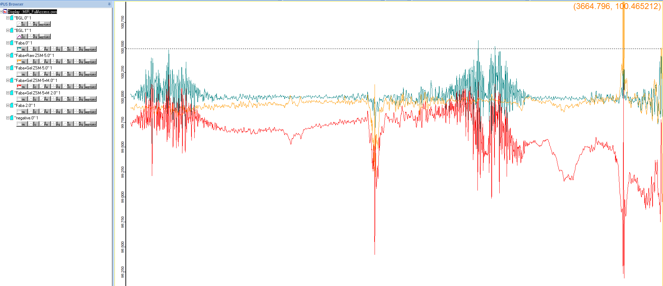

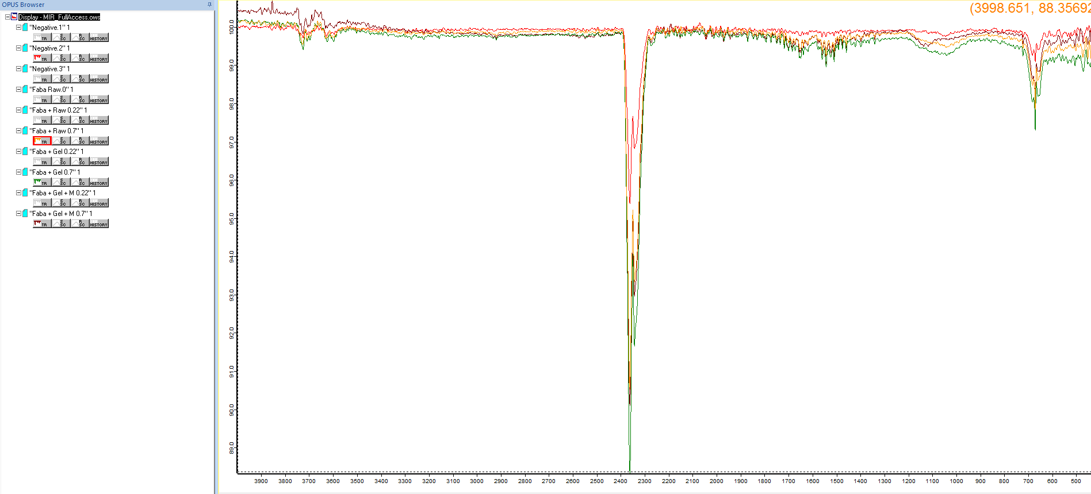

**Fig. S9. FTIR spectroscopy of copper bio-trap (leaf) post-treatment.** The FTIR spectra are shown for lyophilised (freeze-dried) leaves of faba bean bio-trap plants after their respective root systems were exposed the experimental medium polluted with copper sulphate pentahydrate CuSO4.5H2O (0.7 g/L) for 15840 minutes. The red spectrum refers to the treatment (ZnGZ+M+F) where both the bio-trap and the zinc-reinforced zeolite were applied in the presence of the magnet. The orange spectrum refers to a frame of reference where the bio-trap was accompanied by raw zeolite. The green spectrum refers to the treatment (F) where the plant was applied alone. The zeolite of choice was ZSM-5. The added rectangles refer to the ranges of the biochemical changes associated with carbohydrates (1000 cm−1 – 1300 cm−1), Proteins (1400 cm−1 – 1800 cm−1), and Lipids (2700 cm−1 – 3000 cm−1). Refer to the main text Methods for further details.

**Table S1. Comparison of treatment efficiency in copper extraction over time, relative to raw zeolite.** The initial copper concentration was 0.178 g/L in the target medium polluted with copper sulphate pentahydrate CuSO4.5H2O (0.7 g/L). There were four sampling times in minutes (5, 20, 7200 and 15840). The treatment combinations were raw zeolite [RZ] as the baseline, the bio-trap *V. faba* alone [F], zinc-gel-reinforced zeolite minus magnet without *V. faba* [ZnGZ-M-F], zinc-gel-reinforced zeolite plus magnet without *V. faba* [ZnGZ+M-F], zinc-gel-reinforced zeolite plus magnet with *V. faba* [ZnGZ-M+F], and zinc-gel-reinforced zeolite plus magnet with *V. faba* [ZnGZ+M+F]. As specified in the main text Methods, we measured the residual copper concentration over time. Treatment efficiencies in copper extraction are shown as a percentage, relative to the copper extraction value accrued per sampling time by the raw zeolite in [RZ]. For example, at 5min, [ZnGZ-M+F] did 7% better than [RZ], and at 15480 min, [ZnGZ-M+F] was 78% better than [RZ].

|  |  |  |  |  |  |
| --- | --- | --- | --- | --- | --- |
| Effect | Treatment | 5min | 20min | 7200min | 15480min |
| Zinc reinforcement (ZR) | ZnGZ-M-F | 16 | 16 | 56 | 67 |
| ZR + Magnet | ZnGZ+M-F | 12 | 13 | 29 | 61 |
| ZR + Bio-trap | ZnGZ-M+F | 7 | 7 | 68 | 78 |
| ZR + Magnet + Bio-trap | ZnGZ+M+F | 13 | 13 | 55 | 69 |
| Bio-trap | F | 14 | 13 | 3 | 2 |

**Table S2. Comparison of the efficiency of zinc-reinforced zeolite in copper extraction over time, subject to the companion effect of bio-trap, neodymium magnet, or both.** The initial copper concentration was 0.178 g/L in the target medium polluted with copper sulphate pentahydrate CuSO4.5H2O (0.7 g/L). There were four sampling times in minutes (5, 20, 7200 and 15840). The target treatment combinations were: zinc-gel-reinforced zeolite minus magnet without bio-trap *Vicia faba* [ZnGZ-M-F] as the baseline, zinc-gel-reinforced zeolite plus magnet without *V. faba* [ZnGZ+M-F], zinc-gel-reinforced zeolite plus magnet with *V. faba* [ZnGZ-M+F], and zinc-gel-reinforced zeolite plus magnet with *V. faba* [ZnGZ+M+F], and bio-trap alone [F] as a reference frame. As specified in the main text Methods, we measured the residual copper concentration over time. Treatment efficiencies in copper extraction are shown as a percentage, relative to the copper extraction value accrued per sampling time by the zinc-reinforced zeolite in [ZnGZ-M-F]. For example, at 5min, [ZnGZ+M-F] did 6% worse than [ZnGZ-M-F], and at 15480 min, [ZnGZ+M+F] was 4% better than [ZnGZ-M-F].

|  |  |  |  |  |  |
| --- | --- | --- | --- | --- | --- |
| Effect | Treatment | 5min | 20min | 7200min | 15480min |
| Zinc-reinforcement (ZR) + Magnet | ZnGZ+M-F | -6 | -4 | -61 | -19 |
| ZR + Bio-trap | ZnGZ-M+F | -11 | -11 | 28 | 32 |
| ZR + Magnet + Bio-trap | ZnGZ+M+F | -4 | -3 | -2 | 4 |
| Bio-trap | F | -3 | -4 | -121 | -199 |

**Table S3. Comparison of the copper extraction efficiency of the faba bean bio-trap relative to other treatments.** The initial copper concentration was 0.178 g/L in the target medium polluted with copper sulphate pentahydrate CuSO4.5H2O (0.7 g/L). There were four sampling times in minutes (5, 20, 7200 and 15840). The faba bean *Vicia faba* bio-trap alone in [F] is compared to the following treatment combinations: raw zeolite [RZ], zinc-gel-reinforced zeolite minus magnet without bio-trap [ZnGZ-M-F], zinc-gel-reinforced zeolite plus magnet without bio-trap [ZnGZ+M-F], zinc-gel-reinforced zeolite minus magnet with bio-trap [ZnGZ-M+F], and zinc-gel-reinforced zeolite plus magnet with bio-trap [ZnGZ+M+F]. As specified in the main text Methods, we measured the residual copper concentration over time. Treatment efficiencies in copper extraction are shown as a percentage, relative to the copper extraction value (mean) accrued per sampling time by the bio-trap alone in [F]. For example, at 5min, [F] was 14% better than [RZ] but 3% worse than [ZnGZ-M-F]. Whereas, at 15480 min, [F] was 2% better than [RZ] but 213% worse than [ZnGZ+M+F].

|  |  |  |  |  |  |
| --- | --- | --- | --- | --- | --- |
| Effect | Treatment | 5min | 20min | 7200min | 15480min |
| Raw zeolite (zinc-free) | RZ | 14 | 13 | 3 | 2 |
| Zinc reinforcement (ZR) | ZnGZ-M-F | -3 | -4 | -121 | -199 |
| ZR + Magnet | ZnGZ+M-F | 3 | 1 | -37 | -151 |
| ZR + Bio-trap | ZnGZ-M+F | 7 | 7 | -206 | -342 |
| ZR + Magnet + Bio-trap | ZnGZ+M+F | 0.6 | -0.2 | -116 | -213 |

**Table S4. Comparison of the efficiency of having neodymium magnet as a companion of zinc-reinforced zeolite in copper extraction over time.** The initial copper concentration was 0.178 g/L in the target medium polluted with copper sulphate pentahydrate CuSO4.5H2O (0.7 g/L). There were four sampling times in minutes (5, 20, 7200 and 15840). The target treatment combinations were: zinc-gel-reinforced zeolite plus magnet without bio-trap *Vicia faba* [ZnGZ+M-F] as the baseline, zinc-gel-reinforced zeolite minus magnet with *V. faba* [ZnGZ-M+F], and zinc-gel-reinforced zeolite plus magnet with *V. faba* [ZnGZ+M+F], and zinc-gel-reinforced zeolite minus magnet without *V. faba* [ZnGZ-M-F] as a reference frame. As specified in the main text Methods, we measured the residual copper concentration over time. Treatment efficiencies in copper extraction are shown as a percentage, relative to the copper extraction value (mean) accrued per sampling time by the zinc-reinforced zeolite in [ZnGZ-M-F]. For example, at 5min, [ZnGZ-M-F] was 6% worse than [ZnGZ+M-F], and at 15480 min, [ZnGZ+M+F] was 20% better than [ZnGZ+M-F].

|  |  |  |  |  |  |
| --- | --- | --- | --- | --- | --- |
| Effect | Treatment | 5min | 20min | 7200min | 15480min |
| Zinc reinforcement (ZR) | ZnGZ-M-F | -6 | -4 | -61 | -19 |
| ZR + Bio-trap | ZnGZ-M+F | -5 | -6 | 55 | 43 |
| ZR + Magnet + Bio-trap | ZnGZ+M+F | 2 | 1 | 37 | 20 |

**Table S5. GLM model summary on copper extraction analysis.** Model outcome details are provided for the GLM applied to analyse copper extraction as a function of treatment effect, sampling time, and their interaction, as specified in the main text Methods. The treatment combinations were raw zeolite [RZ] as the baseline, bio-trap (*Vicia faba*) alone [F], zinc-reinforced zeolite minus magnet without bio-trap [ZnGZ-M-F], zinc-reinforced zeolite plus magnet without bio-trap [ZnGZ+M-F], zinc-reinforced zeolite minus magnet with bio-trap [ZnGZ-M+F], zinc-reinforced zeolite plus magnet with bio-trap [ZnGZ+M+F], zinc-sputtered zeolite minus magnet [ZnSZ-M], and zinc-sputtered zeolite plus magnet [ZnSZ+M]. There were four sampling times in minutes (5, 20, 7200, and 15840), ST = sampling time. Significant results are shown in bold and marginally significant results are shown in italics.

|  |  |  |  |  |
| --- | --- | --- | --- | --- |
| Coefficients |  | | | |
|  | Estimate | Std. Error | t value | Pr(>|t|) |
| (Intercept) | -1.79 | 0.04 | -45.67 | **<0.0001** |
| ST(20) | -0.02 | 0.06 | -0.43 | 0.667 |
| **ST(7200)** | **-0.21** | **0.06** | **-3.61** | **0.001** |
| **ST(15840)** | **-0.28** | **0.06** | **-4.71** | **<0.0001** |
| **Treatment (F)** | **-0.15** | **0.06** | **-2.58** | **0.013** |
| **Treatment (ZnGZ-M-F)** | **-0.18** | **0.06** | **-3.07** | **0.004** |
| Treatment (ZnGZ-M+F) | -0.07 | 0.06 | -1.3 | 0.201 |
| Treatment (ZnGZ+M-F) | -0.12 | 0.06 | -1.91 | 0.063 |
| **Treatment (ZnGZ+M+F)** | **-0.14** | **0.06** | **-2.48** | **0.017** |
| ST(20) X Treatment (F) | 0.01 | 0.08 | 0.09 | 0.927 |
| ST(7200) X Treatment (F) | 0.12 | 0.08 | 1.37 | 0.177 |
| ST(15840 X Treatment (F) | 0.13 | 0.09 | 1.53 | 0.132 |
| ST(20) X Treatment (ZnGZ-M-F) | 0.002 | 0.08 | 0.03 | 0.979 |
| **ST(7200) X Treatment (ZnGZ-M-F)** | **-0.65** | **0.1** | **-6.58** | **<0.0001** |
| **ST(15840 X Treatment (ZnGZ-M-F)** | **-0.93** | **0.11** | **-8.66** | **<0.0001** |
| ST(20) X Treatment (ZnGZ-M+F) | 0.002 | 0.08 | 0.02 | 0.984 |
| **ST(7200) X Treatment (ZnGZ-M+F)** | **-1.08** | **0.11** | **-10.22** | **<0.0001** |
| **ST(15840 X Treatment (ZnGZ-M+F)** | **-1.43** | **0.12** | **-11.91** | **<0.0001** |
| ST(20) X Treatment (ZnGZ+M-F) | -0.01 | 0.11 | -0.11 | 0.913 |
| **ST(7200) X Treatment (ZnGZ+M-F)** | **-0.22** | **0.09** | **-2.38** | **0.022** |
| **ST(15840 X Treatment (ZnGZ+M-F)** | **-0.81** | **0.11** | **-7.62** | **<0.0001** |
| ST(20) X Treatment (ZnGZ+M+F) | -0.0002 | 0.08 | -0.002 | 0.998 |
| **ST(7200) X Treatment (ZnGZ+M+F)** | **-0.66** | **0.1** | **-6.8** | **<0.0001** |
| **ST(15840) X Treatment (ZnGZ+M+F)** | **-1.01** | **0.11** | **-9.32** | **<0.0001** |

**Table S6. Measurements of pH and conductivity.** The pH and conductivity of the treated experimental medium [polluted with copper sulphate pentahydrate CuSO4.5H2O (0.7 g/L)] were measured at each of the four sampling times in minutes (5, 20, 7200 and 15840). The treatment combinations were raw zeolite alone [RZ], the bio-trap *V. faba* alone [F], zinc-gel-reinforced zeolite minus magnet without *V. faba* [ZnGZ-M-F], zinc-gel-reinforced zeolite plus magnet without *V. faba* [ZnGZ+M-F], zinc-gel-reinforced zeolite plus magnet with *V. faba* [ZnGZ-M+F], and zinc-gel-reinforced zeolite plus magnet with *V. faba* [ZnGZ+M+F].

|  |  |  |  |  |  |  |  |  |
| --- | --- | --- | --- | --- | --- | --- | --- | --- |
|  | 5 min | | 20 min | | 7200 min | | 15480 min | |
| Treatment | pH | Conductivity | pH | Conductivity | pH | Conductivity | pH | Conductivity |
| RZ | 5.9 | 4.16 | 5.78 | 4 | 5.64 | 4.18 | 5.6 | 4.32 |
| F | 6.21 | 4.23 | 6.05 | 4.15 | 5.72 | 4.27 | 6.33 | 4.42 |
| ZnGZ-M-F | 5.83 | 3.7 | 6.01 | 3.6 | 6.9 | 3.66 | 7 | 3.81 |
| ZnGZ+M-F | 5.3 | 3.48 | 5.9 | 3.93 | 6.5 | 4.11 | 6.98 | 3.87 |
| ZnGZ-M+F | 5.98 | 3.75 | 5.89 | 3.66 | 6.55 | 3.6 | 6.6 | 3.89 |
| ZnGZ+M+F | 6.2 | 4.21 | 6.25 | 4.22 | 7 | 3.9 | 7.3 | 4.4 |

**References**

**Correia M, Lopes J, Silva R, Martins Rosa I, Gabriela Henriques A, Delgadillo I, Da Cruz E Silva O, Nunes A. 2016.** FTIR Spectroscopy - a potential tool to identify metabolic changes in dementia patients. *Journal of Alzheimer's Disease* **2:** 007. https://doi.org/10.24966/AND-9608/100007

**Durak R, Depciuch J, Kapusta I, Kisała K, Durak T. 2021.** Changes in chemical composition and accumulation of cryoprotectants as the adaptation of anholocyclic aphid *Cinara tujafilina* to overwintering. *International Journal of Molecular Sciences* **22:** 511. https://doi.org/10.3390/ijms22020511

**Khudr MS, Baleca C, Alqahtani N, Alhassawi H, Garforth A, Tiddy G, Alfutimie A. 2023.** Zinc-reinforced ZSM-5 subject to a rare-earth magnet and the presence of a legume yields substantial copper extraction. *ChemRxiv.* https://doi.org/10.26434/chemrxiv-2023-gn9z7-v2

**Mohammady M, Mohammadi Y, Yousefi G. 2020.** Freeze-drying of pharmaceutical and nutraceutical nanoparticles: The effects of formulation and technique parameters on nanoparticles characteristics. *Journal of Pharmaceutical Sciences* **109:** 3235–3247. https://doi.org/10.1016/j.xphs.2020.07.015

**Roy I, Gupta MN. 2004.** Freeze-drying of proteins: some emerging concerns. *Biotechnology and Applied Biochemistry* **39**, 165–177. https://doi.org/10.1042/BA20030133