Supplementary Material
Rheumatoid arthritis and stroke risk: a systematic review and meta-analysis

The retrieval strategies and retrieval results of each database are shown in Tables 1-3.
Table 1: PubMed
No. | Content | Result
#1 | Search: "Stroke"[Mesh] Sort by: Most Recent | 194,432
#2 | Search: (((((Stroke*[Title/Abstract]) OR (Cerebrovascular Accident*[Title/Abstract])) OR (Cerebrovascular Apoplexy[Title/Abstract])) OR (Brain Vascular Accident*[Title/Abstract])) OR (Apoplexy[Title/Abstract])) OR (CVAs[Title/Abstract]) Sort by: Most Recent | 381,931
#3 | Search: ("Stroke"[Mesh]) OR ((((((Stroke*[Title/Abstract]) OR (Cerebrovascular Accident*[Title/Abstract])) OR (Cerebrovascular Apoplexy[Title/Abstract])) OR (Brain Vascular Accident*[Title/Abstract])) OR (Apoplexy[Title/Abstract])) OR (CVAs[Title/Abstract])) Sort by: Most Recent | 420,995
#4 | Search: "Arthritis, Rheumatoid"[Mesh] Sort by: Most Recent | 133,529
#5 | Search: Rheumatoid Arthritis[Title/Abstract] Sort by: Most Recent | 133,790
#6 | Search: ("Arthritis, Rheumatoid"[Mesh]) OR (Rheumatoid Arthritis[Title/Abstract]) Sort by: Most Recent | 179,770
#7 | Search: (("Stroke"[Mesh]) OR ((((((Stroke*[Title/Abstract]) OR (Cerebrovascular Accident*[Title/Abstract])) OR (Cerebrovascular Apoplexy[Title/Abstract])) OR (Brain Vascular Accident*[Title/Abstract])) OR (Apoplexy[Title/Abstract])) OR (CVAs[Title/Abstract]))) AND (("Arthritis, Rheumatoid"[Mesh]) OR (Rheumatoid Arthritis[Title/Abstract])) Sort by: Most Recent | 1,102
#8 | Search: ("risk"[Mesh]) OR (risk[Title/Abstract]) Sort by: Most Recent | 3,787,488
#9 | Search: ((("Stroke"[Mesh]) OR ((((((Stroke*[Title/Abstract]) OR (Cerebrovascular Accident*[Title/Abstract])) OR (Cerebrovascular Apoplexy[Title/Abstract])) OR (Brain Vascular Accident*[Title/Abstract])) OR (Apoplexy[Title/Abstract])) OR (CVAs[Title/Abstract]))) AND (("Arthritis, Rheumatoid"[Mesh]) OR (Rheumatoid Arthritis[Title/Abstract]))) AND (("risk"[Mesh]) OR (risk[Title/Abstract])) Sort by: Most Recent | 617

Table 2 Embase
No. | Content | Result
#1 | 'cerebrovascular accident'/exp | 523,226
#2 | 'cerebrovascular accident':ab,ti OR stroke*:ab,ti OR 'cerebrovascular accident*':ab,ti OR 'cerebrovascular apoplexy':ab,ti OR 'brain vascular accident*':ab,ti OR apoplexy:ab,ti OR cvas:ab,ti | 608,101
#3 | #1 OR #2 | 738,234
#4 | 'rheumatoid arthritis'/exp | 287,014
#5 | 'arthritis deformans':ab,ti OR 'arthritis, rheumatoid':ab,ti OR 'arthrosis deformans':ab,ti OR 'beauvais disease':ab,ti OR 'chronic articular rheumatism':ab,ti OR 'chronic polyarthritis':ab,ti OR 'chronic rheumatoid arthritis':ab,ti OR 'disease, beauvais':ab,ti OR 'infantile rheumatoid arthritis':ab,ti OR 'inflammatory arthritis':ab,ti OR 'polyarthritis rheumatica':ab,ti OR 'polyarthritis, primary chronic':ab,ti OR 'primary chronic polyarthritis':ab,ti OR rheumarthritis:ab,ti OR 'rheumatic arthritis':ab,ti OR 'rheumatic polyarthritis':ab,ti OR 'rheumatism, chronic articular':ab,ti OR 'rheumatoid polyarthritis':ab,ti OR 'rheumatoid arthritis':ab,ti | 219,933
#6 | #4 OR #5 | 317,857
#7 | 'risk'/exp | 3,561,137
#8 | risk:ab,ti OR 'risk hypothesis':ab,ti | 4,756,206
#9 | #7 OR #8 | 5,782,370
#10 | #3 AND #6 AND #9 | 2,728

Table 3 Cochran Library
No. | Content | Result
#1 | MeSH descriptor: [Stroke] explode all trees | 18393
#2 | (Stroke* or Cerebrovascular Accident* or Cerebrovascular Apoplexy or Brain Vascular Accident* or Apoplexy or CVAs):ti,ab,kw | 82246
#3 | #1 or #2 | 82783
#4 | MeSH descriptor: [Arthritis, Rheumatoid] explode all trees | 8188
#5 | (Rheumatoid Arthritis):ti,ab,kw | 19808
#6 | #4 OR #5 | 20234
#7 | MeSH descriptor: [Risk] explode all trees | 55991
#8 | (risk or relative risk or relative risks):ti,ab,kw | 335311
#9 | #7 OR #8 | 339129
#10 | #3 AND #6 AND #9 | 123

S1 Fig. Sensitivity analysis of rheumatoid arthritis and the risk of stroke.

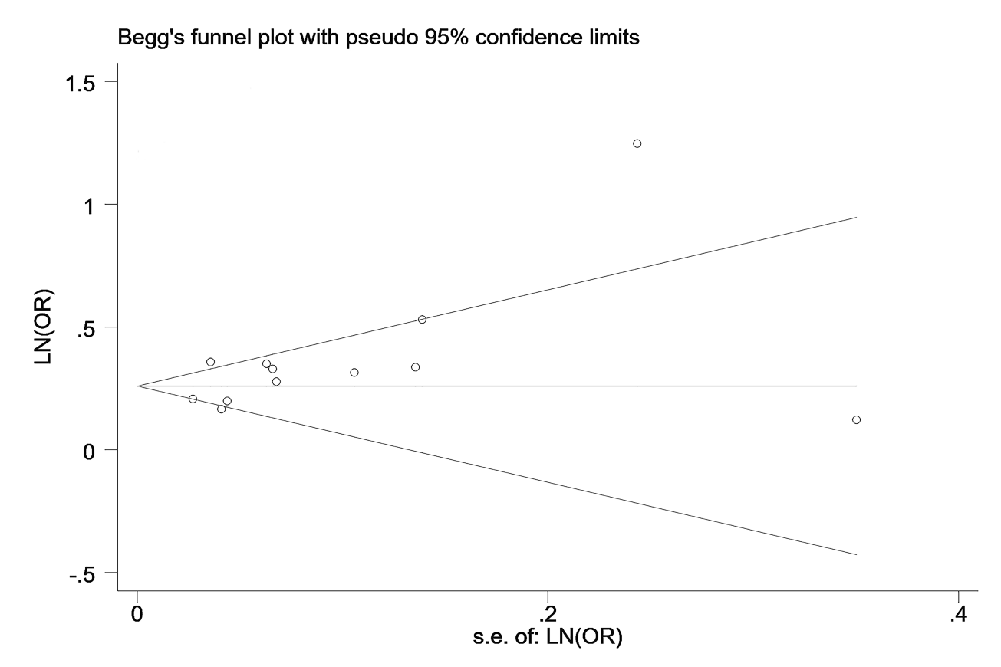

S2 Fig. Begg’s test of the meta-analysis.

S3 Fig. Egger’s test of the meta-analysis.
S4 Fig. Funnel plot of Trim and fill method.

